HYBRIDIZATION AND SPECIATION IN SWORDTAIL FISH (POECILIIDAE: *XIPHOPHORUS*)

Molly Schumer

A DISSERTATION

PRESENTED TO THE FACULTY

OF PRINCETON UNIVERSITY

IN CANDIDACY FOR THE DEGREE

OF DOCTOR OF PHILOSOPHY

RECOMMENDED FOR ACCEPTANCE

BY THE DEPARTMENT OF

ECOLOGY AND EVOLUTIONARY BIOLOGY

Advisor: Peter Andolfatto

April 2016

© Molly Schumer, 2016. All rights reserved.

Abstract

Understanding what makes a species is fundamental to understanding evolutionary biology, yet there is so much about this process that still puzzles us. Until recently, mating between different species, or hybridization, was thought to be a rare event. With the advent of genome sequencing, biologists began to realize that hybridization is remarkably common throughout the tree of life. Despite this realization that hybridization is common, there is much we do not know about its evolutionary effects. In my dissertation work, I use a combination of genomic and computational techniques to ask how selection on hybrids shapes the genomes and evolution of hybrids and parental species. As a model system for this work, I focus on a group of freshwater fish, the swordtails (Poeciliidae: *Xiphophorus*).

In my first chapter, I examine the genome of a proposed hybrid species, the swordtail fish *Xiphophorus clemenciae*. Though the importance of hybridization in speciation has long been recognized in plants, it has been thought to be rarer in animals, and the genomic mechanisms that facilitate its occurrence in animals are still not completely understood. In contrast to previous work, I find that there is no evidence that *X. clemenciae* originated through hybridization.

In my second chapter, I return to the question of hybrid speciation using theoretical and simulation approaches. Though there is still much that we do not understand about the process of hybridization and how hybridization-derived regions are incorporated in the genome, the genetic interactions that underlie reduced fitness in hybrids are well characterized. I use models that describe how gene combinations that are under selection in hybrids (or “hybrid incompatibilities”) to predict how these regions of the genome will evolve in hybrids, and potentially contribute to reproductive isolation between hybrids and parent species.

In my third chapter, I study the genomes of recent, natural hybrids between the sister species *X. birchmanni* and *X. malinche*. I identify on the order of two hundred pairs of hybrid incompatibilities using multiple approaches. In contrast to results found in other systems, these regions are widely distributed throughout the genome, and estimated to experience relatively weak selection. I find evidence that these loci may actually play a role in limiting gene flow between species at functionally important genomic regions.

In my fourth chapter, I study an ancient hybridization event between the swordtail fish *X. nezahualcoyotl* and *X. cortezi*. I find that at least two thousand generations have passed since initial hybridization in these species, allow time for selection to act on hybrid ancestry in the genome. This allows me to study how selection has influenced hybrid ancestry in the genome over time. I find that selection has constrained what regions of the genome are hybridization-derived to less functionally essential genomic regions.

Overall, my dissertation work yields new insights into the importance of hybridization in speciation and how selection acts on hybridization-derived regions to shape hybrid ancestry in the genome.

TABLE OF CONTENTS

iii

iv

v

1

Abstract

Table of Contents

Acknowledgements

Introduction

Chapter One: An evaluation of the hybrid speciation hypothesis for *Xiphophorus clemenciae* based on whole genome sequences

4

4

7

11

14

17

21

26

Abstract

Introduction

Materials and methods

Results

Discussion

Figures and Tables

References

Supporting Information

Chapter Two: Reproductive isolation of hybrid populations driven by genetic incompatibilities

49

49

51

54

58

60

62

68

Abstract

Introduction

Results

Discussion

Materials and methods

Figures and Tables

References

Supporting Information

Chapter Three: High-resolution Mapping Reveals Hundreds of Genetic Incompatibilities in Hybridizing Fish Species

88

88

90

93

96

105

116

121

Abstract

Introduction

Results

Discussion

Materials and methods

Figures and Tables

References

Supporting Information

Chapter Four: Ancient hybridization and genomic stabilization in a swordtail fish

129

129

131

138

143

147

151

156

174

Abstract

Introduction

Materials and methods

Results

Discussion

Figures and Tables

References

Supporting Information

Conclusions

ACKNOWLEDGEMENTS

I have been incredibly fortunate to have two advisers during my PhD who have not only been excellent scientific and career mentors but have truly found every way to help me thrive. It is basically impossible for me to sufficiently thank my primary advisor, Peter Andolfatto, for the ways in which he has shaped my scientific thinking and continuously challenged me to be a more rigorous, creative, and independent scientist. I am very much in his debt. My co-advisor, Gil Rosenthal, has been a fantastic mentor and his scientific insights have pushed me to integrate behavior and ecology and tackle questions outside of my area of expertise. In doing so he has always reminded me that the best science is also fun. I have also benefited from the advice of a supportive committee: Andrea Graham, Dan Rubenstein, and Bridgett VonHoldt.

My research at Princeton has been facilitated by many people. Lab managers Julie Peng and Ilona Ruhl have made my daily life easy for the past five years. Lolly O’Brien, Diane Carlino, Sandy Cominski and Muhamed Mahmutbegovic have been a huge help with logistics and advice. Axel Haenssen helped with my computational work and Jessica Buckles, Donna Storton, and Wei Wang helped with sequencing projects. Members of the Andolfatto, Rosenthal, Ayroles and Kocher labs have provided an excellent scientific community in which to conduct this research; discussions with Molly Przeworski, Graham Coop, Yaniv Brandvain, and Alisa Sedghifar have strengthened this work. The community of EEB postdocs and students has made Princeton a wonderful social as well as scientific community; I am particularly grateful to Emma Fuller, Ruthie Birger, Anieke van Leeuwen, Christina Faust, Albert Kao, and Adam Pellegrini. My husband and family have been, as always, supportive and funny.

This dissertation reflects the efforts of several collaborators whose hard work and insights are invaluable to the products reflected herein. Most of all, Rongfeng (Ray) Cui, has been instrumental in this work and has made my dissertation so much fun. Below, I describe the contributions of each co-author to each chapter. In Chapter 1, Ray Cui and Bastien Boussau aided in phylogenetic analyses; Ron Walter provided genomic resources. For Chapter 2, Ray Cui wrote the admixture simulator used in primary analyses. For Chapter 3, Ray Cui wrote several major scripts used in the analysis, Dan Powell performed gene annotation and GO analysis, Rebecca Dresner was a talented undergraduate who performed early exploratory analyses of the data. For Chapter 4, Ray Cui performed phylogenetic analyses and wrote several scripts used in the analysis and Dan Powell collected fish and performed GO and pathway analysis. Peter Andolfatto and Gil Rosenthal supervised all of this research. My research has been funded by an NSF GRFP and DDIG and by grants from the Society for the Study of Evolution, American Livebearer Association, Animal Behavior Society, Society for the Study of Systematic Biology, and Princeton Environmental Institute.

INTRODUCTION

Fundamentally, evolutionary biologists want to understand the processes that generate and shape species. What processes promote the origin of new species? How does reproductive isolation between new species evolve? What mechanisms maintain barriers between species?

Understanding these basic questions requires us to delve into the topic of hybridization, or mating between species. Once thought rare, hybridization is now recognized to be a common evolutionary process (Mallet 2005) and advances in genomics are revealing more and more cases of interspecific hybridization (e.g. Cui *et al.* 2013). Hybridization can be a major force that reduces reproductive isolation between species by breaking down linkage between locally adapted genes, although there are a few cases in which hybrids themselves have formed new species (Schumer *et al.* 2014). Hybridization can also promote processes such as reinforcement that drive stronger reproductive isolation between species (Hopkins *et al.* 2014). Finally, hybrids can be a tool to identify genes that are under selection in hybrids and thus help us better understand the genetic basis of reproductive isolation between species (Presgraves 2010).

Although we now understand much more than we did a decade ago about the role of hybridization in evolution, there are still many essential unanswered questions. These include: how important is hybridization as a mechanism of speciation? How many genes and what genes are under selection in hybrids, and how strong is this selection? How important is selection in shaping hybrid ancestry in the genomes of hybrids over time? Each of my chapters tackles one of these fundamental questions.

In my first chapter, I ask about the role of hybridization in generating new species using a case study of the swordtail fish *Xiphophorus clemenciae*. Although we now understand that hybridization is common, we still do not know how important hybridization is in generating new, reproductively isolated species. Much work on this topic has focused on the idea of ecological or sexual signal novelty generated by hybridization (Mallet 2007). Due to interactions between genes, or epistasis, hybrids often have novel traits not seen in either parental species (Gompert *et al.* 2006; Mavarez *et al.* 2006) which have been shown to be important in driving reproductive isolation between hybrids and parents in a handful of cases (reviewed in Schumer *et al*. 2014). However, more frequently these epistatic interactions are deleterious and contribute to reduced hybrid fitness. In my first chapter I used whole genome sequencing of several species to test the previously proposed hypothesis that the swordtail *X. clemenciae* is a hybrid between *X. hellerii* and *X. maculatus* (Meyer *et al.* 2006). My results showed that *X. clemenciae* did not have a hybrid genome, and thus is not a hybrid species. These results raised many questions about previous work on hybrid speciation, which I followed up with a comprehensive review in which I conclude that there is little evidence that hybrid speciation is common (Schumer *et al*. 2014). This work has been important in our understanding of the role of hybridization in speciation.

In my second chapter, I build upon ideas developed in my first chapter to explore other potential mechanisms that could lead to hybrid speciation. Past work (discussed above) has focused on the idea that hybrids can have novel traits (Jiggins *et al.* 2008), but has not completely explored how selection on hybrids might affect reproductive isolation between hybrids and parents. Hybrids frequently suffer reduced fitness due to hybrid incompatibilities. If hybrids persist, selection will remove genotypes contributing to hybrid incompatibilities from the population (Gavrilets 1997). In my second chapter I explore the consequences of this selection on reproductive isolation between hybrids and parents using mathematical models and simulations (with the forward-time simulator admix’em; Cui *et al.* 2015). Because selection on hybrids can drive fixation of loci involved in reproductive isolation between parent species in hybrids, these loci can in turn contribute to reproductive isolation between hybrids and parental species. Simulations suggest that this process is expected to occur at appreciably frequency with certain types of hybrid incompatibilities and that this process can generate partial reproductive isolation between hybrids and parents. This modeling work suggests a novel potential route to hybrid speciation that has been previously unappreciated.

Hybrids are also a reflection of the genetic makeup of their parental species, and the differences between these species. As noted above, hybrids frequently suffer reduced fitness because genes that have been independently evolving in each parental lineage interact poorly in hybrids. These interactions, which we call negative epistatic interactions or hybrid incompatibilities, have been primarily studied in a few organisms, so we have only a basic understand of how many such incompatibilities separate closely related species and how strong selection against them is. Most of what we know about these questions comes from studies of artificial hybrids between model species such as *Drosophila* species.In my third chapter, I study these questions in the context of natural hybrids between the species *X. birchmanni* and *X. malinche*. I find that on the order of 200 interactions separate these closely related species and that on average they experience weak selection. Furthermore, I find that regions containing interacting loci are significantly more divergent between the two species than the genomic background, suggesting that they have been resistant to introgression over evolutionary time.

We can see the footprint of past hybridization events in the genomes of many species. One crucial question is whether the regions that we see in present day genomes are randomly derived from hybridization, or whether they have been shaped by selection. There is to date little work addressing this question. The exception comes from studies of human – Neandertal hybridization (Juric *et al.* 2015; Sankararaman *et al.* 2014; Vernot & Akey 2014). This work has shown that there is strong constraint in which regions of the human genome harbor Neandertal ancestry, suggesting that selection (due to epistasis or reduced effective population sizes in Neandertals; Juric *et al.* 2015) has shaped hybrid ancestry in the human genome. There is also evidence that immune related genes underwent adaptive introgression from Neandertals to humans; these genes may have helped humans survive in a non-African environment (Sankararaman *et al.* 2014; Vernot & Akey 2014).

The human-Neandertal work is one of the few cases in which the question of selection shaping hybrid ancestry in the genome has been studied in detail, and though it provides interesting insights, we are in need of a much broader phylogenetic sample to understand more generally the interaction between selection and hybridization. In my fourth chapter, I add another data point addressing this question by investigating the role of selection in structuring hybrid ancestry in the genome of the swordtail fish *X. nezahualcoyotl*, which derived approximately 6% of its genome from hybridization with a closely related lineage. I find that the *X. nezahualcoyotl* genome stabilized rapidly for hybrid ancestry, much more so than would be expected without selection or an extreme bottleneck. I also find that hybridization-derived regions are not randomly distributed in the genome but instead are more prevalent in regions of the genome that experience less evolutionary constraint. This result suggests that selection has shaped what parts of the genome can harbor hybrid ancestry, and gives us new insights into the interactions between selection and hybridization.

Together, my dissertation research addresses major questions about the importance of hybridization as an evolutionary process and the interactions between hybridization and selection. Ultimately, these results give us new insights into the mechanisms that distinguish species and maintain or generate diversity across the tree of life.

References

Cui R, Schumer M, Kruesi K, et al. (2013) Phylogenomics reveals extensive reticulate evolution in Xiphophorus fishes. Evolution 67, 2166–2179.

Cui R, Schumer M, Rosenthal G (In review) A flexible framework for forward-time simulations of hybrid populations with selection and mate choice.

Gavrilets S (1997) Hybrid zones with Dobzhansky-type epistatic selection. Evolution 51, 1027-1035.

Gompert Z, Fordyce JA, Forister ML, Shapiro AM, Nice CC (2006) Homoploid hybrid speciation in an extreme habitat. Science 314, 1923-1925.

Hopkins R, Guerrero RF, Rausher MD, Kirkpatrick M (2014) Strong Reinforcing Selection in a Texas Wildflower. Current Biology 24, 1995-1999.

Jiggins CD, Salazar C, Linares M, Mavarez J (2008) Hybrid trait speciation and Heliconius butterflies. Philos T Roy Soc B 363, 3047-3054.

Juric I, Aeschbacher S, Coop G (2015) The Strength of Selection Against Neanderthal Introgression. bioRxiv.

Mallet J (2005) Hybridization as an invasion of the genorne. Trends Ecol Evol 20, 229-237.

Mallet J (2007) Hybrid speciation. Nature 446, 279-283.

Mavarez J, Salazar CA, Bermingham E, et al. (2006) Speciation by hybridization in Heliconius butterflies. Nature 441, 868-871.

Meyer A, Salzburger W, Schartl M (2006) Hybrid origin of a swordtail species (Teleostei : Xiphophorus clemenciae) driven by sexual selection. Molecular Ecology 15, 721-730.

Presgraves DC (2010) The molecular evolutionary basis of species formation. Nat Rev Genet 11, 175-180.

Sankararaman S, Mallick S, Dannemann M, et al. (2014) The genomic landscape of Neanderthal ancestry in present-day humans. Nature 507, 354-357.

Schumer M, Rosenthal GG, Andolfatto P (2014) How common is homoploid hybrid speciation? Evolution 68, 1553–1560.

Vernot B, Akey JM (2014) Resurrecting Surviving Neandertal Lineages from Modern Human Genomes. Science 343, 1017-1021.

CHAPTER ONE

An evaluation of the hybrid speciation hypothesis for *Xiphophorus clemenciae* based on whole genome sequences

*Abstract*

Once thought rare in animal taxa, hybridization has been increasingly recognized as an important and common force in animal evolution. In the past decade, a number of studies have suggested that hybridization has driven speciation in some animal groups. I investigate the signature of hybridization in the genome of a putative hybrid species, *Xiphophorus clemenciae,* through whole genome sequencing of this species and its hypothesized progenitors. Based on analysis of this data, I find that *X. clemenciae* is unlikely to have been derived from admixture between its proposed parental species. However, I find significant evidence for recent gene flow between *Xiphophorus* species. Though I detect genetic exchange in two pairs of species analyzed, the proportion of genomic regions that can be attributed to hybrid origin is small, suggesting that strong behavioral pre-mating isolation prevents frequent hybridization in *Xiphophorus*. The direction of gene flow between species is potentially consistent with a role for sexual selection in mediating hybridization.

*Introduction*

Gene flow is a potentially important force in adaptation and speciation, and can play a creative role in the evolutionary process (Arnold, 2006). Research has shown that hybridization between animal species is remarkably common (Dowling and Secor 1997; Mallet 2005), and that reproductive isolation can be maintained even in the presence of frequent hybridization. Despite predictions that gene flow may prevent speciation, some of the fastest radiating groups frequently hybridize (Salzburger et al. 2002; Mallet 2008), and recent studies have suggested that hybridization can play an important role in the spread of adaptive alleles between species (Castric et al. 2008; Mullen et al. 2008; Whitney et al. 2010; Song et al. 2011; Hovick et al. 2012). Whole genome sequencing projects have resulted in a much more detailed picture of the adaptive significance of hybridization and patterns of introgression (e.g. Heliconius Genome Consortium 2012).

In the last decade, a number of studies have proposed cases of speciation mediated by hybridization. Though hybrid speciation via polyploidy is common in plants (Soltis et al. 2004), hybrid speciation without chromosome doubling, or homoploid hybrid speciation, is considered rare. Unlike alloploid hybrids, homoploid hybrids are likely to experience continued gene flow with parental species, preventing speciation. Theoretically, hybrid speciation can occur when recombinant phenotypes make hybrids better adapted to particular environments than parental species, allowing them to colonize a niche unavailable to either parental species. Proposed cases include adaptations to high elevation habitats in the butterfly genera *Papilio* and *Lycaeides* (Gompert et al. 2006; Kunte et al. 2011), utilization of new host plants in host-specific fruitflies (Schwarz et al. 2005), adaptation to extreme habitats in *Helianthus* sunflowers (Rieseberg et al. 1995, Rieseberg et al. 2003), and tolerance of warmer waters in an invasive hybrid group of sculpins (Nolte et al. 2005). Another proposed mechanism of hybrid speciation is strong sexual isolation between parental species and their hybrid offspring. This mechanism is likely to be even more rare because most hybrids show weak reproductive isolation from parental species (Christophe and Baudoin 1998; Velthuis et al. 2005; Ganem et al. 2008) but see (Mavarez et al. 2006; Salazar et al. 2010). Putative cases of hybrid speciation via natural or sexual selection have remained controversial (Brower 2011), in part due to the particular ecological conditions which favor this mode of speciation and in part due to the evidence that has been available to support these claims. Much past genetic research on hybrid speciation has relied on a small number of markers to infer genome-wide patterns of mosaicism (e.g. Schwarz et al. 2005; Nolte et al. 2005; Meyer et al. 2006). Whole-genome sequencing now gives us the tools to investigate potential cases of hybrid speciation and distinguish hybrid speciation from other processes that can produce similar patterns.

Though a potentially important evolutionary phenomenon, distinguishing hybridization and hybrid speciation from other processes can be challenging. Incomplete lineage sorting (ILS) can appear similar to hybridization especially in cases where divergence time is short. In the *Drosophila melanogaster* species group, Pollard et al. (2006) found that only ~58% of gene trees supported the species tree, and incomplete lineage sorting resulted in support for two other topologies in the remaining gene trees. Such findings highlight the importance of genome-wide data because sampling few loci can generate misleading results. One promising method that could be used to distinguish between ILS and hybridization is evaluating the size distribution of phylogenetically discordant segments. Recent gene flow will produce large discordant regions (Hanson 1959; Martinsen et al. 2001), while the size of segments supporting discordant trees in the case of incomplete lineage sorting is expected to be small (Hobolth et al. 2011; Pruefer et al. 2012). However, in the case of ancient gene flow, recombination will break apart introgressed regions, causing ILS and introgression to appear more similar. In addition, secondary introgression may appear similar to hybrid speciation in certain contexts. Use of larger datasets can help distinguish between introgression, hybrid speciation and ILS by considering genome-wide patterns.

Another difficulty of studying hybrid speciation stems from disagreement over the nature and extent of genetic contribution required to link hybridization to the speciation process. In general, researchers have identified hybrid species based on genomic mosaicism resulting from recombination between the two parental genomes (Mallet 2005; Mallet 2008). This type of hybrid speciation has been documented in *Helianthus* sunflowers; the genome of *H. anomalus* is a combination of the two parental genomes, even preserving patterns of linkage disequilibirum from its progenitors (Rieseberg et al. 1995). Similarly, genome wide divergence patterns in the pathogenic fungus *Zymospetoria pseudotritici* suggest that this species arose from a single hybridization event between two haploid heterospecifics (Stukenbrock et al. 2012). In contrast, other researchers have suggested a mechanism of hybrid speciation called hybrid trait speciation, in which a trait combination acquired by hybridization is important in driving the speciation process (Jiggins et al. 2008; Salazar et al. 2010). Hybrid trait speciation has been proposed for *Heliconius* butterflies in which the spread of the mimicry locus through hybridization may have allowed for rapid diversification (Heliconius Genome Consortium 2012). In this scenario, new traits arising from recombination between parental genomes are key to the speciation process, but in most cases it is difficult to distinguish between introgression and introgression that facilitates speciation, especially if the loci underlying ecologically important traits are unknown. Though distinguishing between introgression and hybrid trait speciation remains challenging, the first step in investigating the role of past hybridization in speciation is determining how much of the genome can be attributed to hybrid origin.

The genus *Xiphophorus* is composed of 26 species of freshwater fish remarkable both for their striking morphological diversity driven by sexual selection and for the broad interfertility between reproductively isolated species in this genus (Kazianis et al. 1996; Kallman and Kazianis 2006). *Xiphophorus* is made up of three monophyletic groups: the southern swordtails, the northern swordtails, and the platyfish (Figure 1 A). Despite sympatric distribution of interfertile species, most species do not naturally hybridize (but see Culumber et al. 2011; Rosenthal and Garcia de Leon 2011), because there are strong behavioral, prezygotic barriers to mating (Clark et al. 1954; McLennan and Ryan 1999). However, these barriers are prone to disruption due to disturbance of communication channels (Fisher et al. 2006), low densities of conspecifics (Willis et al. 2011) or heightened predation risk (Willis et al. 2012). Past hybridization has been proposed based on discordance between mitochondrial and nuclear phylogenetic trees (Meyer et al. 1994; Meyer et al. 2006). *X. clemenciae*, a southern swordtail, is closely related to *X. hellerii* based on nuclear sequences, and is also morphologically and behaviorally similar to other swordtails. However, mitochondrial sequence analysis grouped *X. clemenciae* with the swordless platyfish *X. maculatus.* Though most *Xiphophorus* species have strong pre-mating isolation, *X. maculatus* females show preference for the elongated caudal fin typical of swordtails (Basolo 1990, 1995; Meyer et al. 2006). In addition to sequence data, this led to the proposal that *X. clemenciae* is derived from ancient hybridization between *X. maculatus-*likeand *X. hellerii-*likeancestors (Figure 1 A, Meyer et al. 2006; Jones et al. 2012). *X. clemenciae* is one of the first vertebrates proposed to be a hybrid species, and one of the few cases in which hybrid speciation was thought to be mediated via sexual selection.

A hybrid origin of *X. clemenciae* is supported by hybrid fertility and by behavioral and morphological data. However, due to the limited number of regions sampled, disagreement between gene trees could also be explained by secondary introgression or incomplete lineage sorting. I examine the evolutionary history of *X. clemenciae* and potential evidence for hybrid ancestry through whole-genome sequencing of *X. clemenciae* and its putative parent species, *X. hellerii* and *X. maculatus*.

A number of methods have been developed to distinguish between incomplete lineage sorting and introgression, but few methods have been developed to distinguish between introgression and hybrid speciation (but see Kubatko, 2009). I therefore take a two-part approach to investigate hybrid ancestry in *X. clemenciae* (Figure 1 B). I use genome-wide phylogenetic analysis to ask whether the genome of *X. clemenciae* is a mosaic of regions more closely related to *X. maculatus* and regions more closely related to *X. hellerii.* If *X. clemenciae* has a mosaic genome, I predict that divergence time and phylogenetic relationships between *X. clemenciae, X. maculatus*, and *X. hellerii* will vary strongly depending on the focal genomic region. Next, I investigate whether secondary introgression has occurred between *X. clemenciae*, *X. hellerii*, and *X. maculatus*, by analyzing the size distribution of regions supporting discordant topologies and using explicit tests for hybridization. I supplement these direct tests for gene flow with simulations of different models of speciation. Finally, to investigate whether gene flow has occurred between *X. hellerii* and *X. clemenciae* since speciation, I include genomic data from another southern swordtail species to clarify phylogenetic relationships between *X. hellerii* and *X. clemenciae* (Figure 1 B). Together, these techniques allow us to distinguish between introgression, ILS, and mosaic genome hybrid speciation. These results highlight the importance of genome-wide datasets in understanding the role of genetic exchange in speciation.

*Methods*

GENOME SEQUENCING

One individual of *X. hellerii* (Río Sarabia near Oaxaca)and *X. clemenciae* (Río Grande, Oaxaca)were obtained from the Xiphophorus Genetic Stock Center (Texas State University, San Marcos). One *X. birchmanni* individual was obtained from a wild population in Río Coacuilco at Coacuilco, Mexico. Genomic DNA was extracted from fin clips using the Agencourt bead-based DNA purification kit (Beckman Coulter Inc., Brea, CA) following manufacturer’s protocol with slight modifications. Fin clips were incubated in a 55 °C shaking incubator (100 rpm) overnight in 94 μl of lysis buffer with 3.5 μl 40 mg/mL proteinase K and 2.5 DTT, followed by bead binding and purification. Genomic DNA was quantified and evaluated for purity using a Nanodrop 1000 (Thermo Scientific, Wilmington, DE). 1 μg was then sheared with a Covaris sonicator (Covaris, Woburn, MA) to approximately 500 bp. The sheared DNA was prepared for sequencing following the protocol outlined in Quail et al. (2009). Briefly, the sheared DNA was end-repaired, and an A-tail was added to facilitate adapter ligation. After adapters were ligated, the product was run on a 2% Agarose gel and fragments between 350-500 bp were selected, purified, and PCR amplified for 14-16 cycles. Purified samples were analyzed for quality and size distribution on a Bioanalyzer 2100 (Agilent, Santa Clara, CA) and sequenced on an Illumina HiSeq 2000 sequencer at the Lewis-Sigler Institute Sequencing Facility (Princeton University, Princeton, NJ).

Raw 101 bp reads were trimmed to remove low quality bases (Phred quality score<20) and reads with fewer than 30 bp of contiguous high quality bases were removed using the script TQSfastq.py (<http://code.google.com/p/ngopt/source/browse/trunk/SSPACE/tools/TQSfastq.py>). The number of reads per species and alignment statistics are summarized in Table S1. Trimmed reads were aligned to the *X. maculatus* reference genome (GenBank Assembly ID: [GCA_000241075.1](http://www.ncbi.nlm.nih.gov/genome/assembly/?term=GCA_000241075.1), Ensembl annotation: http://pre.ensembl.org/Xiphophorus_maculatus) using STAMPY v1.0.17 (Lunter and Goodson, 2011) and the *X. maculatus* mitochondrial genome (GenBank Accession: AP005982.1) using bwa (Li and Durbin, 2009). Mapped reads were analyzed for variant sites using the samtools/bcftools pipeline (Li et al. 2009). Using a custom python script, I used the *X. maculatus* reference genome and mitochondrial genome as a scaffold, and for each species created a new version that incorporated variant sites detected by samtools and masked any sites that had coverage lower than 10 in the mpileup. Since *X. birchmanni* is the only species in which individuals were not lab bred for multiple generations, polymorphism from *X. birchmanni* was used to estimate θ, the population mutation rate, for coalescent simulations (see below). Because the *X. maculatus* reference sequence is currently made up of 20,640 supercontigs, I used the largest 150 scaffolds in my analysis which comprises 56% of the length of the assembled genome. Raw sequences are available through NCBI Sequence Read Archive (Acc # SRA060275).

TRANSCRIPTOME SEQUENCING OF *X. SIGNUM*

To test for gene flow between *X. hellerii* and *X. clemenciae* (see below), I supplemented genomic data with RNAseq data for *X. signum* (see Figure 1B). This data was generated from an mRNAseq library derived from the brain tissue of *X. signum* (obtained from the Xiphophorus Genetic Stock Center) prepared with Illumina’s TruSeq mRNA Sample Prep Kit (Illumina Inc., San Diego, CA) following manufacturer’s instructions. This library was assessed for quality as described above and sequenced with other samples in an Illumina Paired-End lane. Briefly, 18,926,812 reads from *X. signum* were trimmed to QV>20 and mapped to the *X. maculatus* reference genome using STAMPY. Reads with poor mapping scores (<20) and regions of high divergence (greater than 6 differences in a sliding window of 21 bp) were excluded due to potential misalignment at splice junctions. Bases with less than 10X coverage or with polymorphism were masked. Alignments were analyzed for variant sites as described above. If alignments were separated by less than 100 bp they were concatenated for analysis. Only alignments of 800 bp or greater (maximum alignment size: 29,857 bp, median size: 2,519 bp) were used in subsequent analysis. This resulted in 3,095 alignments totaling 10,338,221 bp for analysis of phylogenetic relationships between the southern swordtails. Raw reads are available through NCBI Sequence Read Archive (Acc # SRA060275).

ANALYSIS OF POTENTIAL GENE FLOW

1. Detecting genomic mosaicism using the AU test and PhyML_multi

To investigate whether the genome of *X. clemenciae* showed evidence of mosaicism, I examined phylogenetic relationships throughout the genome using both the approximately unbiased test (AU test, Shimodaira 2002) and PhyML_multi (Boussau et al. 2009). Both of these methods can be used to determine phylogenetic relationships over long sequences but the AU test is window-based while PhyML_multi uses an HMM-based approach to determine breakpoints between alternate topologies (for proof of concept see Supplementary Information i & ii). I found that though these two tests result in the same genome-wide pattern, many of the specific regions they identify as supporting discordant topologies are distinct (Tables S2, S3), likely due to different levels of sensitivity (Supplementary Information i, ii, Figure S1-S4), and as a result I used both methods in my analysis to gain a more complete picture of the history of hybridization in *X. clemenciae*. PhyML_multi cannot be used on the analysis including RNAseq data from *X. signum* because the median alignment size is smaller than the range for which PhyML_multi is accurate (Supplementary Information i).

For the AU test between *X. maculatus*, *X. hellerii*, *X. clemenciae* and *X. birchmanni* a custom script was used to extract alignments of scaffolds 0-149 in non-overlapping 10 kb windows. Windows in which the reference contained Ns, low coverage regions in any species (<10X), unreliable SNP calls (variant quality score < 20) and sites that were polymorphic or contained indels were excluded. This resulted in 33,564 alignments of 219,729,172 bp (median alignment length 9810 bp). I tested each window's support for all possible unrooted 4-taxa tree topologies. Figure 2 shows the three topologies of interest: A) ((*X. hellerii*, *X. clemenciae*), *X. maculatus*, *X. birchmanni*); B) ((*X. hellerii*, *X. maculatus*), *X. clemenciae*, *X. birchmanni*) and C) ((*X. maculatus*,*X. clemenciae*), *X. hellerii*, *X. birchmanni*). Topology A is the likely species tree, topology B supports introgression from platyfish into *X. hellerii* and topology C supports introgression from platyfish into *X. clemenciae*. RAxML 7.2.8 (Stamatakis 2006) was used to calculate site-wise likelihoods for each window optimized under the General Time Reversible model with a gamma distribution of mutation rates (GTR+GAMMA). The program Consel 0.20 (Shimodaira and Hasegawa 2001) uses these likelihoods as input for AU tests. If a particular topology had an AU p-value greater than 0.95 in a window, I assigned the window that topology. The AU p-value is the probability that the alternate topologies have been correctly rejected. To obtain a size distribution of discordant genomic blocks, I repeated this analysis with 5 kb windows and counted the number of contiguous windows that support one topology with AU p-values greater than 0.95.

As a secondary approach, to identify genomic regions supporting discordant topologies I used PhyML_multi (Boussau et al. 2009, Supplementary Information i). Using a custom perl script, I input alignments (quality controlled as above) of the maximum size supported by PhyML_multi (100 kb), specifying as input trees the three topologies of interest (Figure 2). PhyML_multi evaluates the input trees for each window, calculates site likelihoods for each likely input tree, and uses a Hidden Markov Model to identify breakpoints between topologies (Boussau et al. 2009). For each region, I recorded whether a discordant segment was detected using the Viterbi algorithm (instead of the Forward-Backward algorithm, see Supplementary Information i), the size of this segment, and which alternative topology this segment supported. I discarded discordant segments less than 5.5 kb in length because quality tests (Figure S1, Figure S2, Supplementary Information i) suggested that PhyML_multi does not reliably identify segments of this size.

I repeated the AU test for another group of species (highlighted in blue in Figure 1B) to test whether *X. clemenciae* had extensive portions of the nuclear genome derived from *X. hellerii*. Figure 3 shows the three topologies of interest in this analysis: A) ((*X. hellerii*, *X. signum*), *X. clemenciae*, *X. birchmanni*); B) ((*X. hellerii*, *X. clemenciae*), *X. signum*, *X. birchmanni*); and C) ((*X. clemenciae*, *X. signum*), *X. hellerii*, *X. birchmanni*). Topology A is supported by previous molecular phylogenies (Meyer et al. 1994; Meyer et al. 2006), topology B is consistent with hybridization between *X. hellerii* and *X. clemenciae*, and topology C is consistent with hybridization between *X. clemenciae* and *X. signum*.

1. Detecting introgressive hybridization

Even in the absence of a mosaic genome, introgression from *X. maculatus* may have been important in the evolution of *X. clemenciae*. Large regions that support alternative topologies are candidates for recent introgression. To test for introgression between *X. clemenciae-X. maculatus* and *X. hellerii-X. maculatus*,I identify large regions (>10 kb in the AU test or >5.5 kb in PhyML_multi) that support these topologies in either of my phylogenetic analyses. Simulations suggest that regions of this size are unlikely to be caused by ILS, though a combination of ILS and very low recombination rates could result in discordant regions of this size (Supplementary Information iii).

As an additional test for introgression, I estimated Patterson’s D-statistic. The D-statistic tests whether shared sites between species are in excess of that expected by ILS alone (Green et al. 2010). I calculated the D-statistic for individual scaffolds and for the entire dataset (scaffolds 0-149). I calculated ABBA as the number of shared derived substitutions between *X. hellerii* and *X. maculatus*, and BABA as the number of shared derived substitutions between *X. clemenciae* and *X. maculatus*. To test for statistical significance of the D-statistic in this dataset, I used a block jackknife method (Heliconius Genome Consortium, 2012; Green et al. 2010) to determine standard error for each scaffold and for the combined dataset (scaffolds 0-149), and performed a two sided z-test. For all analyses of the D-statistic I excluded windows in which greater than 90% of the sites were uninformative (N in one or more species), and used a coverage cutoff of 20 for SNPs to include only high confidence sites. A block size of 1 Mb was used for the genome-wide D-statistic and a block size of 100 kb was used within scaffolds (see Supplementary Information iv); jackknife bootstrapping was performed using the bootstrap package in R (<http://cran.r-project.org/web/packages/bootstrap/index.html>, R Development Core Team, 2008). A D-statistic that diverges significantly from zero can also indicate the presence of population structure (Green et al. 2010).

To test for introgression between *X. hellerii* and *X. clemenciae* using the D-statistic, I similarly calculated ABBA as the number of shared derived substitutions between *X. clemenciae* and *X. hellerii*, and BABA as the number of shared derived substitutions between *X. clemenciae* and *X. signum*. To test for statistical significance of the D-statistic I performed a two sample z-test. Because the length of alignments and space between the alignments is variable with RNAseq data, I calculated standard error by jackknifing the D-statistic for each scaffold (0-149).

1. Examination of potential mitochondrial introgression

Previous research based on two mitochondrial sequences suggested that a platyfishmitochondrial sequence introgressed into *X. clemenciae*. I repeated the analysis of mitochondrial relationships using the whole mitochondrial sequence.Multispecies mitochondrial alignments were produced as above, using a *X. maculatus* mitochondrial genome (Genbank accession AP005982.1, unknown strain; Setiamarga et al. 2008) as reference. Protein coding genes were aligned to their correct reading frames using Muscle (Edgar 2004) in MEGA 5 (Kumar et al. 2008). I built a maximum likelihood mitochondrial tree based on the entire mitochondrial sequence, coding sequences only, 1st and 2nd positions of protein coding sequences only, and four-fold degenerate sites. Due to potential long branch attraction using the entire sequence and four-fold degenerate sites, I included only coding sequences in my final analysis. All analyses were performed in RAxML 7.2.8 using GTR+GAMMA for each partition with nodal support using 500 rapid bootstraps with the General Time Reversible substitution model with the CAT approximation of rate heterogeneity (GTR+CAT).

COALESCENT SIMULATION OF SPECIATION MODELS

*X. clemenciae* may have originated through speciation with no gene flow, hybrid speciation, or speciation with limited gene flow.To investigate these potential models of speciation, I simulate the neutral coalescent with recombination (Hudson, 1990) in a simple allopatric speciation model, speciation of *X. clemenciae* via admixture with different proportions of contributions from each parental genome, and speciation with limited gene flow (Figure S5). To estimate the parameters for these simulations, I use the average proportion of polymorphic sites in *X. birchmanni* as an estimate of θ. Because no genome-wide mutation rate is available for fish species (but see initial estimates for *Xiphophorus* species: Shen et al., 2012), I used the mutation rate (μ) of 3.8 x 10-8 per base pair per generation derived from *Mus musculus* (Lynch 2010) because it has a similar genome size to *Xiphophorus* (approximately 2 times larger). I assumed an average genome-wide recombination rate (r) for *Xiphophorus* of 1 cM/3.78 Mb (Walter et al. 2004). I estimated the population recombination rate, ρ = 4Ner, using θ /4μ as an estimate of Ne. Based on these values, I found that the effective population size is approximately 10,500 and ρ is approximately 0.0016, suggesting that ρ/ θ is approximately 1.

Due to limitations in processing speed, I simulated 100 kb of sequence in 10 kb regions scattered throughout a 10 Mbp region (see Figure S6) using msHOT (Hellenthal and Stephens, 2007). For each model (allopatric, admixture, and limited hybridization), I varied parameters in order to achieve the best match between the simulated and observed data. 500 simulations were completed for each model. In all simulations, time of divergence was a free parameter. Simulations of allopatric speciation with per site θ of 0.0016 (θA = θ) matched the mean but not the variance of the observed data (data not shown). Because the ancestral population size may have been larger (and thus result in a larger ancestral θ, θA) I repeated these simulations over a range of θA (1X to 9X the current θ) and varied splitting time concordantly so that mean divergence of the simulated data matched the real data. For the admixture model I set ancestral population size equal to current population size (θA = θ) and varied extent of admixture and time of admixture so that mean divergence matched the observed data. As an additional model I included allopatric speciation with limited hybridization. For this model I set the ancestral population size equal to current population size (θA = θ) and varied rate of migration from 0-1 (4m* Ne, where m=proportion of each subpopulation made up of migrants each generation) and splitting time so that mean divergence matched the observed data. Scripts used for coalescent simulations are available through the DRYAD repository: doi:10.5061/dryad.6k7gh.

*Results*

GENOME SEQUENCING

Average genome wide coverage ranged from 21 to 45X and the total length of the alignment for each species ranged from 98-99% of the assembled *X. maculatus* genome (Table 1). Divergence between species, considering only sites with coverage greater than or equal to 20 was as follows: 1.4% *X. hellerii*-*X. clemenciae*, 1.44 % *X. maculatus-X. clemenciae*, 1.8 % *X. maculatus-X. hellerii*, 1.7% *X. birchmanni*-*X. clemenciae*, 1.6% *X. maculatus*- *X. birchmanni*, and 2.0%  *X. hellerii-X. birchmanni* (see Figure S7 for coverage cutoff validation), and genome wide polymorphism ranged from 0.16% for *X. birchmanni* to 0.22% for *X. hellerii* (Table 1). More details on the sequencing and alignment statistics can be found in Table S1.

ANALYSIS OF POTENTIAL GENE FLOW

1. No evidence for genomic mosaicism in *X. clemenciae*

I predicted that if *X. clemenciae* was a hybrid species derived from *X. maculatus* and *X. hellerii,* I would observe larger than expected discordance between gene trees and an excess of topologies supporting a close grouping between *X. clemenciae* and *X. maculatus*.The majority of maximum likelihood topologies supported the relationship shown in Figure 2 A: ((*X. hellerii*, *X. clemenciae*), *X. maculatus*, *X. birchmanni*). At an AU p-value of >0.95, only 9% of trees based on 10 kb windows supported alternate topologies (Figure 2). Of these, 6.4% supported a closer grouping of *X. maculatus* and *X. hellerii*, and 2.5% supported a closer grouping of *X. maculatus* and *X. clemenciae*. The number of discordant regions supporting the grouping of *X. maculatus-X. hellerii* is significantly greater than the number of regions supporting *X. maculatus-X. clemenciae*, (95% CI of 1000 nonparametric bootstraps *X. maculatus-X. hellerii*: 6.0%,7%; *X. maculatus*-*X. clemenciae*: 2.2%, 2.7%). These results are inconsistent with hybrid speciation, but also suggest that ILS alone cannot account for the genome-wide pattern. Analysis of phylogenetic relationships with PhyML_multisimilarly found that >99% of windows grouped *X. hellerii-X. clemenciae*, while all remaining windows found support for the *X. hellerii-X. maculatus* topology.Interestingly, PhyML_multi found no regions >5.5 kb that supported a close relationship between *X. clemenciae-X. maculatus*; this was not unexpected given its limited sensitivity to detect small discordant regions.

In order to determine whether *X. hellerii* made a large genomic contribution to *X. clemenciae*,I repeated the AU analysis using an additional southern swordtail species, *X. signum* (species highlighted in blue in Figure 1B), which is more closely related to *X. hellerii* than *X. clemenciae*. 94.4% of the maximum likelihood topologies support the relationship ((*X. hellerii*, *X. signum*), *X. clemenciae*, *X. birchmanni*) at an AU p-value of >0.95 (Figure 3 A). More regions (3.4%) supported the *X. clemenciae-X. hellerii* topology (Figure 3 B) than the *X. clemenciae-X. signum* (Figure 3 C) topology (1.1%), suggesting potential introgression between *X. clemenciae* and *X. hellerii*  (95% CI of 1000 nonparametric bootstraps: *X. hellerii-X.clemenciae*:2.8%, 3.6%; *X. signum-X. clemenciae*:1.1%, 1.6%) but ruling out the hypothesis that much of the *X. clemenciae* genome is derived from backcrossing with *X. hellerii* (Meyer et al. 2006).

Though these results confirm that the genome of *X. clemenciae* is not a mosaic of *X. hellerii* and *X. maculatus*, they do not rule out instances of limited introgression between any of these three species. To investigate this possibility I considered the size distribution of discordant regions, explicit tests for introgression, and simulations of the coalescent process.

1. Evidence for historical gene flow between *Xiphophorus* species

Discordant regions identified by the AU test and PhyML_multi could be the result of introgression or ILS. To further investigate whether discordant regions are likely to be due to ILS or introgression, I determined the size distribution of discordant segments. Based on AU tests in 5 kb windows, 12.5% of regions supporting the (*X. clemenciae, X. maculatus*) topology and 22% of regions supporting the (*X. hellerii*, *X. maculatus*) topology are adjacent to a neighboring region supporting the same topology (Figure S8). This suggests that ~80-90% of the regions supporting discordant topologies are 5 kb or smaller, consistent with ILS (Figure S6). These results also show that approximately 20% of regions supporting a close grouping of *X. hellerii-X. maculatus* are larger than 5 kb. Using PhyML_multi, I detected 226 regions supporting a close grouping of *X. hellerii* and *X. maculatus* with a median size of 9.9 kb (Supplementary Table S3). Many regions supporting recent gene flow between *X. hellerii* and *X. maculatus* identified by the AU test and Phyml_multi (Figure S9) are larger than expected based on ILS (Figure S10). This suggests that there may have been significant recent gene flow between *X. hellerii* and *X. maculatus* but not between *X. maculatus* and *X. clemenciae*. Analysis of size distribution is not possible for the dataset including *X. signum* (species highlighted in blue in Figure 1B) because of the discontinuity of the RNAseq data.

Patterson’s D-statistic can also be used to reject the null hypothesis of ILS. I first calculated the D-statistic for introgression between *X. maculatus*, *X. hellerii*, and *X. clemenciae*.The genome wide D-statistic was not significantly different from zero (D=-0.01, P=0.10), but I detected 16 scaffolds with a significantly positive D-statistic, and 18 scaffolds with a significantly negative D-statistic (Figure 4). The regions with a significantly positive or negative D-statistic are candidates for introgression between *X. maculatus* and *X. hellerii*, and *X. maculatus* and *X. clemenciae*, respectively. Though these results differ from my findings from the AU test and PhyML_multi, performance tests applying the D-statistic to simulations of allopatric speciation suggest that processes other than gene flow can produce D-statistics significantly different from zero (Supplementary Information iv). In addition, I find that the D-statistic is highly consistent with the AU test in regions with strong support for discordant topologies (Supplementary Information iv).

I also used Patterson’s D-statistic to investigate introgression between *X. hellerii* and *X. clemenciae*. The D-statistic (D=0.17, P= 9.6e-13), based on RNAseq reads mapped to scaffolds 0-149, shows a significant excess of shared sites between *X. hellerii* and *X. clemenciae*, supporting the findings of the AU test. This suggests that gene flow has occurred between *X. hellerii* and *X. clemenciae* since the divergence of *X. signum* and *X. hellerii*.

1. Re-evaluating the evidence for mitochondrial introgression

To test for mitochondrial introgression, I built a maximum likelihood mitochondrial tree based on the protein coding regions. This phylogeny groups *X. clemenciae* with the southern swordtails but has weak support at this node (Figure 5). Different partitioning of the data (using 1st and 2nd positions of protein coding regions, and all coding regions) did not improve support at this node or group *X. clemenciae* with platyfish as found previously (Meyer et al. 1994; Meyer et al. 2006). Though I include more sites, previous analyses were based on more species (Meyer et al., 1994; Meyer et al., 2006) and it is unclear which analysis is more informative. Including full mitochondrial sequences of additional platyfish and southern swordtails would likely improve resolution of *X. clemenciae*’s relatedness to other *Xiphophorus* species. However, my simulations of mitochondrial sequences using *ms* (Hudson 2002) and Seq-gen (Rambaut and Grassly, 1997) demonstrate that discordant topologies based on mitochondrial sequences may be common due to incomplete lineage sorting (Supplementary Information v, Ballard and Rand 2005). In an allopatric model of coalescence of mitochondrial sequences, lineage sorting resulted in mitonuclear discordance in 22% of simulations; with hybridization discordance was found in 61% of simulations. Frequent exchange of mitochondrial haplotypes has been observed in other fish species, (e.g. Keck and Near 2010), and mito-nuclear discordance may not be a reliable indicator of a history of hybridization in these groups.

EVALUATION OF DIFFERENT SPECIATION MODELS

I simulated divergence among *X. maculatus*, *X. hellerii*, and *X. clemenciae* using a simple allopatric speciation model, a model which incorporates admixture in the origin of *X. clemenciae*, and a model including limited hybridization between all three species (Figure S5). I find that a simple allopatric model (θA = θ) does not describe patterns of variation in the observed data. Similarly, the admixture model describes the mean but not the variance observed in the real data, even when different admixture proportions are included in the model. Increasing the ancestral population size (θA = 8.5*θ) in the allopatric model results in simulated data which describes the mean divergence and variance observed in the actual data (Table 2), but a larger ancestral population size may not be a realistic assumption. A model including limited gene flow and assuming no change in population size (θA = θ) can also describe both the mean and variance in the observed data (Table 2), and fits well with the genetic data. These basic simulations demonstrate that, though admixture is possible in the evolutionary history of *X. clemenciae*, the observed data can be described adequately with a simple allopatric speciation model or an allopatric speciation model with limited gene flow.

*Discussion*

Distinguishing hybrid speciation from other processes can be difficult. In species with high levels of hybridization, introgression can closely resemble the mosaic pattern expected in cases of hybrid speciation, especially when a limited number of markers are used. Similarly, if the branch length between speciation events is short, ILS can result in large portions of the genome that do not support the species tree even when genome-wide datasets are used (for example 42% of gene trees in Pollard et al. 2006). Phylogenetic discordance due to ILS can persist even when the speciation events which produced this discordance are relatively ancient (Degnan and Rosenberg 2009). In the case of *X. clemenciae*, including genome-wide data gives us a more detailed picture of the role of hybridization in the evolutionary history of this species.

I expected that if *X. clemenciae* originated from hybridization of a platyfish and a swordtail, its phylogenetic relationship to *X. hellerii* and *X. maculatus* would vary strongly depending on the genomic region being examined. This pattern was not evident in genome-wide data, and I saw very few regions in which *X. clemenciae* was more closely related to *X. maculatus* than to *X. hellerii*. I find that based on the whole mitochondrial protein coding sequence, *X. clemenciae* is not grouped closely with *X. maculatus*, butthe position of *X. clemenciae* is not well resolved (Figure 5). In sum this evidence suggests that hybridization with a platyfish species was not involved in the origin of *X. clemenciae*.

Cytonuclear signatures, the relationship between mitochondrial and nuclear genotypes, are frequently used to infer the presence and direction of hybridization (Arnold 1993; Scribner and Avise 1994; Avise 2000). These results demonstrate that cytonuclear signatures can be misleading. In particular, simulations of mitochondrial coalescence suggested that one can expect to observe a paraphyletic tree 22% of the time even under a simple allopatric model. A meta-analysis of phylogenetic studies incorporating mitochondrial markers found that monophyly is not supported in upwards of 20% of species surveyed (Funk and Omland 2003). Though this could reflect ubiquitous hybridization, studies have also suggested that such paraphyly can be achieved by selection or by lineage sorting (Ballard and Rand 2005). Thus, evidence for hybridization based on mitochondrial data alone should be interpreted cautiously.

An alternative hypothesis proposed for the origin of *X. clemenciae* based on behavioral datais initial hybridization between *X. maculatus* and *X. hellerii* followed by repeated backcrossing between *X. clemenciae* and an isolated *X. hellerii* population (Meyer et al. 2006). Such patterns of backcrossing could reduce genomic contribution from *X. maculatus* to the levels I observed. Though this hypothesis is difficult to distinguish from normal allopatric speciation between *X. hellerii* and *X. clemenciae,* it generates the prediction that *X. clemenciae* should be more closely related to *X. hellerii* than to other southern swordtails through much of its genome. I find that levels of discordance are likely too low to be consistent with extensive admixture (*X. hellerii* and *X. clemenciae* are most closely related in ~3.4% of alignments), but may reflect past hybridization (see below).

Previous research suggested that *X. clemenciae* may be a hybrid of platyfish and southern swordtail lineages based on both nuclear and mitochondrial data (Meyer et al. 2006; Meyer et al. 1994). I do not find evidence that *X. clemenciae* has genomic contributions from platyfish, or that *X. clemenciae* has extensively admixed with *X. hellerii*. However, similarly to Meyer et al. (2006, 1994) my results suggest that hybridization has occurred between *X. clemenciae, X. hellerii*, and *X. maculatus*.

My analysis reveals that there has been gene flow both between *X. hellerii* and *X. maculatus*, and between *X. clemenciae* and *X. hellerii*. While *X. clemenciae* is grouped with *X. maculatus* in 2.5% of windows, *X. hellerii* is grouped with *X. maculatus* in 6.4% of windows. Similarly, in analysis of the southern swordtails, *X. clemenciae* is grouped with *X. signum* in 1.1% of windows, while it is grouped with *X. hellerii* in 3.4% of windows. With no gene flow between species, the support for discordant topologies due to lineage sorting should be equal (but see Slatkin and Pollack 2008). The discordant regions I detect are also much larger than the expected size for discordant regions caused by incomplete lineage sorting (Figure S8, Figure S9, Figure S10), though regions of low recombination could also produce discordant segments of comparable size (Supplementary Information iii). The excess of closely related regions between *X. maculatus-X. hellerii* and *X. hellerii-X. clemenciae* suggests that gene flow has occurred, but in both cases, genomic contributions that can be attributed to hybridization are relatively small. Though I cannot evaluate the expected time of admixture in *X. hellerii-X.clemenciae*, the median discordant segment size of ~10 kb in regions that group *X. hellerii-X. maculatus* suggests relatively ancient hybridization (as suggested in Meyer et al. 2006), but also that hybridization occurred well after speciation.A recent study using microsatellite markers found little evidence for current gene flow between *X. hellerii*, *X. clemenciae*, and *X. maculatus* throughout their ranges (Jones et al. 2012). The strains of *X. hellerii*, *X. clemenciae*, and *X. maculatus* I sampled are from adjacent river systems, raising the possibility that gene flow between these species is ongoing. Comparing levels of introgression and genomic regions that have introgressed between different populations of these *Xiphophorus* species will allow us to determine whether introgression has occurred repeatedly between species. A population level approach to gene flow between *X. hellerii*, *X. clemenciae*, and *X. maculatus* using techniques such as reduced representation sequencing is an important next step in confirming the patterns of introgression found in this study more broadly.

Sexual selection has received significant attention as a barrier to hybridization, but my results are consistent with a role for female preference in mediating gene flow between species (Meyer et al. 2006; Basolo et al. 1990). Previous research has shown that *X. maculatus* females prefer males with a sword ornament on the caudal fin, even though conspecific males are unornamented (Basolo 1990). Such preferences for heterospecific traits could drive hybridization. Given that *X. hellerii* and *X. maculatus* are sympatric through much of their ranges, hybridization has been suspected but not documented between the two species. The finding of substantial gene flow between *X. hellerii* and *X. maculatus* suggests that hybridization has occurred between these two species historically. The strength of premating isolation between *X. hellerii* and *X. clemenciae* has not been studied, but the two species are similar in a number of secondary sexual characteristics. Given evidence of past hybridization between *X. hellerii* and *X. clemenciae*,investigating the strength of isolating mechanisms between these species is an interesting future direction. Even with strong isolating behavioral barriers, ecological changes such as habitat disturbance or skewed sex ratios have been shown to alter preferences in ways that promote hybridization (Fisher et al. 2006; Willis et al. 2011; 2012).

Since the recognition that hybridization is relatively ubiquitous in animal species, one of the major questions has been what types of genomic regions are likely to introgress. A number of studies have shown widespread introgression of regions underlying ecologically important traits such as mimicry (Mullen et al. 2008; Heliconius Genome 2012), toxin resistance (Song et al. 2011), and abiotic tolerance (Whitney et al. 2010). Given the rapid increase in the number of animal taxa in which hybridization has been documented, both investigating the functional identity of introgressed regions, and distinguishing between adaptive and neutral introgression, will be crucial areas of future research.

How important is hybridization in speciation and how can we distinguish hybrid speciation from other processes? Though hybrid speciation has been proposed in a range of taxa, verified cases of genomic mosaicism remain scarce. Advances in sequencing will result in a clearer picture of whether hybrid speciation in animals is as rare as historically thought, or an important force in speciation. What has become clear is that hybridization has great potential to spread adaptive alleles between species. Recently, researchers have proposed that such instances of adaptive introgression can lead to speciation. In this scenario, introgression of a trait allows for colonization of a new niche or immediate sexual isolation from parental species, ultimately resulting in speciation (Jiggins et al. 2008). This hypothesis, though intriguing, has not been widely tested, and requires detailed knowledge of the genetic basis of ecologically important traits and the evolutionary history of the focal species. Because hybrid trait speciation predicts hybrid ancestry at only a few loci, and hybridization is much more widespread than previously thought, many species are likely to resemble this genomic pattern. Thus, claims of hybrid trait speciation should be based on strong evidence that introgression drove speciation. The first step in determining whether adaptive introgression may have led to speciation is the genetic mapping of ecologically relevant traits.

*Conclusions*

I do not find evidence of a mosaic genome in *X. clemenciae*, or extensive backcrossing of *X. clemenciae* with *X. hellerii*. Despite this, hybridization has been an important part of the evolutionary history of these *Xiphophorus* species. Gene flow from heterospecifics may be responsible for a number of the genomic regions analyzed in *X. hellerii* and *X. clemenciae*. The patterns of gene flow among *X. maculatus*, *X. hellerii*, and *X. clemenciae* are consistent with current species distribution and suggest that female preferences may play a role in hybridization. Female preference likely plays a major role in hybridization in *Xiphophorus* because of weak post-zygotic isolation between most species. Investigating the role of female preference in patterns of hybridization and introgression, in *Xiphophorus* and other species groups, is a rich area for future research.

ACKNOWLEDGEMENTS

I would like to thank the *Xiphophorus* Genetic Stock Center for providing samples. Funding for this project was provided in part by the SSE’s Rosemary Grant Award to M.S. and R.C. This material is based upon work supported by the NSF GRFP under Grant No. DGE0646086 and an NIH, NCRR, Division of Comparative Medicine grant R24OD011120 (R.W.) including an ARRA supplement to this award. Heidi Fisher and members of the Rosenthal and Andolfatto labs provided helpful comments on earlier versions of this manuscript.

TABLES

Table 1. Summary of divergence, polymorphism, coverage, and alignment length (covered at 1X or greater) in the three species for which whole genome data was collected.

|  |  |  |  |  |  |
| --- | --- | --- | --- | --- | --- |
| Species | Average coverage | Length of alignment (percent of reference) | Percent of genome covered ≥ 10X | Div  from *X. maculatus* | Percent polymorph-ic sites |
| *X. hellerii* | 24 | 645,260,495 bp (99%) | 70% | 1.8% | 0.22% |
| *X. clemenciae* | 21 | 642,871,178 bp (98%) | 64% | 1.4% | 0.19% |
| *X. birchmanni* | 45 | 648,384,058 bp (99%) | 79% | 1.6% | 0.16% |

Table 2. Summary of input parameters and 500 simulations of 100 kb (of an 10 Mb segment) under three speciation models (simulated in msHOT) compared to observed values. Variance is calculated for the number of divergent sites between 10 kb windows. Divergence was calculated by the number of fixed differences between simulated sequence pairs, and ranged from 1.43-1.45% between *X. clemenciae-X. maculatus*, and 1.39-1.42% between *X. clemenciae-X. hellerii*.

|  |  |  |  |
| --- | --- | --- | --- |
| Model | Input parameters | Variance in divergence (95% confidence intervals):  *X. clemenciae-X. maculatus* | Variance in divergence (95% confidence intervals):  *X. clemenciae-X. hellerii* |
| *Observed values* | Tdiv(hel,clem)=3.9 a  Tdiv(hel,mac)=5  θ=0.0016  ρ=0.0016 | 1008 | 696 |
| Allopatry | Tdiv(hel,clem)=0.001  Tdiv(hel,mac)=0.008  θA=ρ=0.014 | 778.9  (2.5%: 170.0, 97.5%: 1799) | 780.6  (2.5%: 150.0, 97.5%: 2084) |
| Allopatry with migration | Tdiv(hel,clem)=4.8  Tdiv(hel,mac)=5  4Ne*m=0.6  θA =ρ=0.0016 | 937.6  (2.5%: 214.2, 97.5%: 2753) | 959.2  (2.5%: 171.7; 97.5%: 2763) |
| Admixture | Tdiv(hel,mac)=4  Tadmix(hel,mac)=3.9  θA =ρ=0.0016 | 67.10  (2.5%: 60.80, 97.5%: 70.42) | 75.05  (2.5%:65.50, 97.5%: 78.85) |

FIGURES





Figure 1. A) Unrooted nuclear phylogeny of the species used in this study (reproduced from Meyer et al. 2006). Light gray and dark gray arrows show the two hybridization events proposed to have lead to *X. clemenciae*; Meyer et al. (2006) proposed that either a hybridization event between extant swordtails and platyfish lead to the formation of *X. clemenciae* (dark gray arrows), or an ancient hybridization event was involved (light gray arrows). Both hypotheses can be addressed with my approach. B) Experimental design used in the present study. Most analyses focus on species highlighted in red: *X. maculatus*, *X. clemenciae, X. hellerii* and outgroup *X. birchmanni*. Species highlighted in blue (*X. clemenciae*, *X. hellerii*, *X. signum*, and *X. birchmanni*) were used for an additional set of comparisons to investigate whether gene flow has occurred between *X. clemenciae* and *X. hellerii*.



Figure 2. With potential gene flow between *X. hellerii*, *X. clemenciae*, and *X. maculatus*, three unrooted topologies are likely relative to *X. birchmanni*.Topology A is the genome-wide consensus tree, B suggests incomplete lineage sorting or introgression between *X. hellerii* and *X. maculatus*, and C suggests incomplete lineage sorting or introgression between *X. clemenciae* and *X. maculatus*. The percent of informative 10 kb regions that support each of the three topologies in Scaffolds 0-149 is listed above each topology.



Figure 3. To investigate gene flow between *X. hellerii* and *X. clemenciae*, AU tests were performed including *X. hellerii*, *X. clemenciae*, *X. signum* and *X. birchmanni*. Three unrooted topologies are likely relative to *X. birchmanni*.Topology A is the consensus tree from RNAseq data and agrees with previous nuclear phylogenies (i.e. Meyer et al. 1994), B suggests incomplete lineage sorting or introgression between *X. clemenciae* and *X. hellerii*, and C suggests incomplete lineage sorting or introgression between *X. clemenciae* and *X. signum*. The percent of informative regions that support each of the three topologies genome-wide is listed above each topology.



Figure 4. Patterson’s D- statistic calculated for each of scaffolds 0-149 plotted with 2*Standard Error derived from block jackknifing (see text for details). A positive D-statistic indicates potential introgression between *X. hellerii* and *X. maculatus*; a negative D-statistic indicates potential introgression between *X. clemenciae* and *X. maculatus*. The genome wide D-statistic of -0.01 is not significantly different from zero (dashed line). Scaffolds are not listed in size order but sorted by D-statistic value, scaffolds and corresponding D-statistics are listed in Table S4.



Figure 5. Maximum likelihood mitochondrial phylogeny based on the whole mitochondrial coding sequence for *Xiphophorus* species included in this study with rapid bootstrap values shown at nodes. This phylogeny shows weak resolution of the position of *X. clemenciae* and does not group *X. clemenciae* with platyfish *X. maculatus*.

LITERATURE CITED

Arnold, J. 1993. Cytonuclear disequilibria in hybrid zones. Annu. Rev. Ecol. Syst. 24:521-554.

Avise, J. C. 2000. Cytonuclear genetic signatures of hybridization phenomena: Rationale, utility, and empirical examples from fishes and other aquatic animals. Rev. Fish Biol. Fisher. 10:253-263.

Ballard, J. W. O. and D. M. Rand. 2005. The population biology of mitochondrial DNA and its phylogenetic implications. Annu. Rev. Ecol. Syst. 36:621-642.

Basolo, A. L. 1990. Female preference predates the evolution of the sword in swordtail fish. Science 250:808-810.

Basolo, A. L. 1995. A further examination of preexisting bias favoring a sword in the genus Xiphophorus. Anim. Behav. 50:365-375.

Boussau, B., L. Gueguen, and M. Gouy. 2009. A Mixture Model and a Hidden Markov Model to Simultaneously Detect Recombination Breakpoints and Reconstruct Phylogenies. Evol. Bioinform. 5:67-79.

Brower, A. V. Z. 2011. Hybrid speciation in Heliconius butterflies? A review and critique of the evidence. Genetica 139:589-609.

Castric, V., J. Bechsgaard, M. H. Schierup, and X. Vekemans. 2008. Repeated Adaptive Introgression at a Gene under Multiallelic Balancing Selection. Plos Genetics 4.

Christophe, N. and C. Baudoin. 1998. Olfactory preferences in two strains of wild mice, Mus musculus musculus and Mus musculus domesticus, and their hybrids. Anim. Behav. 56:365-369.

Clark, E., L. R. Aronson, and M. Gordon. 1954. Mating behavior patterns in two sympatric species of Xiphophorin fishes; their inheritance and significance in sexual isolation. Bull. Amer. Mus. Nat. Hist. 103:135-226.

Culumber, Z. W., H. S. Fisher, M. Tobler, M. Mateos, P. H. Barber, M. D. Sorenson, and G. G. Rosenthal. 2011. Replicated hybrid zones of Xiphophorus swordtails along an elevational gradient. Mol. Ecol. 20:342-356.

Degnan, J. H. and N. A. Rosenberg. 2009. Gene tree discordance, phylogenetic inference and the multispecies coalescent. Trends Ecol. Evol. 24:332-340.

Dowling, T. E. and C. L. Secor. 1997. The role of hybridization and introgression in the diversification of animals. Annu. Rev. Ecol. Syst. 28:593-619.

Edgar, R. C. 2004. MUSCLE: a multiple sequence alignment method with reduced time and space complexity. BMC Bioinformatics 5:1-19.

Fisher, H. S., B. B. M. Wong, and G. G. Rosenthal. 2006. Alteration of the chemical environment disrupts communication in a freshwater fish. P. Roy. Soc. B. 273:1187-1193.

Funk, D. J. and K. E. Omland. 2003. Species-level paraphyly and polyphyly: Frequency, causes, and consequences, with insights from animal mitochondrial DNA. Annu. Rev. Ecol. Evol. Syst. 34:397-423.

Ganem, G., C. Litel, and T. Lenormand. 2008. Variation in mate preference across a house mouse hybrid zone. Heredity 100:594-601.

Gompert, Z., J. A. Fordyce, M. L. Forister, A. M. Shapiro, and C. C. Nice. 2006. Homoploid hybrid speciation in an extreme habitat. Science 314:1923-1925.

Green, R. E., J. Krause, A. W. Briggs, T. Maricic, U. Stenzel, M. Kircher, N. Patterson, H. Li, W. Zhai, M. H.-Y. Fritz, N. F. Hansen, E. Y. Durand, A.-S. Malaspinas, J. D. Jensen, T. Marques-Bonet, C. Alkan, K. Pruefer, M. Meyer, H. A. Burbano, J. M. Good, R. Schultz, A. Aximu-Petri, A. Butthof, B. Hoeber, B. Hoeffner, M. Siegemund, A. Weihmann, C. Nusbaum, E. S. Lander, C. Russ, N. Novod, J. Affourtit, M. Egholm, C. Verna, P. Rudan, D. Brajkovic, Z. Kucan, I. Gusic, V. B. Doronichev, L. V. Golovanova, C. Lalueza-Fox, M. de la Rasilla, J. Fortea, A. Rosas, R. W. Schmitz, P. L. F. Johnson, E. E. Eichler, D. Falush, E. Birney, J. C. Mullikin, M. Slatkin, R. Nielsen, J. Kelso, M. Lachmann, D. Reich, and S. Paeaebo. 2010. A Draft Sequence of the Neandertal Genome. Science 328:710-722.

Hanson, W. D. 1959. The breakup of initial linkage blocks under selected mating systems. Genetics 44:857-868.

Heliconius Genome Consortium. 2012. Butterfly genome reveals promiscuous exchange of mimicry adaptations among species. Nature 487:94-98.

Hellenthal, G. and M. Stephens. 2007. msHOT: modifying Hudson's ms simulator to incorporate crossover and gene conversion hotspots. Bioinformatics 23.

Hobolth, A., J. Y. Dutheil, J. Hawks, M. H. Schierup, and T. Mailund. 2011. Incomplete lineage sorting patterns among human, chimpanzee, and orangutan suggest recent orangutan speciation and widespread selection. Genome Res. 21:349-356.

Hovick, S. M., L. G. Campbell, A. A. Snow, and K. D. Whitney. 2012. Hybridization Alters Early Life-History Traits and Increases Plant Colonization Success in a Novel Region. Amer. Nat. 179:192-203.

Hudson, R. R. 2002. Generating samples under a Wright-Fisher neutral model of genetic

variation. Bioinformatics 18: 337-338.

Jiggins, C. D., C. Salazar, M. Linares, and J. Mavarez. 2008. Hybrid trait speciation and Heliconius butterflies. Philos. T. Roy. Soc. B. 363:3047-3054.

Jones, J. C., J.-A. Perez-Sato, and A. Meyer. 2012. A phylogeographic investigation of the hybrid origin of a species of swordtail fish from Mexico. Mol. Ecol. 21:2692-2712.

Kallman, K. D. and S. Kazianis. 2006. The Genus Xiphophorus in Mexico and Central America. Zebrafish 3:271-285.

Kazianis, S., D. C. Morizot, B. B. McEntire, R. S. Nairn, and R. L. Borowsky. 1996. Genetic mapping in Xiphophorus hybrid fish: Assignment of 43 AP-PCR/RAPD and isozyme markers to multipoint linkage groups. Genome Res. 6:280-289.

Keck, B. P. and T. J. Near. 2010. Geographic and Temoporal aspects of Mitochondrial Replacement in nothonotus darters (Teleostei: Percidae: Etheostomatinae). Evolution 64:1410-1428.

Kumar, S., M. Nei, J. Dudley, and K. Tamura. 2008. MEGA: A biologist-centric software for evolutionary analysis of DNA and protein sequences. Brief. Bioinform. 9:299-306.

Kunte, K., C. Shea, M. L. Aardema, J. M. Scriber, T. E. Juenger, L. E. Gilbert, and M. R. Kronforst. 2011. Sex Chromosome Mosaicism and Hybrid Speciation among Tiger Swallowtail Butterflies. PLoS Genetics 7:1-14.

Kubatko, L. S. 2009. Hybridization Events in the Presence of Coalescence via Model Selection. Syst. Biol. 58:478-488.

Li, H. and R. Durbin. 2009. Fast and accurate short read alignment with Burrows-Wheeler transform. Bioinformatics 25.

Li, H., B. Handsaker, A. Wysoker, T. Fennell, J. Ruan, N. Homer, G. Marth, G. Abecasis, R. Durbin, and P. Genome Project Data. 2009. The Sequence Alignment/Map format and SAMtools. Bioinformatics 25:2078-2079.

Lunter, G. and M. Goodson. 2011. Stampy: A statistical algorithm for sensitive and fast mapping of Illumina sequence reads. Genome Res. 21.

Mallet, J. 2005. Hybridization as an invasion of the genorne. Trends. Ecol. Evolut. 20:229-237.

Mallet, J. 2008. Hybridization, ecological races and the nature of species: empirical evidence for the ease of speciation. Philos. T. Roy. Soc. B. 363:2971-2986.

Martinsen, G. D., T. G. Whitham, R. J. Turek, and P. Keim. 2001. Hybrid populations selectively filter gene introgression between species. Evolution 55:1325-1335.

Mavarez, J., C. A. Salazar, E. Bermingham, C. Salcedo, C. D. Jiggins, and M. Linares. 2006. Speciation by hybridization in Heliconius butterflies. Nature 441:868-871.

McLennan, D. A. and M. J. Ryan. 1999. Interspecific recognition and discrimination based upon olfactory cues in northern swordtails. Evolution 53:880-888.

Meyer, A., J. M. Morrissey, and M. Schartl. 1994. Recurrent origin of a sexually selected trait in Xiphophorus fishes inferred from a molecular phylogeny. Nature 368:539-542.

Meyer, A., W. Salzburger, and M. Schartl. 2006. Hybrid origin of a swordtail species (Teleostei : Xiphophorus clemenciae) driven by sexual selection. Mol. Ecol. 15:721-730.

Mullen, S. P., E. B. Dopman, and R. G. Harrison. 2008. Hybrid zone origins, species boundaries, and the evolution of wing-pattern diversity in a polytypic species complex of North American admiral butterflies (Nymphalidae : Limenitis). Evolution 62:1400-1417.

Nolte, A. W., J. Freyhof, K. C. Stemshorn, and D. Tautz. 2005. An invasive lineage of sculpins, Cottus sp (Pisces, Teleostei) in the Rhine with new habitat adaptations has originated from hybridization between old phylogeographic groups. Philos. T. Roy. Soc. B. 272:2379-2387.

Nolte, A. W. and D. Tautz. 2010. Understanding the onset of hybrid speciation. Trends in Genetics 26:54-58.

Pollard, D. A., V. N. Iyer, A. M. Moses, and M. B. Eisen. 2006. Widespread discordance of gene trees with species tree in Drosophila: Evidence for incomplete lineage sorting. Plos Genetics 2:1634-1647.

Pruefer, K., K. Munch, I. Hellmann, K. Akagi, J. R. Miller, B. Walenz, S. Koren, G. Sutton, C. Kodira, R. Winer, J. R. Knight, J. C. Mullikin, S. J. Meader, C. P. Ponting, G. Lunter, S. Higashino, A. Hobolth, J. Dutheil, E. Karakoc, C. Alkan, S. Sajjadian, C. R. Catacchio, M. Ventura, T. Marques-Bonet, E. E. Eichler, C. Andre, R. Atencia, L. Mugisha, J. Junhold, N. Patterson, M. Siebauer, J. M. Good, A. Fischer, S. E. Ptak, M. Lachmann, D. E. Symer, T. Mailund, M. H. Schierup, A. M. Andres, J. Kelso, and S. Paeaebo. 2012. The bonobo genome compared with the chimpanzee and human genomes. Nature 486:527-531.

Quail, M. A., H. Swerdlow, and D. Turner. 2009. Improved protocols for the Illumina Genome Analyzer Sequencing Systerm. Curr. Protoc. Hum. Genet. 18:18.2.1-18.2.27.

R Development Core Team. 2008. R: A language and environment for statistical computing. R

Foundation for Statistical Computing, Vienna, Austria. ISBN 3-900051-07-0, URL <http://www.R-project.org.>

Rambaut, A. and N. C. Grassly. 1997. Seq-Gen: An application for the Monte Carlo simulation of DNA sequence evolution along phylogenetic frees. Comput. Appl. Biosci. 13.

Rieseberg, L. H., O. Raymond, D. M. Rosenthal, Z. Lai, K. Livingstone, T. Nakazato, J. L. Durphy, A. E. Schwarzbach, L. A. Donovan, and C. Lexer. 2003. Major ecological transitions in wild sunflowers facilitated by hybridization. Science 301:1211-1216.

Rieseberg, L. H., C. Vanfossen, and A. M. Desrochers. 1995. Hybrid speciation accompanied by genomic reorganization in wild sunflowers. Nature 375:313-316.

Rosenthal, G. G. and F. J. Garcia de Leon. 2011. Speciation and hybridization. Ecology and evolution of poeciliid fishes. pp. 109-119.

Salazar, C., S. W. Baxter, C. Pardo-Diaz, G. Wu, A. Surridge, M. Linares, E. Bermingham, and C. D. Jiggins. 2010. Genetic Evidence for Hybrid Trait Speciation in Heliconius Butterflies. PLoS Genetics 6.

Salzburger, W., S. Baric, and C. Sturmbauer. 2002. Speciation via introgressive hybridization in East African cichlids? Mol. Ecol. 11:619-625.

Schwarz, D., B. M. Matta, N. L. Shakir-Botteri, and B. A. McPheron. 2005. Host shift to an invasive plant triggers rapid animal hybrid speciation. Nature 436:546-549.

Scribner, K. T. and J. C. Avise. 1994. Cytonuclear genetics of experimental fish hybrid zones inside Biosphere-2. Proc. Natl. Acad. Sci. U.S.A. 91:5066-5069.

Setiamarga, D. H. E., M. Miya, Y. Yamanoue, K. Mabuchi, T. P. Satoh, J. G. Inoue, and M. Nishida. 2008. Interrelationships of Atherinomorpha (medakas, flyingfishes, killifishes, silversides, and their relatives): The first evidence based on whole mitogenome sequences. Mol. Phylogenet. and Evol. 49:598-605.

Shen, Y., J. Catchen, T. Garcia, A. Amores, I. Beldorth, J. Wagner, Z. Zhang, J. Postlethwait, W. Warren, M. Schartl, and R.B. Walter. 2012. Identification of transcriptome SNPs between Xiphophorus lines and species for assessing allele specific gene expression within F1 interspecies hybrids. Comp. Biochem. Physiol. C. Toxicol. Pharmacol. 155:102-108.

Shimodaira, H. 2002. An approximately unbiased test of phylogenetic tree selection. Syst. Biol. 51:492-508.

Shimodaira, H. and M. Hasegawa. 2001. CONSEL: for assessing the confidence of phylogenetic tree selection. Bioinformatics 17:1246-1247.

Slatkin, M. and J. L. Pollack. 2008. Subdivision in an ancestral species creates asymmetry in gene trees. Mol. Biol. Evol. 25:2241-2246.

Soltis, D. E., P. S. Soltis, and J. A. Tate. 2004. Advances in the study of polyploidy since Plant speciation. New Phytol. 161:173-191.

Song, Y., S. Endepols, N. Klemann, D. Richter, F.-R. Matuschka, C.-H. Shih, M. W. Nachman, and M. H. Kohn. 2011. Adaptive Introgression of Anticoagulant Rodent Poison Resistance by Hybridization between Old World Mice. Curr. Biol. 21:1296-1301.

Stamatakis, A. 2006. RAxML-VI-HPC: Maximum likelihood-based phylogenetic analyses with thousands of taxa and mixed models. Bioinformatics 22:2688-2690.

Stukenbrock, E. H., F. B. Christiansen, T. T. Hansen, J. Y. Dutheil, and M. H. Schierup. 2012. Fusion of two divergent fungal individuals led to the recent emergence of a unique widespread pathogen species. Proc. Natl. Acad. Sci. U.S.A. 109:10954-10959.

Velthuis, B. J., W. C. Yang, T. van Opijnen, and J. H. Werren. 2005. Genetics of female mate discrimination of heterospecific males in Nasonia (Hymenoptera, Pteromalidae). Anim. Behav. 69:1107-1120.

Walter, R. B., J. D. Rains, J. E. Russell, T. M. Guerra, C. Daniels, D. A. Johnston, J. Kumar, A. Wheeler, K. Kelnar, V. A. Khanolkar, E. L. Williams, J. L. Hornecker, L. Hollek, M. M. Mamerow, A. Pedroza, and S. Kazianis. 2004. A microsatellite genetic linkage map for Xiphophorus. Genetics 168:363-372.

Whitney, K. D., R. A. Randell, and L. H. Rieseberg. 2010. Adaptive introgression of abiotic tolerance traits in the sunflower Helianthus annuus. New Phytol. 187:230-239.

Willis, P. M., G. G. Rosenthal, and M. J. Ryan. 2012. An indirect cue of predation risk counteracts female preference for conspecifics in a naturally hybridizing fish Xiphophorus birchmanni. PloS one 7:e34802.

Willis, P. M., M. J. Ryan, and G. G. Rosenthal. 2011. Encounter rates with conspecific males influence female mate choice in a naturally hybridizing fish. Behav. Ecol. 22:1234-1240.

Supporting Information

i. Sensitivity and accuracy of PhyML_multi

I used the Hidden Markov Model (HMM) implemented in PhyML_multi (Boussau et al. 2009) to identify chromosomal segments that supported alternative phylogenetic topologies. PhyML_multi was originally tested on viral sequences (Boussau et al. 2009). With these sequences PhyML_multi was accurate at finding discordant segments as short as 200 bp. However, vertebrate sequences have a much lower per base pair diversity, so in order to validate the use of PhyML_multi for my analysis, I performed a series of performance tests. To determine the accuracy of PhyML_multi in detecting breakpoints in data similar to the actual data, I used Seq-gen (Rambaut and Grassly 1997) to simulate sequences with branch lengths consistent with branch lengths produced by PhyML_multi for the real data. I produced sequences with known breaks between topologies. The total length of the simulated sequence was 50 kb to reduce computational time. I simulated discordant sequence segments ranging from 2 to 10 kb in increasing size of 1 kb. For each size class, I simulated 100 alignments for input into PhyML_multi. For each simulation I recorded whether breakpoints were detected within 2000 bp of the true breakpoints. I excluded discordant regions in which one of the breakpoints was detected within 10 kb of the end of the alignment since this region had a higher rate of erroneous discordance (data not shown).

Breaks between regions supporting alternative topologies can be called using either the Viterbi or the Forward-Backward algorithm. To determine which algorithm was most appropriate for my analysis, I used simulated sequences (see above) with known discordant segments to determine which algorithm was the most reliable in identifying true breakpoints. Based on 100 simulations of sequences with a known 5 kb discordant region, the Viterbi algorithm performed better on all sequences in which breakpoints were identified, while the Forward-Backward algorithm consistently called more breakpoints than were actually present in the simulated data.

I found a relationship between segment size and the power of PhyML_multi to detect regions with discordant topologies using mutation and divergence time parameters that mimic those in the *Xiphophorus* species I surveyed (Figure S1). With sequences 2 kb or shorter, PhyML_multi was unable to detect breakpoints in any of the simulated sequences. Accuracy increased as the discordant segments increased in length. With sequences 8 kb or larger, PhyML_multi detected the discordant region in >85% of simulations. However, I also found that when PhyML_multi detected evidence for a discordant topology in a sequence, it spuriously called discordant segments in a large number of simulations. In general these spurious discordant regions were small (<5.5 kb, Figure S2A). Based on the results of these tests, I conclude that PhyML_multi is accurate in finding large discordant regions (>5.5 kb) but many of the small discordant regions detected in the real data may be artifacts. However, spurious breakpoints are not found if PhyML_multi does not detect evidence for discordance in a sequence (Figure S2B). I therefore limit my analysis to large regions (>5.5 kb) identified by PhyML_multi. Since PhyML_multi ranges from 40-90% accuracy in detecting discordant regions from 5 kb-11 kb, I may fail to detect a number of real breakpoints in the analysis.

ii. Sensitivity and accuracy of AU tests

To carry out genome-wide scans for regions supporting alternative topologies I also used the AU test (Shimodaira, 2002) on non-overlapping windows across scaffolds 0-149. A window-based approach can be problematic if a window contains a breakpoint between two topologies. In order to evaluate the performance of the AU test when windows contained conflicting signals I performed 1000 simulations of a performance test. I generated a 50 kb sequence using Seq-gen with a 10 kb discordant segment inserted 10 kb into the sequence. As above, I used branch lengths observed in the real data to generate the simulated sequence. I performed AU tests using both 5 and 10 kb windows on the simulated data; the starting position of the first window was assigned randomly (between 1-5000 bp for AU tests of 5 kb windows and between 1-10000 bp for AU tests of 10 kb windows).

This resulted in 5 kb and 10 kb alignments with varying support for two topologies. My results suggest that the AU test is highly accurate in windows with support for only one topology (Figure S3). In windows with conflicting signal, performance was dependent on the length of discordant sequence in the window (Figure S3C, Figure S4). If the length of the discordant sequence was small relative to the window size, the AU test identified the discordant topology <60% of the time. As the length of the discordant segment relative to the window size increased, the proportion of times in which the AU test identified the discordant topology increased (Figure S4). This suggests that the accuracy of the AU test is reduced if a window contains conflicting signal.

iii. Simulations of Incomplete Lineage Sorting using *ms*

To investigate the expected size distribution of discordant regions caused by incomplete lineage sorting (as opposed to introgression), I used *ms* (Hudson, 2002) to simulate allopatric speciation in 100 replicates of 100 kb segments for four taxa. I set the ancestral population size, θA, equal to 8.5*θ, and ρ= θA, where per base θ = 0.0016 (estimated from the genome-wide polymorphism in *X. birchmanni*). I chose this value for θA because in simulations under the null model of no gene flow between species, this value of θA generated a simulated data which best matched the observed data (see main text). When output trees are specified in the *ms* command line, *ms* outputs the location of all recombination breakpoints and the topology that this region supports. I used a custom perl script to collapse identical topologies, determine the size of contiguous regions with the same topology, and output the size of regions supporting discordant topologies. This gives an estimate of the size distribution of discordant regions that are expected under ILS that I can compare to the size distribution found in the actual data.

From my simulations I identified 21,836 recombination events that resulted in a change in topology. Of these, 14,039 resulted in a discordant topology. I found that the average size of discordant segments caused by ILS was 349 bp with 95% confidence intervals of 6 bp and 1693 bp (Figure S10). These results imply that PhyML_multi and the AU test will not detect most discordant regions that are caused by ILS given mutation rate and divergence time parameters in *Xiphophorus*.

I find a number of large discordant regions (Tables S1 and S2) that are inconsistent with ILS and are thus likely to be derived from hybridization. However, many vertebrate genomes have extensive variation in recombination rates (Coop and Przeworski, 2007), a parameter that is not included in my simulations. A recent analysis of recombination rate in zebrafish suggested that the recombination rate variation between different genomic regions could be as high as 8-fold (Bradley et al., 2011). To be conservative, I repeated the analysis of ILS but reduced the recombination rate 8-fold to investigate whether recombination rate variation could also result in large discordant segments.

Reducing the recombination rate 8-fold results in an increase in the size of discordant regions that can be attributed to ILS. The median size of discordant regions when recombination rate is lowered 8-fold is 1369 bp; however, out of 3,177 segments in this simulations, 83 discordant segments >10 kb were found. Though this simulation assumes an extreme case, it demonstrates that large discordant regions may not be unexpected under ILS given large scale variation in recombination rate.

iv. Evaluation of the D-statistic

To assess statistical significance of the D-statistic while taking into account linkage between ABBA and BABA sites, I used block jackknife bootstrapping (as in Green et al., 2010). Based on my estimation of ρ/θ=1, per base pair ρ is approximately 0.0016 (see main text), I infer that ρ = 100 at sites separated by ~63 kb, suggesting that linkage disequilibrium will be low over regions separated by 63 kb or more (Ohto and Kimura, 1971; McVean, 2002). To be conservative I use 100 kb windows within scaffolds for block jackknife bootstrapping in both observed and simulated data (see below). I used 1 Mbp segments for block jackknife bootstrapping of the genome-wide D-statistic.

In order to confirm that the values for Patterson’s D-statistic that I observed in the data could not be produced through allopatric speciation but instead were the result of gene flow, I simulated allopatric speciation with a per base pair θ of 0.0138 (8.5* θ in *X. birchmanni*) and set divergence time such that the number of segregating sites per taxa produced by simulations was consistent with that observed in *X. hellerii*, *X. maculatus*, *X. clemenciae* and *X. birchmanni*. I performed 100 simulations of 1 Mbp with ρ=θ and calculated the D-statistic for these sequences.

Surprisingly, I found that simulations of the neutral coalescent could result in values of the D-statistic significantly different from zero. Out of 100 simulations of 1 Mbp, I found 6 regions with a D-statistic significantly more positive than zero (Figure S11). However, there was no overall trend across all simulations (D=0.0025, p= 0.54).

In my analysis of genome-wide phylogenetic relationships between *X. clemenciae*, *X. hellerii*, *X. maculatus*, and *X. birchmanni* I find evidence of introgression between *X. hellerii* and *X. maculatus* based on both AU tests and PhyML_multi but not based on the D-statistic. To confirm that the D-statistic and the AU tests give consistent results, I calculated the D-statistic based on regions which support discordant topologies at an AU p-value of 0.9 or higher in Scaffolds 0-10. I found that the D-statistic agreed with the AU test supported topology in 91% of the 375 regions analyzed (for summary see Table S5). Given that the AU test and D-statistic give consistent results locally, the lack of agreement in genome wide patterns suggests that there may be regions supporting the grouping of *X. clemenciae-X. maculatus* that are below the sensitivity of the AU test (see above), or regions supporting the grouping of *X. maculatus-X. hellerii* that are below the sensitivity of the D-statistic.

v. Simulations of mitochondrial discordance using *ms*

To investigate how frequently I expect to see mitochondrial discordance in groups with similar population genetic parameter to *Xiphophorus*, I simulated the coalescence of mitochondrial-like sequences from four species with *ms* under an allopatric speciation model. I used divergence times estimated under the allopatric speciation model and 2X θ (where θ=0.0016, polymorphism in *X. birchmanni*) in the simulations because the mutation rate in mitochondrial protein coding regions is approximately four times higher than the nuclear mutation rate (*X. maculatus­-X. birchmanni*: 4.3, *X. hellerii-X. birchmanni*: 4.3, *X. clemenciae-X. birchmanni*: 4.5) but population size of haploid sequences is half that of nuclear sequences. I generated sequences from these simulations with Seq-gen using base composition parameters derived from *Xiphophorus* mitochondrial sequences. From these sequences, maximum likelihood trees were built using RAxML7.2.8 using GTR+GAMMA with nodal support from 100 rapid bootstraps with GTR+CAT. The python script sumtrees from the Dendropy package (Sukumaran and Holder, 2010) was used to determine the percentage of the 1000 coalescent simulations that matched the species tree. The same simulation was also performed with limited migration.

The following commands were used for simulations:

./ms 4 1 -I 4 1 1 1 1 0 -t 51.2 -ej 3.5 4 3 -ej 4 3 2 -ej 4.5 2 1 -T | head -n 5 | tail -n 1 >treefile

./Seq-Gen.v1.3.3/source/seq-gen -mHKY -l 16000 -s .2 -a 0.597 -f 0.27 0.31 0.15 0.26 <treefile >seqfile

In simulations of mitochondrial coalescence with 2X θ and no migration, the incorrect tree was identified 22% of the time. With low levels of migration ( 4Ne*m=0.6) and 2X θ, the incorrect tree was identified 61% of the time.

Supplementary Tables

Table S1. Information on alignments of each species to the *X. maculatus* reference genome.

|  |  |  |  |  |  |
| --- | --- | --- | --- | --- | --- |
| Species | Number of reads | Percent mapped | Divergence from *X. maculatus* | Average Coverage | 95% quantiles of mean coverage |
| *X. birchmanni* | 320,296,082 | 99 % | 1.6% | 45 | 97.5%: 63.6  2.5%: 16 |
| *X. hellerii* | 179,564,560 | 98% | 1.8% | 24 | 97.5%: 83.7  2.5%: 7.6 |
| *X. clemenciae* | 138,371,315 | 98% | 1.4% | 21 | 97.5%: 81  2.5%: 7.6 |
| *X. signum* | 18,926,812 | 89% | N/A | N/A | N/A |

Table S2. Large discordant regions identified by the AU test.

|  |  |  |  |  |
| --- | --- | --- | --- | --- |
| Scaffold | Start | Stop | Length | Supporting Topology |
| 0 | 7517107 | 7537126 | 20019 | *X.hellerii-X.maculatus* |
| 0 | 7587224 | 7607243 | 20019 | *X.hellerii-X.maculatus* |
| 1 | 91029 | 112276 | 21247 | *X.hellerii-X.maculatus* |
| 1 | 1402810 | 1423272 | 20462 | *X.hellerii-X.maculatus* |
| 1 | 1589383 | 1619402 | 30019 | *X.hellerii-X.maculatus* |
| 1 | 1718399 | 1739618 | 21219 | *X.hellerii-X.maculatus* |
| 1 | 2818456 | 2868475 | 50019 | *X.hellerii-X.maculatus* |
| 1 | 3398349 | 3448700 | 50351 | *X.hellerii-X.maculatus* |
| 1 | 4073021 | 4095080 | 22059 | *X.clemenciae-X.maculatus* |
| 1 | 4254561 | 4394943 | 140382 | *X.hellerii-X.maculatus* |
| 1 | 4415287 | 4435286 | 19999 | *X.hellerii-X.maculatus* |
| 1 | 5273409 | 5299914 | 26505 | *X.hellerii-X.maculatus* |
| 1 | 5609458 | 5635523 | 26065 | *X.hellerii-X.maculatus* |
| 1 | 6447044 | 6468906 | 21862 | *X.hellerii-X.maculatus* |
| 2 | 498400 | 518439 | 20039 | *X.hellerii-X.maculatus* |
| 2 | 934706 | 954705 | 19999 | *X.hellerii-X.maculatus* |
| 2 | 1024829 | 1064828 | 39999 | *X.hellerii-X.maculatus* |
| 3 | 244938 | 269637 | 24699 | *X.clemenciae-X.maculatus* |
| 5 | 60970 | 89464 | 28494 | *X.hellerii-X.maculatus* |
| 5 | 467114 | 497113 | 29999 | *X.clemenciae-X.maculatus* |
| 5 | 4342116 | 4364485 | 22369 | *X.clemenciae-X.maculatus* |
| 6 | 4390270 | 4411557 | 21287 | *X.hellerii-X.maculatus* |
| 6 | 4889021 | 5019765 | 130744 | *X.hellerii-X.maculatus* |
| 7 | 1369470 | 1389509 | 20039 | *X.hellerii-X.maculatus* |
| 7 | 2994734 | 3014753 | 20019 | *X.hellerii-X.maculatus* |
| 7 | 3300348 | 3320347 | 19999 | *X.hellerii-X.maculatus* |
| 12 | 285927 | 305946 | 20019 | *X.hellerii-X.maculatus* |
| 12 | 908680 | 928679 | 19999 | *X.hellerii-X.maculatus* |
| 13 | 2356711 | 2376730 | 20019 | *X.hellerii-X.maculatus* |
| 17 | 3450238 | 3470370 | 20132 | *X.hellerii-X.maculatus* |
| 17 | 3550411 | 3571699 | 21288 | *X.hellerii-X.maculatus* |
| 19 | 875279 | 895278 | 19999 | *X.hellerii-X.maculatus* |
| 19 | 1210798 | 1250797 | 39999 | *X.hellerii-X.maculatus* |
| 19 | 1291001 | 1311020 | 20019 | *X.hellerii-X.maculatus* |
| 19 | 1331427 | 1381471 | 50044 | *X.hellerii-X.maculatus* |
| 19 | 1504565 | 1524717 | 20152 | *X.hellerii-X.maculatus* |
| 19 | 1919577 | 1950014 | 30437 | *X.hellerii-X.maculatus* |
| 19 | 2339937 | 2752631 | 412694 | *X.hellerii-X.maculatus* |
| 19 | 2772652 | 2792671 | 20019 | *X.clemenciae-X.maculatus* |
| 20 | 346369 | 366368 | 19999 | *X.hellerii-X.maculatus* |
| 24 | 358342 | 380291 | 21949 | *X.clemenciae-X.maculatus* |
| 24 | 643380 | 673737 | 30357 | *X.hellerii-X.maculatus* |
| 24 | 953537 | 974802 | 21265 | *X.hellerii-X.maculatus* |
| 24 | 1744296 | 1765055 | 20759 | *X.hellerii-X.maculatus* |
| 24 | 1895096 | 1949427 | 54331 | *X.hellerii-X.maculatus* |
| 24 | 2002647 | 2022646 | 19999 | *X.hellerii-X.maculatus* |
| 24 | 2104811 | 2150735 | 45924 | *X.hellerii-X.maculatus* |
| 26 | 857186 | 877205 | 20019 | *X.hellerii-X.maculatus* |
| 26 | 2689354 | 2709794 | 20440 | *X.hellerii-X.maculatus* |
| 27 | 1403670 | 1423669 | 19999 | *X.clemenciae-X.maculatus* |
| 27 | 2689354 | 2709794 | 20440 | *X.hellerii-X.maculatus* |
| 32 | 472325 | 523536 | 51211 | *X.hellerii-X.maculatus* |
| 32 | 679126 | 699145 | 20019 | *X.hellerii-X.maculatus* |
| 32 | 749186 | 769185 | 19999 | *X.hellerii-X.maculatus* |
| 32 | 1015670 | 1046188 | 30518 | *X.hellerii-X.maculatus* |
| 33 | 920361 | 940360 | 19999 | *X.hellerii-X.maculatus* |
| 33 | 1336427 | 1357818 | 21391 | *X.hellerii-X.maculatus* |
| 33 | 1504393 | 1524412 | 20019 | *X.hellerii-X.maculatus* |
| 36 | 2360434 | 2380906 | 20472 | *X.hellerii-X.maculatus* |
| 36 | 2602636 | 2640309 | 37673 | *X.hellerii-X.maculatus* |
| 38 | 2425213 | 2470506 | 45293 | *X.clemenciae-X.maculatus* |
| 42 | 256920 | 296959 | 40039 | *X.hellerii-X.maculatus* |
| 42 | 764953 | 789717 | 24764 | *X.hellerii-X.maculatus* |
| 42 | 809718 | 855022 | 45304 | *X.hellerii-X.maculatus* |
| 42 | 1506503 | 1526543 | 20040 | *X.hellerii-X.maculatus* |
| 42 | 2600791 | 2640892 | 40101 | *X.hellerii-X.maculatus* |
| 43 | 1185896 | 1205895 | 19999 | *X.clemenciae-X.maculatus* |
| 44 | 851759 | 885088 | 33329 | *X.clemenciae-X.maculatus* |
| 45 | 56309 | 76308 | 19999 | *X.hellerii-X.maculatus* |
| 46 | 1623480 | 1790139 | 166659 | *X.hellerii-X.maculatus* |
| 47 | 1931581 | 1951897 | 20316 | *X.hellerii-X.maculatus* |
| 49 | 1759749 | 1779748 | 19999 | *X.clemenciae-X.maculatus* |
| 55 | 60526 | 81389 | 20863 | *X.clemenciae-X.maculatus* |
| 55 | 571439 | 610693 | 39254 | *X.hellerii-X.maculatus* |
| 56 | 844196 | 864195 | 19999 | *X.hellerii-X.maculatus* |
| 56 | 2230428 | 2263585 | 33157 | *X.hellerii-X.maculatus* |
| 57 | 612960 | 633695 | 20735 | *X.hellerii-X.maculatus* |
| 60 | 2045057 | 2067887 | 22830 | *X.clemenciae-X.maculatus* |
| 63 | 924146 | 944165 | 20019 | *X.hellerii-X.maculatus* |
| 65 | 175192 | 195758 | 20566 | *X.hellerii-X.maculatus* |
| 66 | 1499994 | 1524252 | 24258 | *X.hellerii-X.maculatus* |
| 69 | 210606 | 230605 | 19999 | *X.hellerii-X.maculatus* |
| 70 | 40001 | 60000 | 19999 | *X.hellerii-X.maculatus* |
| 70 | 1030205 | 1090554 | 60349 | *X.hellerii-X.maculatus* |
| 71 | 358916 | 388915 | 29999 | *X.hellerii-X.maculatus* |
| 71 | 1626332 | 1646351 | 20019 | *X.hellerii-X.maculatus* |
| 72 | 1747968 | 1769713 | 21745 | *X.clemenciae-X.maculatus* |
| 75 | 602218 | 622913 | 20695 | *X.hellerii-X.maculatus* |
| 75 | 704108 | 724107 | 19999 | *X.hellerii-X.maculatus* |
| 75 | 764841 | 784840 | 19999 | *X.hellerii-X.maculatus* |
| 76 | 383588 | 415114 | 31526 | *X.clemenciae-X.maculatus* |
| 80 | 773218 | 793217 | 19999 | *X.hellerii-X.maculatus* |
| 80 | 833238 | 863237 | 29999 | *X.hellerii-X.maculatus* |
| 80 | 883842 | 903841 | 19999 | *X.hellerii-X.maculatus* |
| 80 | 963862 | 993861 | 29999 | *X.hellerii-X.maculatus* |
| 80 | 1013862 | 1033861 | 19999 | *X.hellerii-X.maculatus* |
| 80 | 1223885 | 1253884 | 29999 | *X.hellerii-X.maculatus* |
| 80 | 1305208 | 1335227 | 30019 | *X.hellerii-X.maculatus* |
| 80 | 1405660 | 1435699 | 30039 | *X.hellerii-X.maculatus* |
| 80 | 1506962 | 1537755 | 30793 | *X.hellerii-X.maculatus* |
| 80 | 1577776 | 1608716 | 30940 | *X.hellerii-X.maculatus* |
| 84 | 62686 | 82938 | 20252 | *X.hellerii-X.maculatus* |
| 85 | 299670 | 319689 | 20019 | *X.hellerii-X.maculatus* |
| 88 | 10840 | 31744 | 20904 | *X.hellerii-X.maculatus* |
| 88 | 281278 | 311342 | 30064 | *X.hellerii-X.maculatus* |
| 88 | 331363 | 361669 | 30306 | *X.hellerii-X.maculatus* |
| 88 | 391690 | 411689 | 19999 | *X.hellerii-X.maculatus* |
| 88 | 546337 | 566336 | 19999 | *X.hellerii-X.maculatus* |
| 88 | 1439411 | 1469430 | 30019 | *X.hellerii-X.maculatus* |
| 88 | 1827248 | 1847501 | 20253 | *X.hellerii-X.maculatus* |
| 97 | 1366475 | 1386474 | 19999 | *X.hellerii-X.maculatus* |
| 101 | 293600 | 315375 | 21775 | *X.hellerii-X.maculatus* |
| 101 | 580141 | 600161 | 20020 | *X.hellerii-X.maculatus* |
| 101 | 620382 | 640381 | 19999 | *X.hellerii-X.maculatus* |
| 101 | 1552803 | 1573687 | 20884 | *X.hellerii-X.maculatus* |
| 102 | 1 | 20020 | 20019 | *X.clemenciae-X.maculatus* |
| 104 | 52594 | 72593 | 19999 | *X.hellerii-X.maculatus* |
| 104 | 130021 | 150040 | 20019 | *X.hellerii-X.maculatus* |
| 104 | 372357 | 418226 | 45869 | *X.hellerii-X.maculatus* |
| 107 | 167566 | 216495 | 48929 | *X.hellerii-X.maculatus* |
| 107 | 289724 | 320328 | 30604 | *X.hellerii-X.maculatus* |
| 121 | 1197866 | 1217865 | 19999 | *X.clemenciae-X.maculatus* |
| 124 | 1186960 | 1238596 | 51636 | *X.clemenciae-X.maculatus* |
| 124 | 1352689 | 1374287 | 21598 | *X.clemenciae-X.maculatus* |
| 124 | 1414288 | 1434731 | 20443 | *X.clemenciae-X.maculatus* |
| 127 | 873762 | 893904 | 20142 | *X.hellerii-X.maculatus* |
| 127 | 1281967 | 1382093 | 100126 | *X.hellerii-X.maculatus* |
| 135 | 340259 | 420329 | 80070 | *X.hellerii-X.maculatus* |
| 135 | 598880 | 623339 | 24459 | *X.hellerii-X.maculatus* |
| 135 | 674290 | 694349 | 20059 | *X.hellerii-X.maculatus* |
| 136 | 507894 | 527893 | 19999 | *X.hellerii-X.maculatus* |
| 136 | 602999 | 622998 | 19999 | *X.hellerii-X.maculatus* |
| 138 | 1 | 53704 | 53703 | *X.hellerii-X.maculatus* |
| 138 | 290684 | 319862 | 29178 | *X.hellerii-X.maculatus* |
| 140 | 313786 | 333805 | 20019 | *X.hellerii-X.maculatus* |
| 140 | 1183224 | 1205608 | 22384 | *X.hellerii-X.maculatus* |
| 143 | 387904 | 407903 | 19999 | *X.hellerii-X.maculatus* |
| 143 | 537904 | 557903 | 19999 | *X.clemenciae-X.maculatus* |
| 147 | 653366 | 674413 | 21047 | *X.hellerii-X.maculatus* |
| 148 | 242697 | 279707 | 37010 | *X.hellerii-X.maculatus* |
| 148 | 491161 | 511160 | 19999 | *X.hellerii-X.maculatus* |
| 148 | 834805 | 863904 | 29099 | *X.clemenciae-X.maculatus* |
| 148 | 1132854 | 1157001 | 24147 | *X.clemenciae-X.maculatus* |
| 148 | 1237168 | 1257207 | 20039 | *X.clemenciae-X.maculatus* |

Table S3. Large discordant regions identified by PhyML_multi

|  |  |  |  |
| --- | --- | --- | --- |
| Scaffold | Start coordinate | Stop coordinate | Length of segment |
| 0 | 5216551 | 5252910 | 36359 |
| 0 | 5260152 | 5294043 | 33891 |
| 0 | 6210995 | 6219646 | 8651 |
| 0 | 6260191 | 6266094 | 5903 |
| 0 | 6289229 | 6300000 | 10771 |
| 1 | 1305019 | 1327918 | 22899 |
| 1 | 1328864 | 1400000 | 71136 |
| 1 | 1700000 | 1725805 | 25805 |
| 1 | 1729699 | 1744829 | 15130 |
| 1 | 1745879 | 1751426 | 5547 |
| 1 | 1752607 | 1768593 | 15986 |
| 1 | 1770216 | 1800000 | 29784 |
| 1 | 1800000 | 1851335 | 51335 |
| 1 | 1871885 | 1885857 | 13972 |
| 1 | 1888666 | 1894664 | 5998 |
| 1 | 2600000 | 2643002 | 43002 |
| 1 | 2644758 | 2662357 | 17599 |
| 1 | 2663072 | 2668948 | 5876 |
| 1 | 2674834 | 2681471 | 6637 |
| 1 | 2682481 | 2689360 | 6879 |
| 1 | 4313494 | 4320507 | 7013 |
| 1 | 6954060 | 6959958 | 5898 |
| 3 | 216567 | 224139 | 7572 |
| 3 | 225977 | 240619 | 14642 |
| 3 | 242818 | 250800 | 7982 |
| 3 | 261488 | 286880 | 25392 |
| 5 | 4300000 | 4349512 | 49512 |
| 5 | 4377154 | 4400000 | 22846 |
| 6 | 430879 | 437643 | 6764 |
| 6 | 2448944 | 2454759 | 5815 |
| 7 | 187139 | 192900 | 5761 |
| 7 | 901157 | 906866 | 5709 |
| 7 | 2793697 | 2799522 | 5825 |
| 7 | 2805734 | 2827759 | 22025 |
| 7 | 2831014 | 2846240 | 15226 |
| 7 | 2850099 | 2857269 | 7170 |
| 7 | 2868890 | 2877605 | 8715 |
| 7 | 2878180 | 2884652 | 6472 |
| 7 | 2887128 | 2893633 | 6505 |
| 13 | 614778 | 629311 | 14533 |
| 13 | 632635 | 638463 | 5828 |
| 13 | 656987 | 670441 | 13454 |
| 13 | 683848 | 700000 | 16152 |
| 13 | 3360561 | 3400000 | 39439 |
| 15 | 358983 | 364530 | 5547 |
| 15 | 381701 | 400000 | 18299 |
| 15 | 1017504 | 1023219 | 5715 |
| 15 | 1053743 | 1062968 | 9225 |
| 15 | 1076781 | 1082724 | 5943 |
| 19 | 154714 | 164802 | 10088 |
| 19 | 300000 | 352425 | 52425 |
| 19 | 352686 | 374971 | 22285 |
| 19 | 375243 | 400000 | 24757 |
| 19 | 800000 | 815302 | 15302 |
| 19 | 816189 | 871279 | 55090 |
| 19 | 872555 | 900000 | 27445 |
| 19 | 917080 | 924843 | 7763 |
| 19 | 939843 | 945373 | 5530 |
| 19 | 3005093 | 3018699 | 13606 |
| 20 | 504858 | 529677 | 24819 |
| 20 | 542134 | 550323 | 8189 |
| 20 | 552018 | 575930 | 23912 |
| 20 | 577395 | 600000 | 22605 |
| 24 | 904401 | 917256 | 12855 |
| 24 | 917409 | 924571 | 7162 |
| 24 | 979753 | 987715 | 7962 |
| 26 | 949774 | 956582 | 6808 |
| 27 | 600000 | 624410 | 24410 |
| 27 | 1300000 | 1400000 | 100000 |
| 27 | 1500740 | 1507072 | 6332 |
| 27 | 1508184 | 1534511 | 26327 |
| 27 | 1536019 | 1587904 | 51885 |
| 27 | 1588632 | 1600000 | 11368 |
| 27 | 2000000 | 2100000 | 100000 |
| 27 | 2901136 | 2909132 | 7996 |
| 27 | 2909965 | 2921301 | 11336 |
| 27 | 2922694 | 2934354 | 11660 |
| 27 | 2961332 | 2966834 | 5502 |
| 27 | 2973067 | 2985246 | 12179 |
| 27 | 2988026 | 2993759 | 5733 |
| 32 | 1509192 | 1531148 | 21956 |
| 32 | 1533584 | 1598467 | 64883 |
| 32 | 1776362 | 1785264 | 8902 |
| 32 | 2000000 | 2006850 | 6850 |
| 32 | 2018323 | 2026551 | 8228 |
| 32 | 2052734 | 2058622 | 5888 |
| 32 | 2060196 | 2066739 | 6543 |
| 32 | 2080746 | 2096293 | 15547 |
| 33 | 109783 | 118075 | 8292 |
| 33 | 123457 | 132152 | 8695 |
| 33 | 164634 | 174605 | 9971 |
| 33 | 176014 | 184654 | 8640 |
| 33 | 1200000 | 1224189 | 24189 |
| 33 | 1224447 | 1300000 | 75553 |
| 33 | 2591104 | 2600000 | 8896 |
| 36 | 2500000 | 2515030 | 15030 |
| 36 | 2516095 | 2523227 | 7132 |
| 36 | 2540460 | 2579802 | 39342 |
| 36 | 2586116 | 2600000 | 13884 |
| 38 | 2647886 | 2656408 | 8522 |
| 39 | 1200000 | 1211863 | 11863 |
| 42 | 438029 | 446534 | 8505 |
| 42 | 463325 | 470269 | 6944 |
| 42 | 492546 | 500000 | 7454 |
| 42 | 2400000 | 2405561 | 5561 |
| 42 | 2433331 | 2439304 | 5973 |
| 42 | 2439898 | 2450971 | 11073 |
| 42 | 2451479 | 2458863 | 7384 |
| 42 | 2459998 | 2482322 | 22324 |
| 42 | 2487625 | 2495697 | 8072 |
| 44 | 831422 | 841999 | 10577 |
| 44 | 870185 | 875945 | 5760 |
| 45 | 831422 | 841999 | 10577 |
| 45 | 870185 | 875945 | 5760 |
| 50 | 1565376 | 1571420 | 6044 |
| 52 | 2203656 | 2221659 | 18003 |
| 52 | 2222971 | 2241092 | 18121 |
| 52 | 2250998 | 2263593 | 12595 |
| 52 | 2264104 | 2292150 | 28046 |
| 56 | 300000 | 400000 | 100000 |
| 56 | 1500000 | 1523241 | 23241 |
| 63 | 900000 | 915354 | 15354 |
| 63 | 933827 | 953766 | 19939 |
| 63 | 961406 | 967313 | 5907 |
| 63 | 990107 | 1000000 | 9893 |
| 65 | 1320545 | 1326783 | 6238 |
| 65 | 1350354 | 1357300 | 6946 |
| 65 | 1358087 | 1400000 | 41913 |
| 65 | 1400000 | 1500000 | 100000 |
| 67 | 1000000 | 1018670 | 18670 |
| 68 | 309296 | 341418 | 32122 |
| 68 | 380292 | 400000 | 19708 |
| 68 | 1159169 | 1166214 | 7045 |
| 70 | 1100000 | 1133355 | 33355 |
| 70 | 1148345 | 1156219 | 7874 |
| 70 | 1160394 | 1167972 | 7578 |
| 70 | 1179663 | 1196961 | 17298 |
| 70 | 1237230 | 1243467 | 6237 |
| 70 | 1248074 | 1273412 | 25338 |
| 70 | 1284381 | 1300000 | 15619 |
| 71 | 535841 | 541661 | 5820 |
| 75 | 609608 | 616001 | 6393 |
| 75 | 618746 | 629658 | 10912 |
| 75 | 660716 | 667308 | 6592 |
| 75 | 676636 | 686489 | 9853 |
| 75 | 688706 | 698095 | 9389 |
| 75 | 801378 | 876253 | 74875 |
| 76 | 609608 | 616001 | 6393 |
| 76 | 618746 | 629658 | 10912 |
| 76 | 660716 | 667308 | 6592 |
| 76 | 676636 | 686489 | 9853 |
| 76 | 688706 | 698095 | 9389 |
| 76 | 801378 | 876253 | 74875 |
| 80 | 600000 | 700000 | 100000 |
| 80 | 701033 | 707935 | 6902 |
| 80 | 712411 | 743027 | 30616 |
| 80 | 744551 | 772291 | 27740 |
| 80 | 773942 | 784477 | 10535 |
| 80 | 786009 | 793891 | 7882 |
| 81 | 1058126 | 1067906 | 9780 |
| 85 | 1003575 | 1012517 | 8942 |
| 87 | 804446 | 809968 | 5522 |
| 91 | 547162 | 555339 | 8177 |
| 91 | 800000 | 837299 | 37299 |
| 91 | 850218 | 859627 | 9409 |
| 91 | 1400491 | 1407382 | 6891 |
| 91 | 1409395 | 1418786 | 9391 |
| 91 | 1422483 | 1429040 | 6557 |
| 91 | 1434008 | 1442082 | 8074 |
| 91 | 1452008 | 1481740 | 29732 |
| 96 | 1405598 | 1492392 | 86794 |
| 96 | 1492495 | 1500000 | 7505 |
| 97 | 1587165 | 1593939 | 6774 |
| 100 | 703521 | 710334 | 6813 |
| 101 | 1402118 | 1409258 | 7140 |
| 103 | 1400000 | 1414480 | 14480 |
| 103 | 1425600 | 1449214 | 23614 |
| 103 | 1458725 | 1466716 | 7991 |
| 103 | 1477311 | 1490785 | 13474 |
| 104 | 113505 | 121914 | 8409 |
| 104 | 125103 | 130667 | 5564 |
| 104 | 135596 | 142778 | 7182 |
| 104 | 146821 | 153683 | 6862 |
| 104 | 154451 | 160292 | 5841 |
| 104 | 192694 | 200000 | 7306 |
| 104 | 1569095 | 1574702 | 5607 |
| 104 | 1577923 | 1585225 | 7302 |
| 105 | 1400000 | 1500000 | 100000 |
| 107 | 200000 | 294522 | 94522 |
| 124 | 1143984 | 1181707 | 37723 |
| 124 | 1181950 | 1200000 | 18050 |
| 129 | 246032 | 253332 | 7300 |
| 129 | 307940 | 313815 | 5875 |
| 129 | 319366 | 326752 | 7386 |
| 129 | 330029 | 336983 | 6954 |
| 129 | 361766 | 370724 | 8958 |
| 129 | 375763 | 385059 | 9296 |
| 129 | 1300000 | 1306040 | 6040 |
| 131 | 1101851 | 1122687 | 20836 |
| 132 | 400000 | 406580 | 6580 |
| 132 | 422693 | 431984 | 9291 |
| 132 | 436736 | 443664 | 6928 |
| 132 | 452575 | 459736 | 7161 |
| 132 | 462948 | 488453 | 25505 |
| 132 | 491369 | 500000 | 8631 |
| 132 | 601391 | 613636 | 12245 |
| 133 | 232376 | 249354 | 16978 |
| 134 | 1326005 | 1333204 | 7199 |
| 136 | 600000 | 629365 | 29365 |
| 136 | 629475 | 643062 | 13587 |
| 136 | 643402 | 700000 | 56598 |
| 144 | 1204606 | 1212365 | 7759 |
| 144 | 1236727 | 1259573 | 22846 |
| 144 | 1262538 | 1283506 | 20968 |
| 144 | 1289214 | 1300000 | 10786 |
| 147 | 300000 | 349501 | 49501 |
| 147 | 366264 | 380799 | 14535 |
| 148 | 300000 | 366067 | 66067 |
| 148 | 366156 | 381133 | 14977 |
| 148 | 381144 | 400000 | 18856 |
| 148 | 503074 | 510611 | 7537 |
| 148 | 542117 | 547888 | 5771 |
| 148 | 564210 | 569993 | 5783 |
| 148 | 570745 | 583526 | 12781 |
| 148 | 585271 | 596029 | 10758 |
| 148 | 951958 | 959816 | 7858 |

Table S4. D-statistic and jack-knife standard error for each scaffold (0-149).

|  |  |  |
| --- | --- | --- |
| Scaffold | D-statistic | Standard Error |
| 0 | -0.045 | 0.024 |
| 1 | 0.087 | 0.029 |
| 2 | 0.034 | 0.031 |
| 3 | -0.030 | 0.023 |
| 4 | -0.060 | 0.028 |
| 5 | -0.036 | 0.042 |
| 6 | 0.046 | 0.032 |
| 7 | 0.082 | 0.035 |
| 8 | -0.043 | 0.036 |
| 9 | -0.003 | 0.028 |
| 10 | -0.037 | 0.034 |
| 11 | -0.038 | 0.033 |
| 12 | -0.060 | 0.035 |
| 13 | -0.002 | 0.029 |
| 14 | -0.023 | 0.030 |
| 15 | -0.083 | 0.043 |
| 16 | -0.043 | 0.029 |
| 17 | -0.004 | 0.038 |
| 18 | -0.027 | 0.044 |
| 19 | 0.208 | 0.040 |
| 20 | 0.030 | 0.025 |
| 21 | -0.098 | 0.034 |
| 22 | -0.017 | 0.035 |
| 23 | -0.091 | 0.052 |
| 24 | 0.087 | 0.043 |
| 25 | -0.043 | 0.035 |
| 26 | -0.022 | 0.038 |
| 27 | 0.018 | 0.038 |
| 28 | -0.012 | 0.038 |
| 29 | -0.036 | 0.044 |
| 30 | -0.070 | 0.039 |
| 31 | -0.093 | 0.054 |
| 32 | 0.123 | 0.040 |
| 33 | 0.131 | 0.038 |
| 34 | -0.097 | 0.041 |
| 35 | -0.022 | 0.043 |
| 36 | 0.002 | 0.046 |
| 37 | 0.047 | 0.037 |
| 38 | -0.026 | 0.046 |
| 39 | 0.038 | 0.037 |
| 40 | -0.026 | 0.038 |
| 41 | -0.053 | 0.034 |
| 42 | 0.151 | 0.047 |
| 43 | -0.153 | 0.039 |
| 44 | -0.127 | 0.034 |
| 45 | -0.003 | 0.042 |
| 46 | 0.036 | 0.049 |
| 47 | -0.042 | 0.044 |
| 48 | 0.003 | 0.060 |
| 49 | -0.068 | 0.041 |
| 50 | -0.059 | 0.053 |
| 51 | -0.095 | 0.055 |
| 52 | 0.078 | 0.049 |
| 53 | 0.046 | 0.046 |
| 54 | -0.091 | 0.035 |
| 55 | -0.064 | 0.054 |
| 56 | 0.073 | 0.052 |
| 57 | -0.033 | 0.044 |
| 58 | -0.067 | 0.061 |
| 59 | -0.088 | 0.045 |
| 60 | -0.148 | 0.038 |
| 61 | -0.092 | 0.068 |
| 62 | -0.158 | 0.045 |
| 63 | -0.025 | 0.038 |
| 64 | -0.030 | 0.032 |
| 65 | 0.020 | 0.053 |
| 66 | 0.083 | 0.037 |
| 67 | -0.016 | 0.062 |
| 68 | 0.042 | 0.050 |
| 69 | 0.056 | 0.063 |
| 70 | 0.017 | 0.035 |
| 71 | 0.089 | 0.045 |
| 72 | -0.173 | 0.059 |
| 73 | -0.002 | 0.039 |
| 74 | 0.061 | 0.039 |
| 75 | 0.160 | 0.053 |
| 76 | -0.152 | 0.056 |
| 77 | -0.031 | 0.059 |
| 78 | -0.070 | 0.059 |
| 79 | -0.099 | 0.027 |
| 80 | 0.264 | 0.044 |
| 81 | -0.145 | 0.071 |
| 82 | -0.076 | 0.050 |
| 83 | -0.082 | 0.055 |
| 84 | -0.057 | 0.071 |
| 85 | 0.069 | 0.032 |
| 86 | 0.014 | 0.048 |
| 87 | -0.043 | 0.054 |
| 88 | 0.095 | 0.077 |
| 89 | -0.024 | 0.036 |
| 90 | -0.024 | 0.039 |
| 91 | 0.141 | 0.058 |
| 92 | 0.047 | 0.053 |
| 93 | 0.074 | 0.080 |
| 94 | -0.057 | 0.043 |
| 95 | -0.006 | 0.056 |
| 96 | -0.018 | 0.064 |
| 97 | 0.055 | 0.036 |
| 98 | 0.029 | 0.062 |
| 99 | 0.103 | 0.053 |
| 100 | -0.055 | 0.051 |
| 101 | 0.018 | 0.028 |
| 102 | -0.082 | 0.057 |
| 103 | -0.195 | 0.069 |
| 104 | 0.018 | 0.054 |
| 105 | 0.148 | 0.046 |
| 106 | -0.004 | 0.034 |
| 107 | -0.109 | 0.085 |
| 108 | -0.025 | 0.044 |
| 109 | -0.060 | 0.041 |
| 110 | 0.013 | 0.047 |
| 111 | -0.015 | 0.047 |
| 112 | -0.016 | 0.047 |
| 113 | -0.078 | 0.047 |
| 114 | -0.050 | 0.042 |
| 115 | -0.093 | 0.072 |
| 116 | 0.130 | 0.044 |
| 117 | -0.031 | 0.051 |
| 118 | -0.006 | 0.058 |
| 119 | -0.020 | 0.100 |
| 120 | -0.093 | 0.071 |
| 121 | 0.032 | 0.065 |
| 122 | -0.167 | 0.064 |
| 123 | 0.013 | 0.073 |
| 124 | -0.064 | 0.052 |
| 125 | -0.071 | 0.051 |
| 126 | -0.062 | 0.093 |
| 127 | 0.195 | 0.096 |
| 128 | 0.051 | 0.058 |
| 129 | 0.033 | 0.052 |
| 130 | -0.137 | 0.064 |
| 131 | 0.016 | 0.045 |
| 132 | -0.194 | 0.071 |
| 133 | -0.229 | 0.111 |
| 134 | 0.009 | 0.067 |
| 135 | 0.120 | 0.092 |
| 136 | 0.052 | 0.045 |
| 137 | -0.037 | 0.051 |
| 138 | 0.016 | 0.100 |
| 139 | -0.016 | 0.068 |
| 140 | 0.129 | 0.068 |
| 141 | -0.104 | 0.045 |
| 142 | -0.115 | 0.069 |
| 144 | -0.055 | 0.054 |
| 145 | 0.222 | 0.063 |
| 146 | 0.005 | 0.057 |
| 147 | 0.002 | 0.067 |
| 148 | 0.104 | 0.051 |
| 149 | 0.056 | 0.122 |

Table S5. Values of Patterson’s D-statistic for regions supporting a discordant topology (as identified by an AU p-value >0.9 for an alternate topology) suggest that the D-statistic and AU test give consistent results.

|  |  |  |  |
| --- | --- | --- | --- |
| Scaffold | Scaffold wide D-statistic | *X. clemenciae-X. maculatus*  discordant region D-statistic | *X. hellerii-X. maculatus*  discordant region D-statistic |
| 0 | -0.045 | -0.27 | 0.25 |
| 1 | 0.087 | -0.32 | 0.43 |
| 2 | 0.034 | -0.27 | 0.60 |
| 3 | -0.030 | -0.29 | 0.25 |
| 4 | -0.060 | -0.18 | 0.31 |
| 5 | -0.036 | -0.42 | 0.43 |
| 6 | 0.046 | -0.28 | 0.38 |
| 7 | 0.082 | -0.12 | 0.42 |
| 8 | -0.043 | -0.20 | 0.26 |
| 9 | -0.003 | -0.38 | 0.36 |
| 10 | -0.037 | -0.14 | 0.18 |

Supplementary Figures:

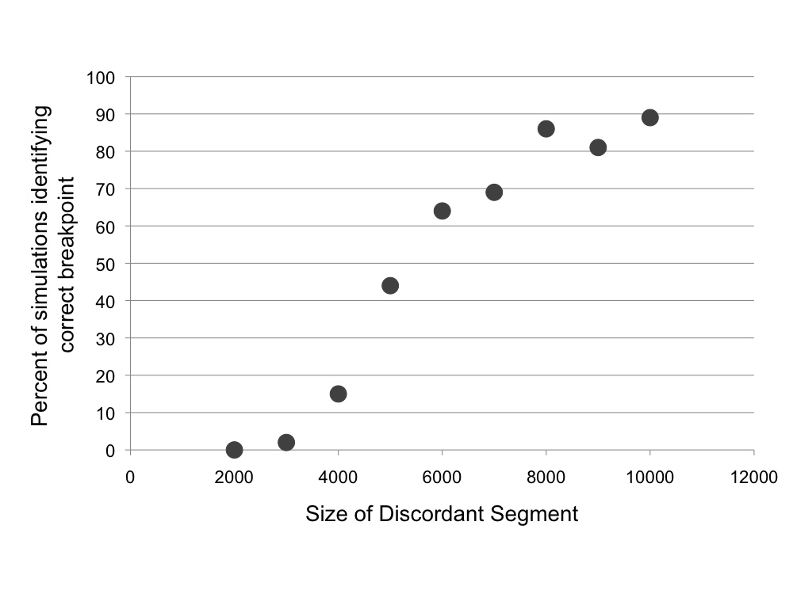

Figure S1. Performance of PhyML_multi on test sequences with known breakpoints between topologies with discordant segments ranging from 2 kb – 10 kb in size. 100 simulations were performed for each discordant segment size. PhyML_multi was considered to have detected the breakpoint if the true breakpoint occurred within 2 kb of the breakpoint determined by PhyML_multi.

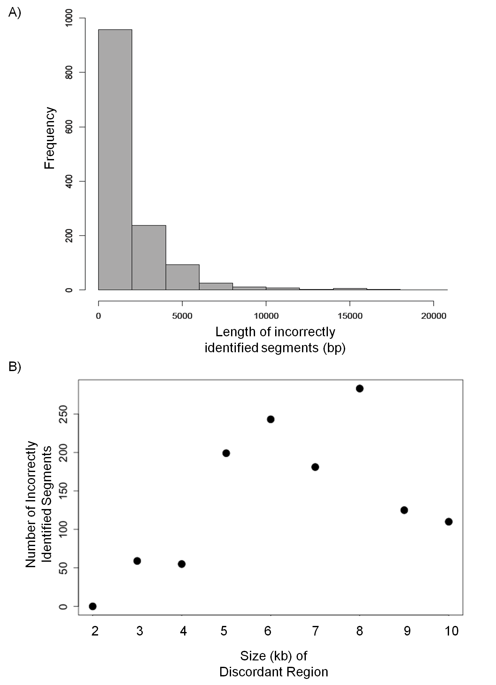

Figure S2. A) Size distribution of erroneous discordant regions detected by PhyML_multi in 900 simulated sequences, excluding breakpoints detected in the last 10 kb of the simulated alignment. This suggests that most erroneous discordant regions detected by PhyML_multi are <5 kb. B) Number of incorrectly identified breakpoints in 100 simulations of each size class of discordant segments. Sequences in which few discordant segments are detected also have few instances of detection of erroneous breakpoints.

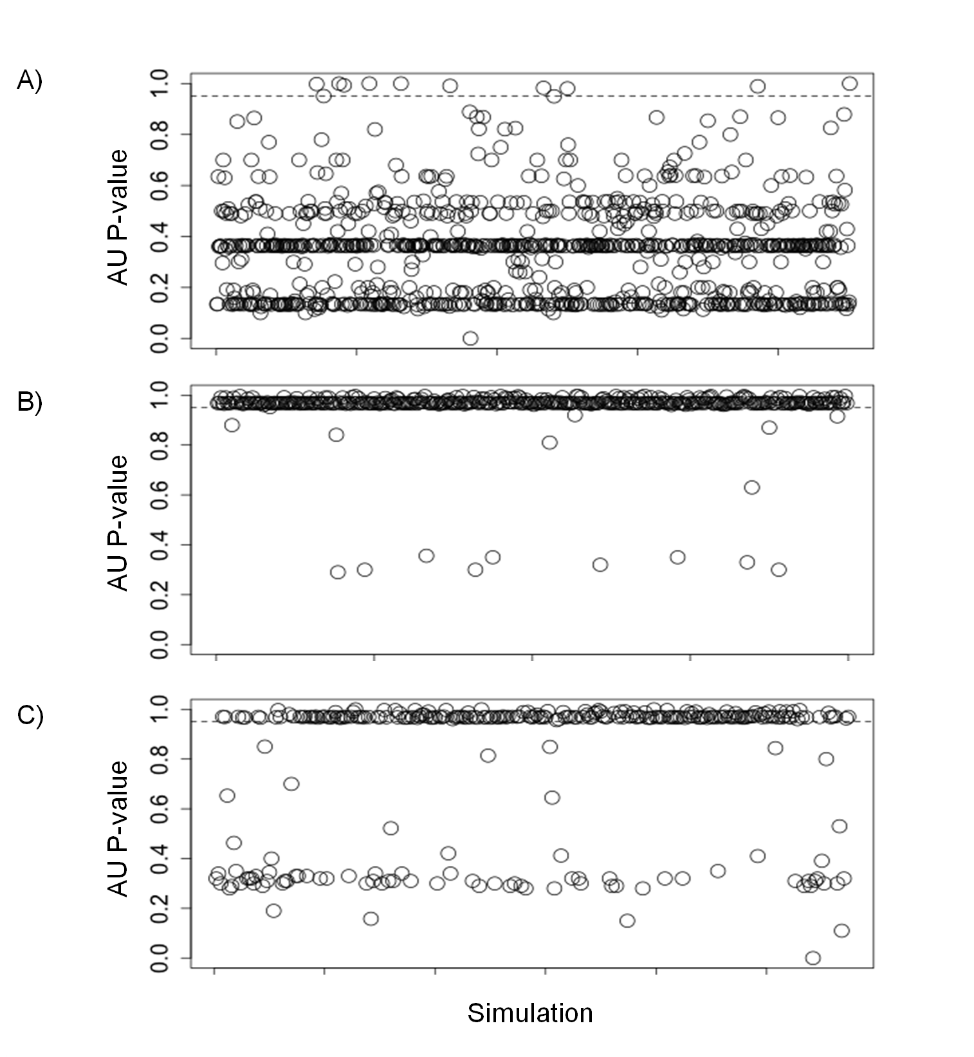

Figure S3. AU P-value for support of the discordant topology in 1000 simulations of A) windows containing support only for the concordant topology, B) windows contain support only for the discordant topology, and C) windows containing some support for both topologies. The dotted line is placed at the AU P-value cutoff of 0.95. Figures S10A and S10B demonstrate that the AU test correctly determines the best supported topology in ~99% of simulated cases, but performs more variably in windows containing conflicting signal (see Figure S4 for more detail).

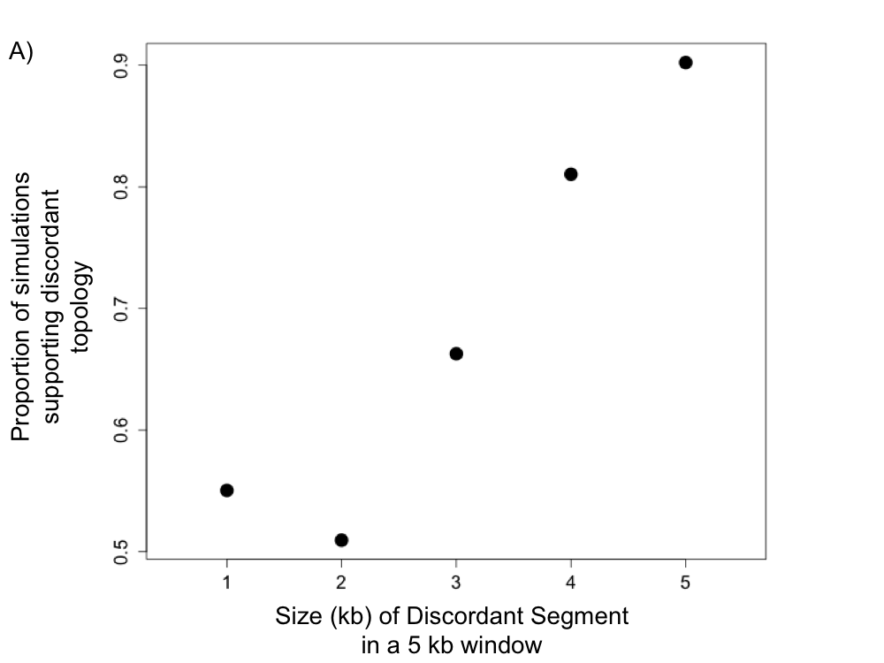

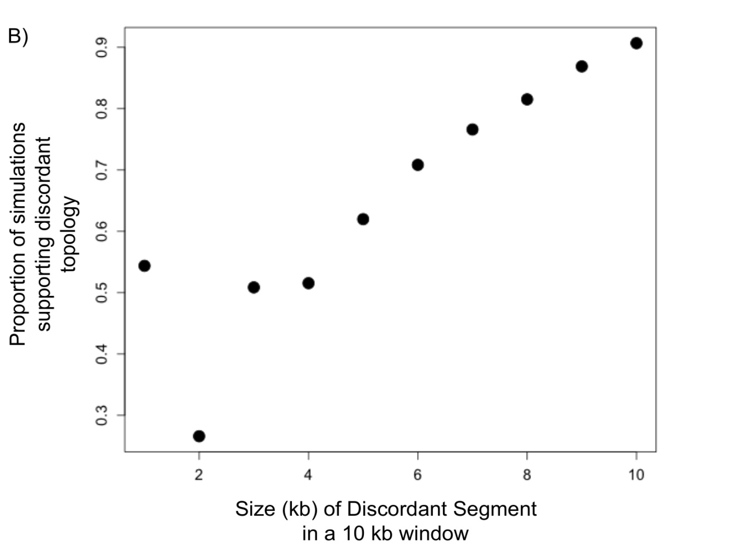

Figure S4. AU p-value support for the discordant topology in 1000 simulations with varying numbers of contiguous base pairs supporting that topology in 5 kb (A) and 10 kb (B) windows. Some windows that only contain a small amount of discordant sequence are still called with high confidence for the discordant topology.

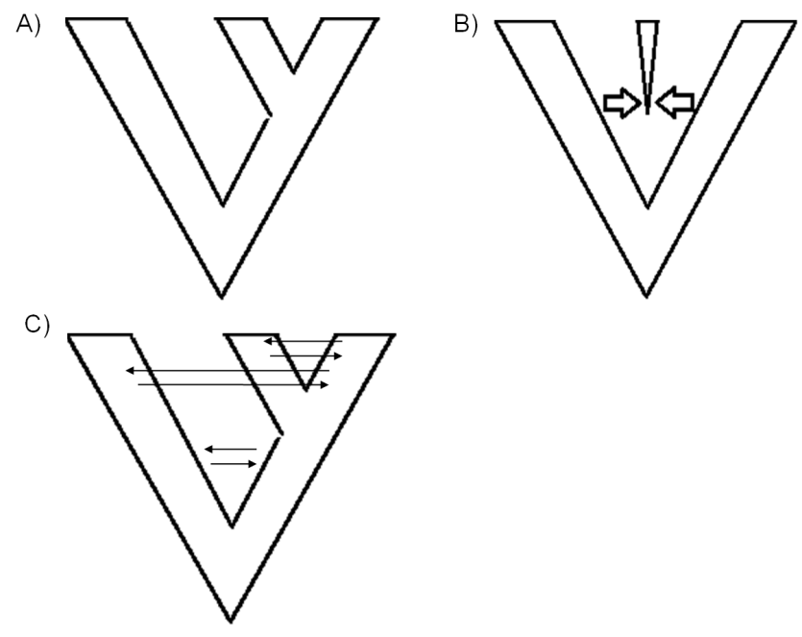

Figure S5. Three speciation models simulated with msHOT: A) Allopatric speciation, B) speciation via admixture C) Allopatric speciation with limited gene flow.

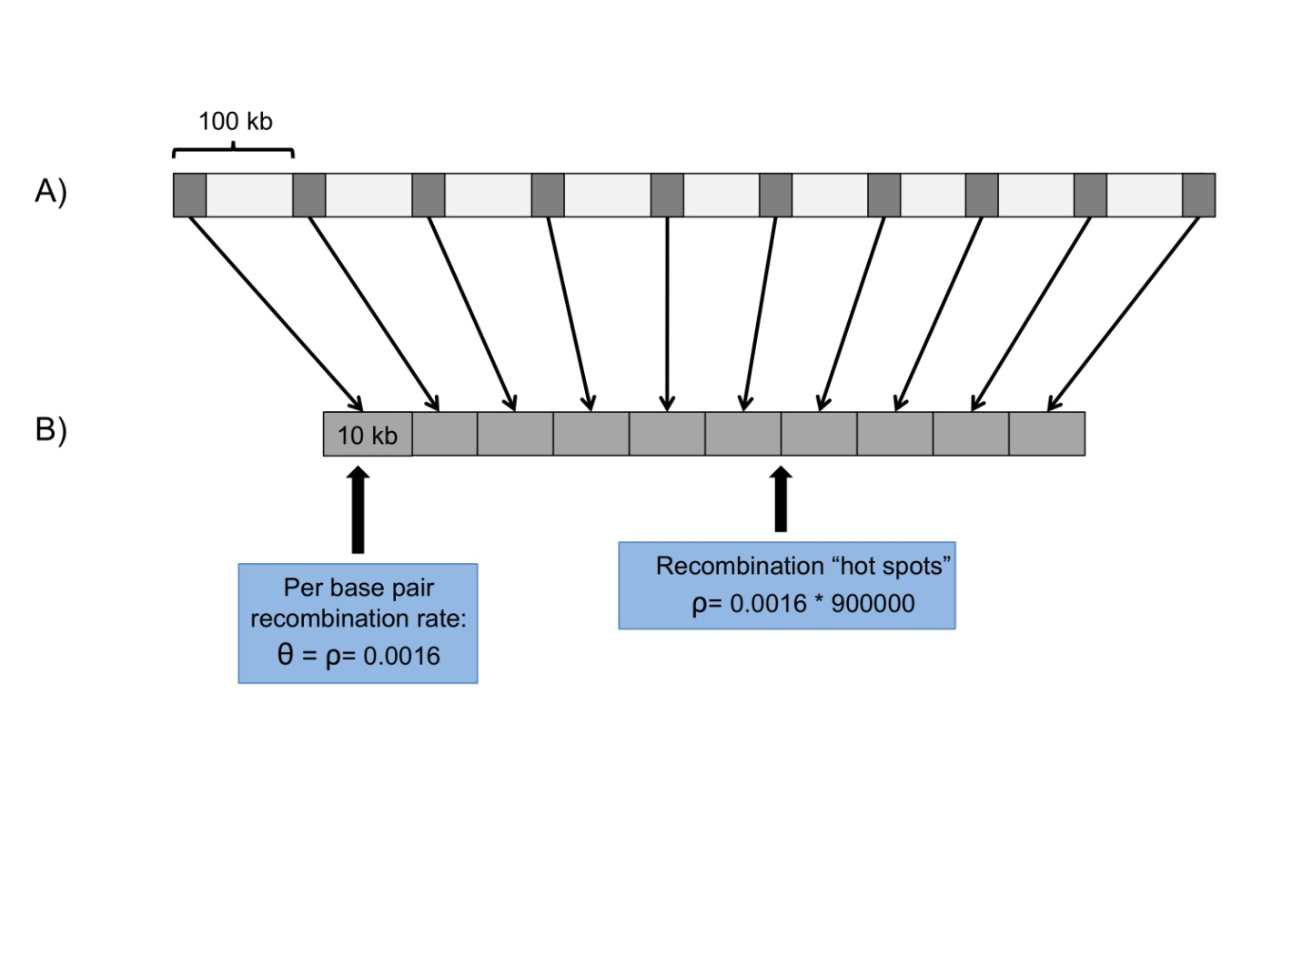

Figure S6. Schematic of simulation strategy with msHOT. A) Entire region being simulated based on input parameters, approximately the size of Scaffold 0 (8 Mbp). B) Sequences generated by msHOT for each simulation only represented 100 kb of the 10 Mbp region but capture the variation expected from recombination over a 10 Mbp segment.

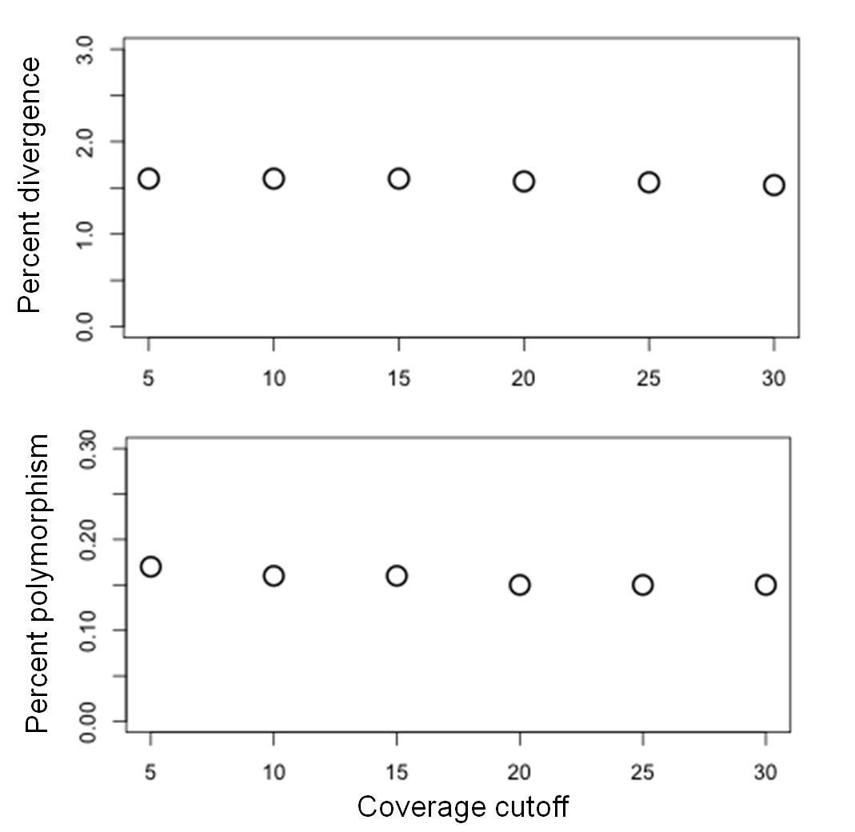

Figure S7. Percent divergence (from *X. maculatus*) and polymorphism in *X. birchmanni* at different coverage thresholds suggests that polymorphism and divergence estimates are not coverage dependent.

Figure4.tif

Figure S8. Based on AU tests, the three topologies, (*X. clemenciae, X. hellerii*), (*X. maculatus*, *X. hellerii*), and (*X. maculatus*, *X. clemenciae*) are all supported in some regions in Scaffolds 0-149, but the regions that support them vary in size.Thelength of supporting regions is derived from determining whether a 5 kb window is contiguous with other windows supporting the same topology. Approximately half of the total support for the (*X. clemenciae*, *X. hellerii*) topology is derived from windows contiguous with at least one more window supporting that same topology. In contrast, the majority of windows supporting the (*X. clemenciae*, *X. maculatus*) and (*X. maculatus, X. hellerii*) topologies comes from isolated windows.

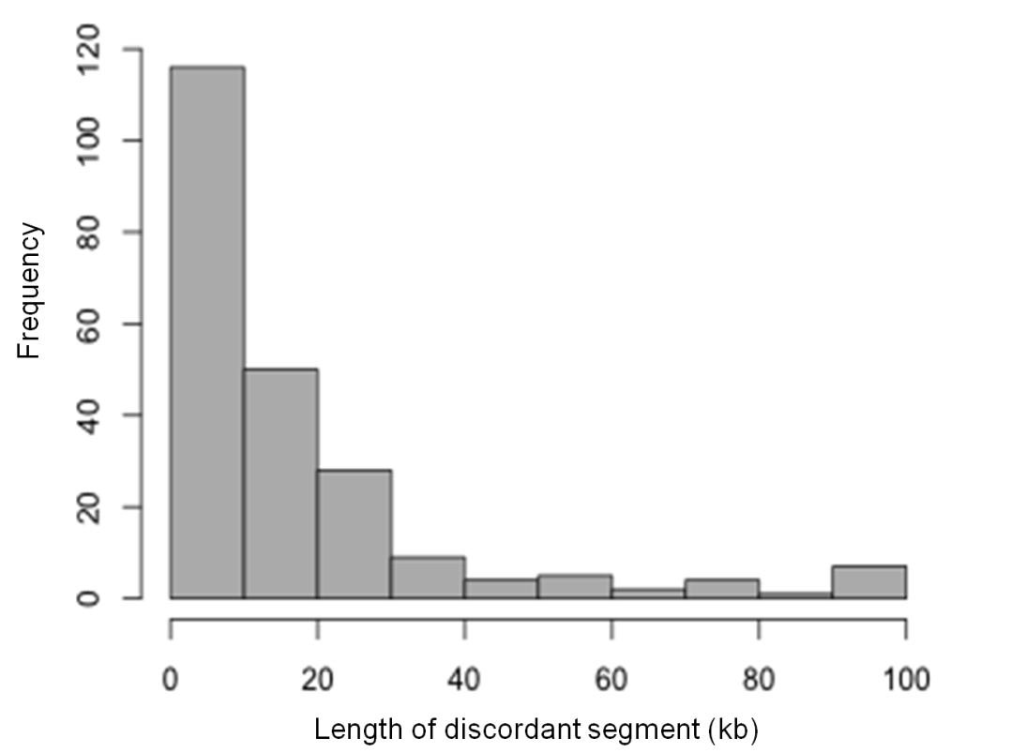

Figure S9. Size distribution of regions supporting a close grouping of *X. hellerii* and *X. maculatus* (sampled from Scaffolds 0-149) based on analysis with PhyML_multi. Small regions (<5.5 kb) have been removed due to PhyML_multi’s precision at this size distribution. This demonstrates that many discordant regions are larger than expected from ILS, and may have resulted from introgression.

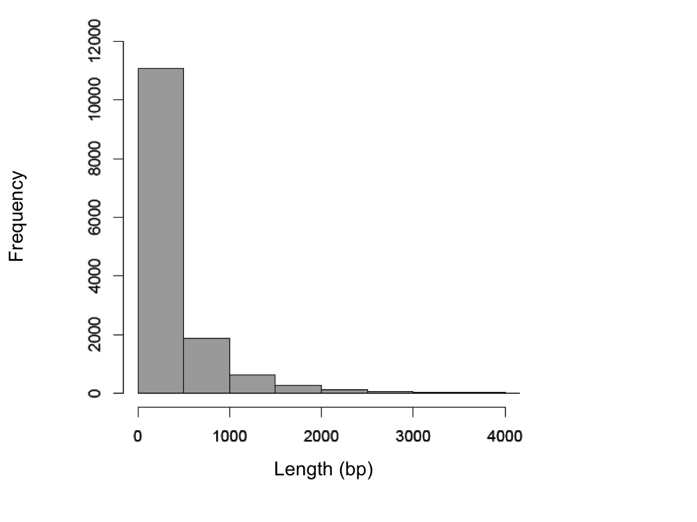

Figure S10. Expected size of discordant regions due to ILS based on 100 simulations of 100 kb regions using *ms*. The speciation model simulated was allopatric speciation of four taxa with per base pair θ of 0.014. This suggests that large discordant regions detected by PhyML_multi are not likely to be caused by ILS.

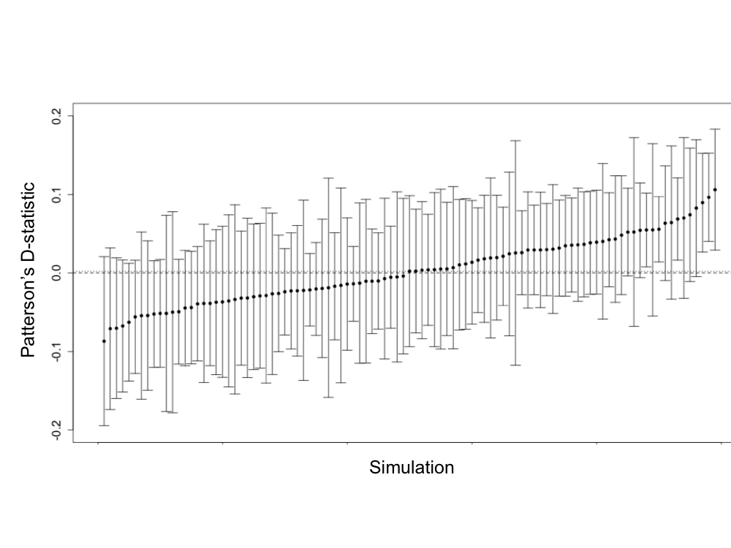

Figure S11. D-statistic and 97.5% confidence intervals (calculated from 1000 nonparametric bootstraps of the simulated ABBA and BABA sites) of 1 Mb sequences generated through 100 simulations of allopatric speciation. This suggests that calculating the D-statistic for small regions may not be a valid way to scan for local introgression. The dashed line indicates the expected value of 0, the dotted line shows the average of 100 simulations.

Supplementary Literature Cited:

Bradley, K., Breyer, J., Melville, D., Broman, K., Knapik, E., and J. Smith. 2011. A SNP-

Based Map for Zebrafish Reveals Sex Determination Loci. G3 1:3-9.

Coop, G. and M. Przeworski. 2007. An evolutionary view of human recombination. Nat.

Rev. Genet. 8: 23-24.

Hudson, R. R. 2002. Generating samples under a Wright-Fisher neutral model of genetic

variation. Bioinformatics 18: 337-338.

McVean, G. 2002. A genealogical interpretation of linkage disequilibrium. Genetics.

162:987-991.

Ohta, T. and M. Kimura. 1971. Linkage disequilibrium between two segregating

nucleotide sites under the steady flux of mutations in a finite population. Genetics. 68: 571-80.

Sukumaran, J. and M. Holder. 2010. DendroPy: A Python library for phylogenetic

computing. Bioinformatics26: 1569-1571.

CHAPTER TWO

Reproductive isolation of hybrid populations driven by genetic incompatibilities

Abstract

Despite its role in homogenizing populations, hybridization has also been proposed as a means to generate new species. The conceptual basis for this idea is that hybridization can result in novel phenotypes through recombination between the parental genomes, allowing a hybrid population to occupy ecological niches unavailable to parental species. Here I present an alternative model of the evolution of reproductive isolation in hybrid populations that occurs as a simple consequence of selection against genetic incompatibilities. Unlike previous models of hybrid speciation, this model does not incorporate inbreeding, or assume that hybrids have an ecological or reproductive fitness advantage relative to parental populations. I show that reproductive isolation between hybrids and parental species can evolve frequently and rapidly under this model, even in the presence of substantial ongoing immigration from parental species and strong selection against hybrids. An interesting prediction of this model is that replicate hybrid populations formed from the same pair of parental species can evolve reproductive isolation from each other. This non-adaptive process can therefore generate patterns of species diversity and relatedness that resemble an adaptive radiation. Intriguingly, several known hybrid species exhibit patterns of reproductive isolation consistent with the predictions of the model.

Introduction

The evolutionary significance of hybridization has been a hotly debated topic for decades [1]. Homoploid hybrid speciation, speciation that occurs as a result of hybridization without a ploidy change [2, 3], is generally thought to be an exceptionally rare outcome of hybridization, and there are indeed only a handful of well-supported cases of this phenomenon [4]. Though it is not uncommon for species’ genomes to exhibit evidence of past hybridization, hybrids are often thought to be weakly isolated from parental species, though few studies have explicitly investigated this.

Empirical research on homoploid hybrid speciation over the last decade has primarily focused on the role of hybrid phenotypes in establishing reproductive isolation between hybrids and parental species [5-9]. Hybrids can have recombinant or transgressive traits that differentiate them from parental species. In some cases, these traits can allow hybrids to occupy new niches. For example, in *Rhagoletis* fruit flies, hybrid lineages have novel host preferences, potentially contributing to reproductive isolation between hybrids from parental species [10, 11]. Similarly, if hybrid lineages have novel mate preferences, this can isolate hybrids from parental species via assortative mating, a mechanism which has been implicated in hybrid speciation in *Heliconius* butterflies ([8], and see [12] for a model of this process). This work has lead to the idea that novel hybrid phenotypes are key to hybrid speciation [13].

Despite several well-documented examples [6, 8], it has been difficult to determine the evolutionary importance of hybrid speciation, in part because few theoretical models have been developed. The existing models of hybrid speciation simulate either positive selection on certain hybrid genotypes or inbreeding [9, 12, 14]. In one model [14, 15], novel combinations of underdominant parental inversions can fix in hybrid populations, particularly if the novel inversion combination is under positive selection or if rates of inbreeding (selfing) are high (see Discussion). Though there is evidence that this process combined with ecological factors was involved in the formation of hybrid *Helianthus* sunflower species [5, 6, 16], the basis for invoking positive selection on recombinant inversion genotypes is unclear. Later versions of this model incorporated ecological differentiation between hybrid and parental species and showed that hybrid speciation occurred frequently if hybrids had higher fitness than parental species in an unoccupied niche [9, 17]. Though hybridization often generates novel traits [18-20] it is difficult to evaluate the likelihood that these traits will be more fit than parental types (ecologically or intrinsically), making it difficult to predict the importance of hybridization in generating new species by positive selection on hybrid genotypes.

The genetic incompatibility of hybrids constitutes a key component of reproductive isolation between many species, and is the basis for the biological species concept. While previous models of hybrid speciation incorporated inversions [21], here I investigate the potential role of negative epistatic interactions, another important genetic mechanism of speciation. The first genetic model of speciation, described by Bateson, Dobzhansky and Muller (the BDM incompatibility model, Fig S1, [22-24]), predicts that mutations at two genetic loci differentially accumulating along two lineages can negatively interact in their hybrids. Empirical research has shown that these types of negative epistatic interactions are remarkably common [25-29]; reviewed in [24, 30, 31].

Though the theory of genetic incompatibilities was originally formulated in the context of allopatrically diverging species, more recent research has investigated dynamics of these incompatibilities in the context of hybrid zones. Under the simplest BDM scenario, derived genotypes are presumed to be neutral, meaning that they have the same fitness as ancestral genotypes. When there is gene flow between species, neutral BDMs are predicted to fix for genotype combinations that are compatible with either parental species [32], rendering them ineffective barriers to gene flow [33, 34]. However, incompatibilities may also frequently arise due to adaptive evolution or coevolution of pairs of loci along lineages (Fig S1, S2, [24, 32, 35-37]). Such incompatibilities are more effective barriers to gene flow than neutral BDM incompatibilities ([38], see also [39]).

In its initial description, the BDM model envisioned incompatibilities that cause complete hybrid inviability or sterility, but many negative epistatic interactions in interspecific crosses have more moderate effects on fitness (e.g. [40-42]), allowing hybrid populations to persist. With few exceptions, previous work on genetic incompatibilities has focused on their role in maintaining reproductive isolation between parental species. As a result, hybrid populations have primarily been modeled as tension zones, but incompatibilities may also have interesting dynamics within isolated hybrid populations (i.e. hybrid swarms). Here I present a new model in which reproductive isolation between hybrid and parental populations emerges as a consequence of selection against incompatibilities in a hybrid swarm. Selection on a single adaptive or coevolving incompatibility pair can result in the fixation of genotype combinations that contribute to isolation between the hybrid population and one or the other parental species. Here, I show that in the presence of multiple pairs of such incompatibilities, this process can result in the rapid evolution of reproductive isolation of hybrid populations from both parental species (Fig 1).

Two features of this model make it particularly plausible biologically. First, as noted above, negative epistatic interactions are common, providing ample raw material for my model. Second, hybrid populations in which hybrids are abundant are common in nature (e.g. [43-45]). Though ecological and sexual selection are important factors in the few well-documented cases of hybrid speciation [6, 8], my results suggest that hybrids can evolve reproductive isolation as a result of selection against genetic incompatibilities alone.

Results

Modeling selection against hybrid incompatibilities

In the simplest model of a hybrid population, a equal mixture of individuals from both parental species form a new isolated population and mate randomly with respect to genotype (Fig 1, Fig S3), such that the first mating event generates 50% F1 hybrids and 25% each parental species. Using theory of two-locus selection [46, 47], hereafter the “deterministic two-locus model”, one can model the effect of selection at two polymorphic loci on gamete frequencies of a diploid sexual population (see Methods and Text S1). This model describes the dynamics of two loci subject to any arbitrary fitness matrix. Here, I focus on fitness matrices for three types of incompatibilities that may commonly arise between species (Figs S1 and S2; [30, 35]): 1. BDM incompatibilities arising from neutral substitutions, 2. BDM incompatibilities arising from adaptive substitutions, and 3. BDM incompatibilities arising from coevolution between loci. Applying the two-locus selection model to these incompatibility types, one can see that the direction of fixation depends on the initial frequency of the parental alleles (*f*, see Figs S3 and S4) and dominance at each locus (*h*, Fig S4; see also [48]).

This purely deterministic model of selection on hybrid incompatibilities is unrealistic because even large populations experience some degree of genetic drift. I thus extended the model to include genetic drift, which can affect the speed and direction of fixation of incompatibility pairs (Fig S5). For neutral BDM incompatibilities (Fig S1), this model does not predict fixation of genotypes incompatible with either parental species (Fig S4). In contrast, for coevolving or adaptive BDM incompatibilities (Text S1, Figs S1, S2), the two-locus finite population model predicts that at equal admixture proportions (*f* = 0.5), a single incompatibility pair has a 50% chance of fixing for either parental allele combination (Fig 2, Text S2, Table S1). Interestingly, while genetic drift in small populations could accomplish the same thing (9), the process described here occurs rapidly in large populations and is driven by deterministic selection (Fig 2). Given these dynamics, it is clear that large hybrid populations with two or more of these types of hybrid incompatibilities could, in principle, fix for one parental genotype at one incompatibility pair and the other parental genotype at the other incompatibility pair (Fig 1). This outcome would result in reproductive isolation of the hybrid population from both parental species. With two codominant incompatibility pairs and equal admixture proportions, the probability that a hybrid population will become isolated can be predicted by a simple binomial. However the binomial prediction breaks down when there is variation in dominance, admixture proportions, or linkage between incompatibilities, and thus I explore these further by simulation.

Simulations of an isolated hybrid population

To investigate the dynamics of multiple incompatibility pairs, I simulated a large, randomly-mating and spatially isolated hybrid population with two pairs of unlinked hybrid incompatibility loci (see Methods; Fig S3, setting *m1*=*m2*=0). The fitness scheme used is that of a coevolutionary incompatibility model (Fig S2), assuming that incompatibilities are codominant (i.e. *h*=0.5), that fitness is symmetric with respect to the parental source of alleles (i.e. *wij* = *wji*) and that the cumulative fitness effects of multiple incompatibility pairs is multiplicative. If hybrid populations fixed for the parent species 1 genotype at one incompatibility pair and the parent species 2 genotype at the other, I considered the hybrid population as having evolved reproductive isolation from both parental species (albeit weaker than between the two parental species).

While selection against hybrids will sometimes be so extreme that few hybrids will survive (or reproduce) in the population (see simulations below), selection against hybrids can also be more moderate, allowing hybrids to persist [41, 45, 49-53]. In simulations of this moderate selection scenario, reproductive isolation between hybrid and parental populations can evolve frequently and rapidly (Fig 3). For example, for two incompatibility pairs with selection coefficients (*s*)of 0.1, 47±2% of simulated hybrid populations became isolated from both parental species within an average of ~200 generations. Exploring a range of *s* (0.1-0.5, Fig S6, Table S2), initial admixture proportions (*f*=0.3-0.7, Fig S7), and population sizes (100-10,000 diploids, Table S3), I conclude that, unless fitness of hybrids is low (i.e. F1 fitness <0.5) or ancestry of the founding population is substantially skewed (>60% one parental species), reproductive isolation evolves rapidly and with surprisingly high probability (27±2% to 43±2% of the time; on average within 75 ± 16 to 258 ± 38 generations, see Text S3).

The effect of dominance and asymmetry in selection intensity

In the above simulations, I assume that selection on different hybrid incompatibility interactions is symmetrical (*s*1=*s*2, Fig S2), but it is unlikely that selection is truly equal on different hybrid genotype combinations. When fitness is completely asymmetrical (i.e. *s*1=0 in Fig S1, as for neutral BDM incompatibilities), only strong genetic drift can cause the fixation of genotype pairs that are incompatible with either parental species, as selection cannot do so (see Figs S4, S8, S9, Text S4). This reliance on genetic drift implies that this process will be slow unless an extreme bottleneck is invoked.

In contrast, the dynamics of BDM incompatibilities resulting from adaptation within parental lineages can be quite different (Fig S1). Notably, while selection may also be highly asymmetric in such cases [38, 54], derived alleles have higher fitness than ancestral alleles, allowing for the fixation of genotype combinations that are incompatible with both parental species. I find that isolation evolves with similar frequency under asymmetric selection as long as selection is strong relative to drift (Text S3, Table S4), because even weak selection will prevent the fixation of the ancestral genotype.

Above I simulated codominant hybrid incompatibilities (*h*=0.5), but the two-locus model (Fig S4) shows that patterns of fixation are different depending on the value of *h*. In particular, when *h* is zero or unity, fixation is not strongly dependent on admixture proportions (Fig S4). When I simulate variation in dominance among incompatibility interactions (see Text S3, Table S5), I find that reproductive isolation between hybrid populations and parental species evolves with comparable frequency (42-48±2% vs 47±2% under the codominant scenario).

Increasing the number of hybrid incompatibilities

Recent empirical studies have suggested that most species are distinguished by multiple hybrid incompatibilities [30, 41, 55-59]. Theoretically, barring extinction of the hybrid population (see simulations below), increasing the number of pairs of incompatibilities should increase the probability that a hybrid population will evolve isolation from both parental species. In order to illustrate this, I simulated 3-6 unlinked hybrid incompatibility pairs (Text S5). As expected, increasing the number of hybrid incompatibilities increases the probability that the hybrid population will be isolated from each parental species by at least one incompatibility pair (>90% with 6 incompatibility pairs, Figs 3, S6, Text S5).

I assume in most of the simulations that loci involved in hybrid incompatibilities are completely unlinked. As the number of incompatibilities increases, this becomes unlikely. Genetic linkage between loci involved in different epistatic interactions can reduce the frequency at which hybrid populations evolve isolation because alleles are more likely to fix for the same parental genotype (Fig S10, Text S5, Table S6). Interestingly, when coevolving incompatibility loci are linked to a neutral BDM incompatibility, this does not significantly lower the frequency at which hybrid populations evolve reproductive isolation (Text S5). Furthermore, linkage between coevolving incompatibilities and neutral BDM incompatibilities can more frequently result in fixation of neutral BDM incompatibilities for a parental genotype (16±2%), resulting in stronger isolation between hybrid and parental populations (Text S5).

The above simulations focus on simple models that show this process can occur in principle. To capture more biological realism in the number and types of incompatibilities, I simulated 20 incompatibility pairs with randomly determined genomic position and dominance, exponentially distributed selection coefficients (mean *s*=0.05)and variation in asymmetry of selection (see above and Text S5). In these simulations, 95% of populations developed isolation from both parental species. On average, the hybrid population first evolved isolation from both parental species after ~250 generations and was isolated from each by 7 incompatibility pairs within 1000 generations. Since incompatibility pairs with the largest fitness effects tend to fix first, hybrid populations developed considerable reproductive isolation from parental species even before all incompatibilities were fixed in the population (Fig 4, Fig S11). Overall, simulation results suggest that rapid evolution of reproductive isolation of hybrid populations is likely when parental species are separated by several hybrid incompatibility pairs.

Reproductive isolation between hybrids and parental species is less likely to evolve as the fitness of hybrids decreases. For example, if I repeat the simulations above (i.e. the 20 incompatibility pairs with exponentially distributed selection coefficients), if $\overline{s}$ = 0.1, the average fitness of an F1 hybrid between the two parental species is 0.38 and isolation evolves in only 56±2% of simulations. When $\overline{s}$ = 0.2, the average fitness of hybrids is 0.1, and only 1.4±0.5% of simulated populations develop isolation and parental genotypes dominated in these populations. Thus, this process is unlikely to occur between species in which post-zygotic isolation is nearly complete.

Similarly, if parental individuals in the simulated hybrid population mate assortatively with conspecifics, reproductive isolation between hybrids and parental species is significantly less likely to evolve (Text S6). The reasons for this are two-fold: assortative mating prevents the formation of a large hybrid population, and parentals outcompete early generation hybrids that are still segregating for parental incompatibilities.

Simulations of hybrid populations with ongoing migration

I model a completely isolated hybrid swarm, but many hybrid populations experience gene flow with parental species. Ongoing migration may impede the evolution of reproductive isolation by preventing the fixation of genetic incompatibilities. To evaluate this, I simulated hybridization scenarios with ongoing migration (Fig S3, Fig S13, 4*Nm=*8-20). Even with substantial gene flow from parental populations, hybrid populations evolved reproductive isolation from them at high probability (i.e. 38±2% of simulations with two incompatibility pairs, *s*=0.1 and 4*Nm=*8; Text S6; Table S7).

In the above simulations, I assume that migration is symmetrical from both parental species, but asymmetrical migration may be common in hybrid zones (e.g. [60-62]). To explore how asymmetrical migration could influence results, I varied asymmetry in migration rates (Text S6). As expected, when migration rates were high and strongly asymmetrical (Fig S12), hybrid reproductive isolation from both parental species evolved infrequently. However, in less extreme cases, hybrid reproductive isolation was still observed frequently (e.g. >20% of simulations with 4*Nm*<20, Fig S12).

It is interesting to consider the fact that chance plays an important role in the direction that incompatibility pairs fix. As a result, one would expect that two or more independently formed hybrid populations from the same pair of parental species could evolve isolation from each other. To demonstrate this effect, I simulated two hybrid populations formed from the same pair of parental species (Fig S14). In the absence of migration, the two hybrid populations evolved isolation from each other frequently (50±5%, as expected given two hybrid incompatibility pairs, see Text S6; Table S8). Remarkably, this outcome is still observed with relatively high gene flow between the two hybrid populations (24±4% with 4*Nm*=8 and two hybrid incompatibility pairs, Text S6; Table S8).

Discussion

I describe a new model of the evolution of reproductive isolation of hybrid populations, a first step towards hybrid speciation. Unlike previous models of hybrid speciation, my model does not assume positive selection on hybrid genotypes or inbreeding, but rather deterministic selection against hybrid incompatibilities in randomly mating hybrid populations. With moderate selection (i.e. *s*≤0.2) on two or more incompatibility pairs in an allopatric hybrid population, reproductive isolation from both parental species emerges with ~50% (or higher) probability. Hybrid reproductive isolation also evolves frequently with substantial levels of ongoing migration between hybrids and parental species (4*Nm* < 20 each parent).

Another striking result of simulations is the speed with which reproductive isolation evolves between hybrids and parental species. Depending on parameters, reproductive isolation can emerge in fewer than 100 generations with moderate selection (Text S3). The idea that hybrid speciation can occur rapidly has been supported by experimental results [14, 63, 64] and to some extent by previous models of hybrid speciation [9, 14]. My model suggests that simple selection on incompatibilities in hybrid populations could also lead to rapid reproductive isolation on timescales much faster than expected for allopatric speciation due to the accumulation of neutral BDM incompatibilities. Given that epistatic incompatibilities are common, my results on the probability and speed of isolation suggest that this process may frequently occur in hybrid populations.

Previous empirical work has emphasized the importance of ecological differentiation between hybrid and parental populations or positive selection on hybrid genotypes as a route to hybrid reproductive isolation [6, 8-10, 12, 63, 65]. The novel finding of my simulations is that reproductive isolation evolves readily in hybrid populations without positive selection on hybrids. However, the two are not mutually exclusive and ecological factors, which have been shown to underlie several cases of hybrid speciation [6, 8, 63], may complement selection on genetic incompatibilities to further strengthen reproductive isolation. For example, in *Helianthus*, a combination of chromosomal rearrangements and novel hybrid phenotypes are important in distinguishing hybrid and parental species [6, 66]. Like other models ([9, 14]), my model predicts that isolation between hybrids and parental species is inherently weaker than isolation between the two parental species. I propose that fixation of incompatibilities could be a crucial step in initially limiting gene flow between hybrids and parental species, allowing for the development of other isolating mechanisms. For example, theoretical work predicts that reinforcement can develop even when selection against gene flow is moderate [67-70].

Previous models of hybrid speciation have incorporated species-specific inversions that are assumed to be underdominant. Under this “underdominant inversion” model, hybrid populations can fix for novel inversion combinations, resulting in isolation between hybrid and parental species [15]. Simulation results under this model have suggested that inbreeding [14] or positive selection on hybrid genotypes [9, 14] is important for the evolution of hybrid reproductive isolation. However, past simulation efforts focused on hybrids in a tension zone, either with no spatial isolation from parental species [14] or with high migration rates from parental species [17]. To investigate the dynamics of the underdominant inversion model in situations where migration is more restricted, I simulate the underdominant inversion model in an isolated hybrid swarm scenario that is similar to the epistatic incompatibility model (Text S7). Interestingly, I find that isolation evolves frequently under this model even without positive selection (~40% of simulations, see Text S7). These results show that, in hybrid-dominated populations, the inversion model has similar behavior to my model of selection against negative epistatic interactions (Text S7). Which mechanism of isolation is more prevalent in hybrid populations will depend on the frequency of hybrid incompatibilities of each type. Empirical evidence suggests that while underdominance can be a common isolating mechanism in plants (reviewed in [21]), negative epistatic interactions may be a more common mechanism of reduced hybrid fitness in animals [24].

It is important to note several factors that may influence how common my epistatic interactions model of hybrid speciation will be in natural populations. First, my model assumes that hybrids are abundant in a population and, while this appears to be reasonably common (see Text S6; Table S9), this is clearly not a feature of all hybrid zones. I also note that my model only represents fitness in terms of genetic incompatibilities and that hybrid populations can have lower fitness as a result of ecological or sexual selection. For example, in simulations, I assumed random mating between hybrids and parentals. But when parental species exert negative sexual selection against hybrids, hybrid populations are significantly more likely to be outcompeted by parentals (Table S10). There is substantial variation in the mating preferences of parentals for hybrids [71]. In two species of cyprinidontiform fishes, male and female parentals mate readily with hybrids [45, 72, 73], while mice discriminate against them [74]. This suggests that the likelihood of this process will depend in part on the biology of the hybridizing species.

An additional consideration is that hybrid reproductive isolation is most likely to evolve during a particular window of divergence between parental species. When the fitness of hybrid populations is low (i.e. corresponding to high levels of divergence between parental species), they are more prone to extinction or displacement by parentals (Fig S6, Text S5). This suggests that the evolution of hybrid reproductive isolation through this mechanism is most likely to occur in a period of evolutionary divergence during which species have accumulated some hybrid incompatibilities but have not diverged to the point at which hybrids are largely inviable. The most detailed work characterizing genetic incompatibilities has been between *Drosophila* species, where hybrids generally have substantially reduced fitness compared to parents [56, 57, 75]. Hybrids between several other species studied to date, however, are affected by fewer incompatibilities or incompatibilities of weaker effects [26, 55, 59, 76-79]. Such groups may be more likely to form hybrid populations, and should be the focus of future empirical research. In addition, even species that currently have strong isolation may have historically produced hybrid populations, though investigating ancient hybrid speciation by the mechanism described here would be challenging. This is because if parental and hybrid lineages have diverged substantially since the time of initial hybridization it may not be possible to determine whether or not incompatibilities were initially derived from parental genomes.

It is interesting to note that reduced frequency of reproductive isolation with increasing selection on hybrids can be mitigated to some extent by an increase in the total number of hybrid incompatibility pairs. In simulations, I see a positive relationship between the number of interactions and the probability of developing reproductive isolation, and a negative relationship between the total strength of selection on hybrids and the probability of developing reproductive isolation (Fig S6, Fig 3). This tradeoff suggests that reproductive isolation can evolve between hybrid and parental populations even when the fitness of hybrids is low (as in Fig 3, Fig 4, Fig S6, keeping in mind that extinction occurs frequently when hybrid fitness is nearly zero).

Similarly, my model is sensitive to skewed initial admixture proportions, but increasing the number of hybrid incompatibility pairs increases the probability that skewed hybrid populations will be isolated from both parental species by at least one incompatibility (Fig S7). For example, with two incompatibility pairs, the probability of isolation from both parental species in an ancestry-skewed population (65% parent 1) was 7% while with four incompatibility pairs the probability rose to 15%. In addition, because discrete populations in a cline often span a range of admixture proportions (e.g. [80-82]), it is likely that some hybrid populations will fall in the range where isolation can evolve. On the other hand, my results show that high levels of migration (as might be observed in continuous clines) can prevent isolation; future research should investigate the dynamics of this process in a range of hybrid zone structures.

Finally, my model assumes that coevolving incompatibilities or BDM incompatibilities arising from adaptive evolution frequently occur between species. Accumulating evidence suggests that incompatibilities arising from coevolution may be common [30, 36, 83-86]. For example, in marine copepods, coevolution between cytochrome *c* and cytochrome *c* oxidase results in a reciprocal breakdown of protein function in hybrids [86]. In addition, the fact that many known incompatibility genes involve sexual conflict, selfish genetic elements, or pathogen defense suggests an important role for coevolution in the origin of incompatibilities [36, 83, 87, 88]. My model also applies to BDM incompatibilities that arise due to within-lineage adaptation, assuming that the fitness advantage of the derived alleles is not dependent on the parental environment. It is currently unknown whether incompatibilities are more likely to be neutral or adaptive. Though there is evidence for asymmetric selection on many hybrid incompatibilities [28, 29, 89], neutrality has not been established in these cases. Anecdotal evidence supports the idea that adaptive incompatibilities are common, since many of the genes underlying hybrid incompatibilities identified so far show evidence of positive selection within lineages [90], but the relative frequency of adaptive and neutral BDM incompatibilities awaits answers from further empirical research. Intriguingly, theoretical work also suggests that neutral BDM incompatibilities are unlikely to persist if there is gene flow between species [32].

The patterns predicted by my model are testable with empirical approaches. A large number of studies have successfully mapped genetic incompatibilities distinguishing species [25, 26, 41, 56, 57, 79, 91]. Ancestry at these sites can be determined in putative hybrid species, and the relative contribution of parental-derived incompatibilities to reproductive isolation can be determined experimentally. For some species, it may be possible to evaluate the dynamics of incompatibilities relative to the genetic background in experimentally generated hybrid swarms [92]. I predict that many hybrid populations exhibiting postzygotic isolation from parental species will have fixed incompatibility pairs for each parental species. Several cases of hybrid speciation report reduced fitness of offspring between parental and hybrid species consistent with the mechanism described here [6, 16, 53, 93] and are promising cases for further empirical research. Strikingly, a recent study on Italian sparrows concludes that reproductive isolation between parental and hybrid species is partly due to the fixation of parental-derived incompatibilities [94].

An intriguing implication of my model is that independently formed hybrid populations between the same parental species can develop reproductive isolation from each other. The likelihood of this outcome increases with the number of incompatibility pairs. In sunflowers, empirical studies of ecologically-mediated hybrid speciation have identified multiple hybrid species derived from the same parental species [95]. It is interesting to note that selection against hybrid incompatibilities could generate the same pattern in replicate hybrid populations. In fact, this mechanism could generate a species phylogeny pattern similar to that expected from an adaptive radiation, with multiple closely related species arising in a relatively short evolutionary window. This finding is striking because my model does not invoke adaptation and suggests that non-adaptive processes (i.e. selection against incompatibilities) could also explain clusters of rapidly arising, closely-related species.

Methods

Mathematical model of selection on hybrid incompatibilities

To characterize evolution at hybrid incompatibility loci in hybrid populations without drift, I used the equations described by Karlin and others [46, 47] to calculate changes in allele frequency as a result of two-locus selection. The frequency of gamete *i* at generation *t* is given by

$x_{i}\left(t\right)=x_{i}\left(t-1\right)\frac{w_{i*}}{\overline{w}}+ϵ_{i}rD\frac{w_{14}}{\overline{w}}$, (1)

where $ϵ_{1}=ϵ_{4}={-ϵ}_{2}=-ϵ_{3}= -1$, the marginal fitness of allele *i*,

$w_{i*}={\sum_{j=1}^{4}{x_{j}w_{ij}}}_{ }$, (2)

the mean fitness of the population,

$\overline{w}={\sum_{i=1}^{4}{\sum_{j=1}^{4}{x_{i}}}x}_{j}w_{ij}$, (3)

$w_{14}$ is the fitness of a double heterozygote, *r* is the recombination rate and *D* is linkage disequilibrium between the two loci. These equations assume random mating, non-overlapping generations and that fitness depends only on two-locus genotype and not on whether the chromosome was maternally or paternally inherited (i.e. *wij*=*wji*). To model changes in allele frequencies over time, I developed a custom R script (available from github: https://github.com/melop/twolocusmodel). Iterating through the change in allele frequencies each generation as a result of selection gives the expected patterns of fixation at incompatibility loci without genetic drift (Fig S4; see also [48]).

The deterministic two-locus model of fixation of hybrid incompatibilities does not realistically predict expected patterns in natural populations because even large populations will have some level of genetic drift. To model drift, I added multinomial sampling of N diploid individuals and recalculated allele frequencies each generation (available from github: https://github.com/melop/twolocusmodel). Patterns of fixation incorporating genetic drift through multinomial sampling show similar dynamics to the model lacking genetic drift, with the exception of several equilibrium states specific to the latter (see Fig S5, Text S2).

Description of simulation program

Exact results for more than two loci have proven difficult to obtain [96-99]. As a result, I used a custom c++ program, called admix’em (github: https://github.com/melop/admixem), to simulate more complex scenarios. The code allows one to specify the number and length of chromosomes and the genomic locations of hybrid incompatibilities and neutral markers. The current implementation assumes non-overlapping generations and diploid sexual individuals. When modeling linkage, I assume a uniform recombination rate and one recombination event per chromosome per meiosis. Unless otherwise specified, I model all pairs of hybrid incompatibility loci as unlinked. As I am interested in short-term dynamics, I do not implement mutation.

Selection coefficients are assigned to particular allelic combinations according to a hybrid fitness matrix (see Figs S1, S2). Based on each individual’s genotype at the hybrid incompatibility loci, I calculate total individual fitness *w*, defined as the probability of survival of that individual. Total fitness across multiple incompatibility pairs is assumed to be multiplicative. Each female mates with one randomly selected male (but the program also accommodates assortative mating, see Text S6), and produces a Poisson distributed number of offspring with a mean=2. After selection, if the carrying capacity (N) is not reached, additional offspring from the same mating events are drawn from a Poisson distribution with a new mean=(carrying capacity – current population size)/number of females. This process is repeated until carrying capacity is reached or females have no available gametes (set to a maximum of 10). A potential concern with this approach for maintaining a constant population size is that it could artificially preserve a hybrid population that would otherwise be ephemeral by continuing to sample offspring (up to 10 per female in these simulations). However, because parentals are present in each population (see below, at 50% frequency each parental species in the initial population), this allows for out-competition of hybrids by parentals when hybrid fitness is low.

All reported results are based on 500 replicate simulations, which were conducted for 2000 generations. In the majority of simulations (except Text S3, S4) the hybrid population is initially colonized by 500 individuals of each parental species. Hybrid and parental populations were modeled as spatially distinct with migration parameters between them; most simulations specified one hybrid population formed between two parental populations (Fig S3) but I also simulated a stepping-stone model and a model with multiple independently formed hybrid populations (Text S6, Fig S13, Fig S14). In simulations with migration, the number of migrating individuals each generation was determined by drawing from a binomial distribution with a mean equal to the number of migrating individuals. Details on individual simulations and results can be found in the supporting text. Hybrid populations are considered to have evolved reproductive barriers from both parental species if they fix at least one incompatibility from each parental type; the strength of reproductive isolation between hybrids and parental species will depend on the selection coefficient and number of incompatibilities.

Acknowledgements

I would like to thank Molly Przeworski and members of the Rosenthal and Andolfatto labs for helpful discussion; as well as Yaniv Brandvain, Guy Sella, Stephen Wright, Clair Han, Ying Zhen, and three anonymous reviewers for helpful comments on earlier versions of this manuscript.

Figures

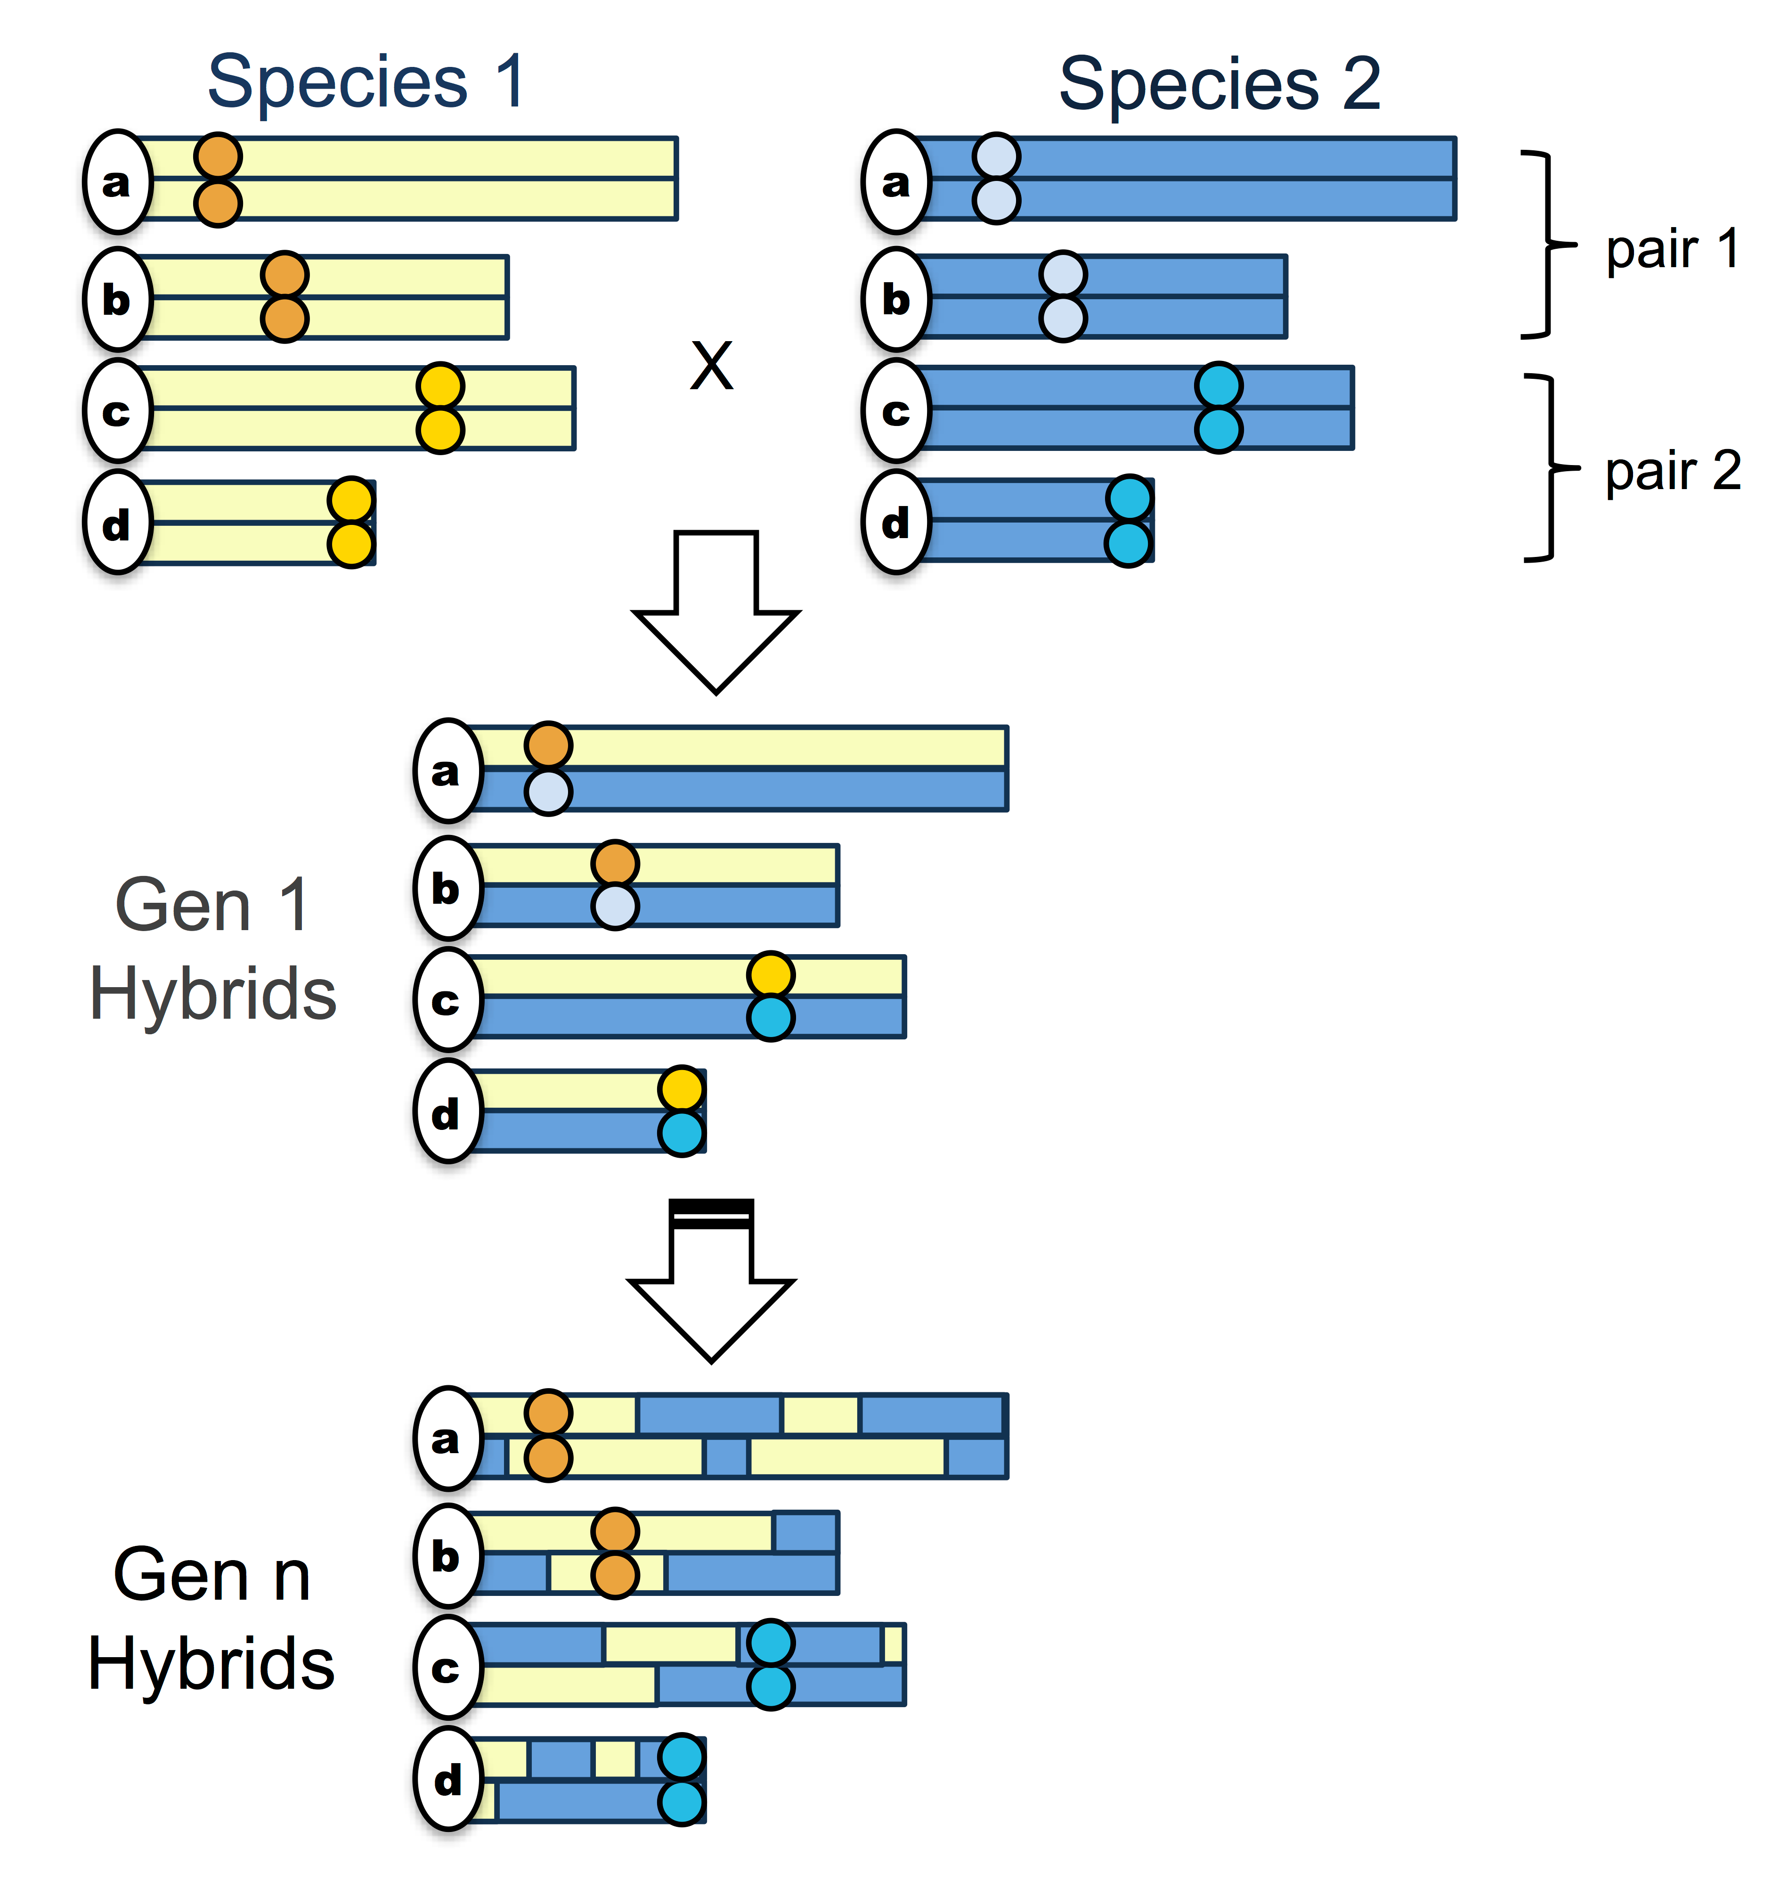

Figure 1. Schematic of the simplest “hybrid speciation by genetic incompatibility” scenario. The simplest model hybrid reproductive isolation evolves in a hybrid swarm (Fig S3) via fixation of parental genetic incompatibility pairs in opposite directions. Circles indicate the location of incompatibility pairs on chromosomes; yellow shading indicates regions derived from species 1 while blue shading indicates regions derived from species 2. In the first generation, assuming random mating, 50% of individuals will be F1 hybrids if both species contribute equally to the hybrid population. In subsequent generations, recombination will break up ancestry blocks and selection will drive the fixation of parental genotypes at incompatibility loci. In some proportion of cases, incompatibility pairs will fix for opposite parental species genotypes.

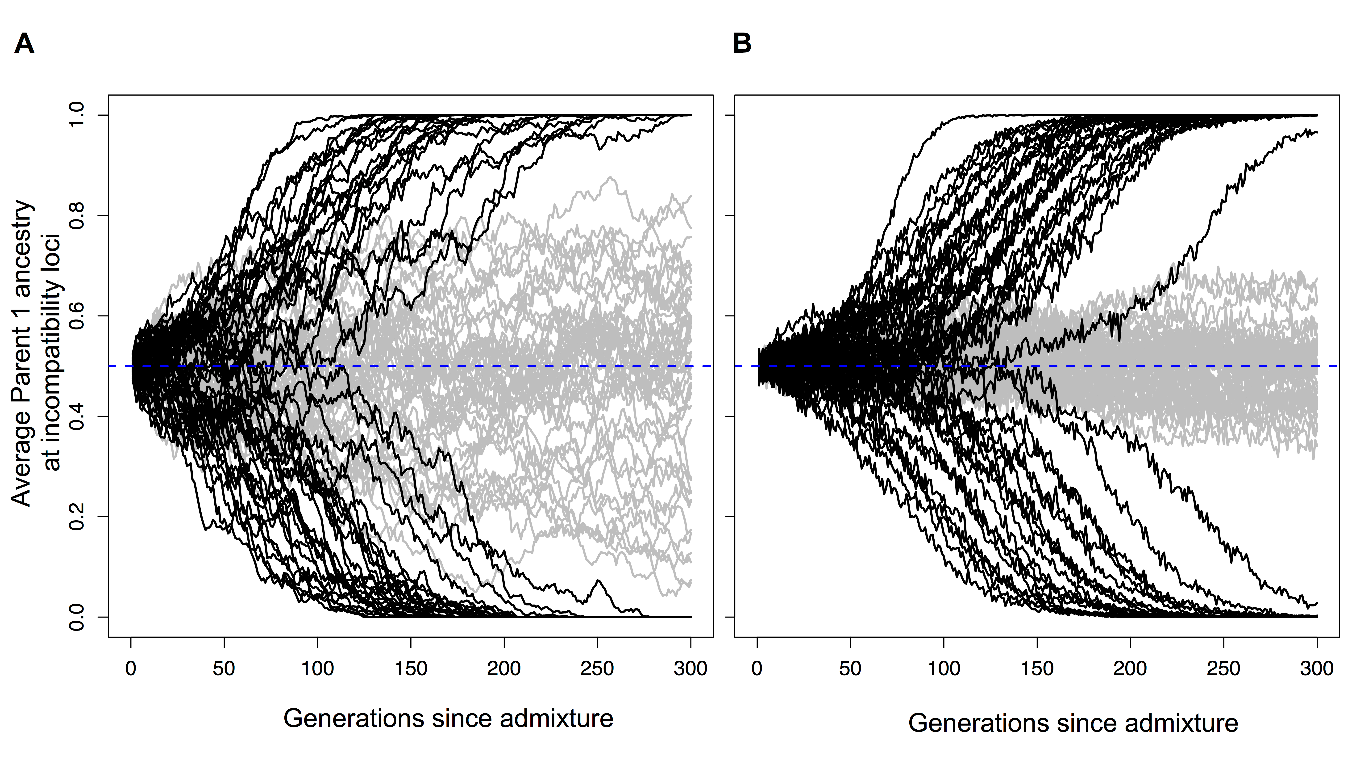

Figure 2. Hybrid populations rapidly fix for hybrid incompatibility locus pairs. Selection drives hybrid incompatibility loci to fixation, even when a hybrid population forms at equal admixture proportions (*f=*0.5). Black lines show average parent 1 ancestry at a hybrid incompatibility pair (*h*=0.5, *s*=0.1) in 50 replicate populations of (A) *N*=1,000 or (B) *N*=10,000 diploid individuals. Gray lines show results for this same population size with no selection. Because of this behavior, two incompatibility pairs may fix for opposite parents, resulting in reproductive isolation of hybrids from both parents (see Fig 1).

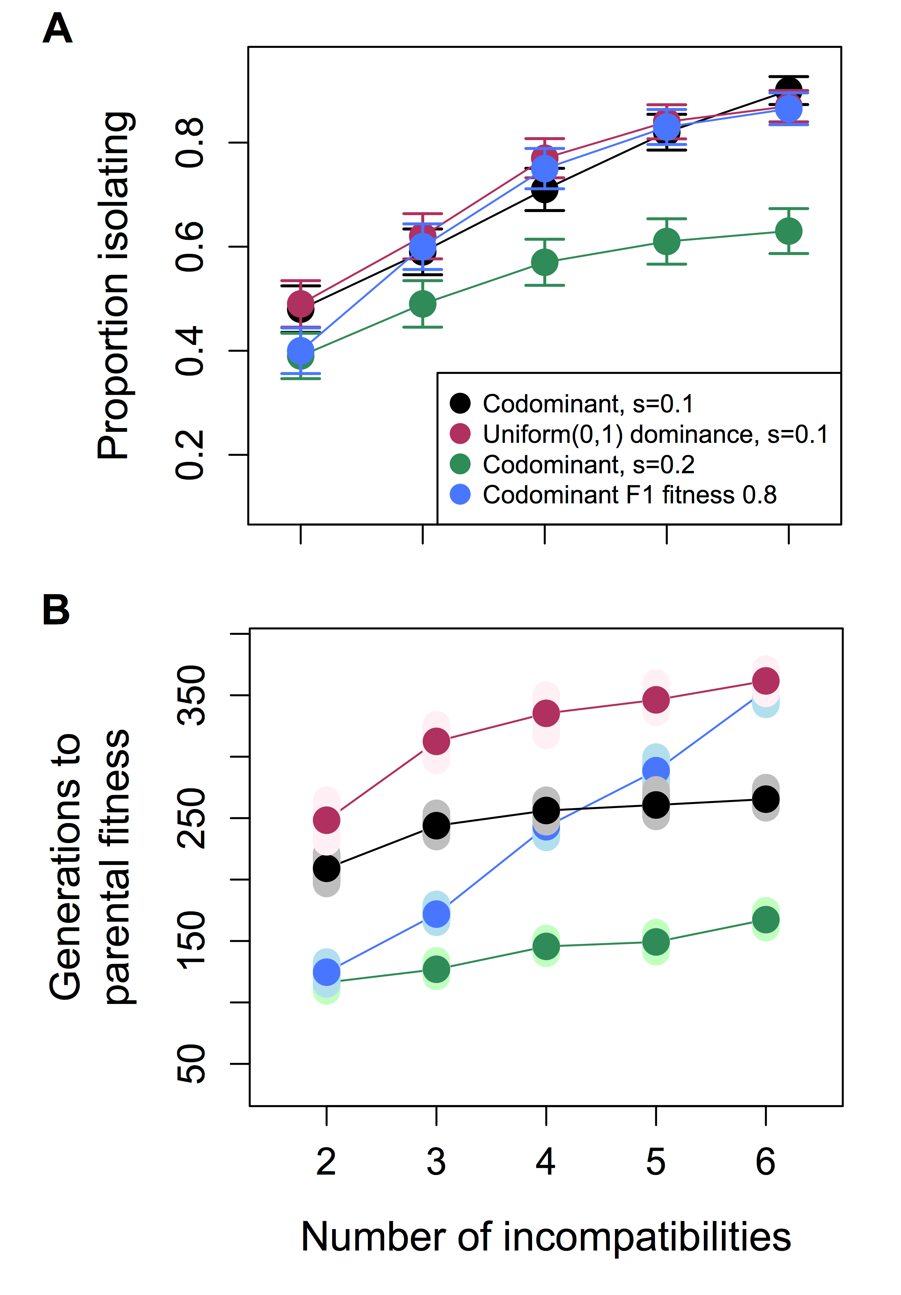

Figure 3. Relationship between the number of hybrid incompatibility pairs and probability of evolving isolation from both parents. With an increasing number of hybrid incompatibility pairs, reproductive isolation from both parents increases in likelihood (A) but populations require longer periods of time to reach parental fitness levels (B). In these simulations two to six hybrid incompatibility pairs distinguish the hybridizing species and hybrid populations formed at equal admixture proportions (*f*=0.5, 1,000 diploid individuals). Simulations labeled F1 indicate that the selection coefficients were set such that the fitness of F1 hybrids between the two parental species equaled 0.8 regardless of the number of incompatibilities. Results are based on 500 replicate simulations. In (A) whiskers represent two standard errors; in (B) smears represent the means of 1,000 bootstrap samples.

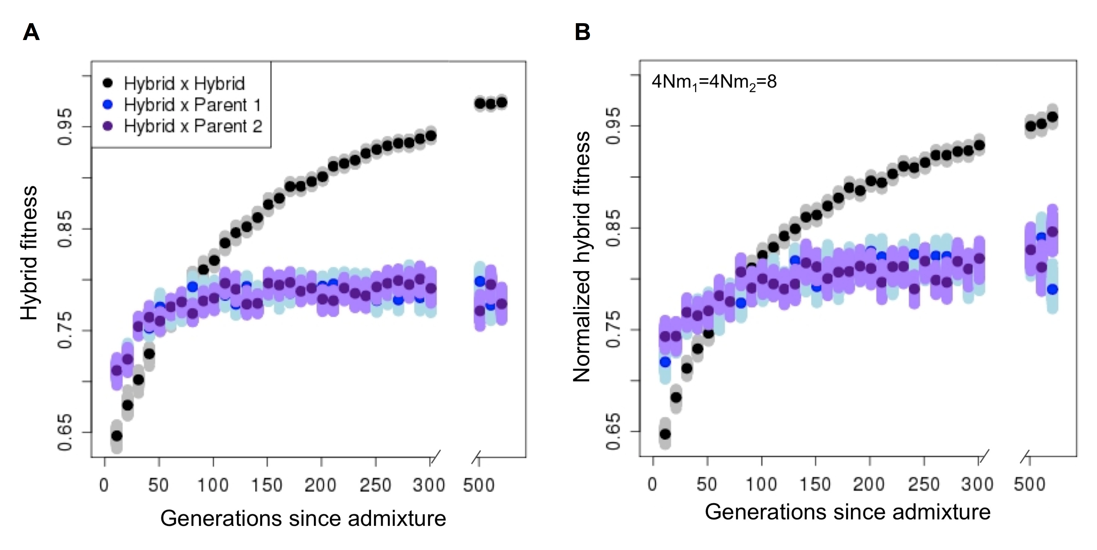

Figure 4. Hybrid populations rapidly develop reproductive isolation from both parental species, even in the presence of migration. Once hybrid populations diverge in ancestry at hybrid incompatibility loci from parental populations, individual hybrids have higher fitness on average when they mate with other hybrids in their population compared to either parent. (A) No migration and (B) ongoing migration (4*Nm*1=4*Nm*2=8) from parental populations. Dark points represent the mean fitness, and smears represent the means of 1,000 bootstrap samples. In B, fitness is normalized to the mean fitness of individuals in the parental populations. Simulation parameters: 100 replicates per time point, *N*=1000, 20 hybrid incompatibility pairs, *s1, s2* and *h* drawn from distributions (exponential, exponential and uniform, respectively, see details Text S5).

References

1. Arnold ML (2006) Evolution through genetic exchange. Oxford, U.K.: Oxford University Press.

2. Mallet J (2007) Hybrid speciation. Nature 446: 279-283.

3. Nolte AW, Tautz D (2010) Understanding the onset of hybrid speciation. Trends Genet 26: 54-58.

4. Schumer M, Rosenthal GG, Andolfatto P (2014) How common is homoploid hybrid speciation? Evolution 68: 1553–1560.

5. Rieseberg LH, Vanfossen C, Desrochers AM (1995) Hybrid speciation accompanied by genomic reorganization in wild sunflowers. Nature 375: 313-316.

6. Rieseberg LH, Raymond O, Rosenthal DM, Lai Z, Livingstone K, et al. (2003) Major ecological transitions in wild sunflowers facilitated by hybridization. Science 301: 1211-1216.

7. Lexer C, Welch ME, Raymond O, Rieseberg LH (2003) The origin of ecological divergence in *Helianthus paradoxus* (Asteraceae): Selection on transgressive characters in a novel hybrid habitat. Evolution 57: 1989-2000.

8. Mavarez J, Salazar CA, Bermingham E, Salcedo C, Jiggins CD, et al. (2006) Speciation by hybridization in *Heliconius* butterflies. Nature 441: 868-871.

9. Buerkle CA, Morris RJ, Asmussen MA, Rieseberg LH (2000) The likelihood of homoploid hybrid speciation. Heredity 84: 441-451.

10. Schwarz D, Matta BM, Shakir-Botteri NL, McPheron BA (2005) Host shift to an invasive plant triggers rapid animal hybrid speciation. Nature 436: 546-549.

11. Schwarz D, Shoemaker KD, Botteri NL, McPheron BA (2007) A novel preference for an invasive plant as a mechanism for animal hybrid speciation. Evolution 61: 245-256.

12. Duenez-Guzman EA, Mavarez J, Vose MD, Gavrilets S. (2009) Case studies and mathematical models of ecological speciation. 4. Hybrid speciation in butterflies in a jungle. Evolution. 63:2611-26.

13. Jiggins CD, Salazar C, Linares M, Mavarez J (2008) Hybrid trait speciation and *Heliconius* butterflies. Philos T Roy Soc B 363: 3047-3054.

14. McCarthy EM, Asmussen MA, Anderson WW (1995) A theoretical assessment of recombinational speciation. Heredity 74: 502-509.

15. Grant V (1971) Plant Speciation. New York: Columbia University Press.

16. Lai Z, Nakazato T, Salmaso M, Burke JM, Tang SX, et al. (2005) Extensive chromosomal repatterning and the evolution of sterility barriers in hybrid sunflower species. Genetics 171: 291-303.

17. Buerkle CA, Wolf DE, Rieseberg LH (2003) The origin and extinction of species through hybridization. In: Brigham CA, Schwarz MW, editors. Population viability in plants: Conservation, management, and modeling of rare plants pp. 117-141.

18. Carr DE, Rieseberg LH, Abbott RJ (2003) The genetic architecture necessary for transgressive segregation is common in both natural and domesticated populations - Discussion. Philos T Roy Soc B 358: 1147-1147.

19. Rieseberg LH, Widmer A, Arntz AM, Burke JM (2003) The genetic architecture necessary for transgressive segregation is common in both natural and domesticated populations. Philos T Roy Soc B 358: 1141-1147.

20. Stelkens R, Seehausen O (2009) Genetic distance between species predicts novel trait expression in their hybrids. Evolution 63: 884-897.

21. Hoffmann AA, Rieseberg LH (2008) Revisiting the impact of inversions in evolution: from population genetic markers to drivers of adaptive shifts and speciation? Ann Rev Ecol Evol Syst 39:21-42.

22. Dobzhansky T (1937) Genetics and the origin of species. New York: Columbia University Press.

23. Muller HJ (1942) Isolating mechanisms, evolution and temperature. Biol Symp 6: 71-125.

24. Coyne JA, Orr HA (2004) Speciation. Sunderland, MA: Sinaeur Associates.

25. Fishman L, Willis JH (2001) Evidence for Dobzhansky-Muller incompatibilites contributing to the sterility of hybrids between *Mimulus guttatus* and *M. nasutus*. Evolution 55: 1932-1942.

26. Sweigart AL, Fishman L, Willis JH (2006) A simple genetic incompatibility causes hybrid male sterility in *Mimulus*. Genetics 172: 2465-2479.

27. Brideau NJ, Flores HA, Wang J, Maheshwari S, Wang X, et al. (2006) Two Dobzhansky-Muller genes interact to cause hybrid lethality in *Drosophila*. Science 314: 1292-1295.

28. Meiklejohn CD, Holmbeck MA, Siddiq MA, Abt DN, Rand DM, et al. (2013) An incompatibility between a mitochondrial tRNA and its nuclear-encoded tRNA synthetase compromises development and fitness in *Drosophila*. PLoS Genet 9.

29. Sawamura K, Yamamoto MT (1997) Characterization of a reproductive isolation gene, zygotic hybrid rescue, of *Drosophila melanogaster* by using minichromosomes. Heredity 79: 97-103.

30. Presgraves DC (2010) The molecular evolutionary basis of species formation. Nat Rev Genet 11: 175-180.

31. Orr HA, Presgraves DC (2000) Speciation by postzygotic isolation: forces, genes and molecules. Bioessays 22: 1085-1094.

32. Bank C, Buerger R, Hermisson J (2012) The limits to parapatric speciation: Dobzhansky-Muller incompatibilities in a continent-island model. Genetics 191: 845-U345.

33. Gavrilets S (1997) Single locus clines. Evolution 51: 979-983.

34. Gompert Z, Parchman TL, Buerkle CA (2012) Genomics of isolation in hybrids. Philos T Roy Soc B 367: 439-450.

35. Seehausen O, Butlin RK, Keller I, Wagner CE, Boughman JW, et al. (2014) Genomics and the origin of species. Nat Rev Genet 15: 176-192.

36. Rieseberg LH, Blackman BK (2010) Speciation genes in plants. Ann Bot 106: 439-455.

37. Johnson NA, Wolf JB, Brodie ED, III, Wade MJ (2000) Gene interactions and the origin of species. In: Wolf J, Brodie EI, Wade M, editors. Epistasis and the evolutionary process. New York: Oxford University Press. pp. 197-212.

38. Gavrilets S (1997) Hybrid zones with Dobzhansky-type epistatic selection. Evolution 51: 1027-1035.

39. Paixão T, Bassler KE, Azevedo RBR (2014) Emergent speciation by multiple Dobzhansky-Muller incompatibilities. bioRxiv doi: <http://dx.doi.org/10.1101/008268>.

40. Schartl M (2008) Evolution of *Xmrk*: an oncogene, but also a speciation gene? Bioessays 30: 822-832.

41. Schumer M, Cui R, Powell D, Dresner R, Rosenthal G, et al. (2014) High-resolution mapping reveals hundreds of genetic incompatibilities in hybridizing fish species. eLife 3: e02535.

42. Fang S, Yukilevich R, Chen Y, Turissini DA, Zeng K, et al. (2012) Incompatibility and competitive exclusion of genomic segments between sibling *Drosophila* species. PLoS Genet 8.

43. Fisher HS, Wong BBM, Rosenthal GG (2006) Alteration of the chemical environment disrupts communication in a freshwater fish. Proc R Soc London Ser B 273: 1187-1193.

44. Hasselman DJ, Argo EE, McBride MC, Bentzen P, Schultz TF, et al. (2014) Human disturbance causes the formation of a hybrid swarm between two naturally sympatric fish species. Mol Ecol 23: 1137–1152.

45. Rosenfield JA, Kodric-Brown A (2003) Sexual selection promotes hybridization between Pecos pupfish, *Cyprinodon pecosensis* and sheepshead minnow, *C. variegatus*. J Evolution Biol 16: 595-606.

46. Karlin S (1975) General 2-locus selection models - Some objectives, results and interpretations. Theor Popul Biol 7: 364-398.

47. Bodmer WF, Felsenstein J (1967) Linkage and selection - theoretical analysis of deterministic 2 locus random mating model. Genetics 57: 237-265.

48. Gavrilets S (2004) Fitness landscapes and the origin of species. Princeton, NJ, USA: Princeton University Press. 1-432 p.

49. James JK, Abbott RJ (2005) Recent, allopatric, homoploid hybrid speciation: The origin of *Senecio squalidus* (Asteraceae) in the British Isles from a hybrid zone on Mount Etna, Sicily. Evolution 59: 2533-2547.

50. Lexer C, Joseph JA, van Loo M, Barbara T, Heinze B, et al. (2010) Genomic Admixture Analysis in European *Populus* spp. Reveals Unexpected Patterns of Reproductive Isolation and Mating. Genetics 186: 699-U391.

51. Kunte K, Shea C, Aardema ML, Scriber JM, Juenger TE, et al. (2011) Sex Chromosome Mosaicism and Hybrid Speciation among Tiger Swallowtail Butterflies. PLoS Genetics 7: 1-14.

52. Rubidge EM, Taylor EB (2004) Hybrid zone structure and the potential role of selection in hybridizing populations of native westslope cutthroat trout (*Oncorhynchus clarki lewisi*) and introduced rainbow trout (*O. mykiss*). Mol Ecol 13: 3735-3749.

53. Trier CN, Hermansen JS, Sætre G-P, Bailey RI (2014) Evidence for mito-nuclear and sex-linked reproductive barriers between the hybrid Italian sparrow and its parent species. PLoS Genet 10.

54. Unckless RL, Orr HA (2009) Dobzhansky-Muller incompatibilities and adaptation to a shared environment. Heredity 102: 214-217.

55. Moyle LC, Graham EB (2006) Genome-wide associations between hybrid sterility QTL and marker transmission ratio distortion. Mol Biol Evol 23: 973-980.

56. Masly JP, Presgraves DC (2007) High-resolution genome-wide dissection of the two rules of speciation in *Drosophila*. PLoS Biol 5: 1890-1898.

57. Presgraves DC (2003) A fine-scale genetic analysis of hybrid incompatibilities in *Drosophila*. Genetics 163: 955-972.

58. Gardner K, Buerkle A, Whitton J, Rieseberg L (2000) Inferring epistasis in wild sunflower hybrid zones. In: Wolf JB, Brodie ED, III, Wade MJ, editors. Epistasis and the evolutionary process. New York: Oxford University Press. pp. 264-279.

59. Payseur BA, Hoekstra HE (2005) Signatures of reproductive isolation in patterns of single nucleotide diversity across inbred strains of mice. Genetics 171: 1905-1916.

60. Teeter KC, Payseur BA, Harris LW, Bakewell MA, Thibodeau LM, et al. (2008) Genome-wide patterns of gene flow across a house mouse hybrid zone. Genome Res 18: 67-76.

61. Ostberg CO, Slatton SL, Rodriguez RJ (2004) Spatial partitioning and asymmetric hybridization among sympatric coastal steelhead trout (*Oncorhynchus mykiss irideus*), coastal cutthroat trout (*O. clarki clarki*) and interspecific hybrids. Mol Ecol 13: 2773-2788.

62. Field DL, Ayre DJ, Whelan RJ, Young AG (2011) Patterns of hybridization and asymmetrical gene flow in hybrid zones of the rare *Eucalyptus aggregata* and common *E. rubida*. Heredity 106: 841-853.

63. Greig D, Louis EJ, Borts RH, Travisano M (2002) Hybrid speciation in experimental populations of yeast. Science 298: 1773-1775.

64. Buerkle CA, Rieseberg LH (2008) The rate of genome stabilization in homoploid hybrid species. Evolution 62: 266-275.

65. Gompert Z, Fordyce JA, Forister ML, Shapiro AM, Nice CC (2006) Homoploid hybrid speciation in an extreme habitat. Science 314: 1923-1925.

66. Rieseberg LH, Whitton J, Gardner K (1999) Hybrid zones and the genetic architecture of a barrier to gene flow between two sunflower species. Genetics 152: 713-727.

67. Servedio MR (2000) Reinforcement and the genetics of nonrandom mating. Evolution 54: 21-29.

68. Servedio MR, Noor MAF (2003) The role of reinforcement in speciation: Theory and data. Annu Rev Ecol Evol S 34: 339-364.

69. Kirkpatrick M, Servedio MR (1999) The reinforcement of mating preferences on an island. Genetics 151: 865-884.

70. Nosil P, Yukilevich R (2008) Mechanisms of reinforcement in natural and simulated polymorphic populations. Biol J Linnean Soc 95: 305-319.

71. Rosenthal GG (2013) Individual mating decisions and hybridization. J Evol Biol 26: 252-255.

72. Fisher HS, Mascuch SJ, Rosenthal GG (2009) Multivariate male traits misalign with multivariate female preferences in the swordtail fish, *Xiphophorus birchmanni*. Anim Behav 78: 265-269.

73. Culumber ZW, Ochoa OM, Rosenthal GG (2014) Assortative mating and the maintenance of population structure in a natural hybrid zone. Am Nat 184: 225-232.

74. Ganem G, Litel C, Lenormand T (2008) Variation in mate preference across a house mouse hybrid zone. Heredity 100: 594-601.

75. Matute DR, Butler IA, Turissini DA, Coyne JA (2010) A test of the snowball theory for the rate of evolution of hybrid incompatibilities. Science 329: 1518-1521.

76. Corbett-Detig RB, Zhou J, Clark AG, Hartl DL, Ayroles JF (2013) Genetic incompatibilities are widespread within species. Nature 504: 135-137.

77. Harushima Y, Nakagahra M, Yano M, Sasaki T, Kurata N (2001) A genome-wide survey of reproductive barriers in an intraspecific hybrid. Genetics 159: 883-892.

78. Janousek V, Wang L, Luzynski K, Dufkova P, Vyskocilova MM, et al. (2012) Genome-wide architecture of reproductive isolation in a naturally occurring hybrid zone between *Mus musculus musculus* and *M. m. domesticus*. Mol Ecol 21: 3032-3047.

79. Turner LM, White MA, Tautz D, Payseur BA (2014) Genomic networks of hybrid sterility. PLoS Genet 10.

80. Gay L, Crochet P-A, Bell DA, Lenormand T (2008) Comparing clines on molecular and phenotypic traits in hybrid zones: A window on tension zone models. Evolution 62: 2789-2806.

81. Nolte AW, Gompert Z, Buerkle CA (2009) Variable patterns of introgression in two sculpin hybrid zones suggest that genomic isolation differs among populations. Mol Ecol 18: 2615-2627.

82. Vines TH, Kohler SC, Thiel A, Ghira I, Sands TR, et al. (2003) The maintenance of reproductive isolation in a mosaic hybrid zone between the fire-bellied toads *Bombina bombina* and *B. variegata*. Evolution 57: 1876-1888.

83. Bomblies K, Lempe J, Epple P, Warthmann N, Lanz C, et al. (2007) Autoimmune response as a mechanism for a Dobzhansky-Muller-type incompatibility syndrome in plants. PLoS Biol 5: 1962-1972.

84. Sweigart AL (2010) Simple Y-Autosomal incompatibilities cause hybrid male sterility in reciprocal crosses between *Drosophila virilis* and *D. americana*. Genetics 184: 779-U225.

85. Lee H-Y, Chou J-Y, Cheong L, Chang N-H, Yang S-Y, et al. (2008) Incompatibility of nuclear and mitochondrial genomes causes hybrid sterility between two yeast species. Cell 135: 1065-1073.

86. Rawson PD, Burton RS (2002) Functional coadaptation between cytochrome c and cytochrome c oxidase within allopatric populations of a marine copepod. Proc Natl Acad Sci USA 99: 12955-12958.

87. Johnson NA (2010) Hybrid incompatibility genes: remnants of a genomic battlefield? Trends Genet 26: 317-325.

88. Crespi B, Nosil P (2013) Conflictual speciation: species formation via genomic conflict. Trends Ecol Evol 28: 48-57.

89. Barbash DA, Roote J, Ashburner M (2000) The *Drosophila melanogaster* hybrid male rescue gene causes inviability in male and female species hybrids. Genetics 154: 1747-1771.

90. Maheshwari S, Barbash DA (2011) The genetics of hybrid incompatibilities. Ann Rev Genet 45: 331-355.

91. Staubach F, Lorenc A, Messer PW, Tang K, Petrov DA, et al. (2012) Genome patterns of selection and introgression of haplotypes in natural populations of the house mouse (*Mus musculus*). PLoS Genet 8.

92. Pritchard VL, Edmands S (2013) The genomic trajectory of hybrid swarms: outcomes of repeated crosses between populations of *Tigriopus californicus*. Evolution 67: 774-791.

93. Schwander T, Suni SS, Cahan SH, Keller L (2008) Mechanisms of reproductive isolation between an ant species of hybrid origin and one of its parents. Evolution 62: 1635-1643.

94. Hermansen JS, Haas F, Trier CN, Bailey RI, Nederbragt AJ, et al. (2014) Hybrid speciation through sorting of parental incompatibilities in Italian sparrows. Mol Ecol doi: 10.1111/mec.12910.

95. Gross BL, Rieseberg LH (2005) The ecological genetics of homoploid hybrid speciation. J Hered 96: 241-252.

96. Hastings A (1984) Linkage disequilibrium, selection and recombination at three loci. Genetics 106: 153-164.

97. Kirkpatrick M, Johnson T, Barton N (2002) General models of multilocus evolution. Genetics 161: 1727-1750.

98. Gardner A, West SA, Barton NH (2007) The relation between multilocus population genetics and social Evolution Theory. Am Nat 169: 207-226.

99. Kopp M, Gavrilets S (2006) Multilocus genetics and the coevolution of quantitative traits. Evolution 60: 1321-1336.

Supporting Information

Text S1. Models of hybrid incompatibility

In order to investigate changes in allele frequencies at hybrid incompatibility loci, we need to define explicit models of selection on each two-locus genotype. Different genotypes at hybrid incompatibility loci will experience different strengths of selection. This can be a consequence of dominance at each locus (*h*), the number of epistatic interactions, the order in which mutations occurred, and the relative fitness of the parental and ancestral genotypes.

My simulations are based on fitness matrices representing adaptive BDM incompatibilities (Figure S1) and coevolving hybrid incompatibilities (Figure S2). Elsewhere, I discuss neutral BDM incompatibilities and coevolving hybrid incompatibilities that will not generate isolation in the absence of strong genetic drift (Figure S8). For simplicity, in most cases I simulate coevolving incompatibilities (Figure S2) and assume that selection on different epistatic interactions is symmetrical (*s*1=*s*2) and that all alleles are codominant (*h*=0.5). However, I relax these assumptions in Text S3C and D. Though I focus on coevolving incompatibilities (Figure S2) my results also generally apply to adaptive BDM incompatibilities which have a similar fitness matrix (Figure S1).

In Figures S1A and S2A, I show a single mutational path to each hybrid incompatibility type; however, in both cases, several possible mutational paths exist. Because the lineage and order in which mutations occur is expected to be random [24], I randomly assign a fitness matrix to each incompatibility in simulations (note: these matrices are identical at *h*=0.5 and *s*1=*s*2).

Using these fitness matrices and the model of two-locus selection developed by Karlin and others (hereafter the “deterministic two-locus model”, [46, 47]) we can determine the expected trajectory of incompatibility pairs in hybrid populations under different parameters (Figure S4). However, some of these dynamics differ in finite populations (see Text S2).

Text S2. The two-locus model with genetic drift and comparison to population simulations.

The deterministic two-locus model ([46]; see Methods) allows us to predict the patterns of fixation for different incompatibility types with different parameters (Figure S4; see also [48]) but is not realistic because even large populations will have some genetic drift, which is not accounted for in the model. To implement drift, I added multinomial sampling of N individuals at each generation (Figure S5). The major difference caused by implementing drift is that fixation patterns do not always follow the predictions of the deterministic two-locus model. This can be seen most clearly in Figure S5C, where some fixation trajectories differ from expectations under the deterministic two-locus model.

The two-locus model equations do not allow us to model the fates of more than one incompatibility pair. I thus used an explicit population simulation code (admix’em) described in the Methods. To validate this code, I compared results from simulations with admix’em to simulations of the two-locus model with drift implemented by multinomial sampling. I simulated a single coevolving hybrid incompatibility (*h*=0.5, *s*1=*s*2=0.1) with population size N=1,000 and 10,000. In both cases the results from admix’em and the two-locus model with drift are nearly identical (Table S1).

Text S3. Evaluation of the hybrid population reproductive isolation model under a range of parameters

Simulations presented in the main text demonstrate that with two hybrid incompatibility pairs, reproductive isolation frequently evolves (47±2%) due to fixation of hybrid incompatibility loci for both parents. This mechanism of hybrid isolation is most likely to be biologically relevant if it occurs under a broad range of parameters. I performed simulations of two coevolving hybrid incompatibility pairs (Figure S2) varying selection (*s*), dominance (*h*), diploid population size (N), admixture proportions (*f*), and degree of asymmetry in selection (*s*1≠*s*2). All results are based on 500 replicate simulations. I consider hybrid populations “isolated” from both parents if they fix for at least one incompatibility pair from each parent; the strength of isolation will always depend on the strength of selection on each incompatibility and the number of incompatibilities. Together, these simulations demonstrate that hybrid reproductive isolation due to fixation of genetic incompatibilities can occur under a range of parameters.

1. *The strength of selection on hybrids.*

Variation in the strength of selection on hybrids can influence the likelihood of hybrid isolation under my model. I performed simulations with two coevolving hybrid incompatibility pairs with different strengths of selection (Table S2, Figure S6). I find that the probability of isolation decreases as total selection on hybrids increases. Lower probability of isolation at higher levels of selection on hybrids is the result of hybrid populations becoming dominated by parental individuals.

1. *Population size*

A number of models of speciation rely on small population sizes to achieve isolation from parental species [e.g. see Gavrilets and Hastings 1996]. One feature of my model is that it does not rely on small population sizes; in large populations incompatibility pairs fix by selection, whereas in small populations they fix by chance. As a result, the proportion of hybrid populations evolving isolation from both parents is not strongly dependent on population size (Table S3). This suggests that this model is applicable to a range of natural hybrid populations.

1. *Initial admixture proportions*

To determine how changing admixture proportions influences the number of hybrid populations evolving isolation, I varied starting admixture proportions from *f*=0.5-0.7. As expected, the probability of isolation from both parents decreased with increasing ancestry skew (Figure S7). Initial admixture proportions close to *f*=0.5 are most likely to result in isolation from both parental species. However, even in skewed populations, isolation from both parents was possible when assuming variation in dominance among alleles (for e.g. *h* =Uniform(0,1), Figure S7A), at lower population sizes (N=100, Figure S6A), or when simulating a larger number of incompatibility pairs (Figure S7B).

1. *Asymmetric selection on hybrid incompatibilities*

For simplicity, in most cases I simulate symmetric selection on hybrid incompatibilities. To introduce asymmetric selection on different hybrid genotypes I use different selection coefficients for distinct interactions in the coevolution model, *s*1 and *s*2 (Figure S2). When selection is asymmetrical (i.e. *s*1 ≠ *s*2), the two-locus model has similar properties to *s*1 = *s*2 as long as *s*1 and *s*2 are both greater than 0 (Figure S4). To investigate this in finite populations, I randomly assigned *s*=0.1 to *s*1 or *s*2 independently for two coevolving incompatibility pairs and set the value for the other selection coefficient to 0.2\**s*, 0.3\**s*, 0.4\**s*, or 0.5\**s*. In these simulations, reciprocal isolation still developed frequently (Table S4).

The adaptive BDM model (Figure S1) might result in even more extreme asymmetry in selection on hybrid genotypes [Gavrilets 1997; Unkless and Orr 2009; 38]. To approximate this scenario, I simulated adaptive BDMIs (Figure S1) and randomly assigned *s*=0.5 to *s*1 or *s*2 independently for two hybrid incompatibility pairs, and assigned *s*=0.02 to the other selection coefficient. In these simulations 36 ± 2% of populations became isolated from both parental species. In populations fixing incompatibility pairs from both parents, the strength of isolation from each parent species was similar. On average, the absolute fitness difference between backcross types (hybrid x parent 1 and hybrid x parent 2) was only 0.003. The average fitness of a hybrid x parent cross after hybrid populations fixed for parental incompatibilities was 0.87 (compared to 0.76 for an F1 cross between the two parent species).

1. *Dominance*

In the above simulations, I model codominant hybrid incompatibilities but varying dominance (*h*) does not have major effects on my conclusions. To demonstrate this, I simulated two scenarios: 1) I drew *h* from a uniform distribution, requiring *h* at each locus to add to 1 and 2) I randomly assigned *h* discrete values of 0 (recessive), 0.5 (co-dominant), or 1 (dominant), again requiring *h* to add to 1 at each locus. Both of these scenarios result in a similar probability of isolation from parental species (Table S5).

Text S3 References

Gavrilets S, Hastings A (1996) Founder effect speciation: A theoretical reassessment. Am

Nat 147: 466-491.

Gavrilets S (1997) Hybrid zones with Dobzhansky-type epistatic selection. Evolution 51:

1027-1035.

Unckless RL, Orr HA (2009) Dobzhansky-Muller incompatibilities and adaptation to a

shared environment. Heredity 102: 214-217.

Text S4. Incompatibilities that do not frequently result in reproductive isolation in the absence of strong drift

Several types of genetic incompatibilities, such as neutral BDM incompatibilities (or other scenarios that generate identical fitness matrices, Figure S8), are not predicted to contribute to reproductive isolation between hybrids and parentals by incompatibility selection (Figure S8). This is because hybrid incompatibility pairs either do not fix, or fix for a genotype that is compatible with both parents (based on the deterministic two-locus model, Figure S4A, Figure S8). Simulations of incompatibilities with these fitness matrices confirm this prediction; the most frequently fixed genotypes are not incompatible with either parent (47±2% of simulations) and in many simulations (38±2%) hybrid populations did not fix for a particular parental genotype at incompatibility loci within 2,000 generations (simulation parameters: N=1000, *s*=0.1, *f*=0.5, *h*=0.5).

Nonetheless, with strong genetic drift, genotypes incompatible with one of the parents can fix by chance, contributing to isolation, even under a neutral BDMI model. This can be seen in Figure S9, which shows the proportion of hybrid populations isolated from both parents as a function of population size. As population size decreases and drift increases, the proportion of hybrid populations isolating from both parents increases. However, the time to isolation is longer than in cases where fixation is driven by deterministic selection (by drift N=100: 264±143 generations, N=500: 1544±289 generations, N=1000: 1679±356 generations, compared to Table S3).

Text S5. Validation of the model under a range of genetic architectures

Because species are likely to be differentiated by a number of incompatibilities even in the early stages of speciation [Cutter 2012] I investigated how the number of incompatibility pairs and their genetic architecture affects the probability of evolving reproductive isolation.

* 1. *Number of incompatibility pairs*

Theoretically, increasing the number of incompatibility pairs should increase the probability that hybrid populations will become isolated from both parents (by at least one incompatibility). However, increasing the number of incompatibility pairs will reduce hybrid fitness and thus may also increase the probability that hybrids will be outcompeted by parental species. Simulating 3-6 unlinked coevolving incompatibility pairs (*f*=0.5, *h*=0.5, *s*1=*s*2=0.1-0.2, N=1000) increased the probability of isolation as a function of the number of pairs and selection coefficient (Figure 3, 49-91%). This result is notable because the probability of reciprocal isolation increases even with an increase in total selection on hybrids (see also Figure S6).

* 1. *Probability of reciprocal isolation in the presence of neutral BDM incompatibilities*

Though there is little data on fitness matrices for specific hybrid incompatibilities (reviewed in [30]), neutral BDM incompatibilities may be common [24]. Because of this, I determined the frequency of isolation between hybrids and parents in simulations including neutral BDM incompatibilities, where either *s*1 or *s*2 equals zero. I simulate two coevolving hybrid incompatibility pairs as described above but also include one linked or unlinked neutral BDM incompatibility pair. I find that the presence of BDM incompatibilities does not significantly decrease the probability of isolation between hybrid and parental populations (unlinked: 44 ± 2%, 1 cM between coevolving incompatibility and neutral BDM as in Figure S10B: 49 ± 2%, compared to 47 ± 2% with no neutral BDMIs). Interestingly, linkage between a neutral BDM incompatibility and a coevolving incompatibility can result in more frequent fixation of one of the parental genotypes at BDMIs (16± 2%, compared to 0.6% without linkage). In such cases, neutral BDMIs will contribute to isolation between hybrids and parental species.

* 1. *Linkage between incompatibility pairs*

Linkage between sites involved in hybrid incompatibilities could influence the frequency of isolation because ancestry at linked sites will be correlated. In order to investigate this I simulated two coevolving hybrid incompatibility pairs and varied genetic distance between loci (50 cM, 10 cM, and 1 cM; Figure S10). Some scenarios of physical linkage did not have a strong effect on the probability of isolation, while others reduced the probability of isolation (Table S6).

* 1. *More complex incompatibility architectures*

I have focused on very simple models that show that hybrid reproductive isolation can evolve in principle. However, empirical studies suggest that even closely related species are sometimes differentiated by dozens of incompatibilities that vary in their fitness effects [55, 59, 76,77, Payseur et al. 2004]. To investigate whether hybrid reproductive isolation evolves with more complex incompatibility architectures, I simulated a large number of incompatibilities with variation in selection, dominance, and asymmetry. I simulate 20 pairs of hybrid incompatibilities with a randomly chosen genomic position (chromosome 1-20, position 1-25000000 bp). Dominance is drawn from a uniform distribution (0-1) and selection coefficients (*s*1 and *s*2) are drawn from an exponential distribution with a mean of *s*=0.05. Because *s*1 and *s*2 are determined independently this introduces asymmetry in selection, and if *s*1 or *s*2 is close to 0 (i.e. on the order of 1/N), this generates an effectively neutral BDM incompatibility.

In these simulations, hybrid populations had a high probability of developing isolation from both parental species (95±1%). On average, backcrosses between parentals and individuals from the hybrid population had a fitness of 0.79±0.11 after 500 generations of selection on hybrid populations, compared to an average of 0.61±0.07 for F1 hybrids between the two parental species (Figures 3, S11). The average fitness of hybrids mating with other hybrids in the population was 0.97±0.02.

To investigate how the frequency of hybrid reproductive isolation changes with stronger selection in this more biologically realistic scenario, I repeated these simulations drawing *s* from an exponential distribution with a mean of 0.1 and 0.2. The average fitness of F1 hybrids between the two parental species in these cases was 0.38±0.09 and 0.12±0.06 respectively. In these cases the frequency of being isolated from both parents within 500 generations by at least one incompatibility was dramatically reduced to 56±2% and 1.4±0.5% respectively. These results demonstrate that hybrid reproductive isolation is unlikely to evolve by this mechanism when hybrid fitness is nearly zero.

Text S5 References

Cutter AD (2012) The polymorphic prelude to Bateson-Dobzhansky-Muller

incompatibilities. Trends in Ecology & Evolution 27: 209-218.

Payseur BA, Krenz JG, Nachman MW (2004) Differential patterns of introgression

across the X chromosome in a hybrid zone between two species of house mice. Evolution 58: 2064-2078.

Text S6. Validation of the model under a range of demographic scenarios

1. *Isolation with migration*

Hybrid populations in nature frequently experience ongoing gene flow with parental species. Given this, it is important to determine the impact of gene flow on how frequently hybrid populations evolve reproductive isolation. I simulated two migration scenarios, one with continuous migration from both parental populations (4N*m* = 8 – 20) and one with a single pulse of migration from either parent (migrating parent determined randomly) at 25, 50, and 75 generations in independent simulations respectively. Because populations with ongoing migration from both parents never completely fix for a particular genotype, I treated cases in which 95% of the hybrid population had a particular genotype as fixed. As expected, higher migration rates lowered the proportion of hybrid populations evolving isolation from both parents (Table S7, compared to 47± 2% with no migration). However, my results demonstrate that isolation still occurs frequently with fairly high levels of gene flow from the parental species. Notably, even before fixation, migration from parental populations lowers hybrid population fitness (Figure 4, Figure S11).

In the above simulations I assume symmetrical migration, but natural hybrid zones vary in the degree to which migration from parental populations is symmetrical (e.g. [60-62]). To explore how asymmetrical migration affects the probability of isolation I performed simulations varying the degree of asymmetry in migration from the parental populations (Figure S12). When migration is highly asymmetrical and migration rates are high, the probability of isolation is low but isolation still evolves at appreciable frequency in other scenarios (Figure S12).

*B. Migration in a stepping stone hybrid zone*

I use the simplest hybrid zone structure in the above simulations (Figure S3), but hybrid zones often exist as a series of populations between the parental species. To simulate this, I modeled three hybrid populations between the parental populations with bidirectional migration between adjacent populations (Figure S13, Table S7). In this scenario, the hybrid population at the center of the hybrid zone (H2, Figure S13) experiences less direct gene flow from the parental populations, and should evolve reproductive isolation more frequently than those adjacent to the parental populations. As expected, I found that the hybrid population at the center of the hybrid zone developed isolation from parental species more frequently (Table S7), and that hybrid populations closer to the parentals were less likely to develop isolation (4*Nm*=8: 25±2 - 29±2%, 4*Nm*=12: 13±2 - 18±2,4*Nm*=20: 1.0±0.6 - 1.2±0.6%).

*C. Reciprocal isolation of multiple hybrid populations*

One interesting prediction of my model is that independent hybrid populations that form from the same parental species could evolve reproductive isolation from each other if they fix for different parental alleles at incompatibility pairs. To investigate this, I simulated two hybrid populations formed from the same parental species (Figure S14). In cases where both hybrid populations in a simulation evolved isolation from the parents, I asked how frequently these populations were isolated from each other. When there was no gene flow between the hybrid populations, isolation evolved frequently between these populations (2 HI: 50 ± 5%, 3HI: 81 ± 4%, Table S8). However, when hybrid populations were connected by gene flow, this outcome was significantly less likely (Table S8). These simulations suggest that hybridization between the same parental species could generate multiple, reproductively isolated hybrid populations, but that this outcome is more likely when gene flow is low.

*D. Non-random mating of parents in hybrid zones*

In the above simulations, mating is random, and pure parental individuals become less common as the number of generations since initial hybridization increases. However, if parentals mate assortatively, larger numbers will exist in the hybrid population, increasing the risk of out-competition of hybrids by parents. To investigate this, I implemented a mating rule in which migrating parentals mate exclusively with conspecifics. If a conspecific is not sampled in 25, 50, or 75 attempts in separate simulations respectively, the parental individual does not mate. With increasing parental effort to mate with a conspecific, hybrid populations evolved isolation less frequently (Table S9). This suggests that hybrid populations are more likely to be outcompeted if parentals have strong preferences against mating with hybrids.

Text S7. Simulations of the inversion model of hybrid speciation

One previous model of hybrid speciation, that I will call the “underdominant inversion” model [14,15,17], explicitly incorporated genetic mechanisms of speciation. In this model, parental species are distinguished by two underdominant inversions. Simulations of this model suggested that hybrid reproductive isolation is expected to be rare without positive selection on hybrid genotypes [14,17]. However, in both of these simulation efforts the authors modeled a spatially explicit hybrid population with a narrow contact zone, and either no spatial isolation between hybrids and parents [14] or high rates of migration from parental populations [17]. This specific population structure may have influenced results, which suggested that hybrid speciation was unlikely in the absence of strong positive selection (e.g. ecological selection ~0.5, [17]) or inbreeding [14].

I performed additional simulations to evaluate whether the inversion model can result in reproductive isolation of hybrid individuals without positive selection in the hybrid swarm scenario I model. Specifically, I simulated two unlinked underdominant inversions with selection only against genotypes heterozygous for the inversion, and assumed that fitness is multiplicative. As in simulations of the epistatic incompatibility model, I simulated 50-50 admixture proportions, random mating, and a diploid population size of 1000 for 500 replicate simulations.

Interestingly, I find that in a hybrid swarm scenario, inversions frequently fix for one of the two possible homozygous recombinant inversion genotypes (43±2% of simulations with *s1*=*s2*=0.05, Table S11). These barriers evolved rapidly, on average within 212±59 generations with *s1*=*s2*=0.05. Thus, the probability and time to isolation are quite similar to the epistatic incompatibility model (see Text S3). In addition, the probability of isolation decreases with increasing skew in admixture proportions, consistent with the results of my model (Figure S15 compared to Figure S7).

My results imply that in a hybrid swarm that is spatially isolated from parental species, reproductive isolation can arise frequently and quickly from underdominant inversions without invoking positive selection. Results for my epistatic incompatibility model show that an increase in the number of incompatibility pairs results in an increase in the probability of isolation, even with stronger selection on hybrids (Figure 3, Figure S6). It will be interesting to explore whether the underdominant inversion model has similar dynamics, since the opposite trend was reported under the simulation conditions of the original paper [14].

Supporting Figures

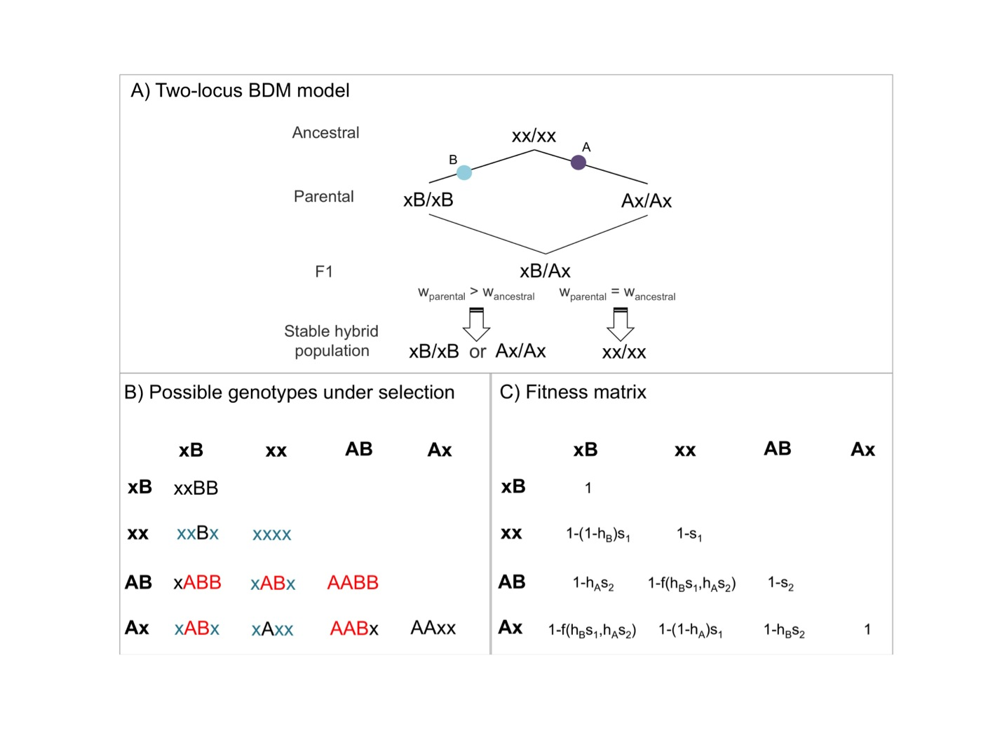

Figure S1. Evolution of two-locus BDM incompatibilities and the fitness of hybrid genotypes. (A) One of two possible mutational paths to the development of a two-locus BDM incompatibility (Not shown is the case where both mutations occur on one lineage). These incompatibilities can arise as the result of neutral fixation (wparental=wancestral) or as the result of adaptive evolution (wparental>wancestral). (B) Potential selection patterns on hybrid genotypes between the two parentals (assuming wparental>wancestral); genotypes corresponding to selection coefficients *s*1 and *s*2 are indicated in blue and red respectively. For BDM incompatibilities, *s*1 and *s*2 can be asymmetric, and in neutral BDM incompatibilities either *s*1 or *s*2 will equal zero. (C) Fitness of hybrid individuals with each genotype will depend on the intensity of selection (*s*1, *s*2) and dominance (*hA, hB*) at the two loci. I assume for simplicity that the fitness advantage of all derived genotypes (here, xB and Ax) is equal.

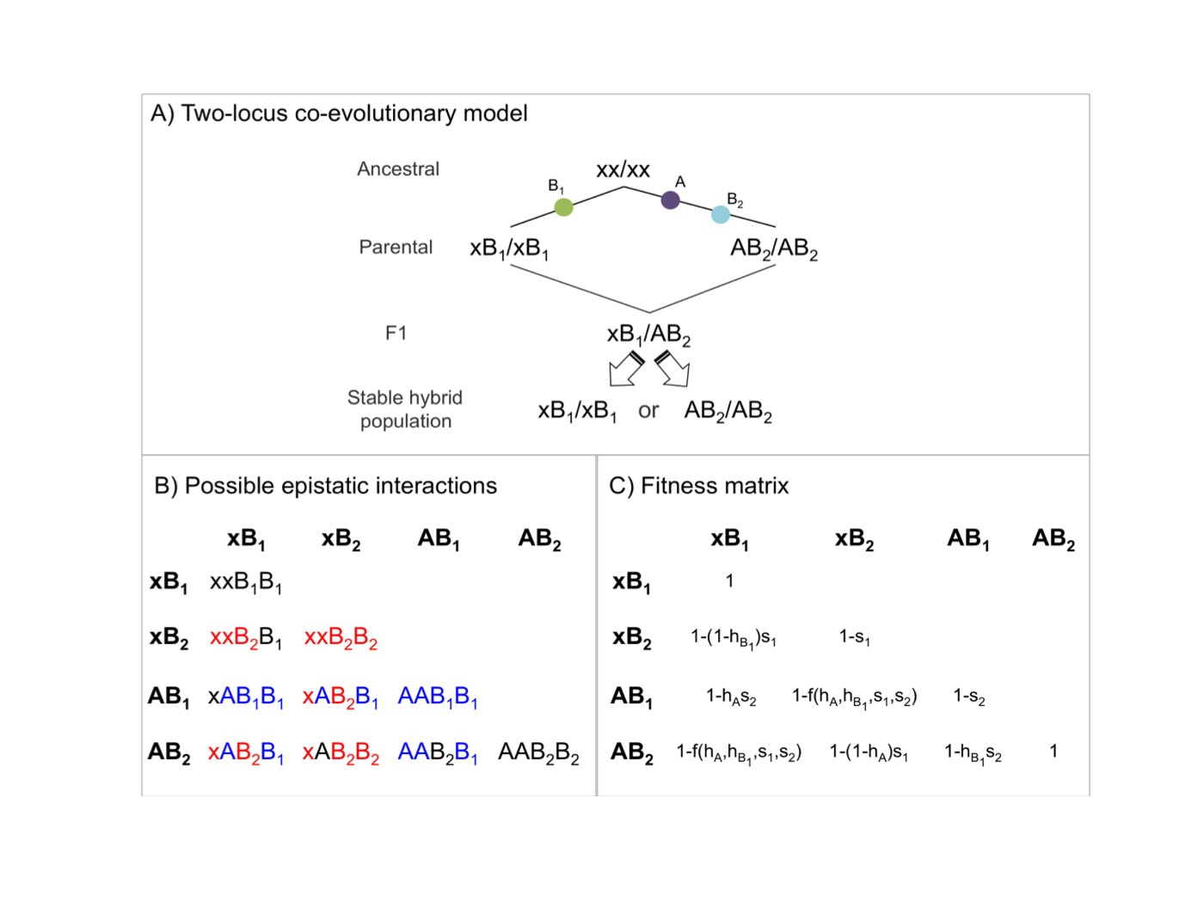

Figure S2. Evolution of two-locus coevolving incompatibilities and the fitness of hybrid genotypes. (A) One of two possible mutational paths to the development of a two-locus coevolved incompatibility. Not shown is the case where B2 precedes A (see Text S4). (B) Potential epistatic interactions among hybrid genotypes. Incompatibilities corresponding to *s*1 and *s*2 are indicated in blue and red, respectively. (C) Fitness of hybrid individuals with each genotype will depend the intensity of selection (*s*1, *s*2) and dominance (*hA, hB*) at the two loci.

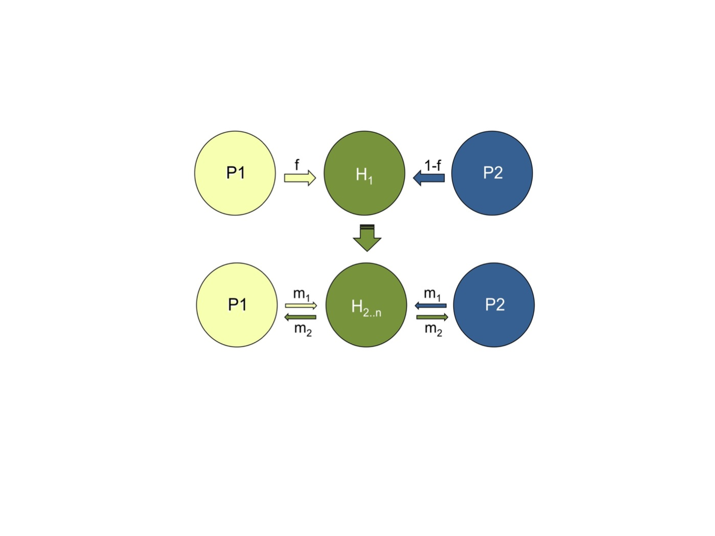

Figure S3. Schematic of hybrid population model used in simulations. The simplest model of hybrid speciation evolves in a hybrid swarm via fixation of parental genetic incompatibility pairs in opposite directions (see Figure 1). *f* is the proportion of the hybrid (H) population colonized by parent 1 (P1), *m1,2*denotes migration rates between the parental and hybrid populations over *n* generations.

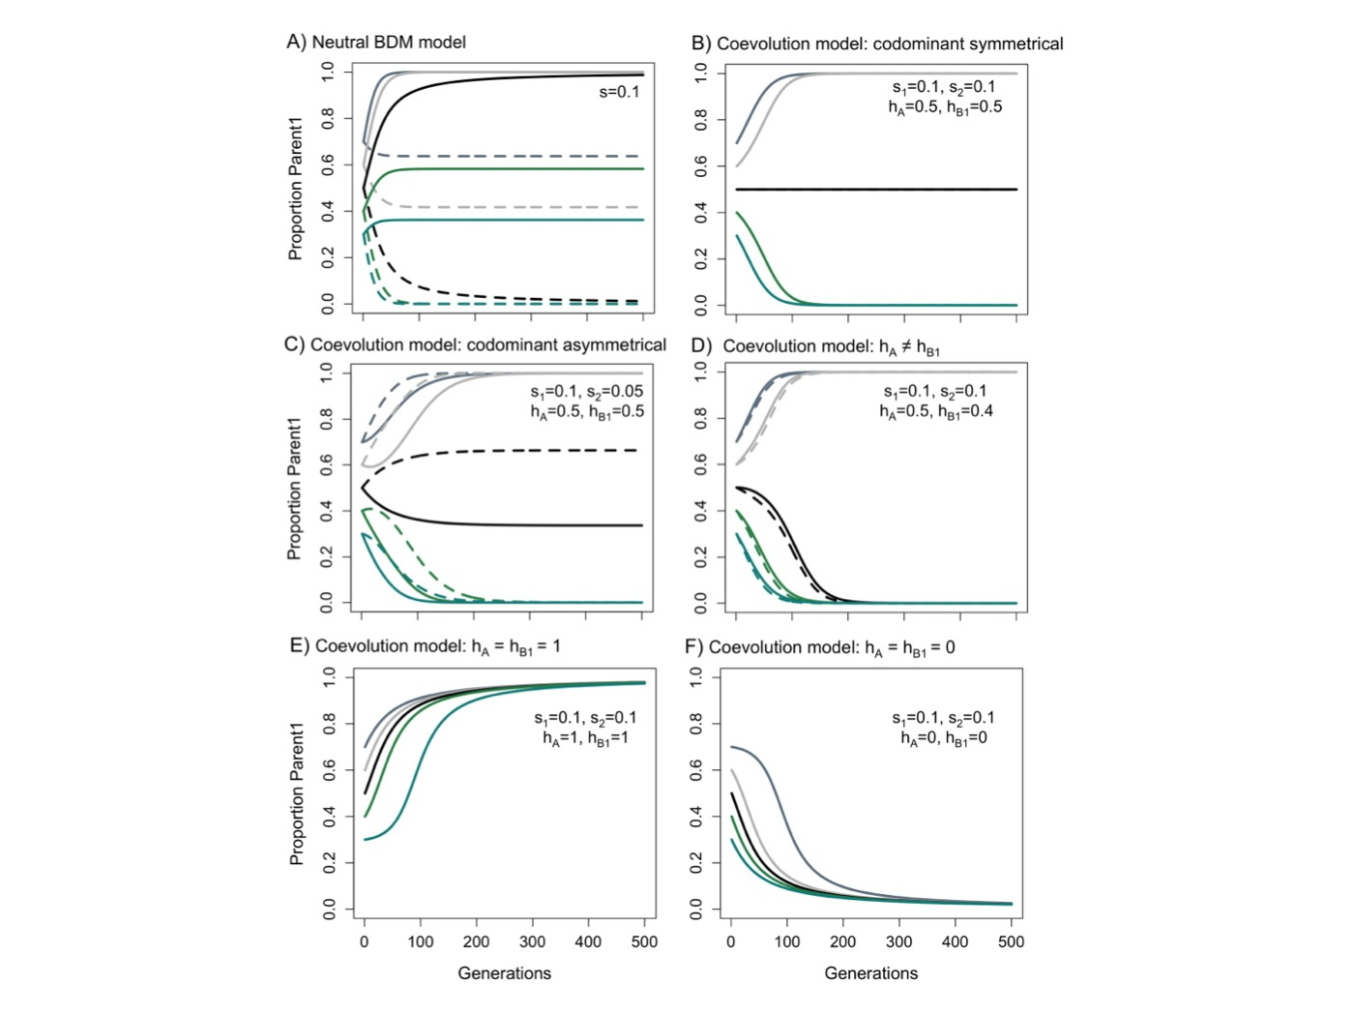

Figure S4. Fixation of two-locus hybrid incompatibilities under deterministic selection (the deterministic two-locus model). The expected parent 1-derived allele trajectories for two unlinked hybrid incompatibilities under the deterministic two-locus model depend on starting admixture proportions (*f*=0.3-0.7 shown here), dominance parameters (*h*), and the intensity of selection (i.e. *s*1, *s*2, see Figures S1 and S2).The solid line tracks ancestry at locus 1 and the dashed line shows ancestry at locus 2. (A) Neutral BDM incompatibility pairs do not fix if *f* ≠ 0.5; at *f =* 0.5 they fix for a hybrid genotype pair that is not incompatible with either parental species (see Text S4). When incompatibilities are codominant (B, C), the two incompatibility loci fix deterministically for the major parent. At certain values of *h* (D, E, F), fixation is less dependent on initial admixture proportions.

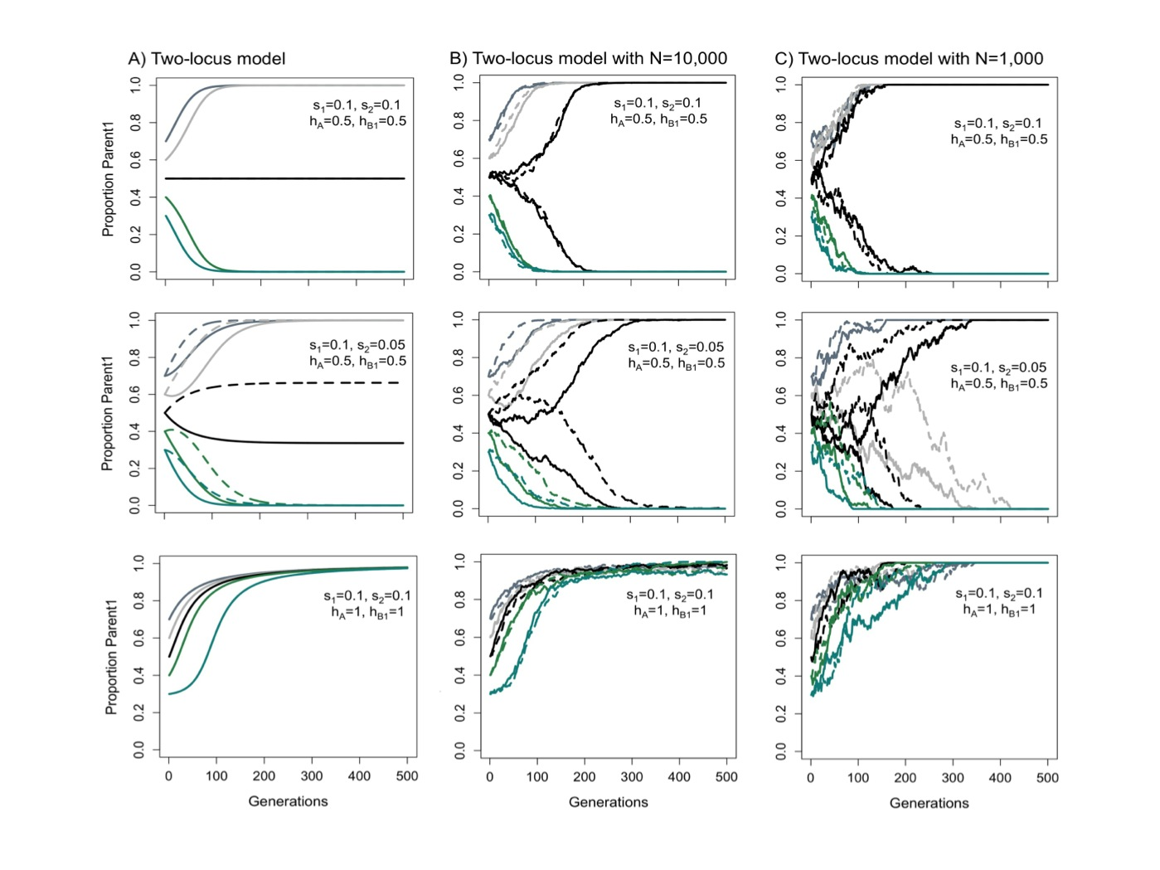

Figure S5. Fixation of two-locus hybrid incompatibilities with genetic drift. The expected patterns of fixation for a coevolving hybrid incompatibility (Figure S2) under the two-locus model depend on starting admixture proportions (*f*=0.3-0.7 shown here), dominance parameters (*h*), and asymmetry in selection (*s*1 ≠ *s*2).The solid line shows ancestry at locus 1 of an incompatibility and the dashed line shows ancestry at locus 2 of an incompatibility. (A) Parent 1 allele trajectories predicted by the two-locus model for a given set of parameters. (B) Results for the same parameters incorporating multinomial sampling of 10,000 individuals at each generation. (C) Results for the same parameters incorporating multinomial sampling of 1,000 individuals at each generation. Patterns of fixation depend less on initial admixture proportions as drift increases. The equilibrium at *f*=0.5 in the selection-only model is unstable in the presence of drift.

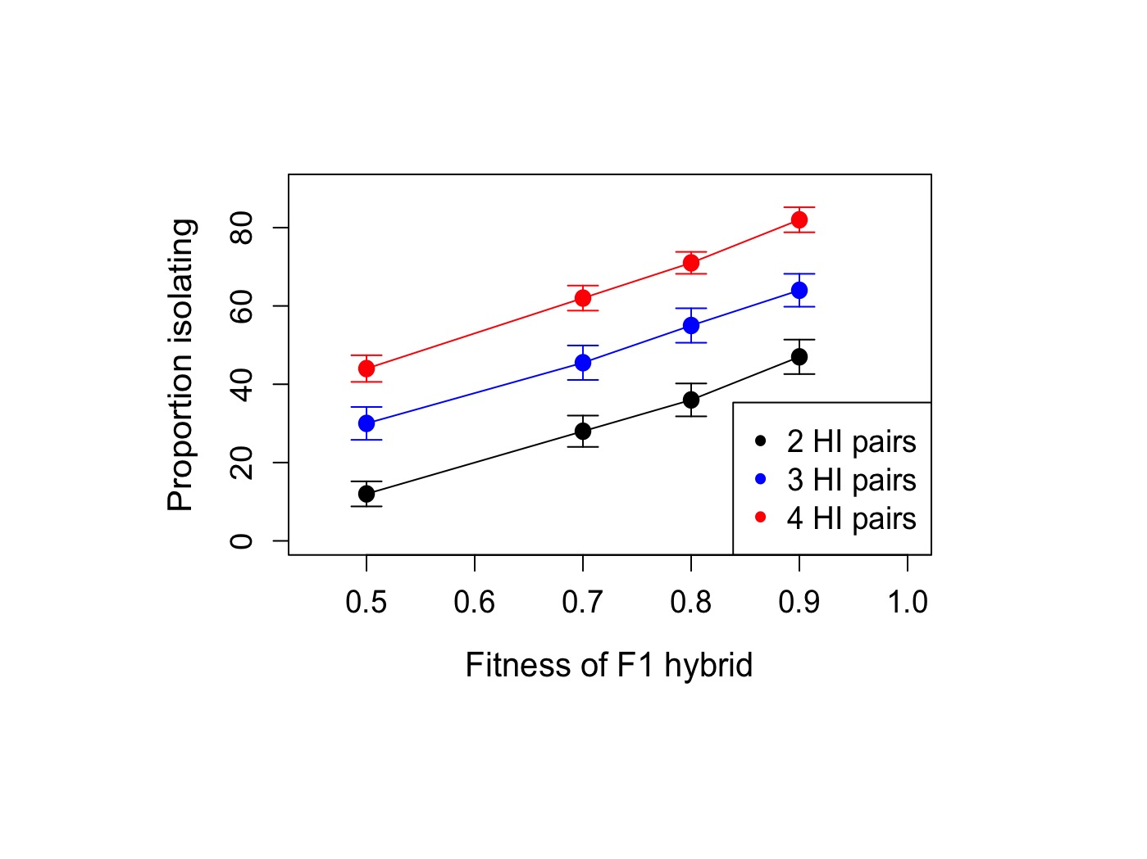

Figure S6. Probability of isolation with increasing selection on hybrids. With increasing selection on F1 hybrids between the parental species, the probability that hybrid populations will develop reproductive isolation from both parents decreases. However, reproductive isolation is more likely to evolve with a greater number of hybrid incompatibilities pairs (HI) when controlling for the total strength of selection against F1 hybrids. Error bars show two standard deviations. Simulation parameters were *h*=0.5, *s*1=*s*2, *f*=0.5, and N=1,000.

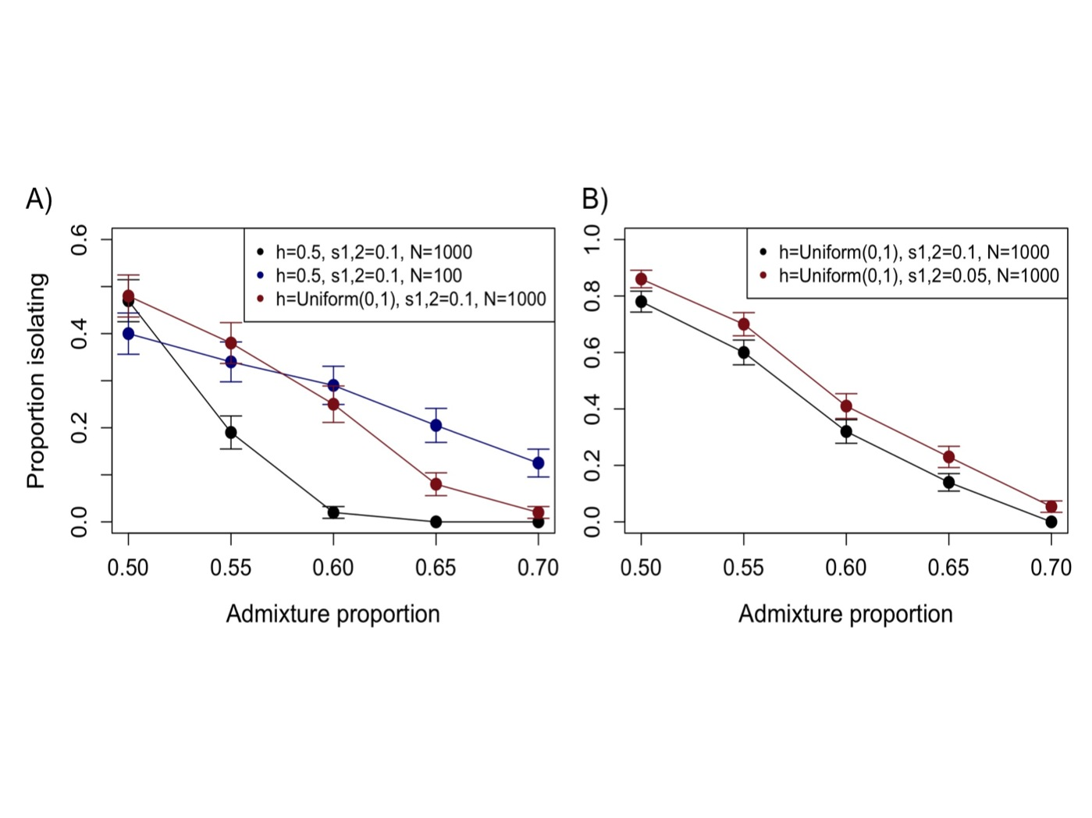

Figure S7. The effect of initial admixture proportion on the probability of isolation. Proportion of hybrid populations developing isolation from both parents as a function of admixture proportions, dominance (*h*) and population size (two incompatibility pairs, *s*1=*s*2) with two (A) and four (B) incompatibility pairs. Isolation occurs most frequently at equal admixture proportions, but can occur in ancestry-skewed populations, especially if the populations are small, there is variation in dominance, or larger numbers of incompatibility pairs. Error bars show two standard deviations.

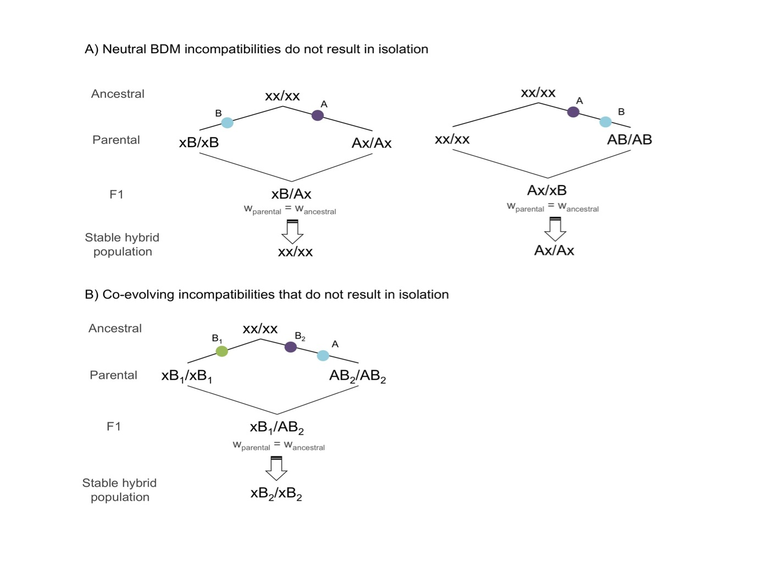

Figure S8. Hybrid incompatibility models that do not frequently result in reproductive isolation between hybrid and parental populations in the absence of drift. (A) When hybrid populations form at equal admixture proportions, the deterministic model predicts that neutral BDM incompatibilities will fix for the ancestral genotype in a two-lineage model (left) and a genotype that is compatible with both species in a one-lineage model (right). (B) In a coevolution scenario, certain mutation orders result in an identical fitness matrix to A and thus do not result in reproductive isolation in hybrid populations. In all cases depicted, mutations in lineage 1 could occur in lineage 2 and vice versa but the expected effects on isolation from parental species do not change.

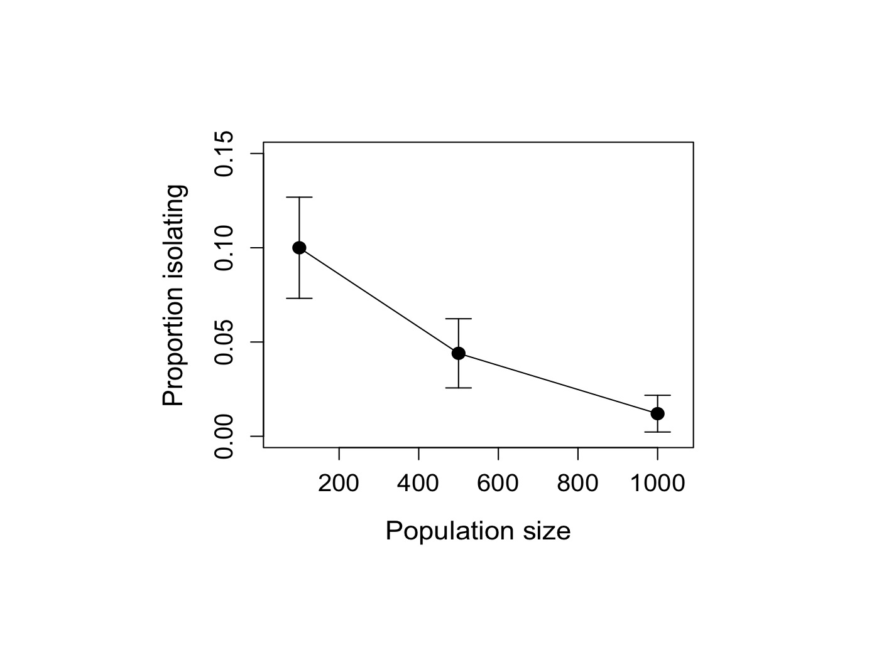

Figure S9. The effect of population size on the probability of isolation due to neutral BDM incompatibilities. As drift increases, the proportion of hybrid populations isolated from parentals by fixation of neutral BDM incompatibilities increases. However, this process does not occur as rapidly as deterministic selection on other types of hybrid incompatibilities. Simulation parameters: two neutral BDMI pairs (Figure S8), *s*=0.1, *f*=0.5, *h*=0.5 for 500 replicate simulations.

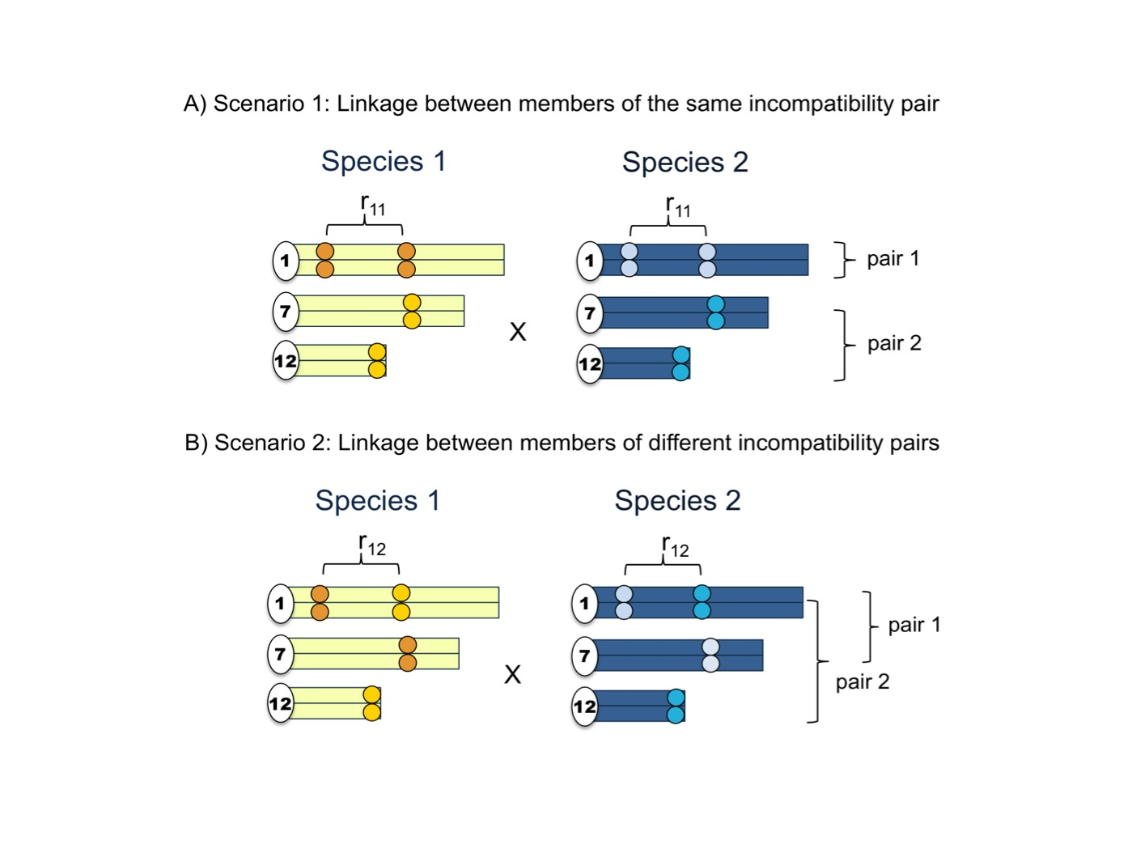

Figure S10. Linkage between incompatibility pairs. Linkage between incompatibility pairs can change the probability of hybrid populations evolving reproductive isolation (Table S6). (A) In scenario 1, linkage between loci in the same incompatibility pair does not influence the frequency of hybrid populations evolving reproductive isolation. (B) In linkage scenario 2, linkage between loci in different incompatibility pairs significantly decreases the frequency at which hybrid populations evolve reproductive isolation. The probability of recombination between two sites is indicated as *r*.

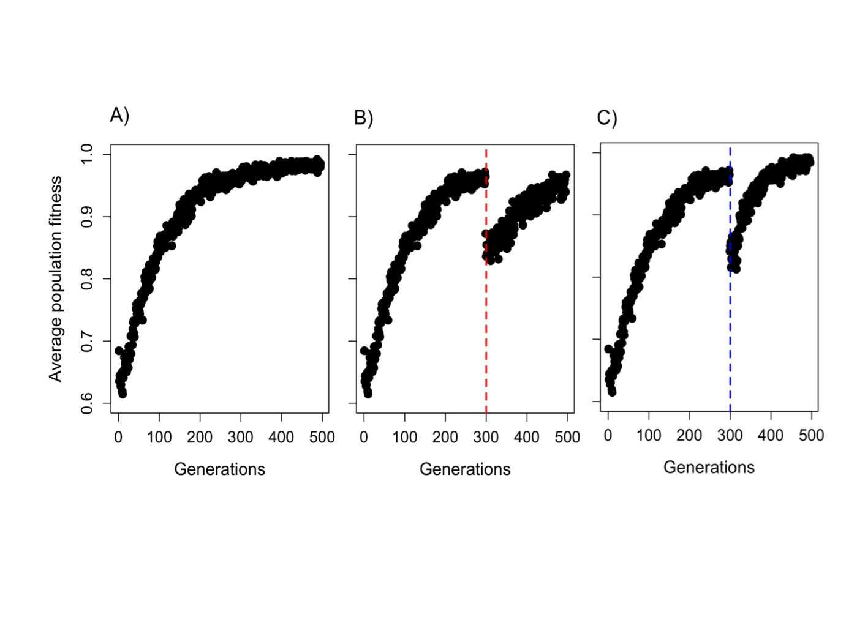

Figure S11. Mating with parents reduces fitness of allopatrically evolving hybrid populations. (A) Change in average hybrid population fitness over time in a simulation of 20 incompatibility pairs with dominance and selection coefficients drawn from an exponential distribution (see Text S5D). (B) The same hybrid population with a one generation burst of migrants from parent 1 (4Nm1=400) at generation 300. (C) The same hybrid population with a one generation burst of migrants from parent 2 (4Nm2=400) at generation 300. Notably, hybrid populations have lower average fitness after gene flow with either parent, but recover rapidly.

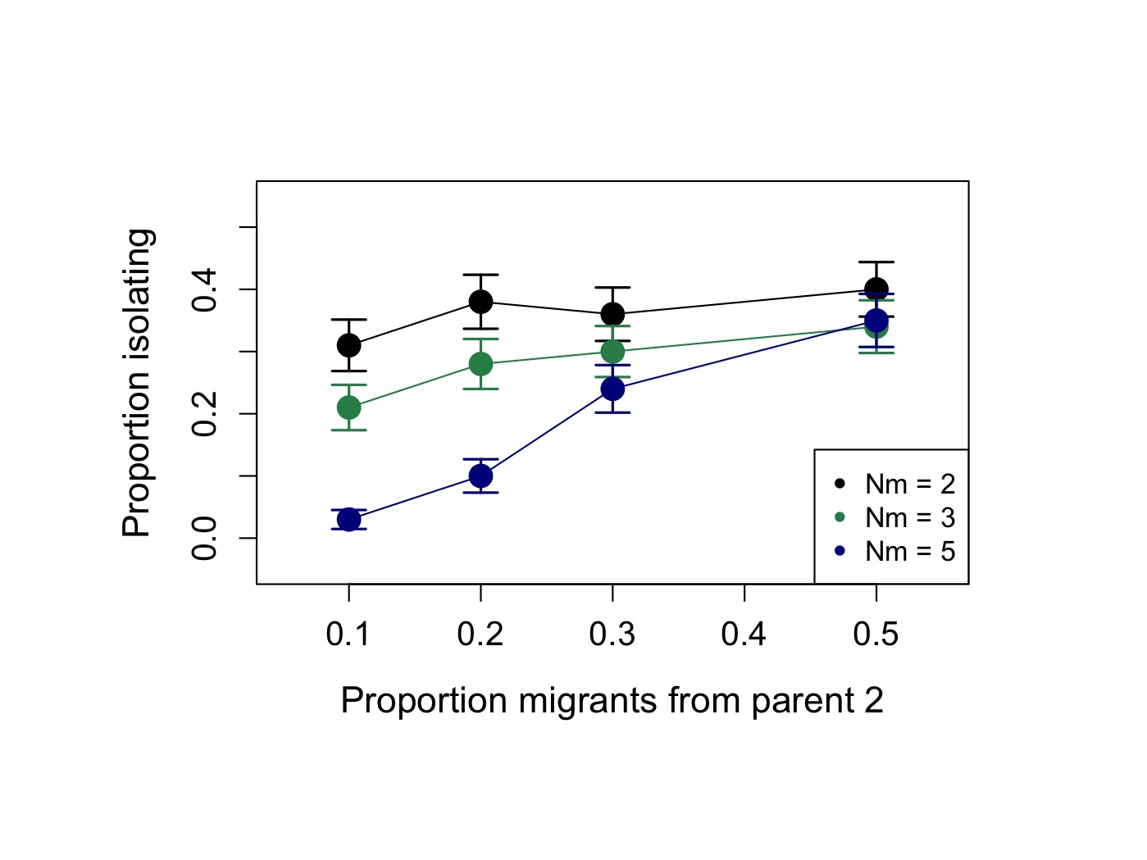

Figure S12. Effect of asymmetry in migration on the probability of isolation from both parents. Proportion of hybrid populations evolving isolation from both parents as a function of asymmetry in migration rates from parental populations. When migration is highly asymmetric hybrid populations are less likely to evolve reproductive isolation from parental species. Simulation conditions: two incompatibility pairs, *h*=0.5, *s1*=*s2*=0.1, *f*=0.5, N=1000 for 500 replicate simulations.

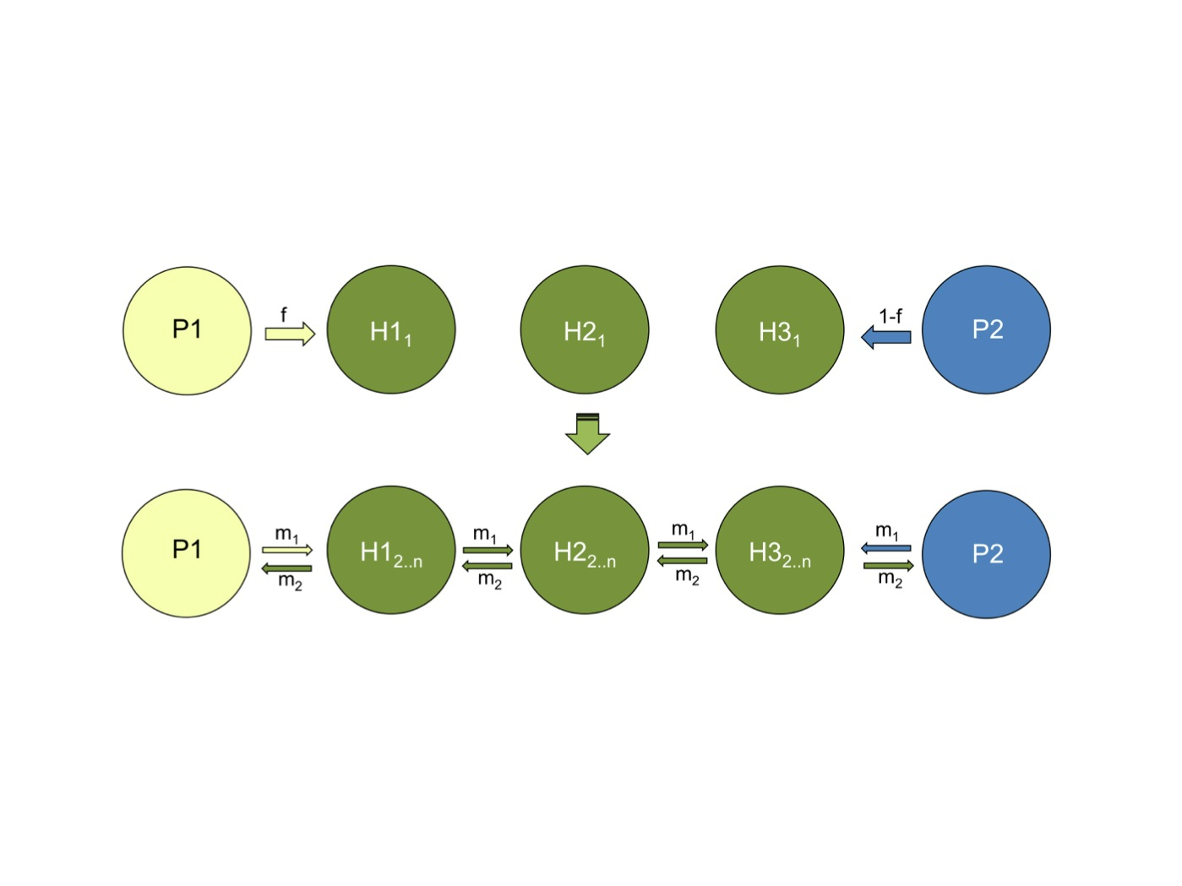

Figure S13. Hybrid zone structure used in simulations. Model of hybrid zone structure used in simulations of complex hybrid zone structures (see Text S6B). This structure of a gradient of hybrid populations with ongoing gene flow from parental and other hybrid populations is similar to many naturally occurring hybrid populations.

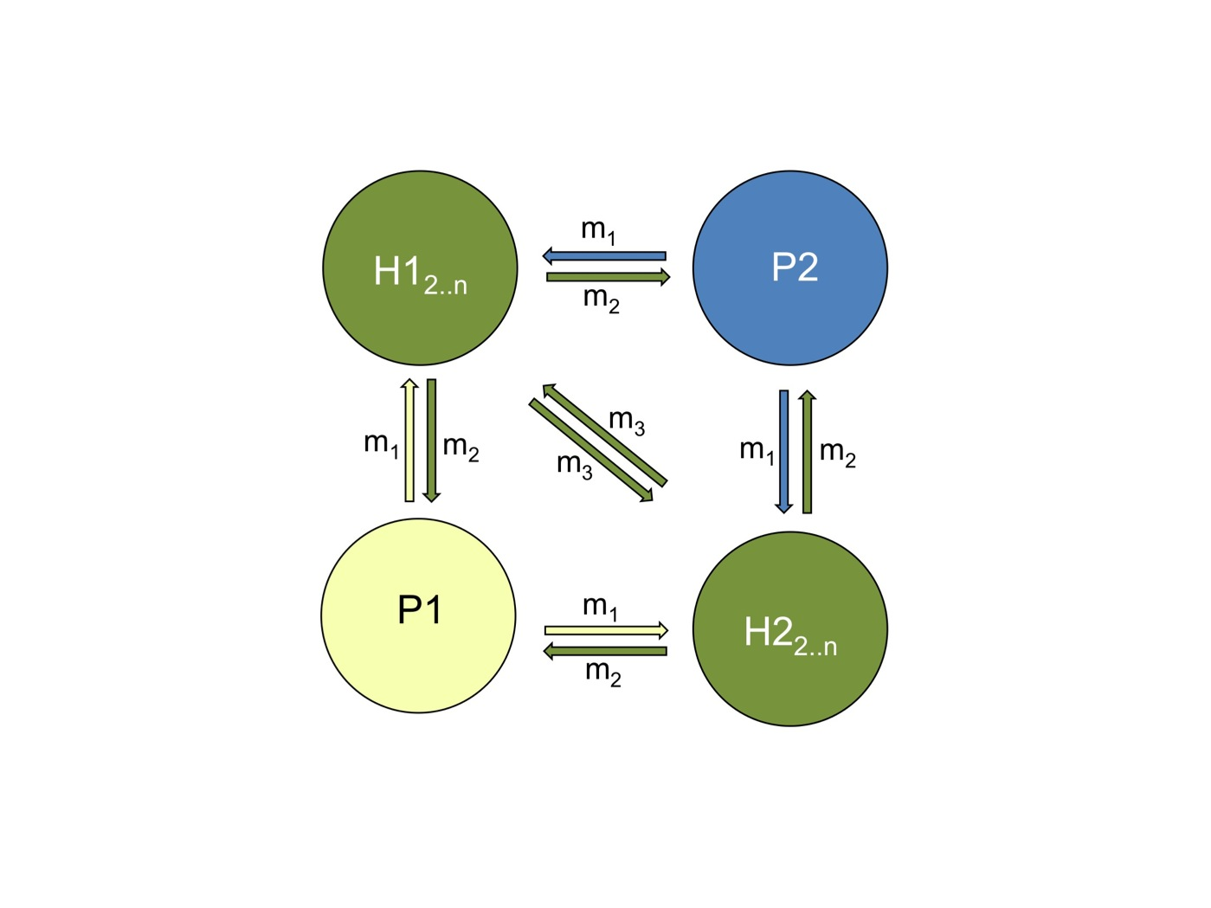

Figure S14. A schematic model of multiple replicate hybrid populations. Hybrid zone structure used in simulations of reciprocal hybrid isolation (Text S6C).

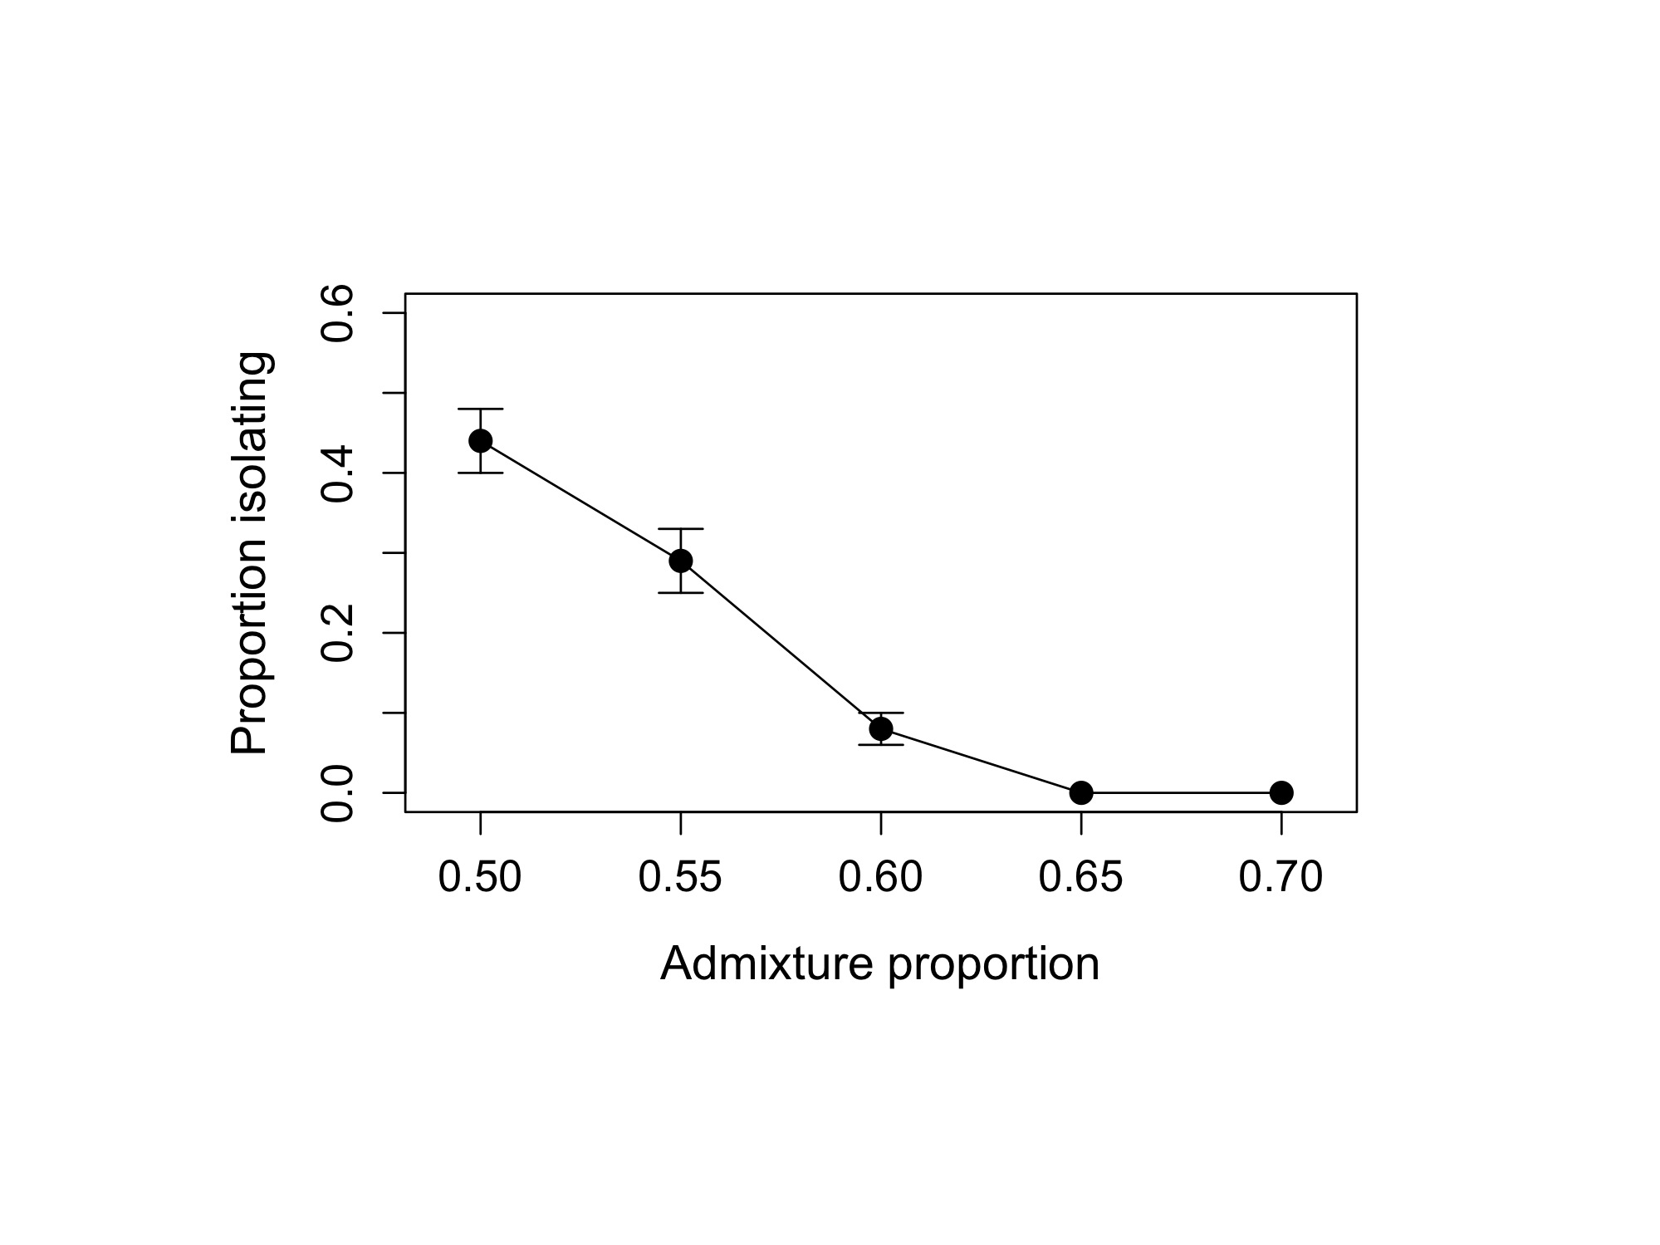

Figure S15. The effect of initial admixture proportion on the probability of isolation under the underdominant inversion model. Proportion of hybrid populations developing isolation from both parents as a function of admixture proportion with two underdominant inversions. Simulation conditions: *s1*=*s2*=0.05, N=1000 for 500 replicate simulations. Error bars show two standard deviations.

Supporting Tables

Table S1. Comparison of rates of fixation based on the two-locus model with genetic drift and the admix’em simulation program at different population sizes.

|  |  |  |  |  |
| --- | --- | --- | --- | --- |
|  | The two-locus model with multinomial sampling | | admix’em | |
| Diploid population size (N) | Percent fixing parent 1 genotype ± SE | Average time to fixation ± SD | Percent fixing parent 1 genotype ± SE | Average time to fixation ± SD |
| 1,000 | 51.2 ± 2 | 178 ± 47 | 50.4 ± 2 | 177 ± 44 |
| 10,000 | 50.2 ± 2 | 233 ± 45 | 49.8 ± 2 | 218 ± 30 |

Note – One hybrid incompatibility pair (Figure S2), *s*1=*s*2=0.1, *f*=0.5, *h*=0.5 for 500 replicate simulations.

Table S2. The effect of increasing selection on hybrids on the probability of and time to isolation.

|  |  |  |
| --- | --- | --- |
| Fitness of F1 hybrid | Percent isolating ± SE | Average time to isolation ± SD |
| 0.9 | 47 ± 2 | 203 ± 41 |
| 0.8 | 36 ± 2 | 120 ± 22 |
| 0.7 | 28 ± 2 | 75 ± 16 |
| 0.5 | 12 ± 2 | 49 ± 9 |

Note – Two hybrid incompatibility pairs (Figure S2), *s*1=*s*2, N=1000, *f*=0.5, *h*=0.5 for 500 replicate simulations.

Table S3. The effect of population size on the probability of and time to isolation.

|  |  |  |
| --- | --- | --- |
| Diploid population size  (N) | Percent isolating  ± SE | Average time to isolation  ± SD |
| 100 | 39 ± 2 | 121 ± 39 |
| 1000 | 47 ± 2 | 203 ± 41 |
| 10000 | 43 ± 2 | 258 ± 38 |

Note – Two hybrid incompatibility pairs (Figure S2), *s*1=*s*2=0.1, *f*=0.5, *h*=0.5 for 500 replicate simulations.

Table S4. Effects of asymmetry in selection on the probability of isolation.

|  |  |  |
| --- | --- | --- |
| Asymmetry of selection | Percent isolating  ± SE | Average time to isolation ± SD |
| *s*A=*s*B | 47 ± 2 | 203 ± 41 |
| *s*A=0.5\**s*B | 45 ± 2 | 296 ± 67 |
| *s*A=0.4\**s*B | 42 ± 2 | 332 ± 88 |
| *s*A=0.3\**s*B | 43 ± 2 | 420 ± 99 |
| *s*A=0.2\**s*B | 36 ± 2 | 543 ± 106 |
| *s*A=0\**s*B | 0.6 ± 0.3 | 1380 ± 360 |

Note – Two hybrid incompatibility pairs (Figure S1), *s*A=0.1, N=1000, *f*=0.5, *h*=0.5 for 500 replicate simulations.

Table S5. The effect of variation in dominance.

|  |  |  |
| --- | --- | --- |
| Dominance | Percent isolating  ± SE | Average time to isolation ± SD |
| *h* = 0.5 | 47 ± 2 | 203 ± 41 |
| *h* = Uniform(0,1) | 48 ± 2 | 244 ± 60 |
| *h* ∈ (0, 0.5, 1) | 42 ± 2 | 291 ± 69 |

Note – Two hybrid incompatibility pairs (Figure S2), *s*1=*s*2=0.1, N=1000, *f*=0.5, for 500 replicate simulations.

Table S6. Effect of linkage between hybrid incompatibilities on

the probability of and time to isolation.

|  |  |  |  |
| --- | --- | --- | --- |
| Linkage scenario  (Figure S10) | Genetic  distance | Percent isolating ± SE | Average time to isolation ± SD |
| Scenario 1 | 50 cM | 46 ± 2 | 195 ± 44 |
| Scenario 1 | 10 cM | 43 ± 2 | 213 ± 46 |
| Scenario 1 | 1 cM | 45 ± 2 | 198 ± 49 |
| Scenario 2 | 50 cM | 42 ± 2 | 206 ± 48 |
| Scenario 2 | 10 cM | 32 ± 2 | 212 ± 47 |
| Scenario 2 | 1 cM | 8 ± 1 | 207 ± 49 |

Note – A visual representation of the linkage scenarios can be found in Figure S10. Simulation parameters: Two hybrid incompatibility pairs (Figure S2), *s*1=*s*2=0.1. N=1000, *f*=0.5, *h*=0.5 for 500 replicate simulations.

Table S7. The effect of on-going and bursts of parental immigration on the probability of and time to isolation.

|  |  |  |  |
| --- | --- | --- | --- |
| Migration scenario | Hybrid zone structure | Percent isolating ± SE | Average time to isolation ± SD |
| Continuous (4*Nm*1,2=8) | Figure S3 | 38 ± 2 | 255 ± 65 |
| Continuous (4*Nm*1,2=12) | Figure S3 | 37 ± 2 | 393 ± 97 |
| Continuous (4*Nm*1,2*=*20) | Figure S3 | 4 ± 1 | 589 ± 81 |
| Burst – generation 25 (4*Nm*1,2=400) | Figure S3 | 38 ± 2 | 205 ± 35 |
| Burst – generation 50 (4*Nm*1,2=400) | Figure S3 | 37 ± 2 | 213 ± 53 |
| Burst – generation 75 (4*Nm*1,2=400) | Figure S3 | 38 ± 2 | 195 ± 44 |
| Continuous (4*Nm*1,2=8) | Figure S13 | 43 ± 2 | 262 ± 82 |
| Continuous (4*Nm*1,2=12) | Figure S13 | 37 ± 2 | 281 ± 91 |
| Continuous (4*Nm*1,2*=*20) | Figure S13 | 3 ± 1 | 533 ± 132 |

Note – Two hybrid incompatibility pairs (Figure S2), *s*1=*s*2=0.1, N=1000, *f*=0.5, *h*=0.5

for 500 replicate simulations. For the “Burst” models, all migration occurs in one generation.

Table S8. Independently formed hybrid populations can evolve reproductive

isolation from each other.

|  |  |  |
| --- | --- | --- |
| Number of incompatibility pairs | Migration rate | Percent reciprocally isolated ± SE |
| 2 | 4*Nm*=0 | 50 ± 5 |
| 2 | 4*Nm*=8 | 24 ± 4 |
| 2 | 4*Nm*=12 | 10 ± 3 |
| 3 | 4*Nm*=0 | 81 ± 4 |
| 3 | 4*Nm*=8 | 72 ± 4 |
| 3 | 4*Nm*=12 | 46 ± 5 |

Note – Two or three hybrid incompatibility pairs (Figure S2), *s*1=*s*2=0.1, N=1000, *f*=0.5. Simulations were conducted until 100 replicates were generated in which both hybrid populations were isolated from parentals.

Table S9. Abundance of hybrids in several previously studied natural hybrid populations.

|  |  |  |
| --- | --- | --- |
| Parent species | Hybrid abundance | References |
| *Alosa pseudoharengas – A. aestivalis* | 100% | [1] |
| *Cyprinella lutrensis – C. venusta* | 84% | [2] |
| *Geum rivale – G. urbanum* | 47% | [3] |
| *Odocoileus hemionus* (subspecies mule and black-tail deer) | 44% | [4] |
| *Oncorhynchus mykiss – O. clarki clarki* | 23% | [5] |
| *Oncorhynchus mykiss – O. clarki lewisi* | 3-57% | [6] |
| *Picea sitchensis – P. glauca* | 88% | [7] |
| *Senecio aethnensis – S. chrysanthemifolius* | 100% | [8] |
| *Quercus grisea – Q. gambelli* | 89% | [9] |
| *Xiphophorus birchmanni* – *X. malinche* | 55-100% | [10] |

Table S9 References

1. Hasselman DJ, Argo EE, McBride MC, Bentzen P, Schultz TF, et al. (2014) Human disturbance causes the formation of a hybrid swarm between two naturally sympatric fish species. Mol Ecol 23: 1137–1152.

2. Ward JL, Blum MJ, Walters DM, Porter BA, Burkhead N, et al. (2012) Discordant introgression in a rapidly expanding hybrid swarm. Evolutionary Applications 5: 380-392.

3. Ruhsam M, Hollingsworth PM, Ennos RA (2011) Early evolution in a hybrid swarm between outcrossing and selfing lineages in Geum. Heredity 107: 246-255.

4. Latch EK, Kierepka EM, Heffelfinger JR, Rhodes OE (2011) Hybrid swarm between divergent lineages of mule deer (Odocoileus hemionus). Molecular Ecology 20: 5265-5279.

5. Moore ME, Goetz FA, Van Doornik DM, Tezak EP, Quinn TP, et al. (2010) Early Marine Migration Patterns of Wild Coastal Cutthroat Trout (Oncorhynchus clarki clarki), Steelhead Trout (Oncorhynchus mykiss), and Their Hybrids. Plos One 5.

6. Rubidge EM, Taylor EB (2004) Hybrid zone structure and the potential role of selection in hybridizing populations of native westslope cutthroat trout (Oncorhynchus clarki lewisi) and introduced rainbow trout (O-mykiss). Molecular Ecology 13: 3735-3749.

7. Hamilton JA, Lexer C, Aitken SN (2013) Genomic and phenotypic architecture of a spruce hybrid zone (Picea sitchensis P. glauca). Molecular Ecology 22: 827-841.

8. James JK, Abbott RJ (2005) Recent, allopatric, homoploid hybrid speciation: The origin of Senecio squalidus (Asteraceae) in the British Isles from a hybrid zone on Mount Etna, Sicily. Evolution 59: 2533-2547.

9. Howard DJ, Preszler RW, Williams J, Fenchel S, Boecklen WJ (1997) How discrete are oak species? Insights from a hybrid zone between Quercus grisea and Quercus gambelii. Evolution 51: 747-755.

10. Schumer M, Cui R, Powell D, Dresner R, Rosenthal G, et al. (2014) High-resolution Mapping Reveals Hundreds of Genetic Incompatibilities in Hybridizing Fish Species. eLife 3.

Table S10. Parental preferences for conspecifics reduce the frequency of hybrid reproductive isolation.

|  |  |  |
| --- | --- | --- |
| Parental preference | Percent isolating ± SE | Average time to isolation ± SD |
| None | 47± 2% | 203 ± 41 |
| 25 attempts | 40 ± 2% | 264 ± 67 |
| 50 attempts | 29 ± 2% | 250 ± 68 |
| 75 attempts | 24 ± 2% | 269 ± 55 |

Note – Two hybrid incompatibility pairs (Figure S2), 4*Nm1*=4*Nm2*=8, *s*1=*s*2=0.1, N=1000, *f*=0.5, *h*=0.5 for 500 replicate simulations.

Table S11. The effect of increasing selection on hybrids on the probability of and time to isolation under the underdominant inversion model.

|  |  |  |
| --- | --- | --- |
| Fitness of F1 hybrid | Percent isolating ± SE | Average time to isolation ± SD |
| 0.9 | 43 ± 2 | 212 ± 59 |
| 0.8 | 37 ± 2 | 118 ± 25 |
| 0.7 | 33 ± 2 | 76 ± 13 |
| 0.5 | 17 ± 2 | 48 ± 10 |

Note – Two underdominant inversions, *s*1=*s*2, N=1000, *f*=0.5, for 500 replicate simulations.

CHAPTER THREE

High-resolution Mapping Reveals Hundreds of Genetic Incompatibilities in Hybridizing Fish Species

Abstract

Hybridization is increasingly being recognized as a common process in both animal and plant species. Negative epistatic interactions between genes from different parental genomes decrease the fitness of hybrids and can limit gene flow between species. However, little is known about the number and genome-wide distribution of genetic incompatibilities separating species. To detect interacting genes, I perform a high-resolution genome scan for linkage disequilibrium between unlinked genomic regions in naturally occurring hybrid populations of swordtail fish. I estimate that hundreds of pairs of genomic regions contribute to reproductive isolation between these species, despite them being recently diverged. Many of these incompatibilities are likely the result of natural or sexual selection on hybrids, since intrinsic isolation is known to be weak. Patterns of genomic divergence at these regions imply that genetic incompatibilities play a significant role in limiting gene flow even in young species.

Introduction

Hybridization between closely related species is remarkably common (Mallet 2005). Many hybridizing populations and species remain genetically and ecologically distinct despite bouts of past admixture (e.g. Scascitelli et al. 2010; Vonholdt et al. 2010). This has led to a surge of interest in identifying which and how many loci are important in maintaining species barriers. Recent work has focused on identifying so-called “genomic islands” of high divergence between closely related species (e.g. Turner et al. 2005; Nadeau et al. 2012). This approach assumes that the most diverged regions between species are most likely to be under divergent selection between species or important in reproductive isolation. However, divergence-based measures need to be interpreted with caution because they are susceptible to artifacts as a result of linked selection events (including background selection and hitchhiking) such that outlier regions might reflect low within-population polymorphism rather than unusually high divergence (discussed in Charlesworth 1998; Noor and Bennett 2009; Renaut et al. 2013), and there are many possible causes of elevated divergence that are not linked to isolation between species.

Investigating genome-wide patterns in naturally occurring or laboratory generated hybrid populations is another approach to characterize the genetic architecture of reproductive isolation (Payseur 2010). Hybridization leads to recombination between parental genomes that can uncover genetic incompatibilities between interacting genes. When genomes diverge in allopatry, substitutions that accumulate along a lineage can lead to reduced fitness when hybridization decouples them from the genomic background on which they arose. The best understood of these epistatic interactions, called “Bateson-Dobzhansky-Muller” (BDM) incompatibilities (Coyne and Orr 2004), can occur as a result of neutral substitution or adaptive evolution, and are thought to be common based on theoretical (Orr 1995; Turelli et al. 2001) and empirical studies (Presgraves 2003; Presgraves et al. 2003; Payseur and Hoekstra 2005; Brideau et al. 2006; Sweigart et al. 2006). One defining feature of BDM incompatibilities is that they are predicted to have asymmetric fitness effects in different parental backgrounds, such that only a subset of hybrid genotypes are under selection. Though the BDMI model is an important mechanism of selection against hybrids, other evolutionary mechanisms can contribute to hybrid incompatibility. For example, co-evolution between genes can result in selection on all hybrid genotype combinations due to the accumulation of multiple substitutions (Seehausen et al. 2014). Similarly, natural or sexual selection against hybrid phenotypes can be considered a form of hybrid incompatibility; in this case the genotypes under selection will depend on their phenotypic effects.

How common are hybrid incompatibilities and what is their genomic distribution? Most studies to date have addressed this question by mapping hybrid incompatibilities that contribute to inviability or sterility (Orr 1989; Orr and Coyne 1989; Barbash et al. 2003; Presgraves 2003; Presgraves et al. 2003), in part because these incompatibilities affect hybrids even in a lab environment. Initial genome-wide studies in *Drosophila* and other organisms suggest that the number of incompatibilities contributing to hybrid viability and sterility can range from a handful to hundreds accumulating between deeply diverged species (Harushima et al. 2001; Presgraves 2003; Moyle and Graham 2006; Masly and Presgraves 2007; Ross et al. 2011); recent work has also suggested that substantial numbers of incompatibilities segregate within species (Cutter 2012; Corbett-Detig et al. 2013). However, because research has focused primarily on postzygotic isolation, little is known about the total number of loci contributing to reproductive isolation between species. For example, research shows that selection against hybrid genotypes can be strong even in the absence of postzygotic isolation (Fang et al. 2012). Thus, the focus on hybrid sterility and inviability is likely to substantially underestimate the true number of genetic incompatibilities distinguishing species.

If negative epistatic interactions are important in maintaining reproductive isolation, specific patterns of genetic variation are predicted in hybrid genomes. In particular, selection against hybrid individuals that harbor unfavorable allele combinations in their genomes will lead to under-representation of these allelic combinations in a hybrid population. Thus, selection can generate non-random associations, or linkage disequilibrium (LD), among unlinked loci in hybrid genomes (Karlin 1975; Hastings 1981). Patterns of LD in hybrid populations can therefore be used to identify genomic regions that are important in establishing and maintaining reproductive isolation between species.

Only a handful of studies have investigated genome-wide patterns of LD in hybrid populations. Gardener et al. (2000) evaluated patterns of LD at 85 widely dispersed markers (~0.03 markers/Mb) in sunflowers and found significant associations among markers known to be related to infertility in hybrids. Similarly, Payseur and Hoekstra (2005) evaluated patterns of LD among 332 unlinked SNPs (~0.12 markers/Mb) in inbred lines of hybrid mice and identified a set of candidate loci with strong conspecific associations. More recently, Hohenlohe et al. (2012) investigated genome-wide patterns of LD at ~2,000 sites (~4.5 markers/Mb) in oceanic and freshwater sticklebacks and found two unlinked regions in strong LD that are highly differentiated between populations. These studies suggest hybridization can expose the genome to strong selection that leaves detectable signatures of LD in hybrids.

Here, I evaluate genome-wide patterns of LD in replicate hybrid populations of two species of swordtail fish, *Xiphophorus birchmanni* and *X. malinche*. These species are recently diverged (0.5% genomic divergence per site; 0.4% genomic divergence following polymorphism masking) and form multiple independent hybrid zones in river systems in the Sierra Madre Oriental of Mexico (Culumber et al. 2011). *X. malinche* is found at high elevations while *X. birchmanni* is common at low elevations; hybrids occur where the ranges of these two species overlap. The strength of selection on hybrids between these two species is unknown, but several lines of evidence have suggested that selection may be weak. Hybrids are abundant in hybrid zones, often greatly outnumbering parental individuals. Hybrids are tolerant of the thermal environments at the elevations in which they are found (Culumber et al. 2012). Though there is some evidence of BDMIs between the species that cause lethal melanomas, these melanomas typically affect hybrids post-reproduction (Schartl 2008) and may constitute a weak or even favorable selective force (Fernandez and Morris 2008; Fernandez and Bowser 2010). Finally, recent behavioral studies show that once hybrids are formed, hybrid males actually have an advantage due to sexual selection compared to parental individuals (Figure 1; and see Fisher et al. 2009; Culumber et al. in press). However, the genomes of adult hybrids sampled from hybrid populations have already been subject to multiple generations of selection (at least 30; Rosenthal et al. 2003), making it difficult to evaluate the extent of selection on hybrids without genetic information. By surveying the genomes of hybrids from natural populations I am able to identify interacting genomic regions under selection in hybrids, giving a powerful picture of the number of regions involved in reproductive isolation between this recently diverged species pair.

To evaluate genome-wide patterns of LD in hybrid populations, I further develop the multiplexed shotgun genotyping (MSG) protocol of Andolfatto et al. (2011). Originally developed for QTL mapping in controlled genetic crosses, I describe modifications that make the technique applicable to population genetic samples from hybrid populations. With this approach, I assign ancestry to nearly 500,000 ancestry informative markers throughout the genome, allowing me to evaluate genome wide patterns of LD at unprecedented resolution (~820 markers/Mb). The joint analysis of two independent hybrid zones allows me to distinguish the effects of selection against genetic incompatibilities from confounding effects due to population history (Gardner et al. 2000). I further evaluate loci that are in significant LD to investigate the mechanisms of selection on these pairs. My results support the conclusion that a large number of loci contribute to reproductive isolation between these two species, that these loci have higher divergence than the genomic background, and that selection against genetic incompatibilities maintains associations between loci derived from the same parental genome.

Results

*Hybrid zones have distinct demographic histories*

I used a modified version of the MSG analysis pipeline, optimized for genotyping in natural hybrids (Materials and Methods, Figure 1 – figure supplement 1) to genotype individual fish collected from two independently formed hybrid zones, Calnali and Tlatemaco (Figure 1, Culumber et al. 2011). I genotyped 143 hybrid individuals from Calnali, 170 hybrids from Tlatemaco, and 60 parents of each species, determining ancestry at 469,400 markers distinguishing *X. birchmanni* and *X. malinche* at a median density of 1 marker per 234 bp(Materials and Methods). On average, hybrids from the Calnali hybrid zone derived only 20% of their genome from *X. malinche*, while hybrids from the Tlatemaco hybrid zone had 72% of their genomes originating from *X. malinche*. Most hybrid individuals were close to the average hybrid index in each group (Tlatemaco: 95% of individuals 66-80% *malinche* ancestry; Calnali: 95% of individuals 14-35% *malinche* ancestry). I determined the time since hybridization based on the decay in linkage disequilibrium (see Materials and Methods), assuming an average genome-wide recombination rate of 1 cM/378 kb (Walter et al. 2004). Estimates of hybrid zone age were similar for the two hybrid zones (Tlatemaco 56 generations, CI: 55-57, Calnali 35 generations CI: 34.5-35.6). Interestingly, these estimates are remarkably consistent with available historical estimates, which suggest that hybridization began within the last ~40 generations due to disruption of chemical cues by pollution (Fisher et al. 2006).

*Significant LD between unlinked genomic regions*

Ancestry calls at 469,400 markers genome-wide were thinned to 12,229 markers that are sufficient to describe all changes in ancestry (+/- 10%) across individuals in both populations (see Materials and Methods). Using this thinned dataset, I analyzed patterns of LD among all pairs of sites. The physical distance over which R2 decayed to <0.5 was approximately 300 kb in both populations (Figure 2 – figure supplement 1). Average genome-wide R2 between physically unlinked loci was 0.003 in Tlatemaco and 0.006 in Calnali (Figure 2A), and did not significantly differ from null expectations (1/2n, where n is the sample size). A p-value for the R2 value for each pair of effectively unlinked sites was estimated using a Bayesian Ordered Logistic Regression t-test (Figure 2B, Materials and Methods).

The expected false discovery rates (FDRs) associated with given p-value thresholds applied to both populations were determined by simulation (Materials and Methods, Figure 3, Figure 3 – figure supplement 1). Using data from two hybrid populations to examine LD circumvents two problems: 1) within a single population cases of LD between unlinked sites are unlikely to be strong enough to survive false discovery corrections and 2) even interactions that are highly significant could be caused by population demographic history. The joint distribution of p-values in the two populations implies several hundreds of unlinked locus pairs are in significant LD in both populations (Figure 3 – figure supplement 1); 327 pairs of regions were significant at FDR=5% and 150 pairs were significant at a more stringent FDR=2% (Figure 3). The genomic distribution of loci in significant LD at FDR=5% is shown in Figure 4. For simplicity I focus on statistics for the less stringent dataset (Supplementary file 1A), but nearly identical results were found for the more stringent dataset (Tables 1 & 2).

Average R2 for unlinked regions in LD is 0.08 in Tlatemaco and 0.12 in Calnali, both significantly higher than the genomic background (p<0.001, by bootstrapping). LD regions were non-randomly distributed in the genome (χ2=87, df=23, p<3e-9). Contrary to findings of a large-X effect in other taxa (see Discussion), I do not find a significant excess of LD pairs involving the X chromosome (p=0.11, Binomial test). Focusing on the overlap of significant regions in both populations allowed me to narrow candidate regions (Figure 4 – figure supplement 3). Regions in significant LD in both populations have a median size of 45 kb (Figure 4 – figure supplement 1; Figure 4 – figure supplement 2); 67% of regions contain 10 genes or fewer, and 13 pairs of regions are at single gene resolution (Supplementary File 1B). Approximately 10% of the genomic regions identified are very large and contain hundreds of genes (>5 Mb, Supplementary File 1A), potentially as a result of reduced recombination or selection. Unlinked regions in significant LD were more strongly linked to neighboring loci (Figure 4 – figure supplement 4), ruling out the possibility that mis-assemblies underlie the patterns I observe.

*Evidence for hybrid incompatibilities*

Models of selection against hybrid genotypes (Figure 5, Figure 5 – figure supplement 1) predict that certain genotype combinations will be less common (Karlin 1975). In particular, selection against hybrid incompatibilities is expected to generate positive R, or conspecific associations between loci. Among loci in significant LD, I found an excess of conspecific associations in both hybrid populations (94% of pairs in Calnali and 67% of pairs in Tlatemaco, p<0.001 for both populations relative to the genomic background by bootstrapping).

I focus all subsequent analyses on the subset of significant LD pairs (FDR=0.05) with conspecific associations in both populations (207 locus pairs) because these sites will be enriched for hybrid incompatibilities, but similar results are observed for the whole dataset (Supplementary File 1C). To estimate parameters under a classic BDM incompatibility model (Figure 5- figure supplement 1), I use an approximate Bayesian approach to simulate selection on two-locus interactions (see Materials and Methods). Though it is likely that other types of hybrid incompatibilities were identified in my analysis, estimates are similar using other models (see Materials and Methods; Figure 5-figure supplement 1C). These simulations demonstrate that the results are well described by a model of selection against hybrid incompatibilities (Figure 5, Figure 5 – figure supplement 1) and that sites are on average under weak to moderate selection (Figure 5, maximum a posteriori estimates for Tlatemaco s^=0.027, and Calnali s^=0.074).

*Elevated divergence at loci linked to incompatibilities*

Strikingly, the median divergence between *X. birchmanni* and *X. malinche* at loci in significant conspecific LD (FDR=0.05) was much higher than the genomic background (p<0.001 by bootstrapping, Figure 6A). Elevated divergence could be caused by differences in selection on individual loci, differences in mutation rate, or reduced susceptibility of these genomic regions to homogenization by ongoing gene flow. To distinguish among these causes, I examined rates of synonymous substitution (dS). Elevated divergence compared to the genomic background is also observed at synonymous sites (p<0.01 by bootstrapping, Table 2). I also examined the same regions in two swordtail species in an independent *Xiphophorus* lineage, *X. hellerii* and *X. clemenciae* and found that the level of genomic divergence in this species pair was not significantly different from the genomic background (Figure 6B). Together, these results imply that variation in selective constraint or mutation rate do not explain elevated divergence between *X. birchmanni* and *X. malinche* at loci in conspecific LD.

*Gene Ontology Analysis*

I performed gene ontology (GO) analysis on unlinked regions in significant conspecific LD and, surprisingly, found no significantly enriched GO categories (see Materials and Methods). This result holds when restricting the analysis to regions resolved to only a few genes (≤ 10 genes, 242 regions). This suggests that regions in significant LD contain genes with a broad range of functional roles.

Discussion

In this study I assign ancestry to nearly 500,000 markers genome-wide in samples from two hybrid fish populations, providing a portrait of the genetic architecture of hybrid incompatibilities between two closely related species at unprecedented resolution. I discover significant LD between hundreds of pairs of unlinked genomic regions and show that a model of selection against hybrid incompatibilities describes the observed conspecific LD patterns. This implies that many negative epistatic interactions segregate in these hybrid fish populations despite the fact that intrinsic post-zygotic isolation is thought to be weak (Rosenthal et al. 2003).

*How many regions are involved in hybrid incompatibility?*

My analysis focuses on a high confidence set of unlinked loci in significant LD. Despite these findings, the true number of loci involved in incompatibilities may involve hundreds more interactions for several reasons. First, I conservatively exclude interactions within chromosomes due to the lack of detailed genetic map information. Second, I only have only moderate power to detect incompatibilities (for example, ~30% using parameter estimates for Calnali). Third, relaxing the p-value threshold suggests the true number of pairs in significant LD could be much larger (Figure 3 – figure supplement 1). Finally, my experimental design incorporates two populations with opposite trends in genome-wide ancestry and independent histories of hybridization. This conservative approach allows us to exclude effects of population history, but false negatives in the joint analysis may result from effects that are population-specific (for example, different effects of extrinsic selection in the two populations). Investigating the role of such a large number of hybrid incompatibilities in determining the structure of hybrid genomes is an exciting area for future empirical and theoretical research.

*How strong is selection on hybrid incompatibilities?*

Using an approximate Bayesian approach, I estimate that the average selection coefficient on negative epistatic interactions is in the vicinity of s=0.03 (Tlatemaco) to s=0.07 (Calnali); scaling these by estimates of the effective population size (2Ns ~10 and ~45, respectively) suggests that selection is strong enough to be deterministic but of moderate strength relative to drift. Given the large number of putative incompatibilities, even weak selection would introduce substantial genetic load in hybrids. Depending on dominance effects, this could explain why hybrid populations are skewed in genome-wide ancestry. However, I may be overestimating the potential for genetic load if epistatic interactions are complex. Though this study focuses on pairwise comparisons because statistically evaluating high-order interactions in a dataset of this size is intractable, more complex interactions are predicted to be likely (Orr 1995). The fact that many locus pairs (~40% of regions localized to 1 Mb or less) identified in this study interact with multiple partners provides indirect support for this prediction.

*Insights from a genome-wide approach in natural hybrids*

Most work on hybrid incompatibilities has focused on characterizing specific incompatibilities at candidate genes, such as those associated with mapped QTL distinguishing species (Ting et al. 1998; Presgraves et al. 2003; Lee et al. 2008; Tang and Presgraves 2009; Moyle and Nakazato 2010). The idea that negative epistatic interactions may be pervasive in closely related species or populations has come from multiple studies of potential candidate genes (e.g. *Arabidopsis thaliana:* Bomblies et al. 2007; Smith et al. 2011, *Xiphophorus:* Nairn et al. 1996*, Drosophila:* Barbash et al. 2000; Bayes and Malik 2009; Tang and Presgraves 2009, *Caenorhabditis elegans:* Seidel et al. 2008) and several genome-wide studies (Harushima et al. 2001; Presgraves 2003; Payseur and Hoekstra 2005; Moyle and Graham 2006; Masly and Presgraves 2007; Matute et al. 2010). These studies suggest that on the order of 100 incompatibilities explain isolation between closely related species. In contrast, though *X. malinche* and *X. birchmanni* have a similar divergence time (~2 Ne generations) to a previously studied *Drosophila* species pair (Masly and Presgraves 2007), I identify approximately 4-fold more genetic incompatibilities at FDR=0.05.

What accounts for this difference? Previous studies on the genomic distribution of hybrid incompatibilities have focused almost entirely on incompatibilities involved in post-zygotic isolation (in some studies, exclusively in males; Presgraves 2003). However, such studies can only provide a lower limit on the number of loci involved in reproductive isolation between lineages. A recent study in *Drosophila simulans* and *D. sechellia* investigated the effects of interspecific competition on the fitness of introgressed lines (Fang et al. 2012). Though introgressed lines had no detectable differences in fertility or viability, the authors nonetheless detected strong selection on hybrids in competition experiments (Fang et al. 2012), implying that the number of loci involved in reproductive isolation has been vastly underestimated in most studies.

My results lend support to this point of view. The hybrid genomes I analyze in this study have been exposed to over 30 generations of intrinsic and extrinsic selection. Given that post-zygotic isolation between *X. birchmanni* and *X. malinche* is weak (Rosenthal et al. 2003), I propose that extrinsic selection is more likely the cause of the majority of hybrid incompatibilities detected in this study. Future research comparing hybrid incompatibilities in lab hybrids to natural hybrids will begin to elucidate how many incompatibilities are targets of extrinsic versus intrinsic selection.

Many studies of hybrid incompatibilities have focused on organisms with clear species boundaries—those that do not frequently hybridize in nature. In species that do frequently hybridize, early research supported the conclusion that these species retain their identity through a few highly differentiated genomic regions, inferred to contain genes responsible for reproductive isolation (Turner et al. 2005; Ellegren et al. 2012). More recent studies have suggested that even hybridizing species remain genetically differentiated through much of the genome (Lawniczak et al. 2010; Michel et al. 2010). My findings in *X. birchmanni* and *X. malinche* support the latter conclusion and suggest that hybrid incompatibilities may be a common mechanism of restricting gene flow genome-wide even in species with incomplete reproductive isolation.

*Evidence for reduced gene flow associated with putative incompatibilities.*

Theory predicts that more rapidly evolving genomic regions will be more likely to result in BDM incompatibilities (Orr 1995; Orr and Turelli 2001). However, an issue that arises in testing this prediction is that functionally diverged regions associated with hybrid incompatibilities may also resist homogenization due to gene flow, conflating the cause and the effect of elevated divergence (but see below). While my study confirms that unlinked genomic regions in LD pairs are significantly more diverged between *X. birchmanni* and *X. malinche* compared to the genomic background (Figure 6), I also find that these regions do not show elevated divergence in an independent comparison of *Xiphophorus* fish (Figure 6B). This supports the hypothesis that these regions are resistant to homogenization due to ongoing gene flow between *X. birchmanni* and *X. malinche.* This finding is interesting because theoretical work suggests BDM incompatibilities are ineffective barriers to gene flow, especially when migration rates are high (Gavrilets 1997; Gompert et al. 2012), but incompatibilities in which all hybrid genotypes are under selection more effectively limit gene flow (Gavrilets 1997).

*Functional evaluation of loci associated with putative incompatibilities*

Remarkably, I found not a single significantly enriched GO category in well-resolved pairs in significant LD. This is in stark contrast to previous studies, such as that of Payseur and Hoekstra (2005), who found 17 over-represented GO categories in a dataset of ~180 pairs of loci (at 2 Mb resolution) detected in *Mus*. My study suggests a much more equal representation of functional categories among genes involved in incompatibilities.

One of the first putative BDM incompatibilities identified at the genetic level involves the *Xmrk-2* gene in *Xiphophorus* hybrids. Hybrids between many *Xiphophorus* species develop lethal melanomas which have been hypothesized to reinforce species boundaries (Orr and Presgraves 2000). Decoupling of *Xmrk-2* from its repressor (thought to be the gene *cdkn2x*) through hybridization triggers melanoma development (Nairn et al. 1996). Though melanomas can develop in *X. malinche - X. birchmanni* hybrids, I found no evidence of LD between *Xmrk-2* and *cdkn2x* in either population. This may support previous hypotheses that melanoma is not under strong selection in hybrids because it affects older individuals (Schartl 2008) or provides an advantage in mate choice (Fernandez and Morris 2008; Fernandez and Bowser 2010). Alternatively, *cdkn2x* may not in fact be the repressor of *Xmrk-2.*

*No evidence for a large X effect*

Theory predicts that the X-chromosome will play a major role in the establishment of reproductive isolation due to Haldane’s rule, faster-X evolution or meiotic drive (Presgraves 2008). Intriguingly, I do not see an excess of interactions involving group 21, the putative X chromosome (Schartl et al. 2013). This is in contrast to results in a large number of species that demonstrate that sex chromosomes play a disproportionate role in the evolution of reproductive isolation (Sperling 1994; Presgraves 2002; Payseur et al. 2004; Turner et al. 2005; Pryke 2010), including studies on LD (Payseur and Hoekstra 2005). However, the X chromosome in *Xiphophorus* is very young (Schartl 2004) and sex determination may also be influenced by autosomal factors (Kallman 1984). Since the non-recombining portion of the Y chromosome is small in *Xiphophorus*, this will reduce the effects of recessive X-chromosome incompatibilities on male fitness.

*What explains significant heterospecific associations?*

I detect an excess of conspecific associations among significant LD pairs, which I evaluate (above) in the context of selection on hybrid incompatibilities. However, the proportion of locus pairs in significant LD that are in conspecific association differs dramatically in the two populations. Six percent of locus pairs in Calnali and 33% in Tlatemaco have significant heterospecific associations (i.e. significantly negative R) at FDR=0.05. Heterospecific associations may be the result of beneficial epistatic interactions that result in hybrid vigor. For example, hybrid males are better at buffering the locomotor costs of sexual ornamentation (Johnson 2013) and have an advantage compared to parental males from sexual selection (Culumber et al. in press), which could in part counteract the negative fitness effects of genetic incompatibilities. However, the fact that few loci are heterospecific in association in both populations (2%, Figure 3 – figure supplement 1B) suggests that these patterns are not repeatable across populations. One possible explanation for this is divergent effects of mate preferences in the two populations. Behavioral studies have shown that *X. malinche* females prefer unfamiliar male phenotypes (Verzijden et al. 2012) while *X. birchmanni* females prefer familiar male phenotypes (Verzijden and Rosenthal 2011; Verzijden et al. 2012). Given that Tlatemaco hybrids are primarily *malinche* and Calnali hybrids are primarily *birchmanni*, divergent effects of male phenotypes on mating preferences could produce the observed patterns.

*Conclusions*

I find hundreds of pairs of unlinked regions in significant LD across the genomes of *X. birchmanni*-*X. malinche* hybrids in two independent hybrid populations. These associations are largely well described by a model of selection against hybrid incompatibilities, implying that reproductive isolation in these recently diverged species involves many loci. These regions were also more divergent between species than the genomic background, likely as a result of reduced permeability to ongoing gene flow between the species. By using samples from two populations with independent histories of hybridization, I am able to exclude population structure and drift as potential causes of these patterns. My results suggest that past research has vastly underestimated the number of regions responsible for reproductive isolation between species by focusing on intrinsic postzygotic reproductive isolation. In addition, my results demonstrate that even in species without strong intrinsic post-zygotic isolation, hybrid incompatibilities are pervasive and play a major role in shaping the structure of hybrid genomes.

Materials and Methods

*Genome sequencing and pseudogenome assembly*

I created “pseudogenomes” of *X. malinche* and *X. birchmanni* based on the *X. maculatus* genome reference sequence. As raw materials, I used previously collected Illumina sequence data (Acc # SRX201248; SRX246515) derived from a single wild-caught male for each species (Cui et al. 2013; Schumer et al. 2013) and the current genome assembly for *X. maculatus* (Schartl et al. 2013). I used a custom python script to trim reads to remove low quality bases (Phred quality score<20) and reads with fewer than 30 nucleotides of contiguous high quality bases and aligned these reads to the *X. maculatus* reference using STAMPY v1.0.17 (Lunter and Goodson 2011) with default parameters except for expected divergence set to 0.03. Between 98%-99% of reads from both species mapped to the *X. maculatus* reference. Mapped reads were analyzed for variant sites using the samtools/bcftools pipeline (Li and Durbin 2009). I used the VCF files and a custom python script to create a new version of the *X. maculatus* reference sequence for each species that incorporated variant sites and masked any sites that had depth <10 reads or were called as heterozygous.

As an additional step to mask polymorphisms, I prepared multiplexed shotgun genotyping (MSG) libraries (Andolfatto et al. 2011) for 60 parental individuals of each species (Figure 1 – figure supplement 1), generating 78,881,136 single end 101 nucleotide reads at MseI sites for *X. malinche* and 80,189,844 single end 101 nucleotide reads for *X. birchmanni*. I trimmed these reads as described above and mapped them to the *X. malinche* and *X. birchmanni* reference pseudogenomes, respectively, using bwa (Li and Durbin 2009). I analyzed variant sites as described above and excluded all sites that were either polymorphic in the sampled parentals or had fixed differences between the sampled parentals and the reference (excluding indels). After masking, 0.4% of sites genome-wide were ancestry informative markers (AIMs) between *X. birchmanni* and *X. malinche*. The total number of AIMs in the assembled 24 linkage groups was 2,189,807. For the same 60 parental individuals of each species, I evaluated MSG output to determine any markers that did not perform well in genotyping the parental individuals (average probability of matching same-parent <0.9). I found that 1.7% of covered markers performed poorly in *X. malinche* and 0.3% of markers performed poorly in *X. birchmanni*; I excluded these 10,877 markers in downstream analysis, leaving 2,178,930 AIMs.

*Sample collection*

The procedures used in this study were approved by the Institutional Animal Care and Use Committee at Texas A&M University (Protocols # 2010-111 and 2012-164). Individuals were collected from two independent hybrid zones (Calnali-mid and Tlatemaco, Culumber et al. 2011) in 2009, and between 2012-2013. Individuals were caught in the wild using baited minnow traps, and lightly anesthetized with tricaine methanesulfate. Fin clips were stored in 95% ethanol until extraction. Population turnover rate is high between years, and sites were sampled only once per year. I also performed relatedness analyses to ensure that individuals had not been resampled (data not shown).

*MSG library preparation and sequencing*

DNA was extracted from fin clips using the Agencourt bead-based purification method (Beckman Coulter Inc., Brea, CA) following manufacturer’s instructions with slight modifications. Fin clips were incubated in a 55 °C shaking incubator (100 rpm) overnight in 94 μl of lysis buffer with 3.5 μl 40 mg/mL proteinase K and 2.5 DTT, followed by bead binding and purification. Genomic DNA was quantified using a Typhoon 9380 (Amersham Biosciences, Pittsburgh, PA) and evaluated for purity using a Nanodrop 1000 (Thermo Scientific, Wilmington, DE); samples were diluted to 10 ng/μl.

MSG libraries were made as previously described (Andolfatto et al. 2011). Briefly, 50 ng of DNA was digested with MseI; following digestion custom barcodes were ligated to each sample. Five μl of sodium acetate and 50 μl of isopropanol were added to each sample and samples were pooled (in groups of 48) and precipitated overnight at -20 °C. Following overnight precipitation, samples were extracted and resuspended in TE (pH 8.0) and purified through a phenol-chloroform extraction and Agencourt bead purification. Pooled samples were run on a 2% agarose gel and fragments between 250-500 bp were selected and purified. Two ng of each pooled sample was amplified for 14-16 PCR cycles with custom indexed primers allowing me to pool ~180 samples for sequencing on one Illumina lane. Due to multiplexing with other libraries, samples were sequenced on a total of four Illumina HiSeq 2000 lanes with v3 chemistry. All raw data is available through the NCBI Sequence Read Archive (SRA Accession: SRX544941).

Raw reads were parsed by index and barcode; the number of reads per individual ranged from 0.4-2.8 million reads, with a median of 900,000 reads. After parsing, 101 bp reads were trimmed to remove low quality bases (Phred quality score<20) and reads with fewer than 30 bp of contiguous high quality bases. If an individual had more than 2 million reads, reads in excess of 2 million were excluded to improve the speed of the MSG analysis pipeline.

*MSG analysis pipeline*

The following parameters were specified in the MSG configuration file: recombination rate recRate=240, rfac=3, *X. birchmanni* error (deltapar1)=0.05, *X. malinche* error (deltapar2)=0.04. See below for details on parameters and parameter determination. All individuals were initially analyzed with naïve priors (probability of ancestry for parent 1 = 0.33, parent 2 = 0.33, and heterozygous = 0.33) with the MSG v0.2 pipeline (https://github.com/JaneliaSciComp/msg). Based on genome-wide ancestry proportions given these priors, population-specific priors were calculated for Tlatemaco (homozygous *X. malinche*=0.49, heterozygous=0.42, homozygous *X. birchmanni* =0.09) and Calnali (homozygous *X. malinche*=0.04, heterozygous=0.32, homozygous *X. birchmanni* =0.64). These estimates were used as new priors for a subsequent run of the MSG pipeline. This resulted in genotype information at 1,179,187 ancestry informative markers (~50% of the total number of ancestry informative markers). MSG ancestry posterior probability files were thinned to exclude markers that were missing or ambiguous in >15% of individuals leaving 469,400 markers (~820 markers/Mb). Following this initial culling, markers were further thinned using a custom Python script to exclude adjacent markers that did not differ in posterior probability values by +/- 0.1. This resulted in 12,269 markers for linkage disequilibrium analysis; the median distance between thinned markers was 2 kb (mean=48 kb). Individuals were considered hybrids if at least 10% of their genome was contributed by each parent; using this definition, 100% of individuals collected from Tlatemaco and 55% of individuals collected from Calnali were hybrids. Three more individuals from Calnali were excluded because their hybrid index was not within the 99% CI of the mean hybrid index. Including them resulted in a significant deviation from the expected R2 between unlinked sites of 1/2n (n – number of sampled individuals).

*Estimates of hybrid zone age*

The expected number of generations since initial hybridization was estimated using the LD decay with distance method described in Hellenthal et al. (2014). First, I used genome sequences of 5 *Xiphophorus* outgroups (*X. maculatus*, *X. hellerii*, *X. clemenciae*, *X. variatus* and *X. nezahualcoyotl*) to identify autapomorphic loci in *X. malinche* and *X. birchmanni* respectively. I limit the analyses to only the autapomorphic loci for the minor parental species in each hybrid zone. I then fit an exponential curve D = a*exp(-T*x), where D is disequilibrium, a is a coefficient, T is time since hybridization in generations and x is the physical distance between markers in Morgans (scripts are available in the Dryad data repository under DOI doi:10.5061/dryad.q6qn0). Because I do not have access to a recombination map for these species, I assumed a uniform recombination rate of 1 cM/378 kb (Walter et al. 2004). This assumption can underestimate the time since hybridization in some cases (Sankararaman et al. 2012), but better estimates await more detailed genetic map information.

*Quantifying LD and establishing significance*

For each pairwise combination of markers (Figure 2 - figure supplement 2), I used a custom php script to calculate R, the correlation coefficient. R is typically defined as D, the disequilibrium coefficient, scaled by the square root of the product of the allele frequencies at the two loci (Hartl and Clark 1997). I use the methods outlined in Rogers & Huff (2009) for calculation of R using unphased data. I recorded whether R was positive or negative, corresponding to conspecific versus heterospecific association. To assess significance of correlations, I used a Bayesian ordered logistic regression as implemented in the R package bayespolr (http://rss.acs.unt.edu/Rdoc/library/arm/html/bayespolr.html) to estimate Student's t; I used this estimate to determine the two-sided p-value for the correlation. I only considered pairs of markers belonging to different linkage groups; intrachromosomal comparisons were excluded due to concerns about false positives caused by recombination rate variation (scripts are available in the Dryad data repository under DOI doi:10.5061/dryad.q6qn0).

To determine our expected false discovery rates (FDRs) associated with given p-value significance thresholds, I used a simulation approach. For LD analysis, I surveyed 12,269 markers (reduced from 1.2 million, see above), but many of these markers are tightly clustered. I used the Matrix Spectral Decomposition method described in Li & Ji (2005) as implemented in the program matSpDlite (Nyholt 2004), to determine the effective number of markers. I used the correlation matrix for each pair-wise marker from Tlatemaco for these calculations; calculations based on the correlation matrix from Calnali resulted in a similar but slightly lower number of tests. I determined based on this analysis that the effective number of markers is 1087. Based on these results, I randomly selected 1087 markers from the dataset, randomly shuffled genotypes within columns, calculated R2 and p-values for the entire dataset, and determined the expected number of false positives at different p-value thresholds. I repeated this procedure 1,000 times. I compared the average number of false positives to the total number of positives in the actual dataset at a number of p-value thresholds. Based on this analysis, I determined that p<0.013 in both populations resulted in an expected false discovery rate (FDR) of 0.05 for 1087 independent markers (excluding within chromosome comparisons), while p<0.007 resulted in an expected FDR of 0.02. My analyses focused on the FDR=0.05 dataset, but I repeated these analyses with a more restricted dataset (FDR=0.02, Tables 1 & 2). I also performed simulations to investigate the potential effects of demographic processes on p-value distributions (see below).

*Establishing the number of independent LD pairs*

In most cases, dozens to hundreds of contiguous markers showed the same patterns of LD. In order to cluster these markers and delineate between independent and non-independent LD blocks, I used an approach designed to conservatively estimate the number of LD pairs. Within adjacent clusters on the same chromosome, I tested for independence between clusters of sites by determining the p-value for R2 between a focal site and the last site of the previous LD cluster. If p>0.013 (the FDR=0.05 significance threshold), I counted the focal site as the first site in a new cluster.

*Excluding mis-assemblies as causes of long range LD*

If regions of the *Xiphophorus* genome are misassembled, incorrect assignment of contigs to different linkage groups could generate strong cross-chromosomal linkage disequilibrium (see for e.g. Andolfatto et al. 2011). To evaluate this possibility, I focused on markers at the edges of identified LD blocks and examine patterns of local LD in these regions (Figure 4 – figure supplement 4). If markers had neighboring markers within 300 kb (86%), I evaluated whether the marker had stronger LD with neighboring markers than detected in any cross-chromosomal comparisons. Only 1.5% of markers in Calnali and 0.6% in Tlatemaco had stronger cross-chromosomal LD than local LD.

*Analysis of potential hybrid incompatibilities*

Selection against hybrid incompatibilities is expected to generate an excess of conspecific associations. To investigate whether regions in significant LD were more likely to have conspecific associations, I determined the direction of association between markers in each population. I compared the sign of R in pairs in significant LD (327 pairs at FDR=0.05) to the sign of R in 1000 datasets of the same size composed of randomly selected pairs from the genomic background (p>0.013 in each population).

*Simulations of selection on hybrid incompatibilities*

To investigate what levels of selection might be required to generate the patterns I observe, I use a model of selection on locus pairs following Karlin (1975) and a regression approach to approximate Bayesian inference using summary statistics as implemented in the program ABCreg (Beaumont et al. 2002; Jensen et al. 2008; Thornton 2009). I focus only on sites that have positive R (207 pairs) since these sites are expected to be enriched for hybrid incompatibilities.

Because selection on two-locus interactions results in changes in the frequency of particular genotypes, I used the frequency of double homozygous genotypes for the major parent (Tlatemaco: MM_MM, Calnali: BB_BB), frequency of homozygous-heterozygous genotypes for the minor parent (Tlatemaco: MB_BB and BB_MB, Calnali: MM_MB and MB_MM), and average final ancestry proportion as summary statistics. Under the BDM incompatibility model, two distinct fitness matrices are possible (Figure 5 – figure 5 supplement 1). Because these models are equally likely (Coyne and Orr 2004) I used the random binomial function in R to assign the 207 conspecific-associated locus pairs to each fitness matrix for each simulation. To simplify simulations, I assume that selection is equal on all genotype combinations that have not previously been exposed to selection in ancestral populations (see Figure 5 – figure 5 supplement 1). For each simulation, I drew from uniform prior distributions for 4 parameters. Limits on the prior distribution for admixture proportions for the two populations were determined as 0.5 to A, where A is the 95% CI of 1,000 bootstrap resamplings of population ancestry from the observed data. Each simulated replicate was generated as follows:

1. Draw values for *s* (0-0.1), initial admixture proportions (Tlatemaco 0.5-0.72, Calnali 0.18-0.5), number of generations of selection (Tlatemaco 40-70, Calnali 20-50), and hybrid population size (50-5,000).
2. Random assignment of 207 pairs to each of two possible BDM incompatibility fitness matrices
3. Calculate expected frequencies of each two-locus genotype using these priors and the methods described by Karlin (1975), introducing drift at each generation as sampling of 2N gametes.
4. After iterating through step 3 for t generations, I multinomially sampled expected frequencies from step 3 for n individuals. To account for variation in sample size, I simulated the actual distribution of sample sizes in the observed data.
5. Calculate the mean of each summary statistic
6. Repeat for 1,000,000 simulations
7. Run ABCreg with a tolerance of 0.5%

These simulations produced well-resolved estimates of the selection coefficient, *s,* and hybrid population size, N (Figure 5)*.* I also repeated these simulations using a model of selection against all hybrid genotypes (Figure 5 – figure supplement 1C). These simulations also resulted in well-resolved posterior distributions of *s* and N and similar maximum a posteriori (MAP) estimates for both populations (Tlatemaco s=0.015, N=4360; Calnali s=0.043, N=270). This model may be more consistent with incompatibilities arising from co-evolving loci or selection against hybrid phenotypes. Scripts for this analysis are available in the Dryad data repository under DOI doi:10.5061/dryad.q6qn0.

To check the consistency of simulations with the observed data I performed posterior predictive simulations by randomly drawing 100 values from the joint posterior (of N, s, generations of selection, and admixture proportions) with replacement for each population. For each draw I then simulated selection using these parameters, applying the same significance threshold as was applied to the real data, until 207 pairs had been generated. Departures from expectations under random mating were compared to departures in the real data (Figure 5, Figure 5 – figure supplement 3).

*Genome divergence analyses*

Regions involved in hybrid incompatibilities are predicted to be more divergent than other regions of the genome for a number of reasons (see main text). To evaluate levels of divergence relative to the genomic background, I compared divergence (calculated as number of divergent sites/length of region) between *X. malinche* and *X. birchmanni* at 207 regions in significant conspecific LD (FDR=0.05) in both populations to 1000 datasets of the same size generated by randomly sampling regions throughout the genome that were not in significant LD (p>0.013 with all unlinked regions) using a custom perl script and the program fastahack (<https://github.com/ekg/fastahack>). For LD regions that included only 1 marker (n=60), I included the flanking region defined by the closest 5’ and 3’ marker. To analyze coding regions, I extracted exons from these regions and calculated dN, N, dS and S for each gene using codeml in PAML with the F3x4 codon model (Yang 1997, scripts are available in the Dryad data repository under DOI doi:10.5061/dryad.q6qn0). For a phylogenetically independent comparison, I repeated this analysis using pseudogenomes for two swordtail species for which I previously collected genome sequence data, *X. hellerii* and *X. clemenciae* (Schumer et al. 2013). Repeating all analyses for the full dataset (i.e. including pairs in heterospecific LD in one or both populations) did not substantially change the results (Supplementary File 1C: Table S3).

*Gene ontology analysis of genomic regions in conspecific LD*

To determine whether there is significant enrichment of certain gene classes in the dataset, I annotated regions in significant LD. I only considered LD regions that contained 10 genes or fewer to limit analysis to regions that are reasonably well-resolved. After excluding regions with no genes, this resulted in 242 regions for analysis containing 202 unique genes. I used the ensembl annotation of the *X. maculatus* genome (<http://www.ensembl.org/Xiphophorus_>maculatus) to identify the HUGO Genome Nomenclature Committee (HGCN) abbreviation for all the genes in each region. Using the GOstats package in R, I built a custom *Xiphophorus* database using the HGCN gene names listed in the genome and matching each of these to Gene Ontology (GO) categories as specified in the annotated human genome database (in bioconductor "org.Hs.eg.db"). This resulted in a total of 12,815 genes that could be matched to GO categories. I then tested for functional enrichment in GO categories, using the GOstats and GSEABase packages in R and a p-value threshold of <0.01.

*Modeling the effect of demographic processes on LD*

Demographic processes such as bottlenecks and continued migration can affect LD measures and could potentially increase the false discovery rate. To explore how demographic changes might influence LD p-value distributions, I performed coalescent simulations using the MAP estimate of hybrid population size (co-estimated with other parameters using ABC, see above).

I used Hudson’s *ms* (Hudson 1990) to simulate an unlinked pair of regions in two populations. I calculated time of admixture relative to the time of speciation using the relationship Tdiv4N=(1/2)((Dxy/θ) -1), where Dxy is the average number of substitutions per site between species; I previously estimated *ρ,* the population recombination rate, θ, the population mutation rate (*ρ =*θ = 0.0016 per site), and Ne, the effective population size (Ne =10,500), for *X. birchmanni* based on the whole genome sequences (Schumer et al. 2013). Because parameter estimates were similar for *X. malinche*,for simplicity, I used these estimates for both parental populations. For population 1, I set the time of admixture (tadmix/4N) to 0.0014 generations, the proportion *X. malinche* to 0.7 (derived from the average hybrid index in samples from Tlatemaco), and the sample size to 170 diploids. For population 2, I set tadmix/4N to 0.000875, the proportion *X. malinche* to 0.2 (derived from the average hybrid index in samples from Calnali), and the sample size to 143 diploids. I specified a bottleneck at tadmix/4N reducing the population to 2% its original size in simulations of Calnali and 18% its original size in simulations of Tlatemaco (based on results of ABC simulations, see Results). In each simulated replicate, I selected one substitution from each unlinked region and accepted a pair of sites if they were fixed for different states between parents (evaluated by generating 30 chromosomes of each species per simulation). Simulations were performed until 100,000 pairs had been simulated (scripts are available in the Dryad data repository under DOI doi:10.5061/dryad.q6qn0); I used the rate of false positives from these simulations to calculate the total expected number of false positives given the effective number of tests. Based on these simulations, the expected FDR at p<0.013 is ~10%, slightly larger than the expected FDR based on permutation of the data.

Because I do not have information about the migration history of these populations, I use simulations of migration only to explore how continued migration or multiple admixture events might affect the false discovery rate. I simulate unidirectional migration of individuals from each parental population to the hybrid population per generation (4Nm=80 for each parental population). Under this migration scenario, the expected FDR at p<0.013 is 15%. In addition to scenarios of ongoing migration I simulated migration bursts. For a short time interval that corresponds to ~1 generation starting ~10 generations ago (tmig/4N=0.00025-0.000275) I set the migration rate to 4Nm=4000, or 10% of the population made up of migrants. I simulated three scenarios: 1) migration from the major parent (expected FDR 15%), 2) migration from the minor parent (expected FDR 11%), and 3) migration from both parents (4Nm=2000 for each parental population, expected FDR 11%). None of these demographic scenarios increased expected FDR above 15%.

*MSG parameter determination and power simulations*

Because MSG has not previously been used to analyze natural hybrids, I evaluated performance at a range of parameters and performed power simulations. To optimize the Hidden Markov Model (HMM) parameters of MSG for analysis of natural hybrids, I used a combination of empirical data and simulations. I set the error rate parameter (deltapar) for each parent based on the genome wide average rate of calls to the incorrect parent in the 60 parental individuals of each species analyzed (deltapar=0.05 and 0.04 for *X. birchmanni* and *X. malinche*, respectively). The transition probability of the HMM in MSG is determined by the mean genome-wide recombination rate multiplied by a scalar (rfac). I set the recombination rate to 240 based on the estimate of approximately 1 recombination event per chromosome per meiosis (24, 1 cM/378 kb, (Walter et al. 2004), and an a prior expectation of at least 10 generations of hybridization. I then increased the recombination factor step-wise to the maximum value that did not induce false breakpoints in parental individuals; I determined that rfac could be set to 3 without leading to spurious ancestry calls for parental individuals.

At some point, ancestry blocks will be too small for the HMM to detect given the density of ancestry informative markers. To determine the ancestry block size at which sensitivity decreases, I used the pseudogenomes to generate 25 Mb chromosomes with a homozygous block for the alternate parent randomly inserted (40, 60, 80, 100, 120 kb). I simulated 100 replicates of each size class and generated 1 million reads at MseI sites genome-wide. I then analyzed these simulated individuals using the MSG pipeline and determined whether the homozygous segment was detected. Based on simulations, I determined that I had low power to detect ancestry blocks smaller than 80 kb (probability of detection <=80%) and high power to detect blocks 120 kb or larger (probability of detection >= 97%). To determine how much of the genome I am failing to detect in small ancestry segments, I fit an exponential distribution to the observed block sizes in the real data for each parent and for each population, generated samples from an exponential distribution with the lambda of the observed distribution, and determined what percent of bases pairs were found in ancestry blocks below my detection threshold. Based on this analysis, I determined that in both hybrid zones, less than 5% of base pairs in the genome are likely to fall into undetectable segments.

As an additional evaluation of MSG’s effectiveness in genotyping hybrid genomes with similar properties, I simulated a 25 Mb admixed chromosome for 100 individuals, drawing ancestry size blocks from the block size distribution observed in the real data.Ie then generated MSG data in silico for each simulated individual (1 million reads), and compared MSG ancestry calls to true ancestry. I found that on average 91.4% of raw calls were made to the correct genotype; if ambiguous calls were excluded (posterior probability <= 0.95, 7% of sites), MSG’s accuracy increased to >98%. The median size of regions for which incorrect calls were made was 29 kb, much smaller than the median block size in the whole dataset.

Acknowledgments

I would like to thank Molly Przeworski, Graham Coop and Priya Moorjani for statistical advice, Bridgett vonHoldt, Stephen Wright and Ying Zhen for reading the manuscript, Dale Nyholt for providing the source code for matSpDlite, John Postlethwait for access to the *Xiphophorus maculatus* genome, and the federal government of Mexico for permission to collect fish.

Competing Interests

The authors declare no conflicts of interest.

Figures

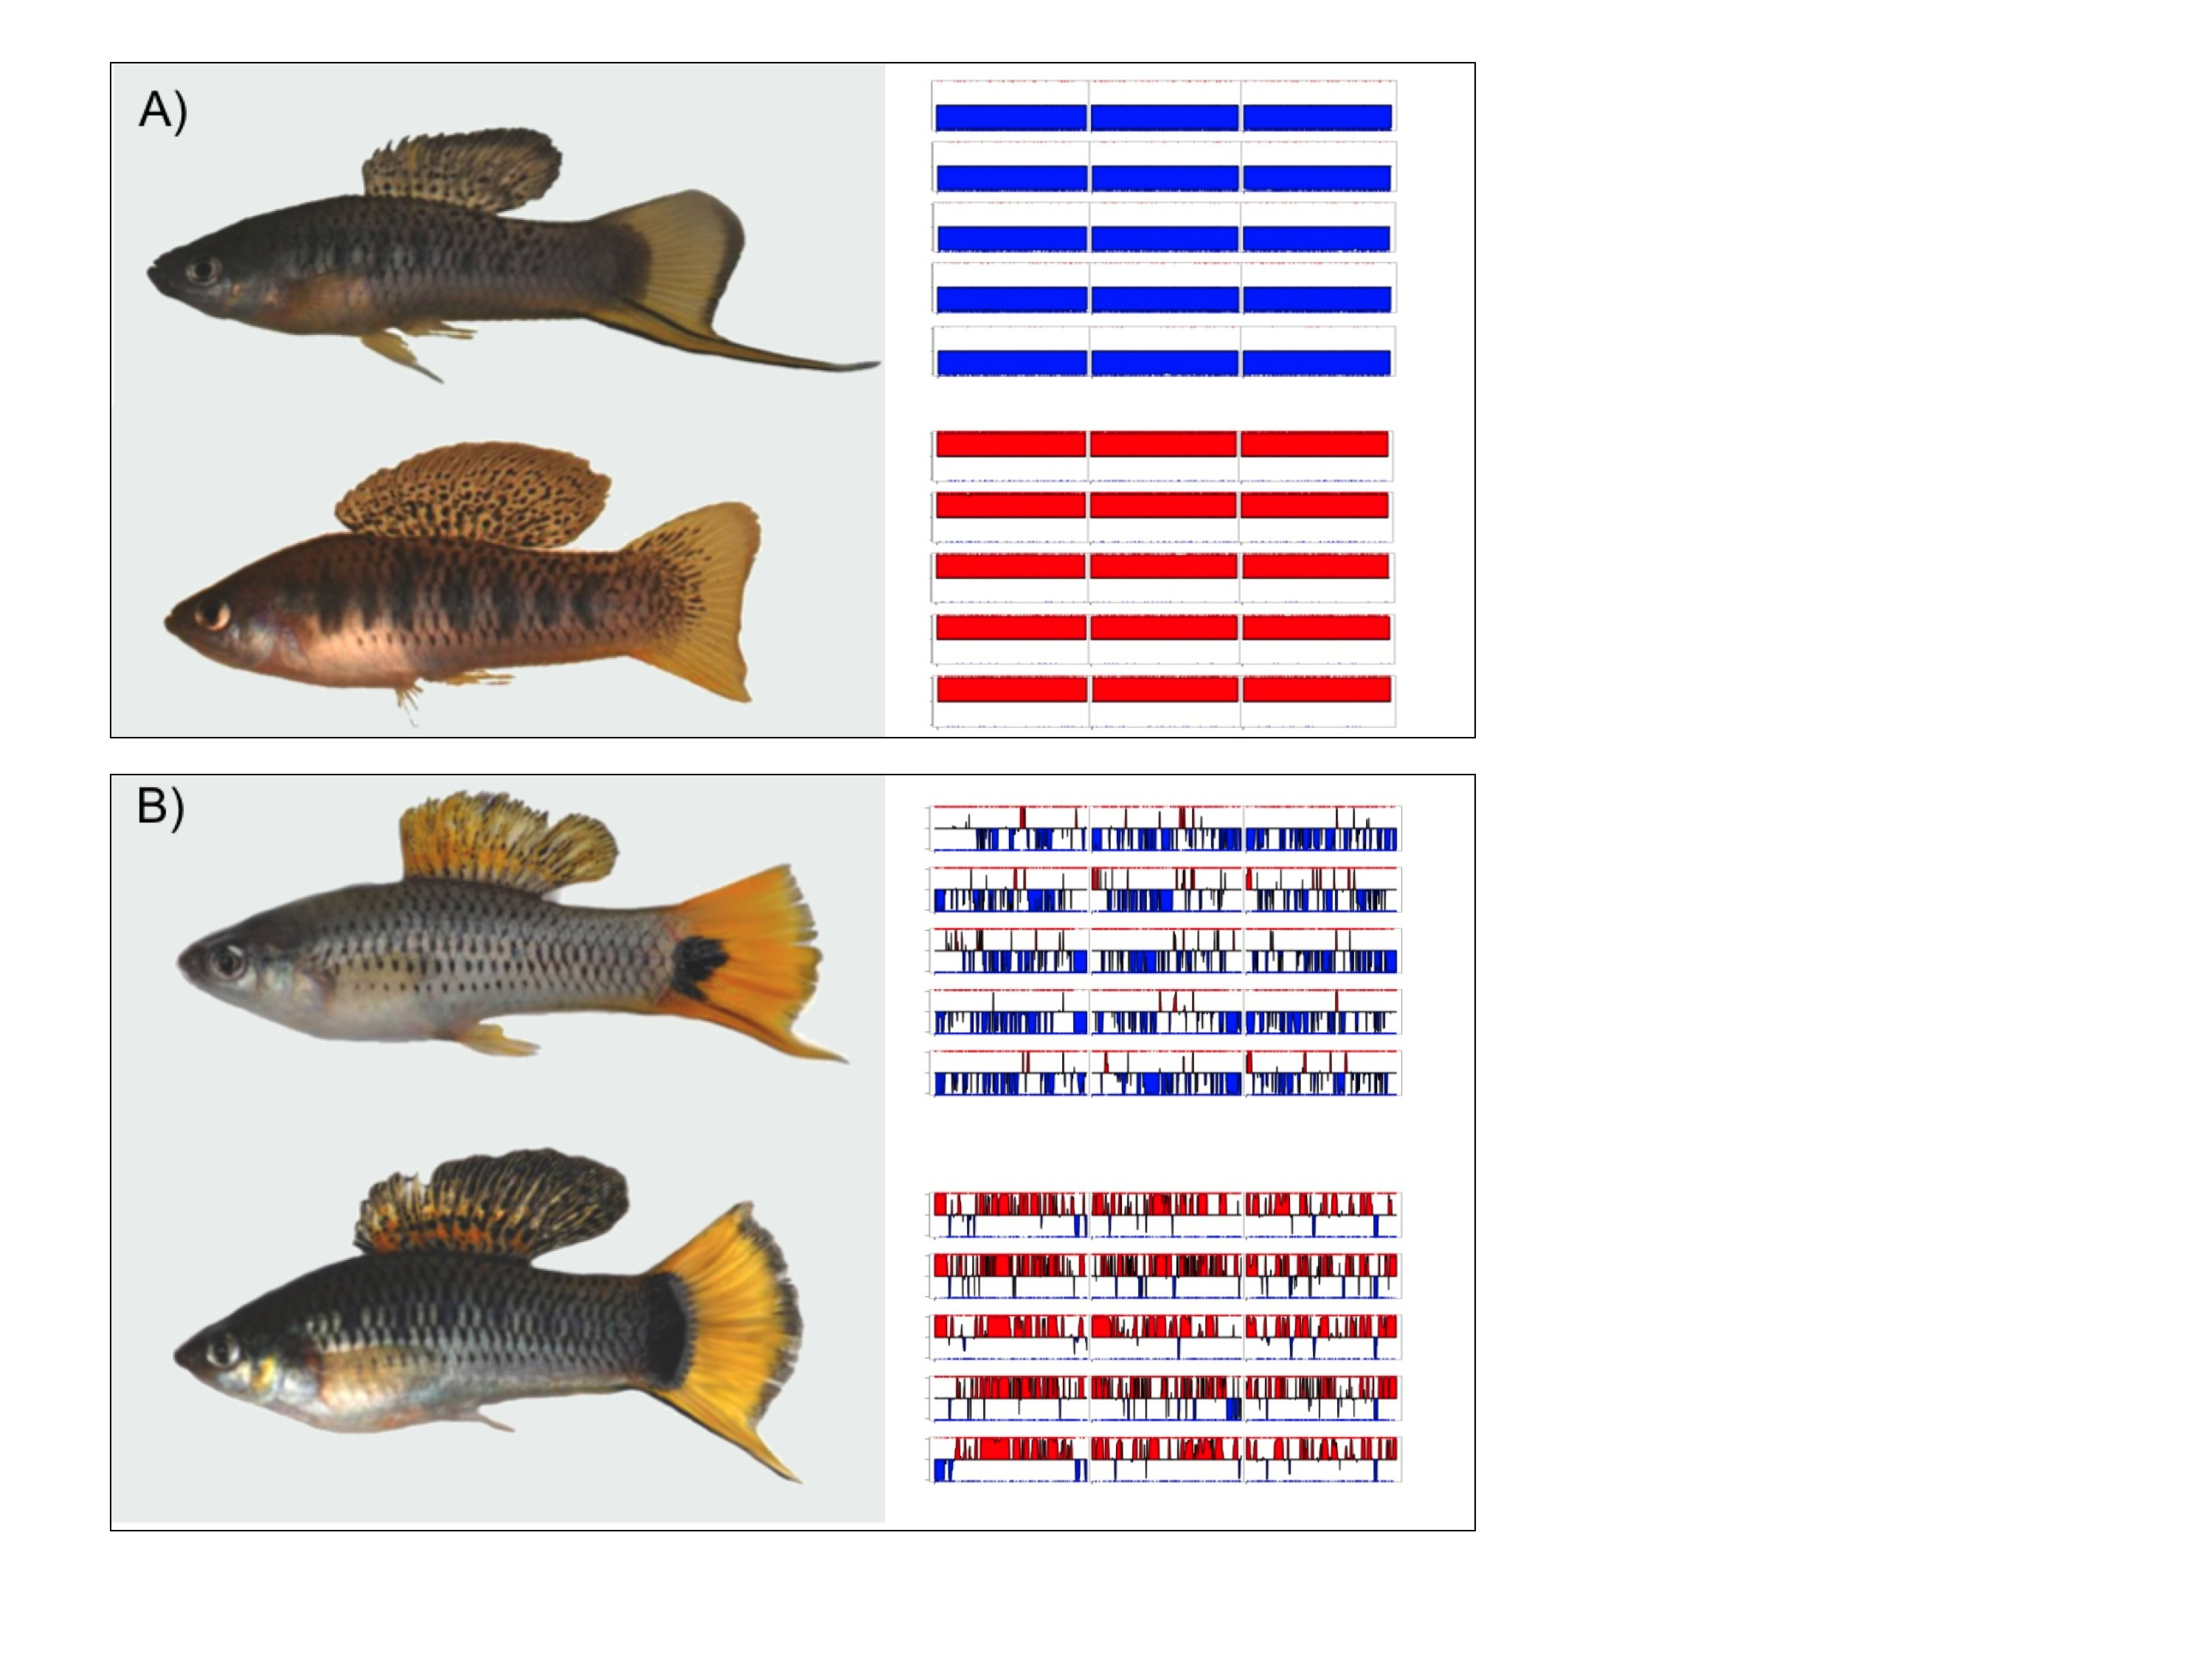

Figure 1. Hybrids between *X. malinche* and *X. birchmanni*. (A) Parental (*X. malinche* top, *X. birchmanni* bottom) and (B) hybrid phenotypes with sample MSG genotype plots for linkage groups 1-3 (see figure supplement 1 for more examples) for each population shown in the right panel. Hybrid individuals from Tlatemaco (B top) have *malinche*-biased ancestry while hybrids from Calnali (B bottom) have *birchmanni-*biased ancestry.

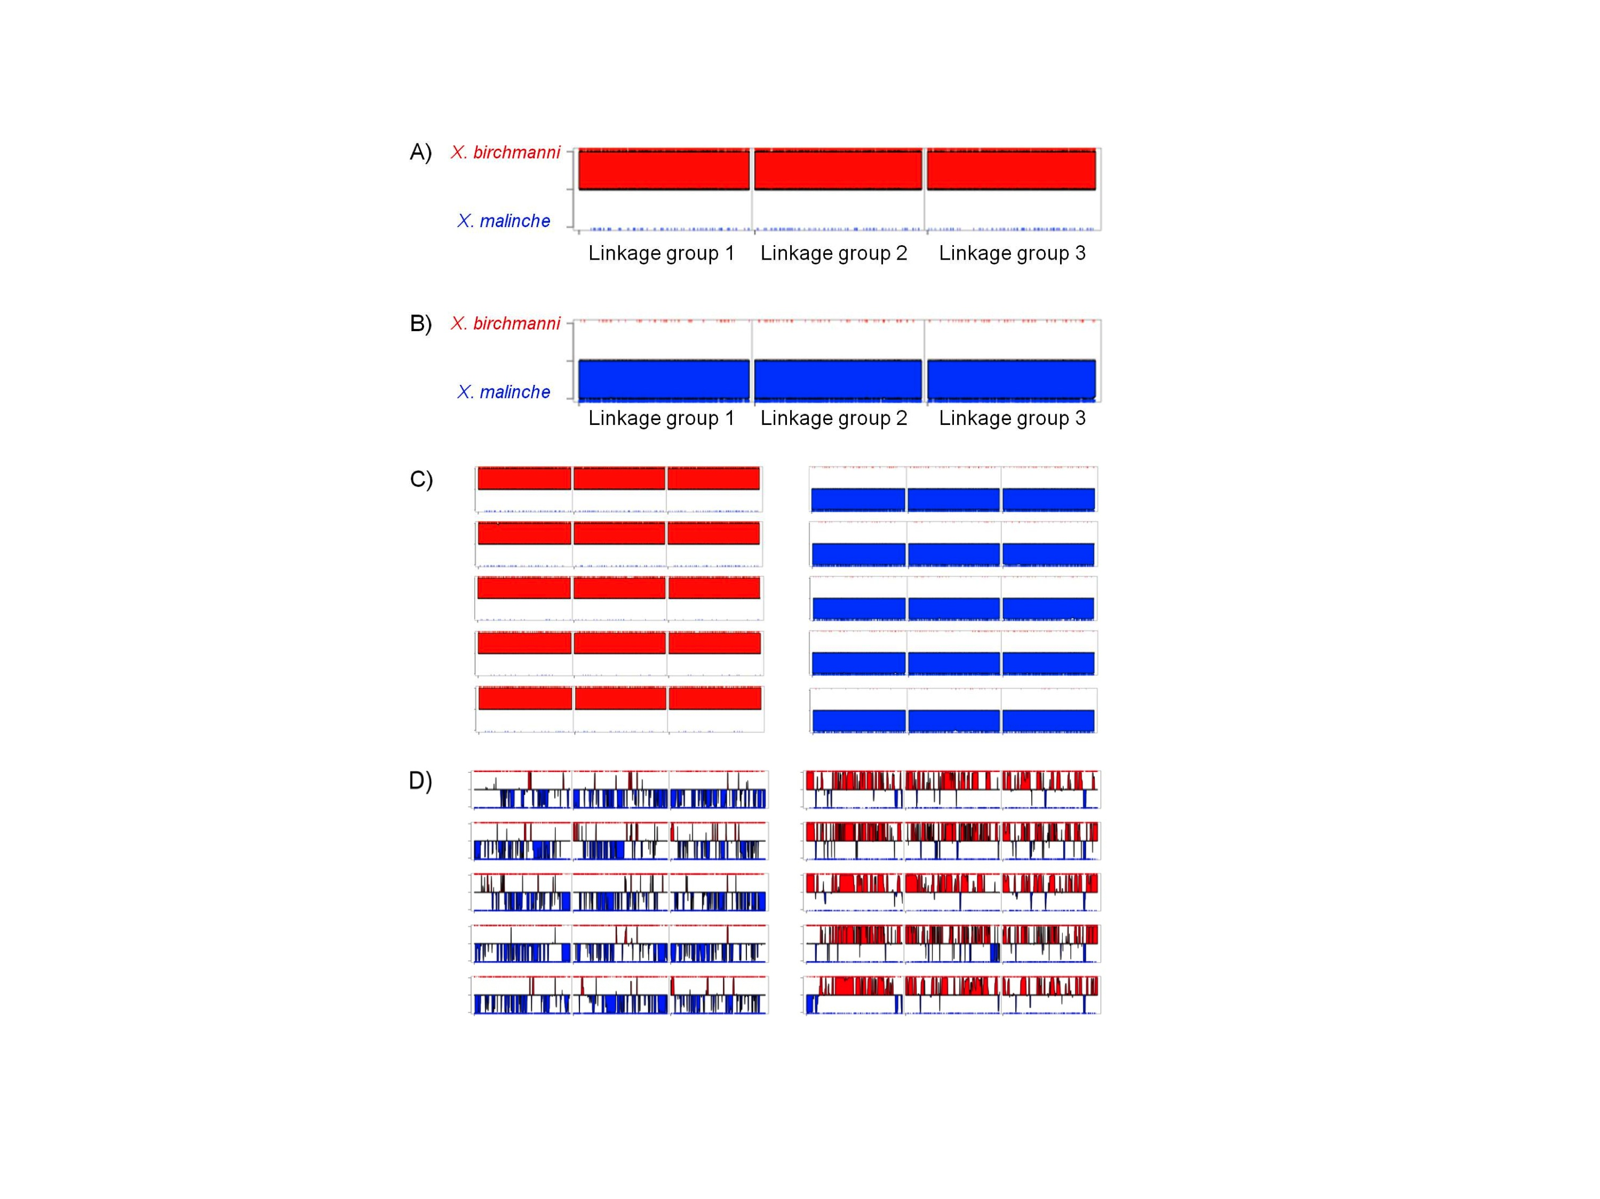

Figure 1-figure supplement 1. MSG ancestry plots for parental and hybrid individuals. Representative parental individuals of *X. birchmanni* (A) and *X. malinche* (B) in linkage groups 1-3, shows that parental individuals are called as homozygous throughout the chromosome. Tick markers indicating calls to the other parent are the result of undetected polymorphism or error. More representatives from the parental panel are shown in (C). Hybrids from Tlatemaco (left) and Calnali (right) are shown in panel (D).

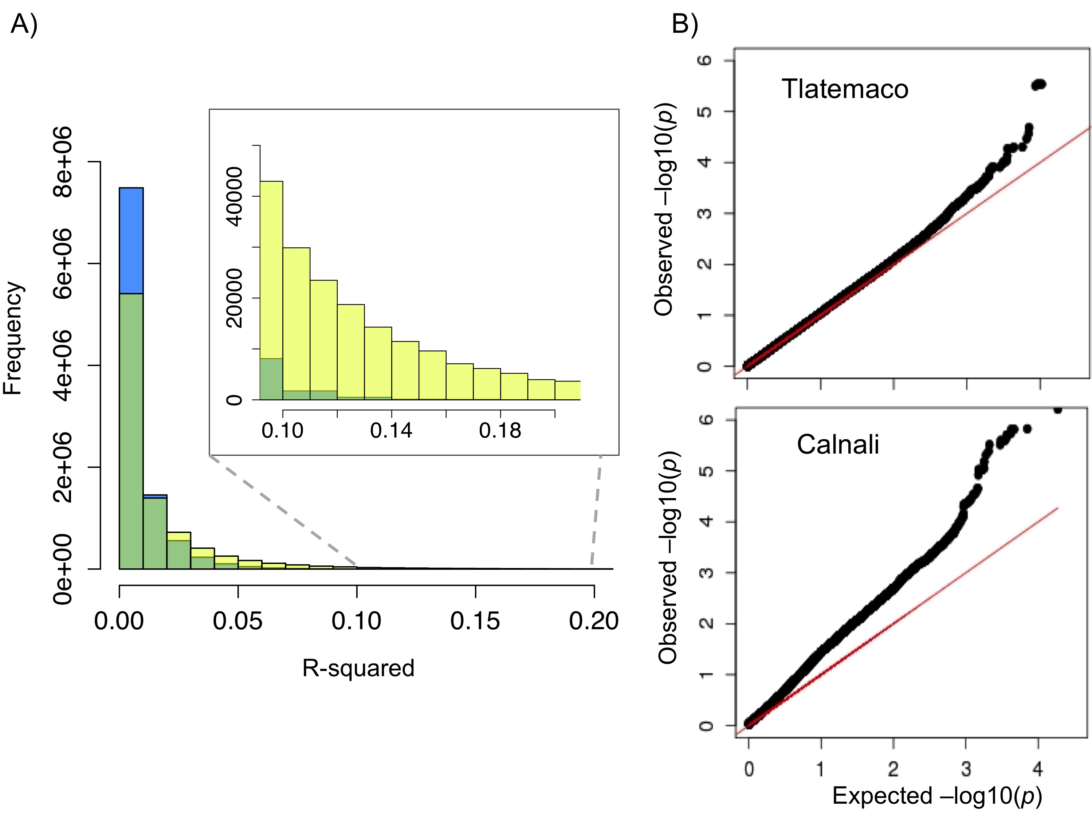

Figure 2. R2 distribution and p-value distributions of the sites analyzed in this study. (A) Genome-wide distribution of randomly sampled R2 values for markers on separate chromosomes (see figure supplement 1 for R2 decay by distance; figure supplement 2 for a genome-wide plot). Blue indicates the distribution in Tlatemaco while yellow indicates the distribution in Calnali. Regions of overlapping density are indicated in green. The average genome-wide R2 in Tlatemaco is 0.003 and in Calnali is 0.006. (B) qq-plots of –log10(p-value) for a randomly selected subset of unlinked sites analyzed in this study in each population; expected p-values are drawn from p-values of the permuted data.

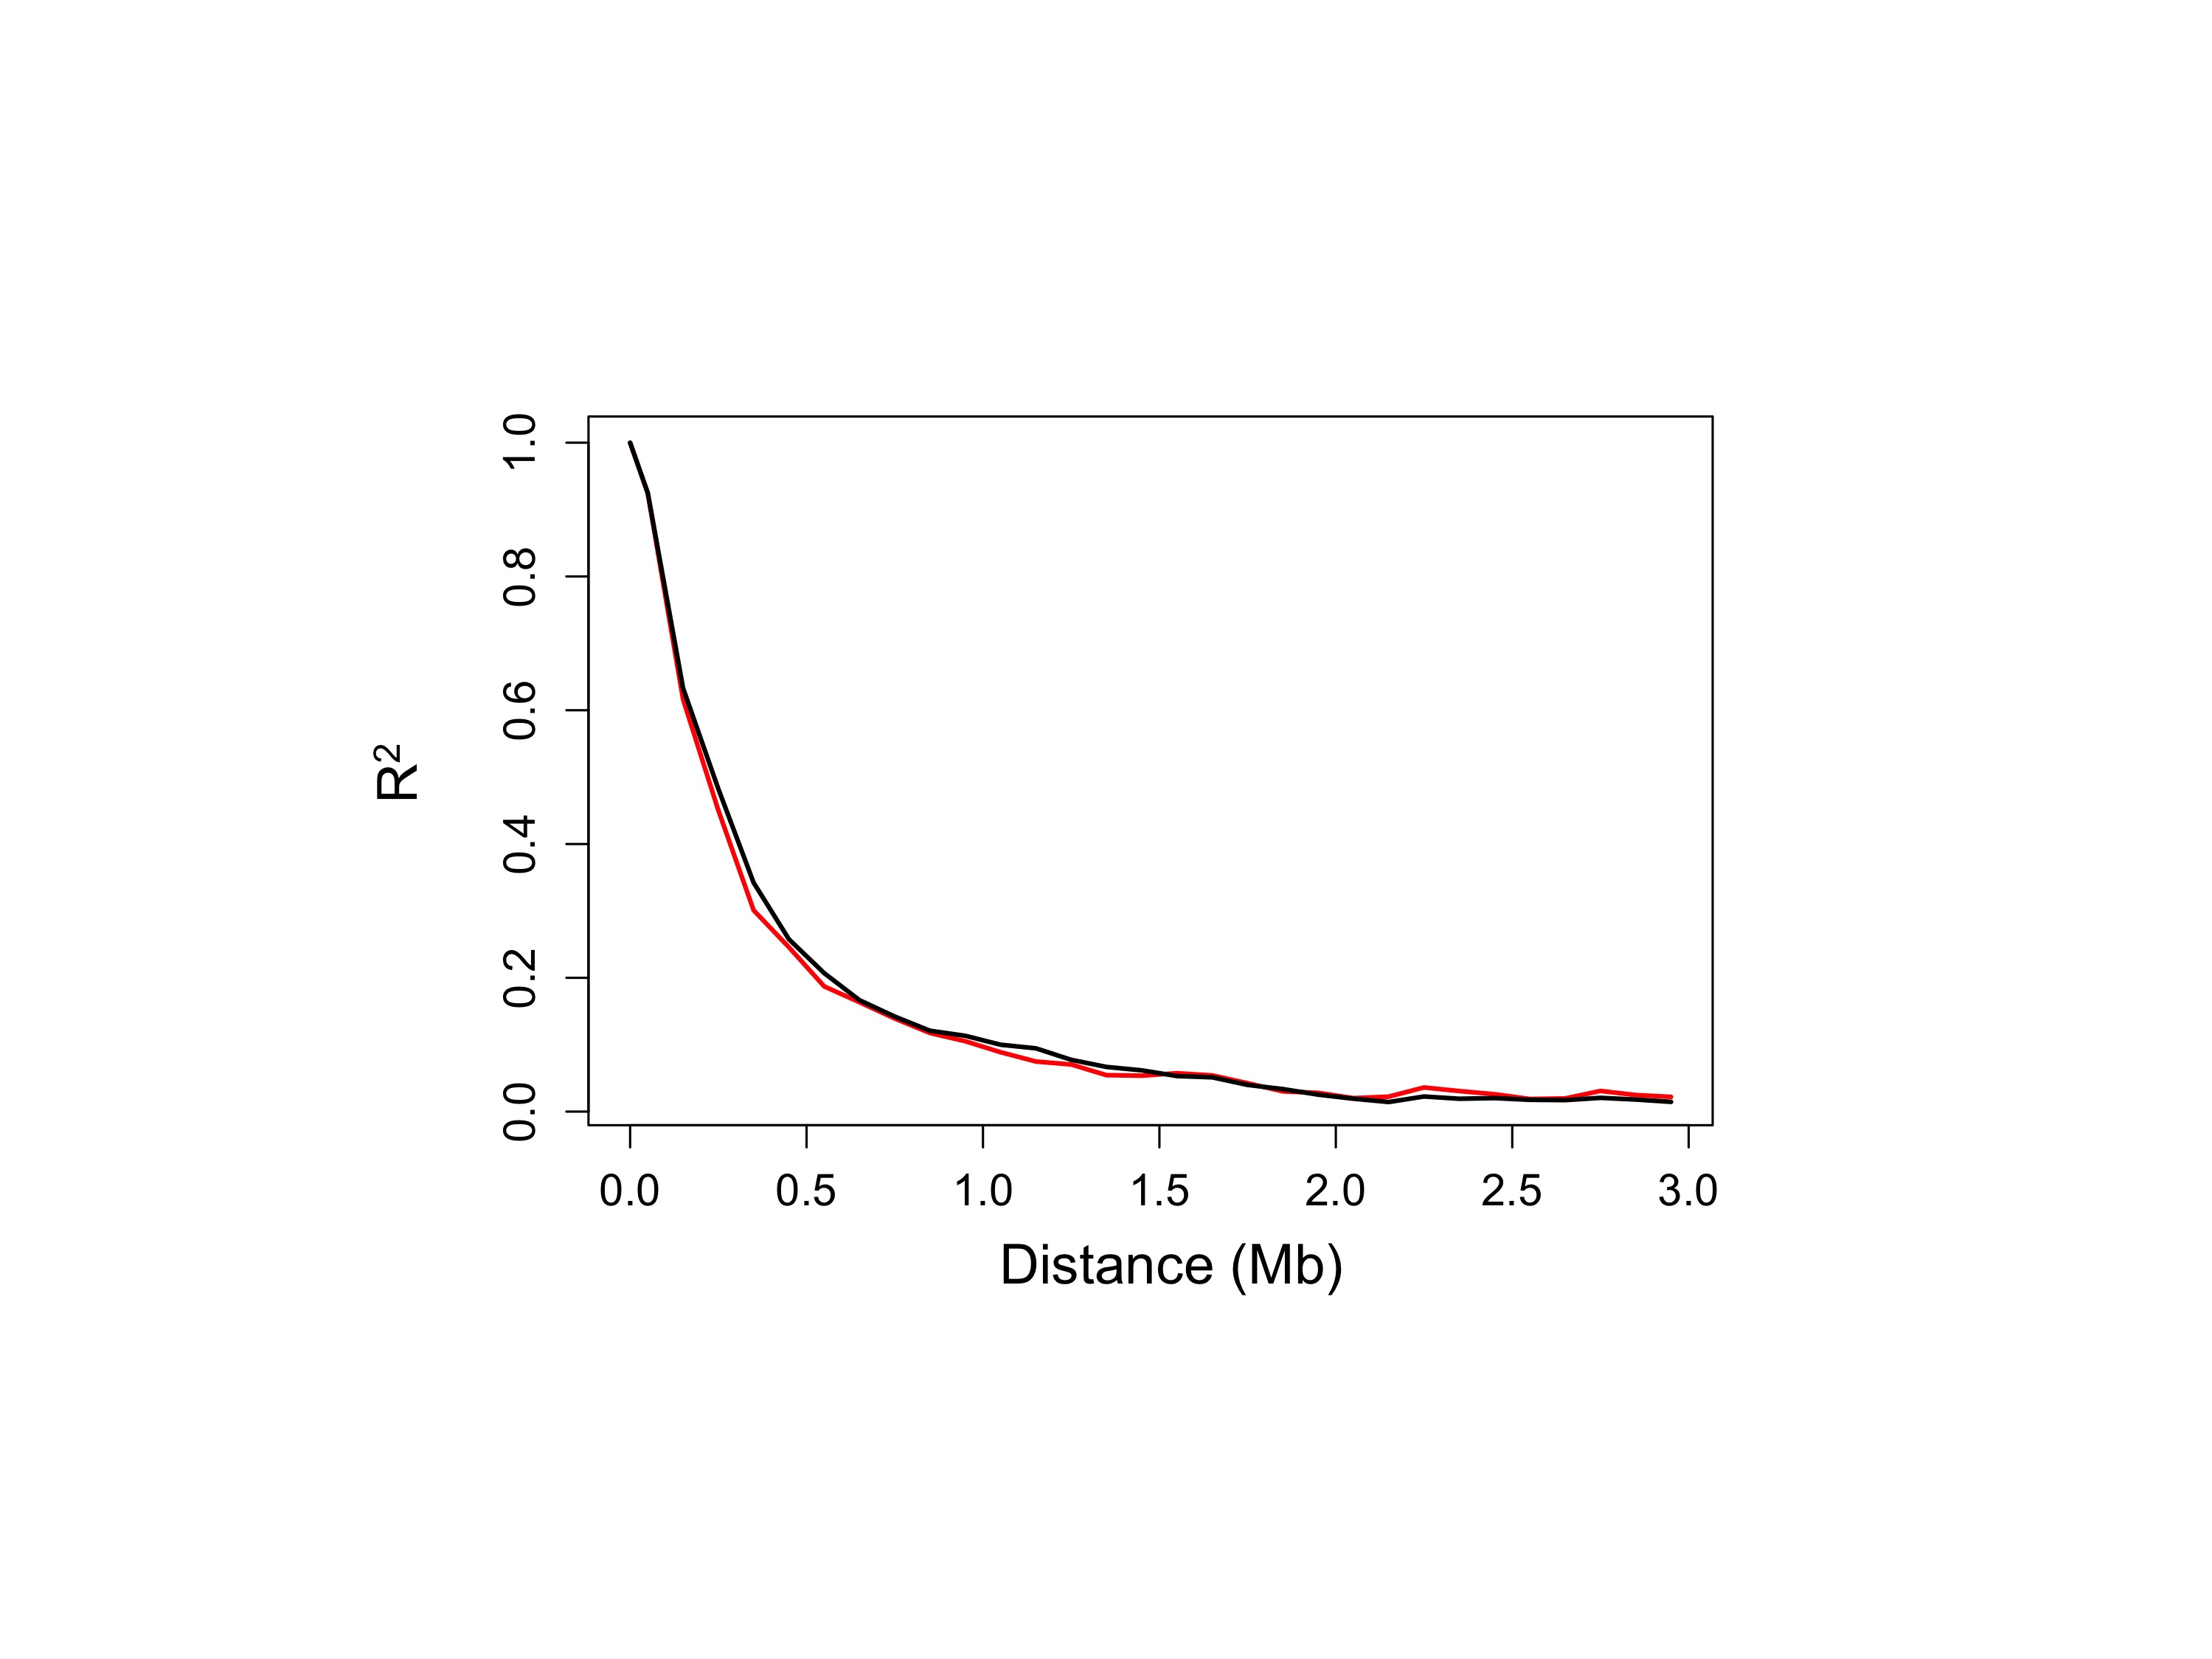

Figure 2-figure supplement 1. Decay in linkage disequilibrium. Average decay of R2 over distance in Tlatemaco (black) and Calnali (red) in 100 kb windows (plot generated from 1000 randomly selected sites).

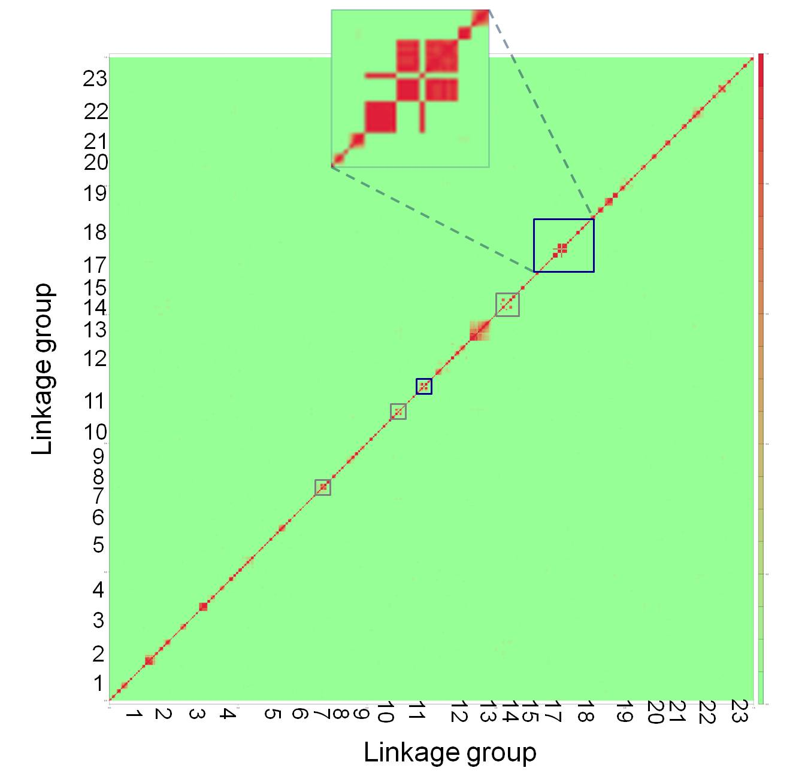

Figure 2-figure supplement 2. Genome-wide linkage disequilibrium plot for Tlatemaco. This plot demonstrates that there are few regions in the *X. birchmanni*-*malinche* genomes that are inverted relative to the *X. maculatus* genome. Red indicates regions of R2 near 1, while green indicates low R2. Regions outlined in dark blue appear to be inverted based on the analysis in both Tlatemaco and Calnali, regions highlighted in gray appear to be inverted only in the Tlatemaco analysis.

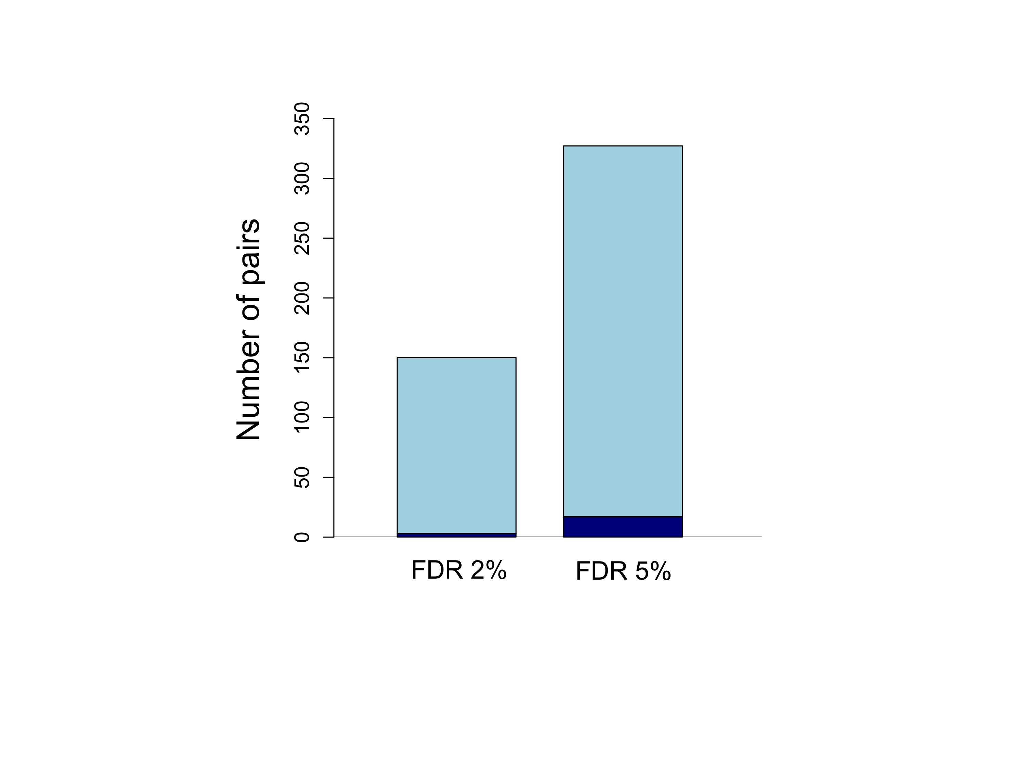

Figure 3. Number of unlinked pairs in significant linkage disequilibrium and expected false discovery rates. Plot showing number of pairs of sites in significant LD in both populations in the stringent and relaxed datasets (light blue). The expected number of false positives in each dataset is shown in dark blue, and was determined by simulation (see main text; figure supplement 1).

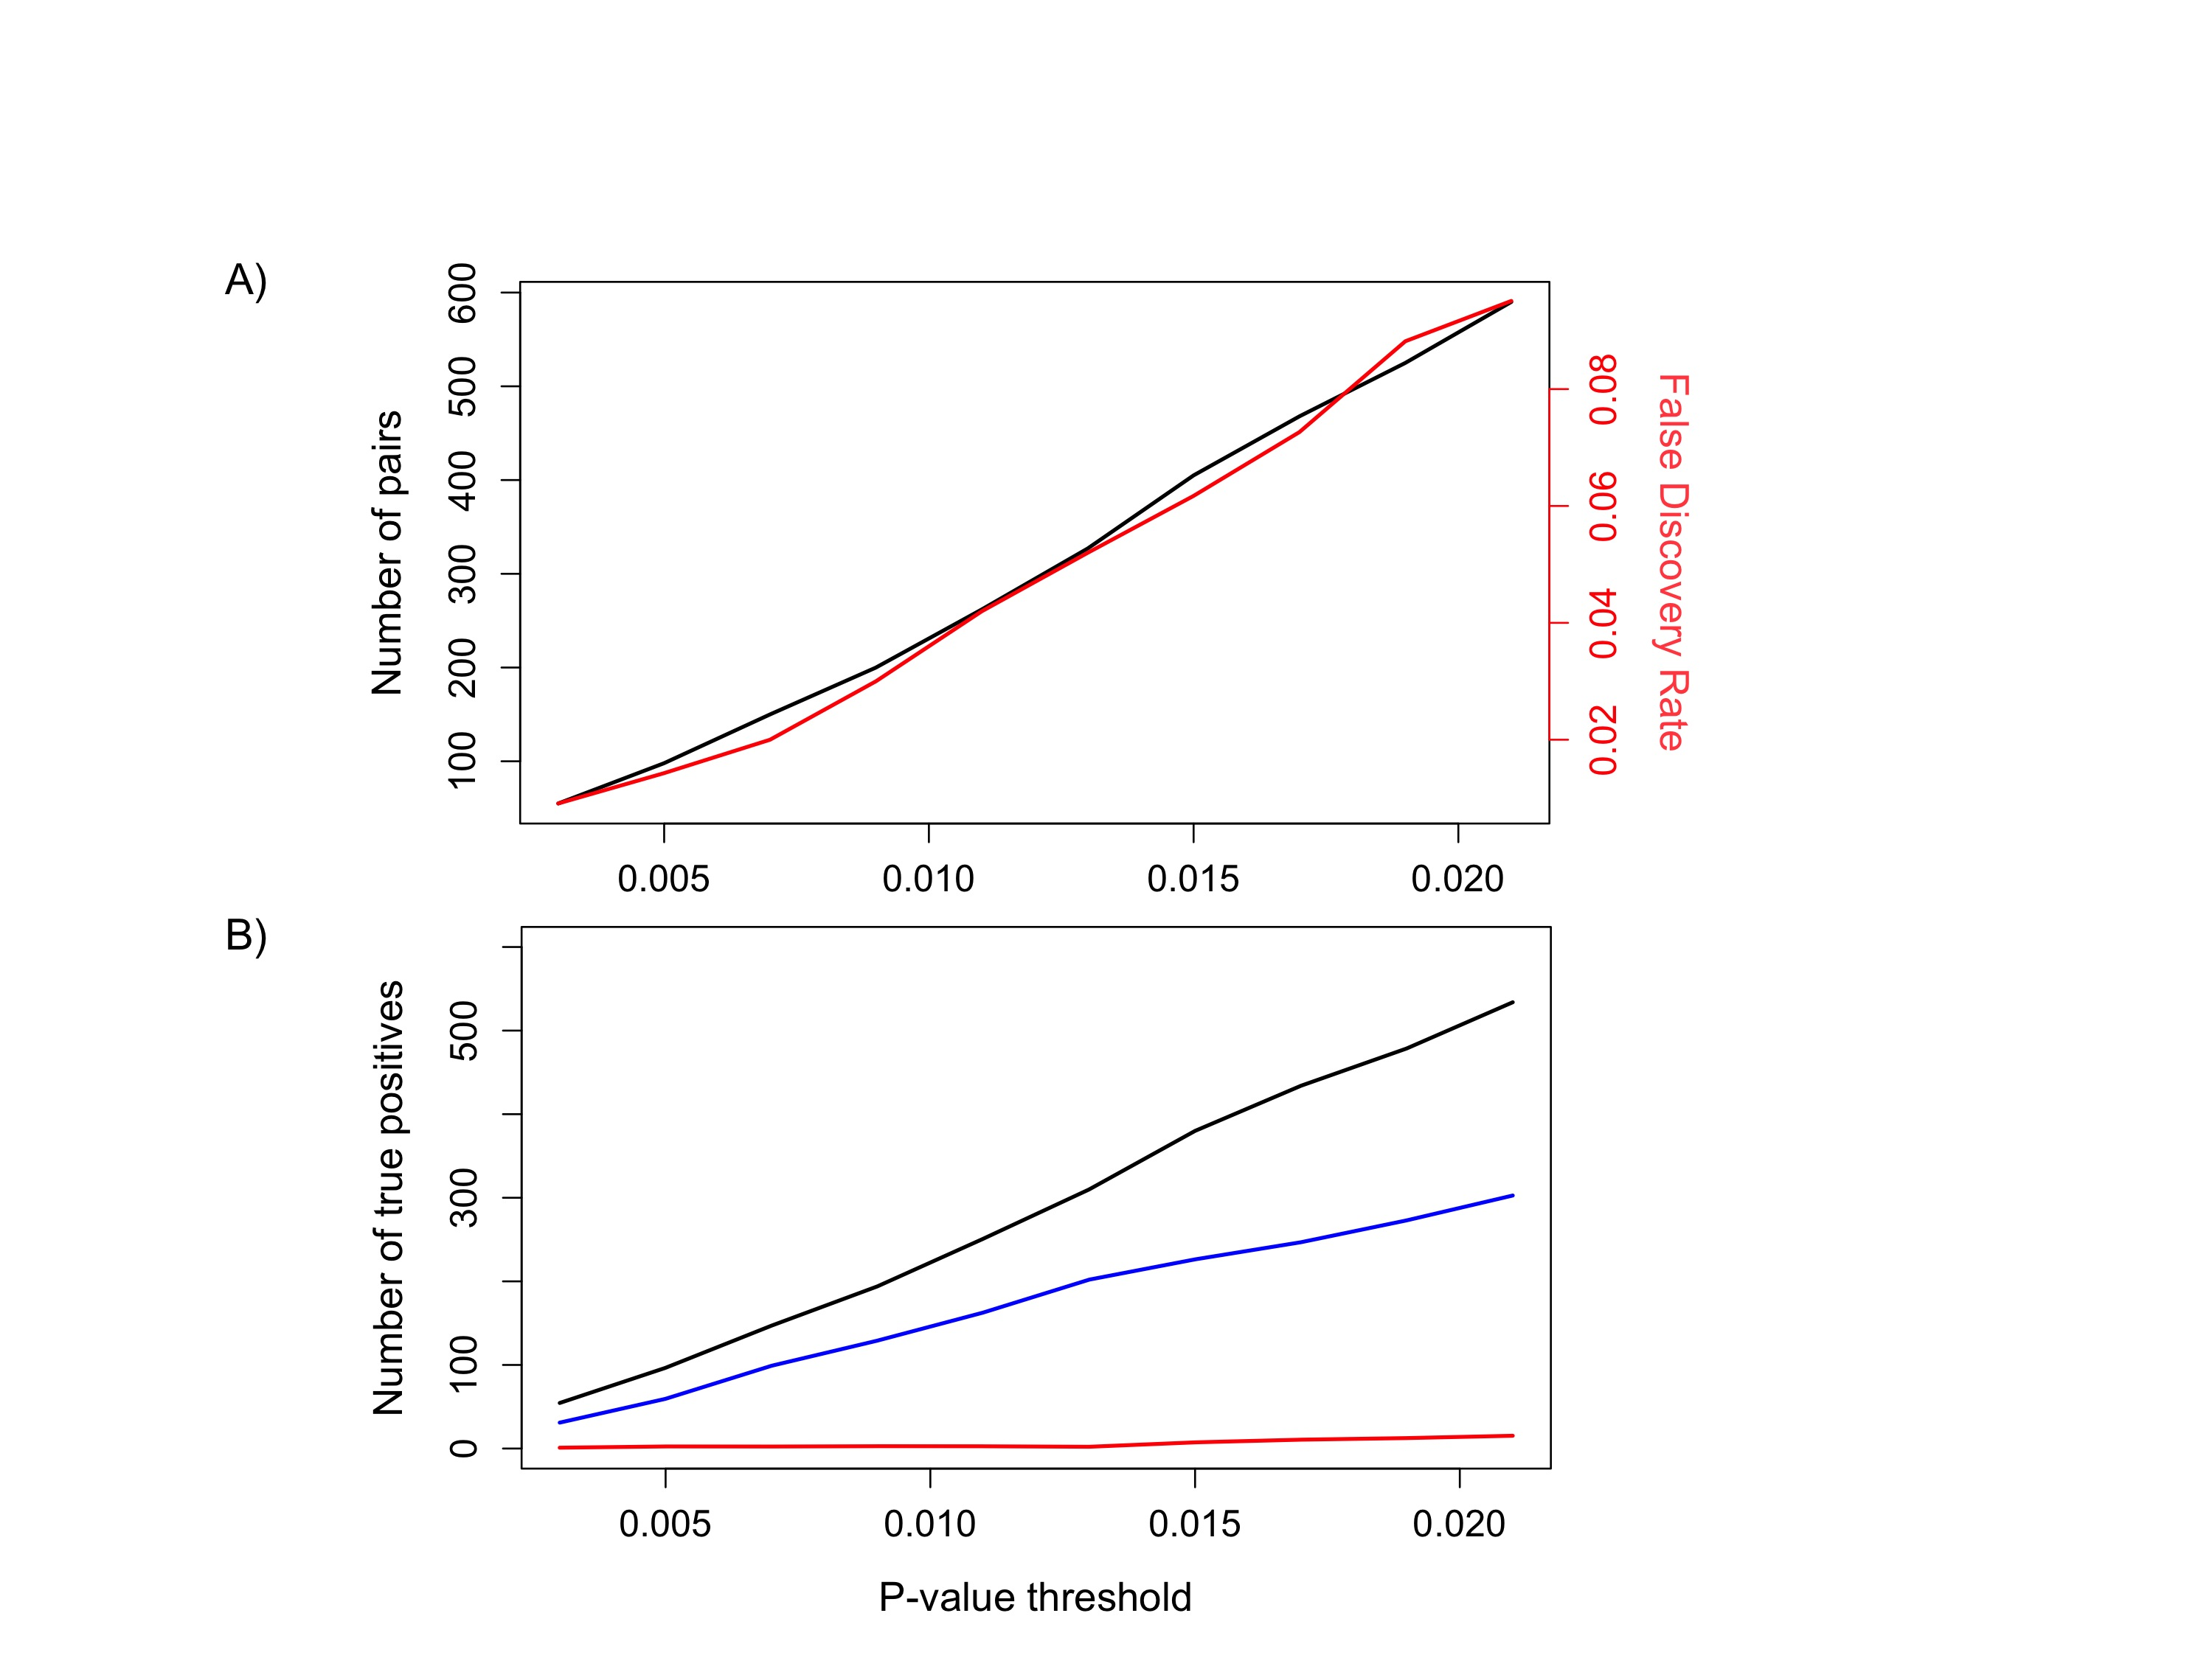

Figure 3-figure supplement 1. False discovery rate (FDR) at different p-value thresholds. (A) The number of pairs of loci in LD in both populations in black (y-axis left) versus the expected false discovery rate in red (y-axis right) at different p-value thresholds. (B) Estimated number of true positives in the dataset at different p-value thresholds for all pairs (black), conspecific pairs (blue), and heterospecific pairs (red). Expected false discovery rate was determined by 1000 simulations randomly permuting markers from the real data in both populations.

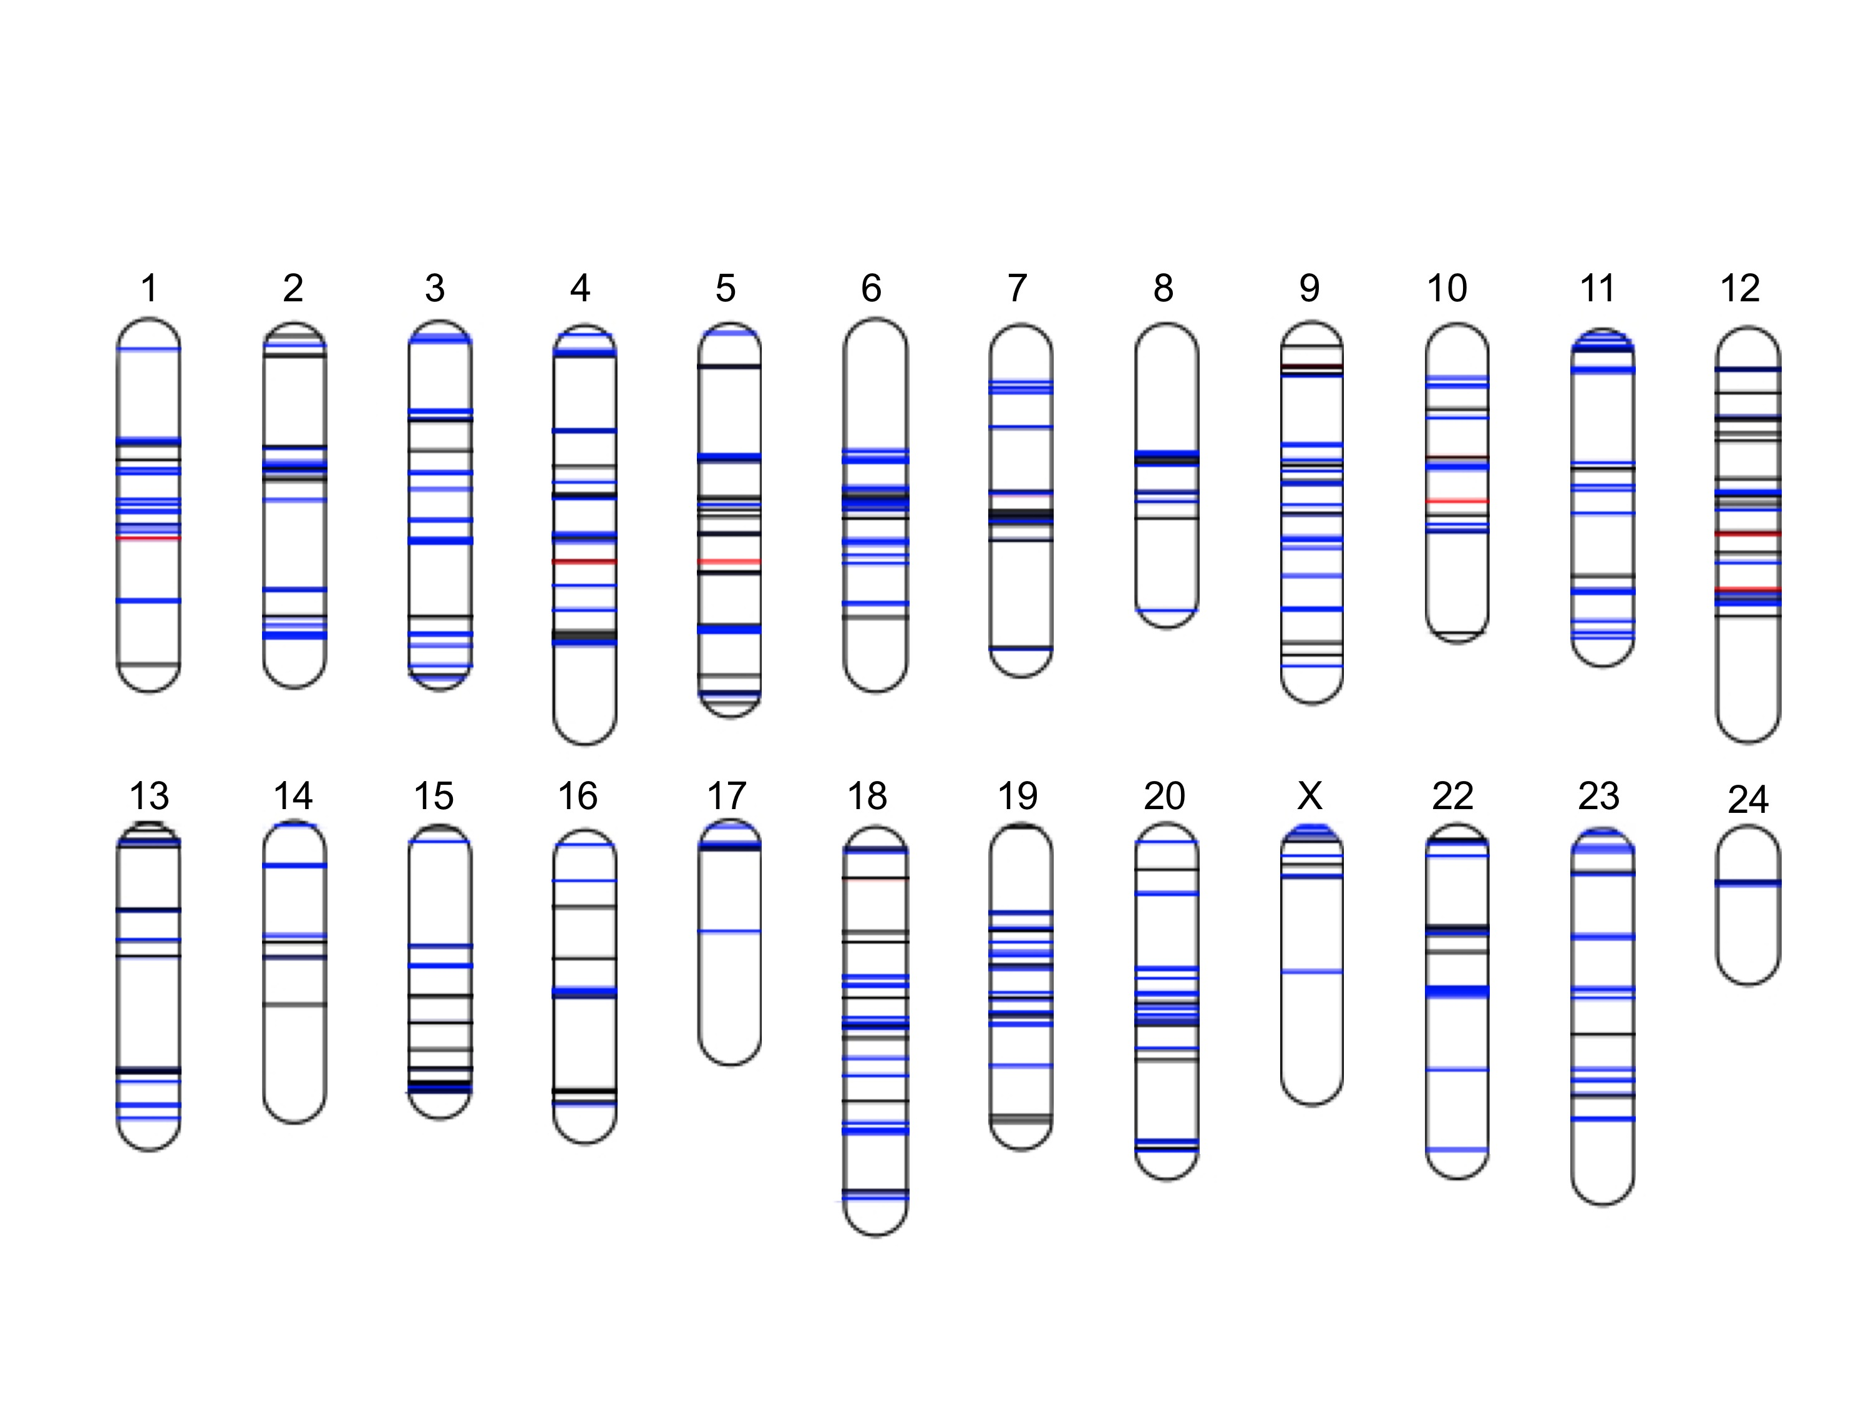

Figure 4. Distribution of sites in significant linkage disequilibrium throughout the *Xiphophorus* genome. Schematic of regions in significant LD in both populations at FDR 5%. Regions in blue indicate regions that are positively associated in both populations (conspecific in association), regions in black indicate associations with different signs of R in the two populations, while regions in red indicate those that are negatively associated in both populations (heterospecific in association). Chromosome lengths and position of LD regions are relative to the length of the assembled sequence for that linkage group; most identified LD regions are <50 kb (figure supplement 1; figure supplement 2; figure supplement 3). Analysis of local LD excludes mis-assemblies as the cause of these patterns (figure supplement 4).

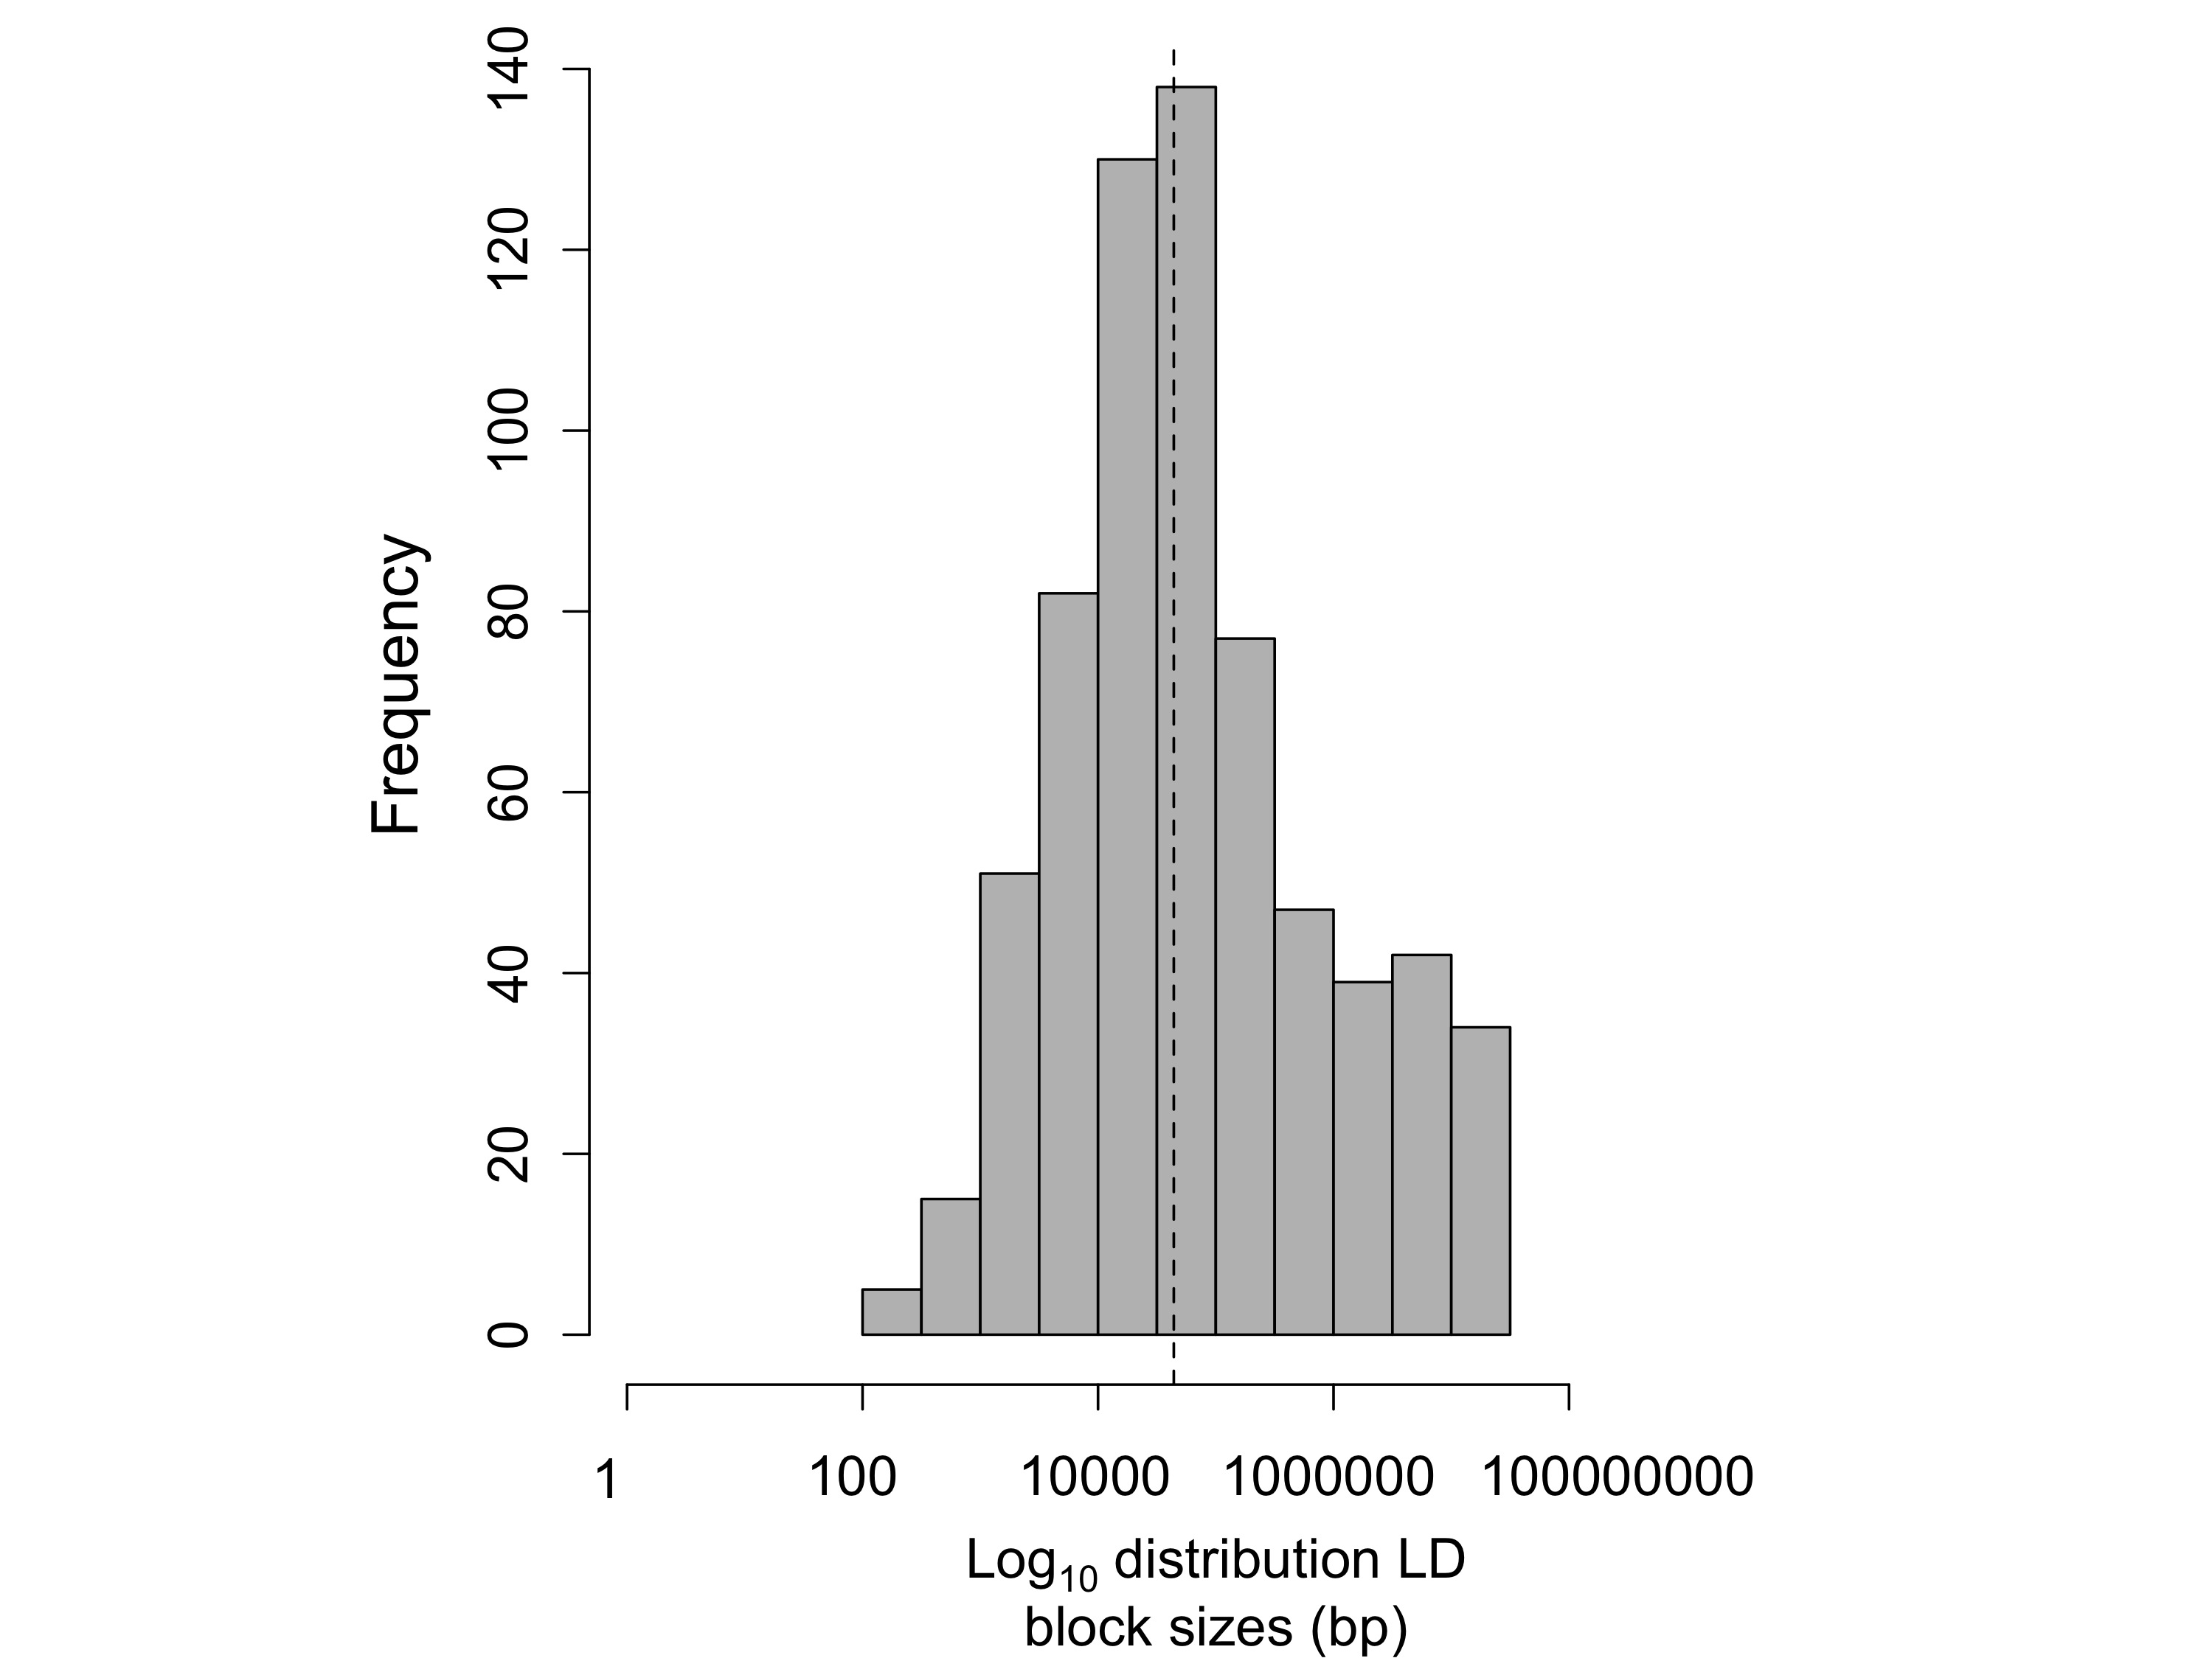

Figure 4-figure supplement 1. Log10 distribution of LD region length in base pairs. The dotted line indicates the median length of regions in cross-chromosomal LD (45 kb).

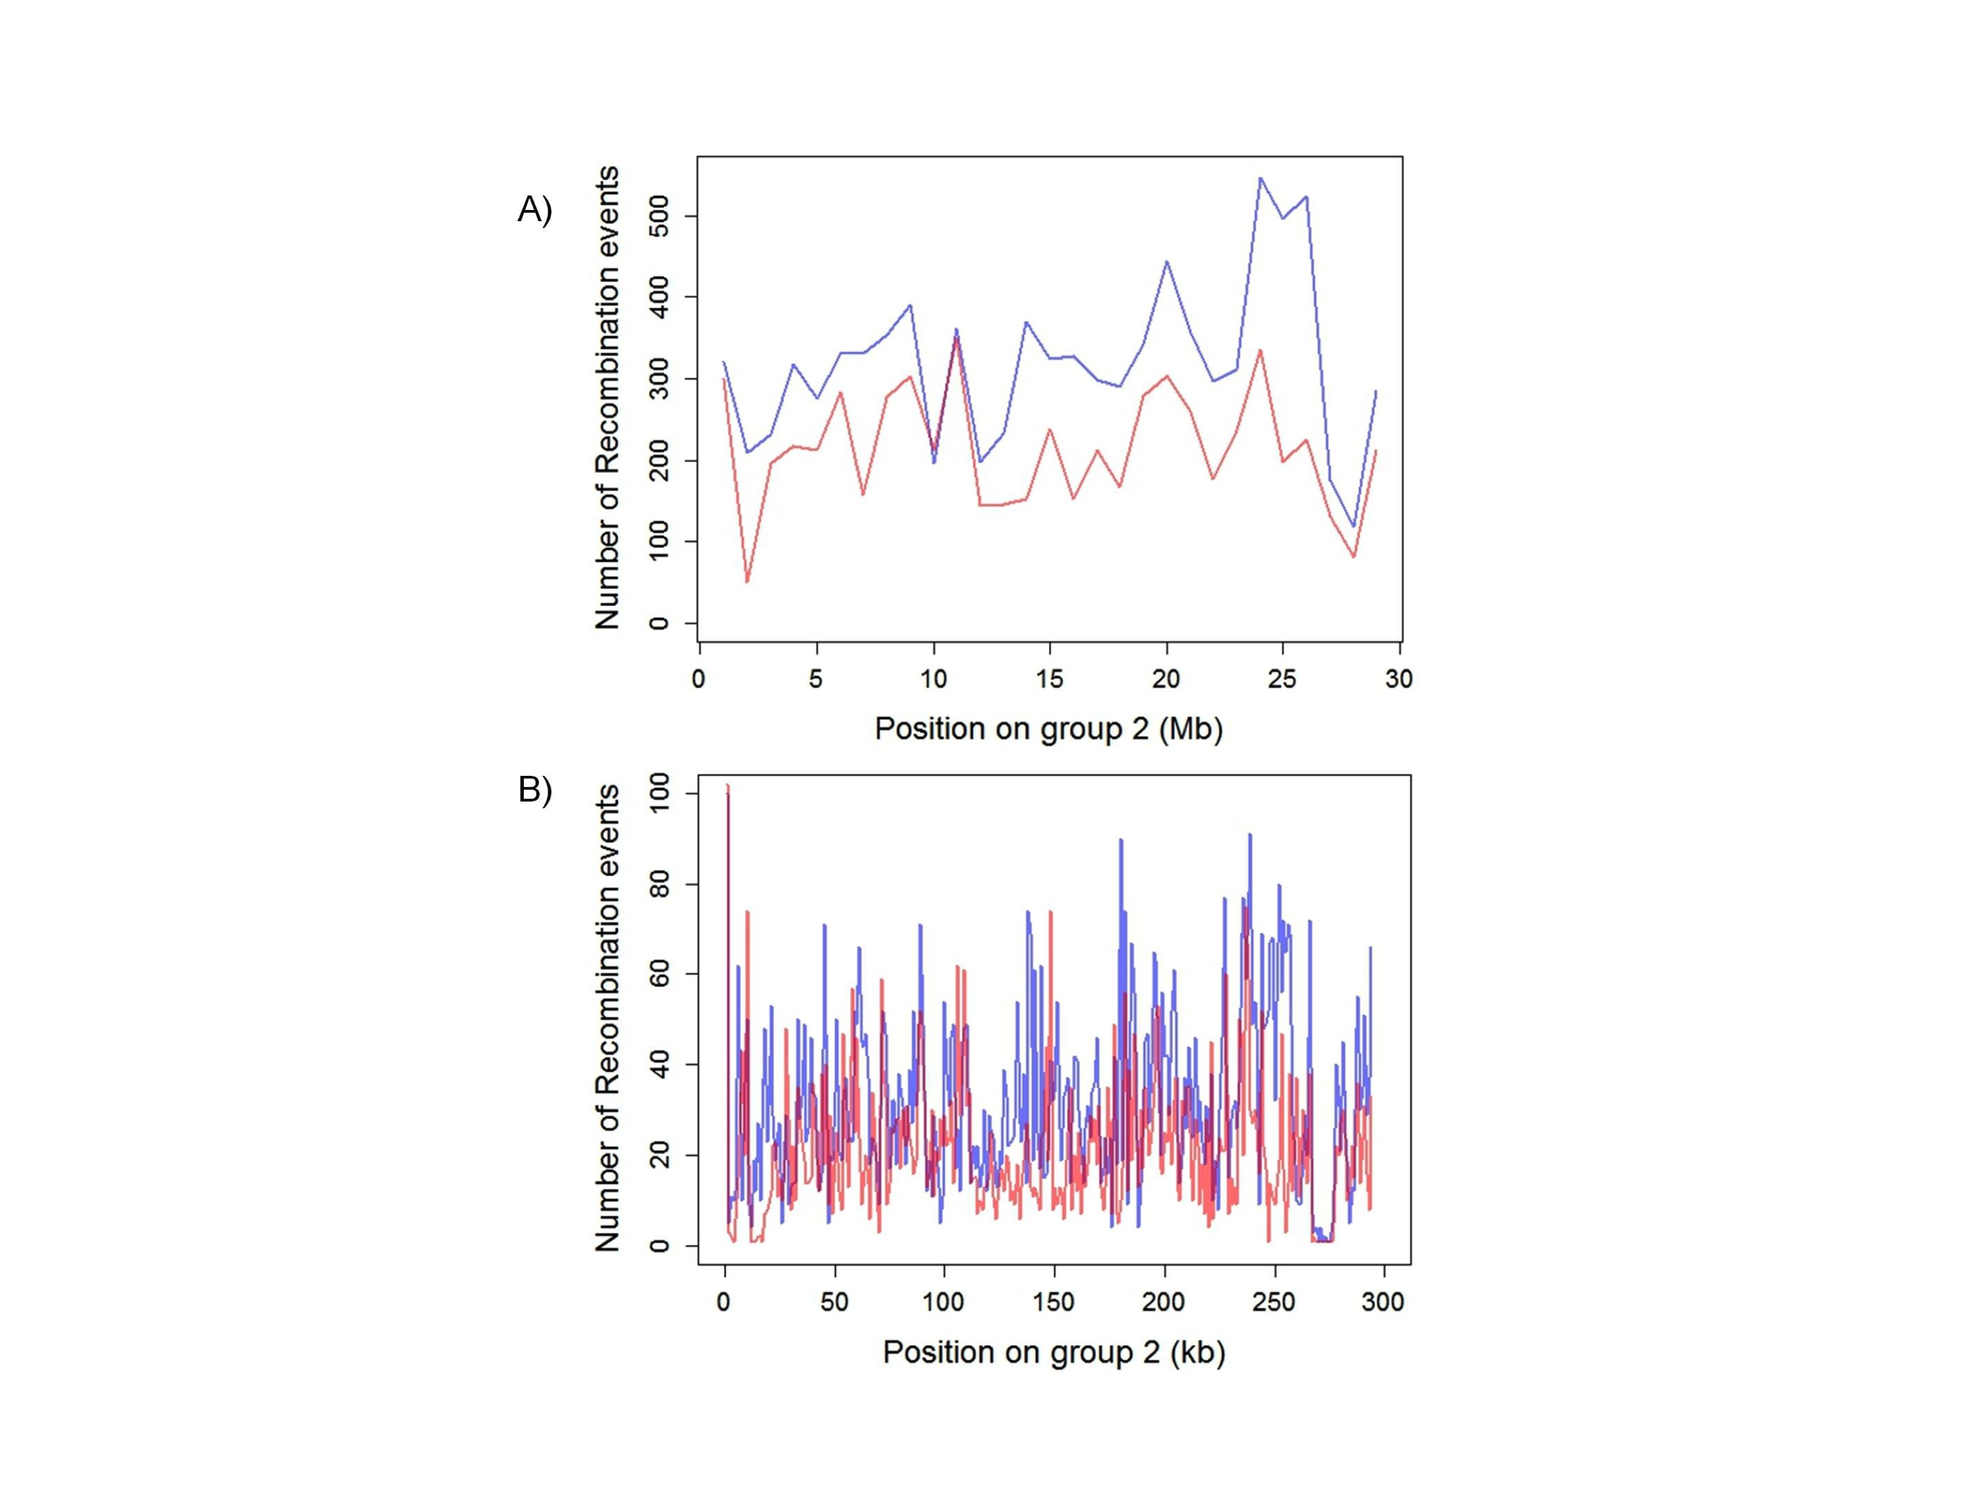

Figure 4-figure supplement 2. Plot of the number of recombination breakpoints detected along linkage group 2. Number of breakpoints in Tlatemaco are indicated in blue and Calnali in red. (A) Breakpoints counted in 1 Mb windows and (B) 100 kb windows. The high density of recombination events allows for the identification of narrow regions in linkage disequilibrium.

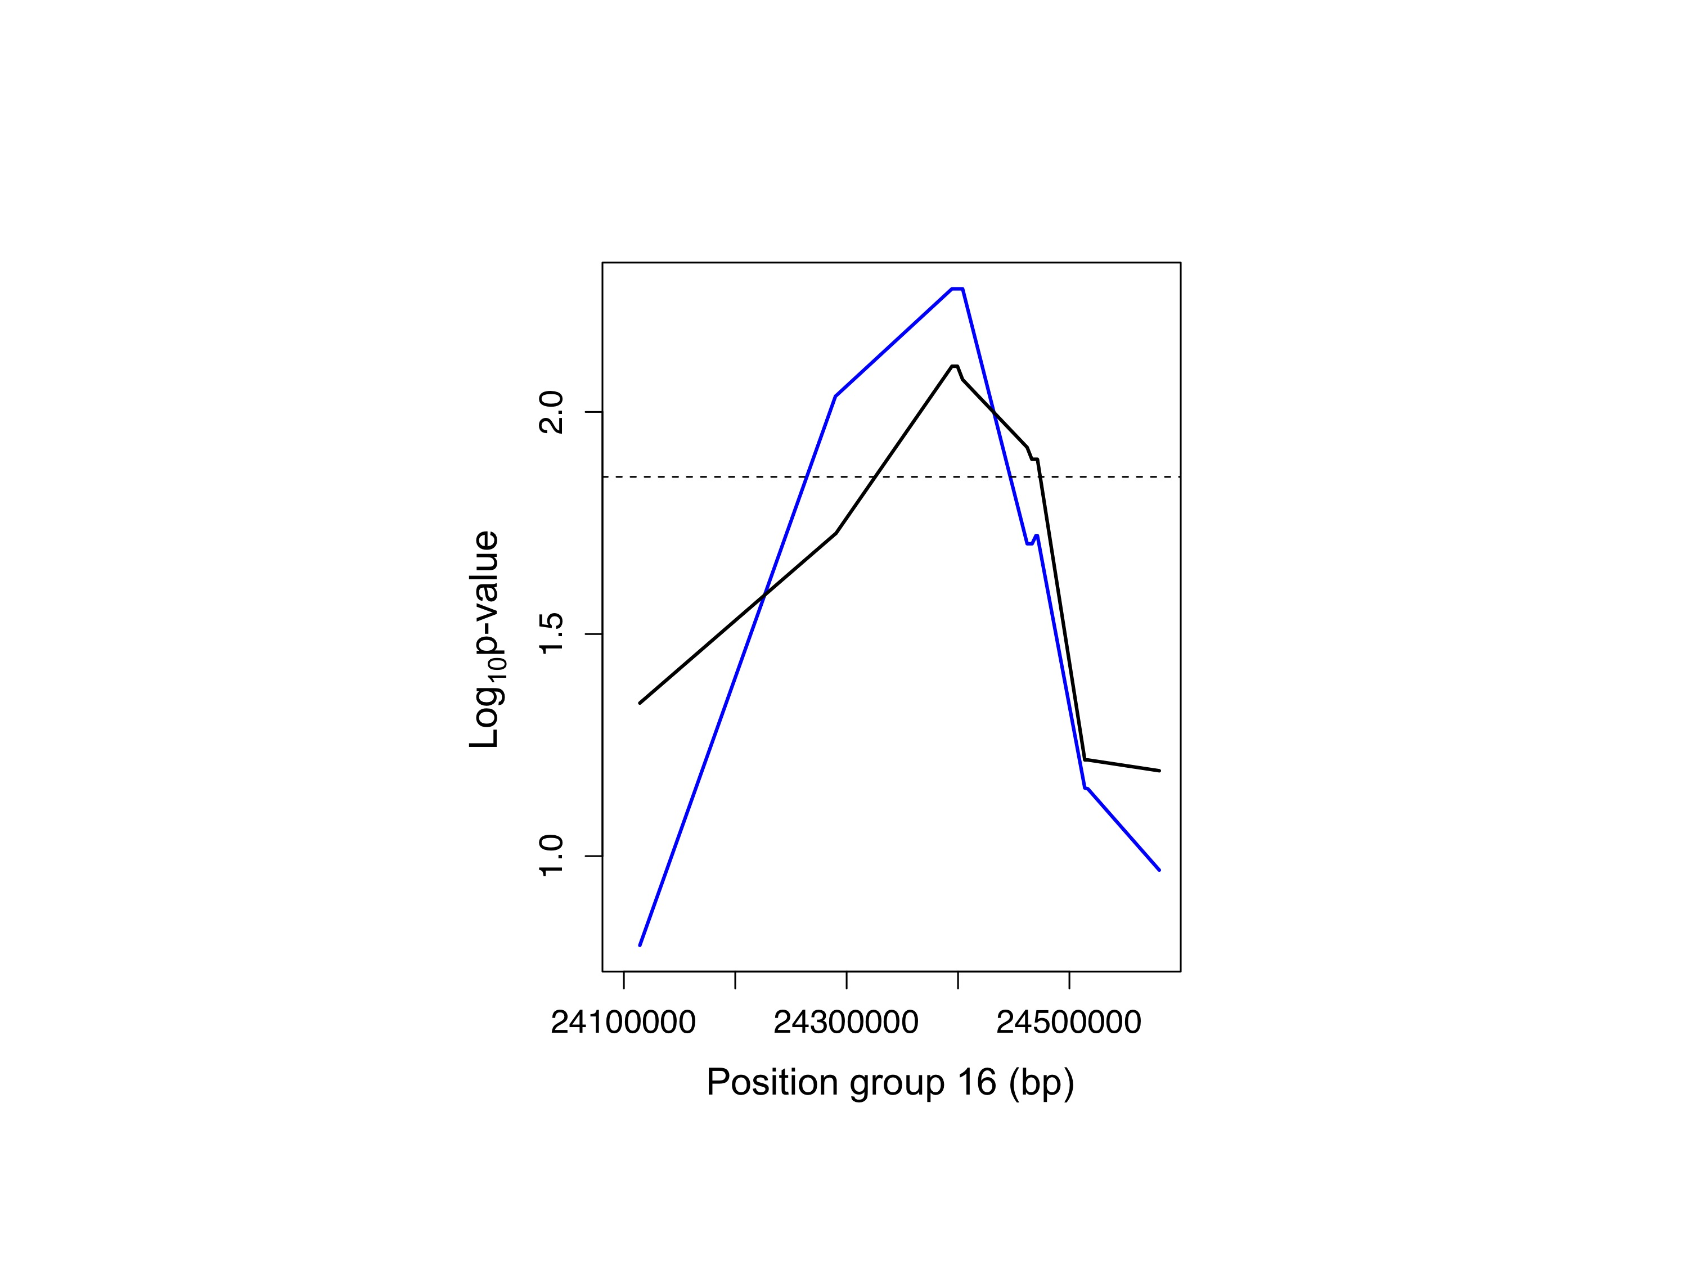

Figure 4-figure supplement 3. Example of the use of data from two populations to narrow candidate regions in cross-chromosomal LD. P-values for linkage disequilibrium between a marker on linkage group 2 and an interval on linkage group 16 (blue: Calnali, black: Tlatemaco). Overlapping significant intervals from the two populations allows me to narrow candidate regions.

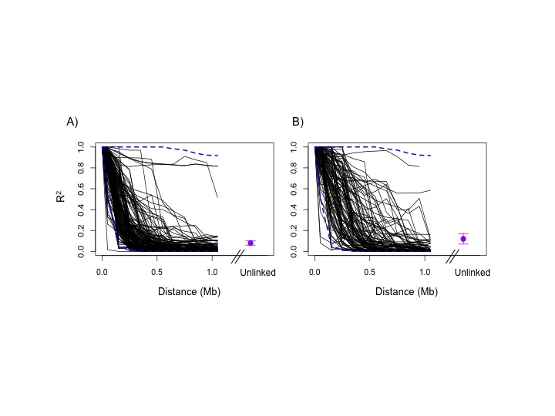

Figure 4-figure supplement 4. Regions in cross-chromosomal LD are also in LD with their neighbors. Decay in R2 of markers at the edge of LD blocks in both populations (black lines) compared to 95% confidence intervals of 1000 markers randomly selected from the genomic background (blue) in Tlatemaco (A) and Calnali (B). Fewer than 5% of markers fall outside of the 95% confidence intervals in each 100 kb window in both populations. Average R2 and 95% CI for regions in significant cross-chromosomal LD are shown in purple. LD blocks without neighboring markers within 300 kb of the focal marker are excluded from this figure.

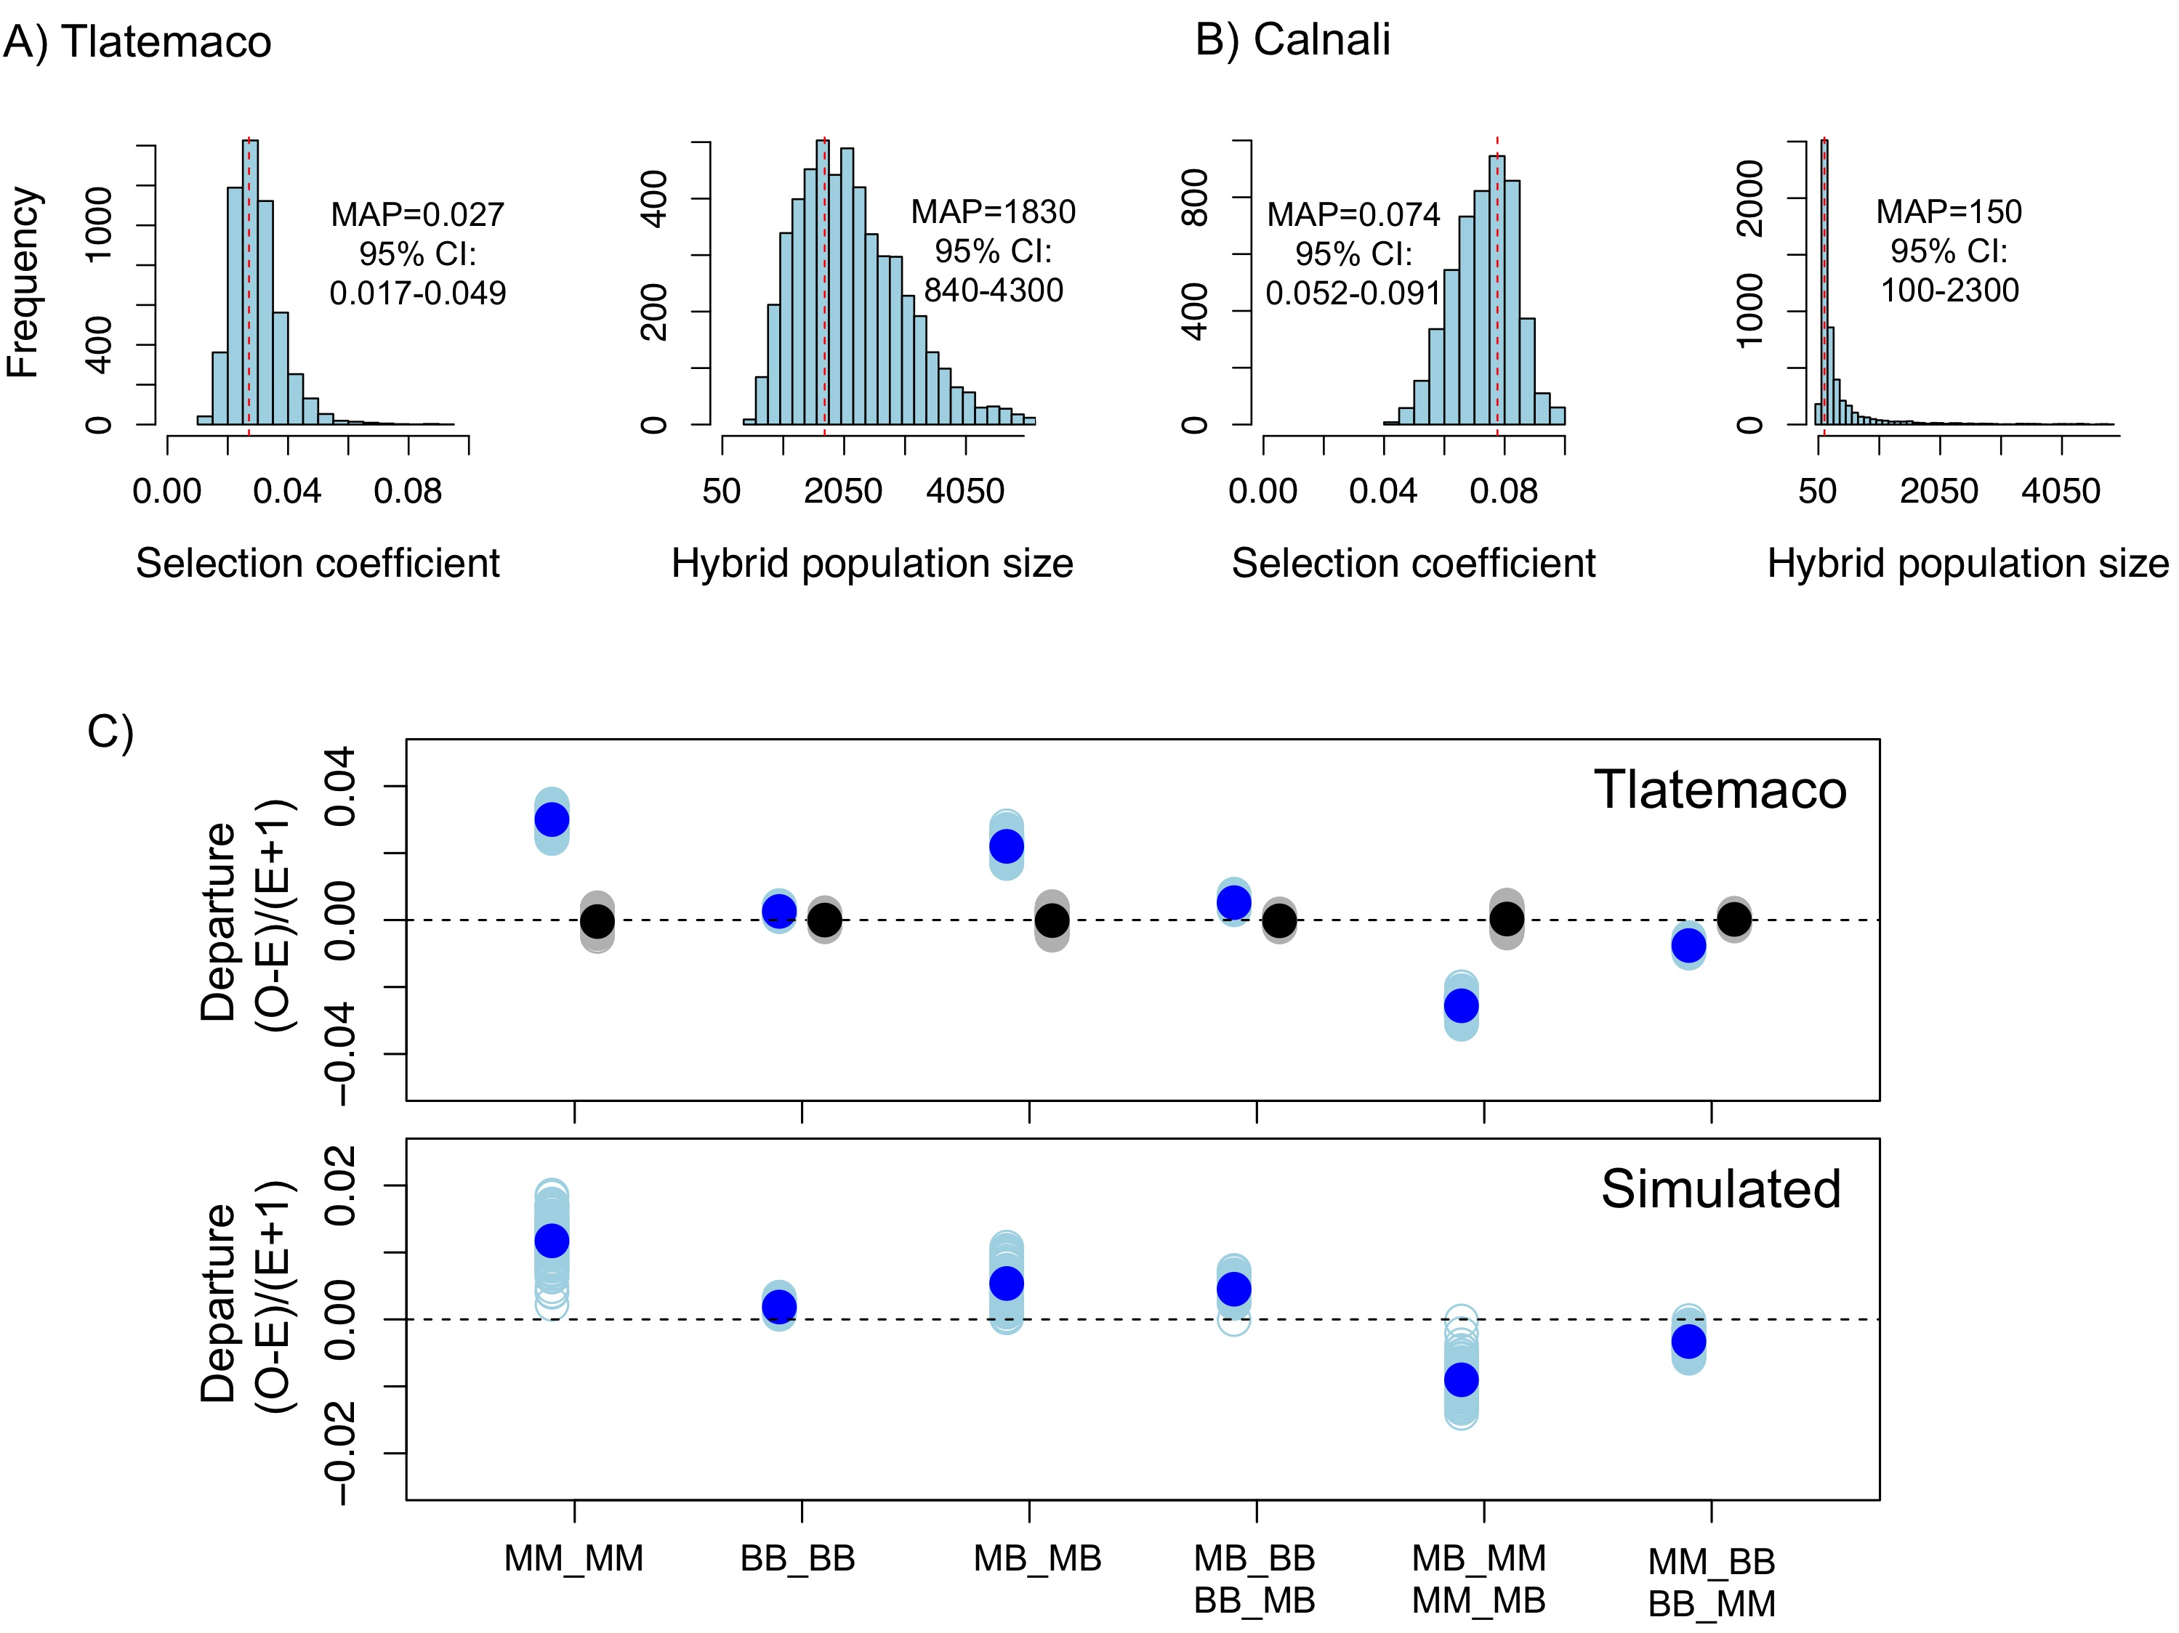

Figure 5. Loci in significant conspecific linkage disequilibrium show patterns consistent with selection against hybrid incompatibilities. (A) Posterior distributions of the selection coefficient and hybrid population size from ABC simulations for Tlatemaco and (B) Calnali. The range of the x-axis indicates the range of the prior distribution, maximum a posteriori estimates (MAP) and 95% CI are indicated in the inset. (C) Departures from expectations under random mating in the actual data (top- blue points indicate LD pairs, black points indicate random pairs from the genomic background) and samples generated by posterior predictive simulations (bottom, see Materials and Methods). The mean is indicated by a dark blue point; in the real data (top) smears denote the distribution of means for 1,000 simulations while in the simulated data (bottom) smears indicate results of each simulation. Genotypes with the same predicted deviations on average under the BDM model have been collapsed (figure supplement 1, but see figure supplement 3) and are abbreviated in the format locus1_locus2. These simulations show that the observed deviations are expected under the BDM model. The posterior distributions for *s* and hybrid population size are correlated at low population sizes (figure supplement 2). Deviations in Calnali also follow expectations under the BDM model (figure supplement 3).

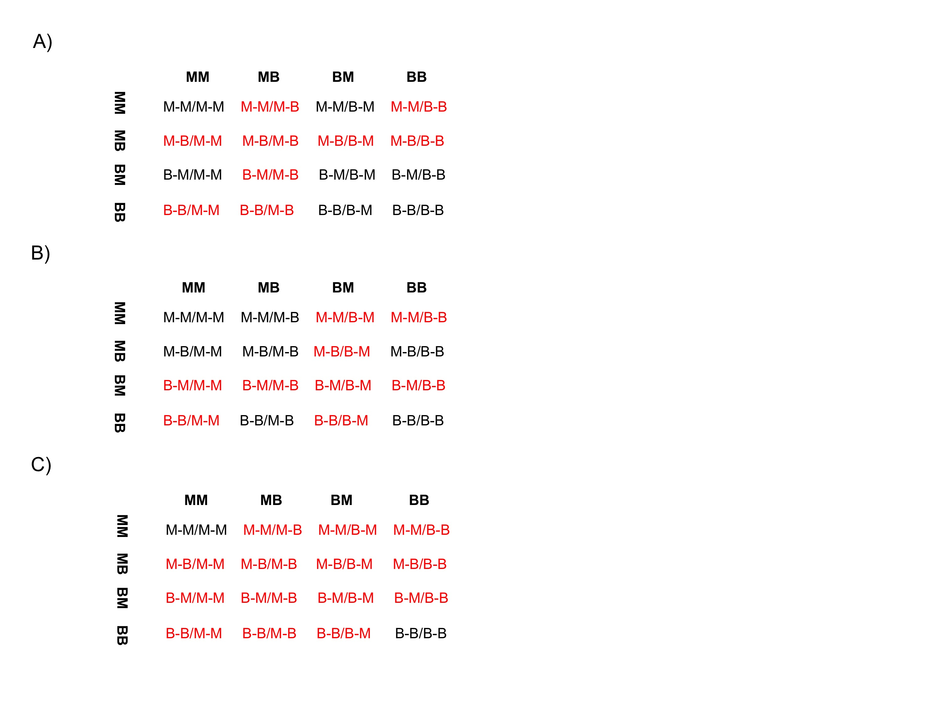

Figure 5-figure supplement 1. Different fitness matrices associated with selection against hybrid incompatibilities. In a classic BDMI model (A & B), hybrid genotypes potentially under selection (indicated in red) are determined by the locus and order in which mutations occur. In a model of co-evolution between loci or extrinsic selection against hybrid phenotypes (C), more genotype combinations are potentially under selection. (A) Interaction between a mutation in locus 1 *malinche* and locus 2 *birchmanni* (two-lineage model)or first substitution occurring in locus 1 *birchmanni* or locus 2 *malinche* (one-lineage model).(B) Interaction between a mutation in locus 1 *birchmanni* and locus 2 *malinche* (two-lineage model) or first substitution occurring in locus 1 *malinche* or locus 2 *birchmanni* (one-lineage model). Format of genotypes is as follows: haplotype1_locus1-haplotype1_locus2/haplotype2_locus1-haplotype2_locus2.

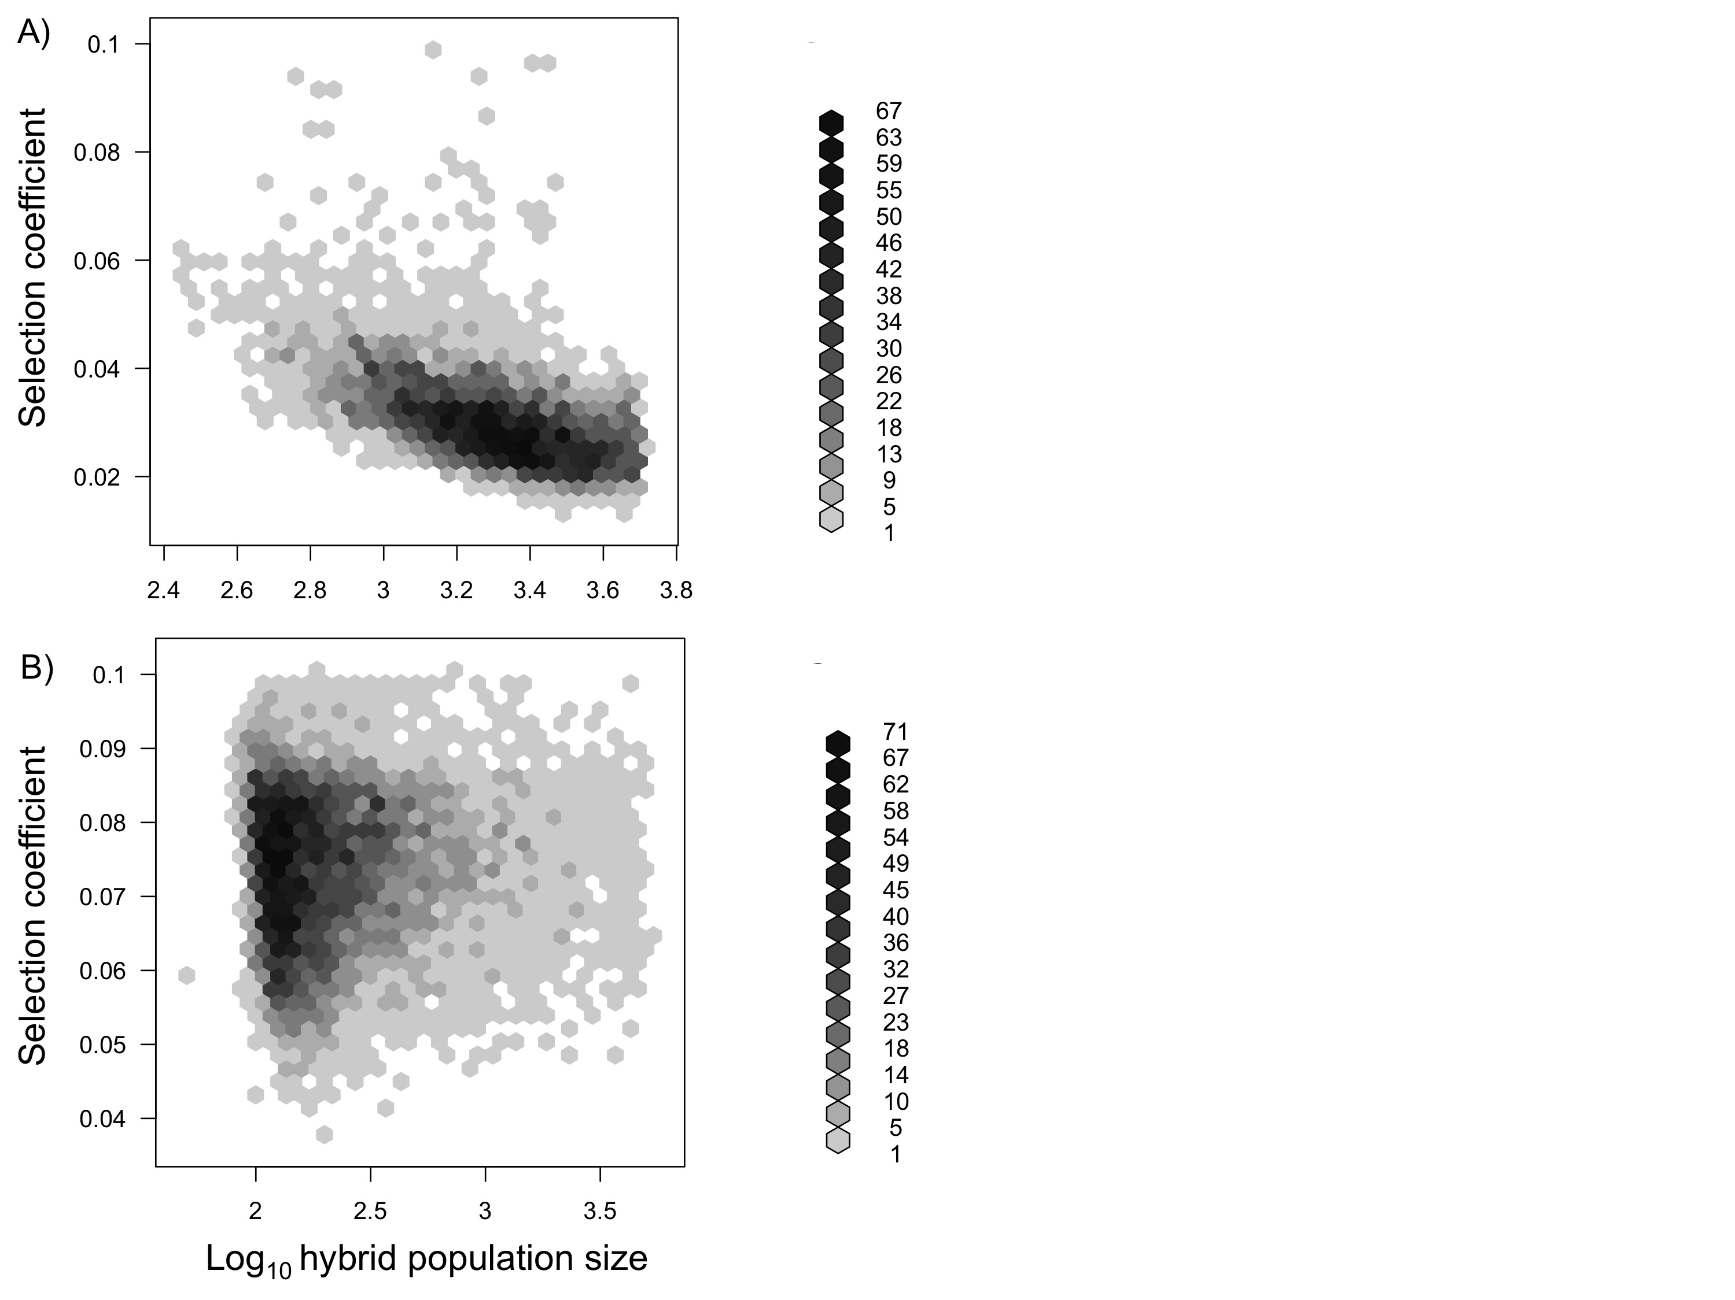

Figure 5-figure supplement 2. Joint posterior distribution of hybrid population size and selection coefficient. Posterior distributions of hybrid population size and *s* indicate a relationship between these parameters in both populations (A-simulations of Tlatemaco, B- simulations of Calnali).

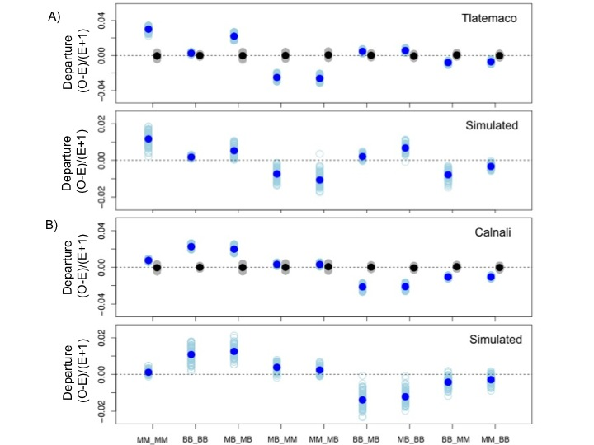

Figure 5-figure supplement 3. Deviations in genotype combinations compared to expected values under a two-locus selection model in both populations. Average deviation of genotype combinations (dark blue point) from expectations under random mating at conspecific LD pairs (top) compared to posterior predictive simulations (bottom, see Materials and Methods) in Tlatemaco (A) and Calnali (B). The light blue smears indicate the distribution of means for 1,000 bootstrap samples in the real data and result of individual simulations in the simulated data. Labels on the x-axis indicate the genotype in the format locus1_locus2.

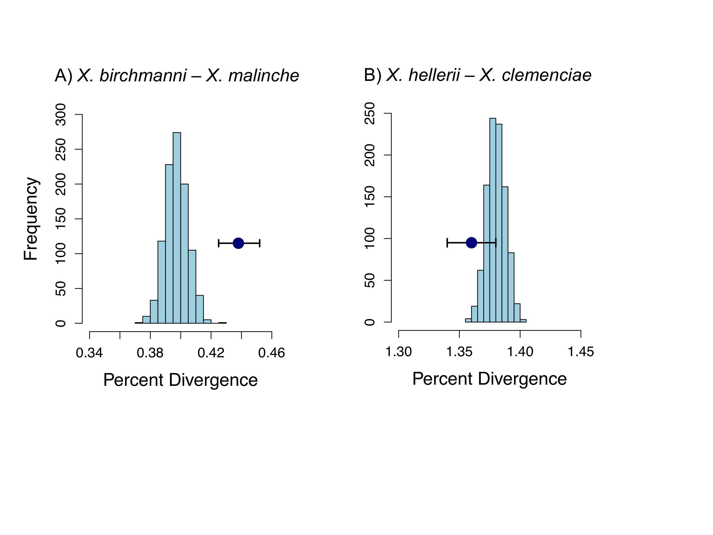

Figure 6. Divergence of LD pairs compared to the genomic background in two species comparisons. (A) Regions identified in *X. birchmanni* and *X. malinche* and (B) orthologous regions in *X. hellerii* and *X. clemenciae*. The blue point shows the average divergence for genomic regions within significant LD pairs, and whiskers denote a 95% confidence interval estimated by resampling genomic regions with replacement. The histogram shows the distribution of the average divergence for 1000 null datasets generated by resampling the genomic background without replacement.

Tables

Table 1. Comparison of results for sites in significant LD at two different p-value thresholds. P-values were determined resampling the genomic background, see main text for details.

|  |  |  |
| --- | --- | --- |
| Dataset | Number of pairs | Proportion of pairs with conspecific associations |
| Stringent (FDR<2%) | 150 | Tlatemaco: 72% (p<0.001)  Calnali: 94% (p<0.001) |
| Relaxed  (FDR 5%) | 327 | Tlatemaco: 67% (p<0.001)  Calnali: 94% (p<0.001) |

Table 2. Sites in significant LD are more divergent than the genomic background. Results shown here are limited to regions that had conspecific associations in both populations (stringent dataset: 200 regions, relaxed dataset: 414 regions). P-values were determined by resampling the genomic background.

|  |  |  |  |
| --- | --- | --- | --- |
| Mutation type | Median divergence  Genomic Background | Median divergence  Stringent | Median divergence  Relaxed |
| All sites | 0.0040 | 0.0045 (p<0.001) | 0.0044 (p<0.001) |
| Nonsynonymous | 0.00040 | 0.00065 (p=0.001) | 0.00040 (p=0.6) |
| Synonymous | 0.0040 | 0.0048 (p<0.001) | 0.0045 (p=0.004) |

References

Andolfatto P, Davison D, Erezyilmaz D, Hu TT, Mast J, Sunayama-Morita T, et al. 2011.

Multiplexed shotgun genotyping for rapid and efficient genetic mapping. Genome Res 21: 610-617. doi: 10.1101/gr.115402.110.

Barbash DA, Roote J, Ashburner M. 2000. The Drosophila melanogaster hybrid male

rescue gene causes inviability in male and female species hybrids. Genetics 154: 1747-1771.

Barbash DA, Siino DF, Tarone AM, Roote J. 2003. A rapidly evolving MYB-related

protein causes species isolation in Drosophila. Proc Natl Acad Sci USA 100: 5302-5307. doi: 10.1073/pnas.0836927100.

Bayes JJ, Malik HS. 2009. Altered Heterochromatin Binding by a Hybrid Sterility

Protein in Drosophila Sibling Species. Science 326: 1538-1541. doi: 10.1126/science.1181756.

Bomblies K, Lempe J, Epple P, Warthmann N, Lanz C, Dangl JL, et al. 2007.

Autoimmune response as a mechanism for a Dobzhansky-Muller-type incompatibility syndrome in plants. PLoS Biol 5: 1962-1972. doi: 10.1371/journal.pbio.0050236

Brideau NJ, Flores HA, Wang J, Maheshwari S, Wang X, Barbash DA. 2006. Two

Dobzhansky-Muller genes interact to cause hybrid lethality in Drosophila. Science 314: 1292-1295. doi: 10.1126/science.1133953.

Charlesworth B. 1998. Measures of divergence between populations and the effect of

forces that reduce variability. Mol Biol Evol 15: 538-543.

Corbett-Detig RB, Zhou J, Clark AG, Hartl DL, Ayroles JF. 2013. Genetic

incompatibilities are widespread within species. Nature 504: 135-137. doi:10.1038/nature12678.

Coyne JA, Orr HA. 2004. Speciation. Sinaeur Associates, Sunderland, MA.

Cui R, Schumer M, Kruesi K, Walter R, Andolfatto P, Rosenthal G. 2013.

Phylogenomics reveals extensive reticulate evolution in Xiphophorus fishes. Evolution 67: 2166–2179. doi: 10.1111/evo.12099.

Culumber ZW, Fisher HS, Tobler M, Mateos M, Barber PH, Sorenson MD, et al. 2011.

Replicated hybrid zones of Xiphophorus swordtails along an elevational gradient. Mol Ecol 20: 342-356. doi: 10.1111/j.1365-294X.2010.04949.x.

Culumber ZW, Ochoa OM, Rosenthal GG. In press. Assortative mating and the

maintenance of population structure in a natural hybrid zone. Amer Nat.

Culumber ZW, Shepard DB, Coleman SW, Rosenthal GG, Tobler M. 2012.

Physiological adaptation along environmental gradients and replicated hybrid zone structure in swordtails (Teleostei: Xiphophorus). J Evol Biol 25: 1800-1814. doi: 10.1111/j.1420-9101.2012.02562.x.

Cutter AD. 2012. The polymorphic prelude to Bateson-Dobzhansky-Muller

incompatibilities. Trends Ecol Evol 27: 209-218. doi: http://dx.doi.org/10.1016/j.tree.2011.11.004.

Ellegren H, Smeds L, Burri R, Olason PI, Backstrom N, Kawakami T, et al. 2012. The

genomic landscape of species divergence in Ficedula flycatchers. Nature 491: 756-760. doi:10.1038/nature11584.

Fang S, Yukilevich R, Chen Y, Turissini DA, Zeng K, Boussy IA, et al. 2012.

Incompatibility and Competitive Exclusion of Genomic Segments between Sibling Drosophila Species. PLoS Genet 8. doi: 10.1371/journal.pgen.1002795.

Fernandez AA, Bowser PR. 2010. Selection for a dominant oncogene and large male size

as a risk factor for melanoma in the Xiphophorus animal model. Mol Ecol 19: 3114-3123. doi: 10.1111/j.1365-294X.2010.04738.x.

Fernandez AA, Morris MR. 2008. Mate choice for more melanin as a mechanism to

maintain a functional oncogene. Proc Natl Acad Sci USA 105: 13503-13507. doi: 10.1073/pnas.0803851105.

Fisher HS, Mascuch SJ, Rosenthal GG. 2009. Multivariate male traits misalign with

multivariate female preferences in the swordtail fish, Xiphophorus birchmanni. Anim Behav 78: 265-269. doi: 10.1016/j.anbehav.2009.02.029.

Fisher HS, Wong BBM, Rosenthal GG. 2006. Alteration of the chemical environment

disrupts communication in a freshwater fish. Proc R Soc London Ser B 273: 1187-1193. doi:  10.1098/rspb.2005.3406.

Gardner K, Buerkle A, Whitton J, Rieseberg L. 2000. Inferring epistasis in wild

sunflower hybrid zones. In: Epistasis and the Evolutionary Process (ed. JB Wolf, ED Brodie III, MJ Wade), pp. 264-279. Oxford University Press, New York.

Gavrilets S. 1997. Single locus clines. Evolution 51: 979-983.

Gompert Z, Parchman TL, Buerkle CA. 2012. Genomics of isolation in hybrids. Phil

Trans R Soc B 367: 439-450. doi: 10.1098/rstb.2011.0196.

Hartl DL, Clark AG. 2007. Principles of population genetics, Fourth edition. Sinauer

Associations, Sunderland.

Harushima Y, Nakagahra M, Yano M, Sasaki T, Kurata N. 2001. A genome-wide survey

of reproductive barriers in an intraspecific hybrid. Genetics 159: 883-892.

Hastings A. 1981. Disequilibrium, selection, and recombination - limits in 2 - locus, 2 -

allele models. Genetics 98: 659-668.

Hellenthal G, Busby GBJ, Band G, Wilson JF, Capelli C, Falush D, Myers S. 2014. A

Genetic Atlas of Human Admixture History. Science 343: 747-751. doi: 10.1126/science.1243518.

Hohenlohe PA, Bassham S, Currey M, Cresko WA. 2012. Extensive linkage

disequilibrium and parallel adaptive divergence across threespine stickleback genomes. Philos Trans R Soc London Ser B 367: 395-408. doi:10.1098/rstb.2011.0245.

Hudson RR. 1990. Gene genealogies and the coalescent process. Oxford Surveys in

Evolutionary Biology 7: 1-44.

Jensen JD, Thornton KR, Andolfatto P. 2008. An Approximate Bayesian Estimator

Suggests Strong, Recurrent Selective Sweeps in Drosophila. Plos Genetics 4: e1000198. doi: 10.1371/journal.pgen.1000198.

Johnson JB. 2013. The architecture of phenotypes in a naturally hybridizing complex of

Xiphophorus fishes. Doctor of Philosophy in Biology, p. 103. Texas A&M University, College Station, TX.

Kallman KD. 1984. A new look at sex determination in poeciliid fishes. In: Evolutionary

genetics of fishes (ed. Turner BJ), pp. 95-171. Plenum Press, New York.

Karlin S. 1975. General 2-locus selection models - Some objectives, results and

interpretations. Theor Popul Biol 7: 364-398.

Lawniczak MKN, Emrich SJ, Holloway AK, Regier AP, Olson M, White B, et al. 2010.

Widespread Divergence Between Incipient Anopheles gambiae Species Revealed by Whole Genome Sequences. Science 330: 512-514. doi:10.1126/science.1195755.

Lee H-Y, Chou J-Y, Cheong L, Chang N-H, Yang S-Y, Leu J-Y. 2008. Incompatibility

of Nuclear and Mitochondrial Genomes Causes Hybrid Sterility between Two Yeast Species. Cell 135: 1065-1073. doi: 10.1016/j.cell.2008.10.047.

Li H, Durbin R. 2009. Fast and accurate short read alignment with Burrows-Wheeler

transform. Bioinformatics 25:1754-1760. doi: 10.1093/bioinformatics/btp324.

Lunter G, Goodson M. 2011. Stampy: A statistical algorithm for sensitive and fast

mapping of Illumina sequence reads. Genome Res 21:936-939. doi: 10.1101/gr.111120.110

Mallet J. 2005. Hybridization as an invasion of the genome. Trends Ecol Evol 20: 229-

237. doi:10.1016/j.tree.2005.02.010.

Masly JP, Presgraves DC. 2007. High-resolution genome-wide dissection of the two rules

of speciation in Drosophila. PLoS Biol 5: 1890-1898. doi:10.1371/journal.pbio.0050243.

Matute DR, Butler IA, Turissini DA, Coyne JA. 2010. A Test of the Snowball Theory for

the Rate of Evolution of Hybrid Incompatibilities. Science 329: 1518-1521. doi: 10.1126/science.1193440

Michel AP, Sim S, Powell THQ, Taylor MS, Nosil P, Feder JL. 2010. Widespread

genomic divergence during sympatric speciation. Proc Natl Acad Sci USA 107: 9724-9729. doi: 10.1073/pnas.1000939107.

Moyle LC, Graham EB. 2006. Genome-wide associations between hybrid sterility QTL

and marker transmission ratio distortion. Mol Biol Evol 23: 973-980. doi: 10.1093/molbev/msj112.

Moyle LC, Nakazato T. 2010. Hybrid Incompatibility "Snowballs" Between Solanum

Species. Science 329: 1521-1523. doi: 10.1126/science.1193063.

Nadeau NJ, Whibley A, Jones RT, Davey JW, Dasmahapatra KK, Baxter SW, et al.

2012. Genomic islands of divergence in hybridizing Heliconius butterflies identified by large-scale targeted sequencing. Philos Trans R Soc London Ser B 367: 343-353. doi: 10.1126/science.1193063.

Nairn RS, Kazianis S, McEntire BB, DellaColetta L, Walter RB, Morizot DC. 1996. A

CDKN2-like polymorphism in Xiphophorus LG V is associated with UV-B-induced melanoma formation in platyfish-swordtail hybrids. Proc Natl Acad Sci USA 93: 13042-13047.

Noor MAF, Bennett SM. 2009. Islands of speciation or mirages in the desert? Examining

the role of restricted recombination in maintaining species. Heredity 103: 439-444. doi: 10.1038/hdy.2009.151.

Nyholt DR. 2004. A simple correction for multiple testing for single-nucleotide

polymorphisms in linkage disequilibrium with each other. Am J Hum Genet 74: 765-769. doi:10.1086/383251.

Orr HA. 1989. Genetics of sterility in hybrids between 2 subspecies of Drosophila.

Evolution 43: 180-189.

Orr HA. 1995. The population genetics of speciation - the evolution of hybrid

incompatibilities. Genetics 139: 1805-1813.

Orr HA, Coyne JA. 1989. The genetics of postzygotic isolation in the Drosophila virilus

group. Genetics 121: 527-537.

Orr HA, Presgraves DC. 2000. Speciation by postzygotic isolation: forces, genes and

molecules. Bioessays 22: 1085-1094. doi: 10.1002/1521-1878(200012)22:12<1085::AID-BIES6>3.0.CO;2-G.

Orr HA, Turelli M. 2001. The evolution of postzygotic isolation: Accumulating

Dobzhansky-Muller incompatibilities. Evolution 55: 1085-1094. doi: 10.1111/j.0014-3820.2001.tb00628.x.

Payseur BA. 2010. Using differential introgression in hybrid zones to identify genomic

regions involved in speciation. Mol Ecol Resour 10: 806-820. doi: 10.1111/j.1755-0998.2010.02883.x.

Payseur BA, Hoekstra HE. 2005. Signatures of reproductive isolation in patterns of single

nucleotide diversity across inbred strains of mice. Genetics 171: 1905-1916. doi: 10.1534/genetics.105.046193

Payseur BA, Krenz JG, Nachman MW. 2004. Differential patterns of introgression across

the X chromosome in a hybrid zone between two species of house mice. Evolution 58: 2064-2078. doi: 10.1554/03-738.

Presgraves DC. 2002. Patterns of postzygotic isolation in Lepidoptera. Evolution 56:

1168-1183. doi: 10.1111/j.0014-3820.2002.tb01430.x.

Presgraves DC. 2003. A fine-scale genetic analysis of hybrid incompatibilities in

Drosophila. Genetics 163: 955-972.

Presgraves DC. 2008. Sex chromosomes and speciation in Drosophila. Trends Genet 24:

336-343. doi: 10.1016/j.tig.2008.04.007.

Presgraves DC, Balagopalan L, Abmayr SM, Orr HA. 2003. Adaptive evolution drives

divergence of a hybrid inviability gene between two species of Drosophila. Nature 423: 715-719. doi:10.1038/nature01679.

Pryke SR. 2010. Sex chromosome linkage of mate preference and color signal maintains

assortative mating between interbreeding finch morphs. Evolution 64: 1301-1310. doi: 10.1111/j.1558-5646.2009.00897.x.

Renaut S, Grassa CJ, Yeaman S, Moyers BT, Lai Z, Kane NC, et al. 2013. Genomic

islands of divergence are not affected by geography of speciation in sunflowers. Nat Commun 4. doi:10.1038/ncomms2833.

Rogers AR, Huff C. 2009. Linkage Disequilibrium Between Loci With Unknown Phase.

Genetics 182: 839-844. doi: 10.1534/genetics.108.093153.

Rosenthal GG, de la Rosa Reyna XF, Kazianis S, Stephens MJ, Morizot DC, Ryan MJ, et

al. 2003. Dissolution of sexual signal complexes in a hybrid zone between the swordtails Xiphophorus birchmanni and Xiphophorus malinche (Poeciliidae). Copeia 2003: 299-307. doi: http://dx.doi.org/10.1643/0045-8511(2003)003[0299:DOSSCI]2.0.CO;2.

Ross JA, Koboldt DC, Staisch JE, Chamberlin HM, Gupta BP, Miller RD, Baird SE, Haag ES. 2011. Caenorhabditis briggsae Recombinant Inbred Line Genotypes Reveal

Inter-Strain Incompatibility and the Evolution of Recombination. PLoS Genet 7:e1002174. doi: 10.1371/journal.pgen.1002174.

Sankararaman S, Patterson N, Li H, Paeaebo S, Reich D. 2012. The Date of Interbreeding

between Neandertals and Modern Humans. PLoS Genet 8:e1002947. doi: 10.1371/journal.pgen.1002947

Scascitelli M, Whitney KD, Randell RA, King M, Buerkle CA, Rieseberg LH. 2010.

Genome scan of hybridizing sunflowers from Texas (Helianthus annuus and H. debilis) reveals asymmetric patterns of introgression and small islands of genomic differentiation. Mol Ecol 19: 521-541. doi: 10.1111/j.1365-294X.2009.04504.x.

Schartl M. 2004. Sex chromosome evolution in non-mammalian vertebrates. Curr Opin

Genet Dev 14: 634-641. doi:10.1016/j.gde.2004.09.005.

Schartl M. 2008. Evolution of Xmrk: an oncogene, but also a speciation gene? Bioessays

30: 822-832. doi: 10.1002/bies.20807.

Schartl M, Walter RB, Shen Y, Garcia T, Catchen J, Amores A, et al. 2013. The genome

of the platyfish, Xiphophorus maculatus, provides insights into evolutionary adaptation and several complex traits. Nat Genet 45: 567-U150. doi: 10.1038/ng.2604.

Schumer M, Cui R, Boussau B, Walter R, Rosenthal G, Andolfatto P. 2013. An

evaluation of the hybrid speciation hypothesis for Xiphophorus clemenciae based on whole genome sequences. Evolution 67: 1155-1168. doi: 10.1111/evo.12009.

Schumer M, Cui R, Powell D, Dresner R, Rosenthal GG, Andolfatto P. Data from: High-

resolution Mapping Reveals Hundreds of Genetic Incompatibilities in Hybridizing Fish Species. Dryad Digital Repository. doi:10.5061/dryad.q6qn0.

Seehausen O, Butlin RK, Keller I, Wagner CE, Boughman JW, Hohenlohe PA, Peichel

CL, Saetre G-P, Bank C, Braennstroem A et al. 2014. Genomics and the origin of species. Nature Reviews Genetics 15: 176-192. doi:10.1038/nrg3644.

Seidel HS, Rockman MV, Kruglyak L. 2008. Widespread genetic incompatibility in C.

elegans maintained by balancing selection. Science 319: 589-594. doi: 10.1126/science.1151107.

Smith LM, Bomblies K, Weigel D. 2011. Complex Evolutionary Events at a Tandem

Cluster of Arabidopsis thaliana Genes Resulting in a Single-Locus Genetic

Incompatibility. PLoS Genet 7: 1-14. doi: 10.1371/journal.pgen.1002164.

Sperling FAH. 1994. Sex-linked genes and species-differences in Lepidoptera. Can

Entomol 126: 807-818. doi:10.4039/Ent126807-3.

Sweigart AL, Fishman L, Willis JH. 2006. A simple genetic incompatibility causes

hybrid male sterility in mimulus. Genetics 172: 2465-2479. doi:

10.1534/genetics.105.053686.

Tang S, Presgraves DC. 2009. Evolution of the Drosophila Nuclear Pore Complex

Results in Multiple Hybrid Incompatibilities. Science 323: 779-782. doi: 10.1126/science.1169123.

Thornton KR. 2009. Automating approximate Bayesian computation by local linear

regression. BMC Genet 10. doi:10.1186/1471-2156-10-35.

Ting CT, Tsaur SC, Wu ML, Wu CI. 1998. A rapidly evolving homeobox at the site of a

hybrid sterility gene. Science 282: 1501-1504. doi: 10.1126/science.282.5393.1501.

Turelli M, Barton NH, Coyne JA. 2001. Theory and speciation. Trends Ecol Evol 16:

330-343. doi:10.1016/S0169-5347(01)02177-2.

Turner TL, Hahn MW, Nuzhdin SV. 2005. Genomic islands of speciation in Anopheles

gambiae. PLoS Biol 3: 1572-1578. doi: 10.1371/journal.pbio.0030285.

Verzijden MN, Culumber ZW, Rosenthal GG. 2012. Opposite effects of learning cause

asymmetric mate preferences in hybridizing species. Behav Ecol 23: 1133-1139. doi: 10.1093/beheco/ars086.

Verzijden MN, Rosenthal GG. 2011. Effects of sensory modality on learned mate

preferences in female swordtails. Anim Behav 82: 557–562.

doi:10.1016/j.anbehav.2011.06.010.

Vonholdt BM, Stahler DR, Bangs EE, Smith DW, Jimenez MD, Mack CM, et al. 2010. A

novel assessment of population structure and gene flow in grey wolf populations of the Northern Rocky Mountains of the United States. Mol Ecol 19: 4412-4427. doi: 10.1111/j.1365-294X.2010.04769.x.

Walter RB, Rains JD, Russell JE, Guerra TM, Daniels C, Johnston DA, et al. 2004. A

microsatellite genetic linkage map for Xiphophorus. Genetics 168: 363-372. doi: 10.1534/genetics.103.019349.

Yang ZH. 1997. PAML: a program package for phylogenetic analysis by maximum

likelihood. Comput Appl Biosci 13: 555-556. doi: 10.1093/molbev/msm088.

Supporting Information

Supplementary File 1A: Pairs of regions in significant linkage disequilibrium (FDR 5%).

|  |  |  |  |  |  |
| --- | --- | --- | --- | --- | --- |
| LG 1 | Start coordinate | End coordinate | LG 2 | Start coordinate | End coordinate |
| 1 | 17336118 | 17352508 | 3 | 25372521 | 25372521 |
| 1 | 9041150 | 14027379 | 4 | 8202830 | 8276795 |
| 1 | 22655822 | 22666726 | 4 | 23314998 | 23356384 |
| 1 | 27979362 | 28160521 | 4 | 25609528 | 25693013 |
| 1 | 16760177 | 16780005 | 5 | 14471066 | 14488287 |
| 1 | 10709652 | 14111741 | 6 | 13140519 | 13214551 |
| 1 | 11859270 | 11872584 | 6 | 13991153 | 13991153 |
| 1 | 16129743 | 16304529 | 7 | 26461649 | 26672342 |
| 1 | 1394132 | 9104793 | 8 | 10091645 | 10163420 |
| 1 | 17336118 | 23141431 | 9 | 2826444 | 2868419 |
| 1 | 14020485 | 14056751 | 10 | 7191819 | 7243591 |
| 1 | 9410180 | 9418996 | 11 | 1433236 | 1436284 |
| 1 | 15121937 | 15121937 | 11 | 1546686 | 1546686 |
| 1 | 15017287 | 15018908 | 11 | 24391642 | 24391642 |
| 1 | 9410180 | 9410180 | 12 | 3047636 | 3048351 |
| 1 | 16218433 | 16286890 | 13 | 21485004 | 21485004 |
| 1 | 9159868 | 9162521 | 15 | 10465666 | 10509594 |
| 1 | 14020485 | 14111741 | 15 | 22416221 | 22880189 |
| 1 | 9159868 | 15354910 | 16 | 11844740 | 12011464 |
| 1 | 11475203 | 11504678 | 16 | 14751151 | 14825511 |
| 1 | 11848350 | 23031051 | 17 | 1915768 | 2261043 |
| 1 | 14504941 | 14506872 | 17 | 9221233 | 9222588 |
| 1 | 14056751 | 16306957 | 18 | 21424222 | 26345526 |
| 1 | 9204755 | 9418996 | 19 | 10052237 | 10455880 |
| 1 | 22535041 | 22535041 | 20 | 14395952 | 14398318 |
| 1 | 9159868 | 14032450 | 21 | 540806 | 1634470 |
| 1 | 9002900 | 9104793 | 22 | 8890935 | 8965609 |
| 1 | 14031125 | 14100412 | 22 | 13899590 | 13931721 |
| 2 | 25593039 | 25603580 | 3 | 276700 | 323308 |
| 2 | 263560 | 279044 | 3 | 7452570 | 7452570 |
| 2 | 11167393 | 11207666 | 3 | 29122080 | 29131143 |
| 2 | 12220711 | 12228460 | 4 | 13546117 | 13568067 |
| 2 | 1040121 | 1315557 | 4 | 16899566 | 16964555 |
| 2 | 24595178 | 24633975 | 4 | 21233317 | 21236027 |
| 2 | 23855209 | 23855209 | 4 | 26179659 | 26182382 |
| 2 | 25543275 | 25546544 | 5 | 10308042 | 10321919 |
| 2 | 11636398 | 11639464 | 5 | 10783094 | 10784698 |
| 2 | 12400386 | 12441032 | 5 | 20161740 | 20162582 |
| 2 | 25297281 | 25370064 | 5 | 30387362 | 30478150 |
| 2 | 14059617 | 14059617 | 6 | 13134404 | 13134404 |
| 2 | 11487618 | 11622125 | 6 | 13877262 | 13897996 |
| 2 | 9747837 | 9751240 | 7 | 17452941 | 17467711 |
| 2 | 25237409 | 25252918 | 11 | 1191424 | 1297746 |
| 2 | 9730811 | 16093705 | 11 | 21825197 | 21872867 |
| 2 | 21603270 | 21604670 | 12 | 14886563 | 14904124 |
| 2 | 1959094 | 1972622 | 15 | 19221963 | 19223718 |
| 2 | 9551264 | 9731714 | 16 | 24262149 | 24495144 |
| 2 | 11432685 | 11794935 | 17 | 2261043 | 2272099 |
| 2 | 21603270 | 25603580 | 20 | 14395952 | 17140805 |
| 2 | 23788489 | 23805274 | 20 | 19109172 | 19219654 |
| 2 | 1908372 | 2008638 | 21 | 1042069 | 1634470 |
| 2 | 21603270 | 21603270 | 22 | 14127266 | 14157951 |
| 2 | 10849465 | 10849465 | 22 | 14667642 | 14673498 |
| 2 | 11670498 | 11670498 | 23 | 2051281 | 2052983 |
| 3 | 17449491 | 17449491 | 4 | 1482148 | 1486970 |
| 3 | 7340111 | 7340111 | 4 | 1716383 | 1721173 |
| 3 | 11880143 | 11888259 | 4 | 17570456 | 17570456 |
| 3 | 17648889 | 17727938 | 4 | 19237112 | 19370548 |
| 3 | 6569361 | 6569523 | 5 | 10522548 | 10522548 |
| 3 | 26346922 | 26372340 | 5 | 24797730 | 24889402 |
| 3 | 23905276 | 23927606 | 5 | 30285219 | 30617226 |
| 3 | 7340111 | 7518742 | 6 | 12985663 | 13004660 |
| 3 | 695789 | 11947610 | 6 | 13148414 | 14480297 |
| 3 | 17429812 | 25326513 | 8 | 10065677 | 10118233 |
| 3 | 11800329 | 11886613 | 9 | 9432419 | 9436826 |
| 3 | 23909958 | 23909958 | 9 | 11147119 | 11148048 |
| 3 | 17727938 | 17783407 | 9 | 17476911 | 17478089 |
| 3 | 15783050 | 29270931 | 10 | 11130931 | 16715367 |
| 3 | 28837287 | 29172219 | 12 | 18514565 | 18581397 |
| 3 | 701958 | 1330571 | 13 | 7657517 | 22541483 |
| 3 | 28028883 | 28066693 | 13 | 25652691 | 25792205 |
| 3 | 6569361 | 7379626 | 15 | 21942895 | 22326461 |
| 3 | 17661368 | 17666616 | 16 | 1990558 | 1990558 |
| 3 | 25326513 | 25372521 | 16 | 5105054 | 12305996 |
| 3 | 6603151 | 6603411 | 17 | 1885375 | 2226585 |
| 3 | 9936216 | 9936272 | 18 | 2279670 | 2279670 |
| 3 | 6569361 | 6586029 | 18 | 13072974 | 13160335 |
| 3 | 11791932 | 28100138 | 20 | 1678052 | 2559548 |
| 3 | 17386732 | 17386811 | 21 | 2839271 | 2868729 |
| 3 | 15783050 | 15801784 | 21 | 4535148 | 4546412 |
| 3 | 25372521 | 25372521 | 22 | 27558163 | 27558163 |
| 3 | 6569361 | 11512487 | 23 | 9548411 | 22907627 |
| 3 | 13177197 | 13180040 | 23 | 24930770 | 24962253 |
| 4 | 21236027 | 21395335 | 5 | 16931217 | 17062162 |
| 4 | 16943225 | 16964555 | 6 | 14472370 | 14530448 |
| 4 | 13711466 | 13711466 | 7 | 15357929 | 15368356 |
| 4 | 1766268 | 2014333 | 8 | 10895228 | 10915008 |
| 4 | 1692081 | 1709066 | 9 | 2826444 | 2827620 |
| 4 | 8314011 | 8328433 | 9 | 3449644 | 3453723 |
| 4 | 25337923 | 25356103 | 9 | 15198701 | 15199433 |
| 4 | 19174050 | 19181303 | 11 | 20590225 | 20594765 |
| 4 | 180699 | 18799751 | 12 | 3137634 | 3283393 |
| 4 | 25119815 | 25130537 | 13 | 7590601 | 7590601 |
| 4 | 1672192 | 1680173 | 13 | 11650338 | 11723739 |
| 4 | 26142510 | 26171029 | 13 | 24505076 | 24576936 |
| 4 | 8302322 | 13948758 | 15 | 22283344 | 22291461 |
| 4 | 12529064 | 24902258 | 17 | 1942483 | 2035638 |
| 4 | 1921711 | 1969636 | 17 | 2226585 | 2261043 |
| 4 | 11234348 | 11234348 | 18 | 17282642 | 17302940 |
| 4 | 13940194 | 13948758 | 18 | 26286966 | 26294885 |
| 4 | 26088830 | 26088830 | 20 | 4006412 | 4006412 |
| 4 | 25942921 | 25942921 | 20 | 6030189 | 6079344 |
| 4 | 23284323 | 23284323 | 20 | 14481624 | 14509117 |
| 4 | 26164477 | 26183594 | 20 | 16776052 | 16830666 |
| 4 | 17296452 | 17544197 | 21 | 90370 | 2868729 |
| 4 | 1967138 | 14109057 | 22 | 10938214 | 11108388 |
| 4 | 8202830 | 25693013 | 23 | 295725 | 2865971 |
| 4 | 13940194 | 13968299 | 23 | 9771788 | 9771788 |
| 5 | 2877174 | 2877259 | 6 | 10665425 | 10665425 |
| 5 | 10308042 | 10522548 | 6 | 13660319 | 13681283 |
| 5 | 31195531 | 31356977 | 6 | 15637418 | 15647097 |
| 5 | 16931217 | 16931217 | 6 | 17470397 | 17476451 |
| 5 | 25200564 | 25277535 | 7 | 4109257 | 26681591 |
| 5 | 20161740 | 20162582 | 8 | 11173118 | 11173118 |
| 5 | 24843831 | 24844314 | 8 | 13436390 | 13448570 |
| 5 | 14885069 | 14885069 | 8 | 15596244 | 15596744 |
| 5 | 2875251 | 24812827 | 9 | 2906523 | 3453723 |
| 5 | 10308042 | 10309582 | 9 | 20428135 | 20461775 |
| 5 | 30472086 | 30510695 | 9 | 23220027 | 23224888 |
| 5 | 25200564 | 30532210 | 11 | 21825197 | 21872867 |
| 5 | 25200564 | 25206309 | 11 | 25358300 | 25358300 |
| 5 | 30357882 | 30357885 | 12 | 7307282 | 7314774 |
| 5 | 14028531 | 28918986 | 12 | 23853759 | 23930688 |
| 5 | 13854984 | 13854984 | 13 | 1570379 | 1582080 |
| 5 | 34962 | 59866 | 13 | 7657517 | 7658396 |
| 5 | 30286391 | 30718453 | 13 | 21485004 | 24576936 |
| 5 | 25200564 | 25271407 | 14 | 3708085 | 3733021 |
| 5 | 10783094 | 10784166 | 15 | 20797030 | 20815009 |
| 5 | 2808709 | 2877259 | 15 | 22067487 | 22067487 |
| 5 | 10643095 | 10677821 | 15 | 22283344 | 22332596 |
| 5 | 19260572 | 19272336 | 18 | 4762823 | 4786778 |
| 5 | 20161740 | 20162582 | 18 | 17430190 | 17430190 |
| 5 | 25200564 | 25213429 | 18 | 25995706 | 26044956 |
| 5 | 28863755 | 28874792 | 20 | 15215308 | 15226492 |
| 5 | 16940482 | 16940482 | 20 | 20045588 | 20047448 |
| 5 | 24621971 | 24647190 | 21 | 3596746 | 3603564 |
| 5 | 30387362 | 30388585 | 22 | 14077895 | 14085043 |
| 5 | 15471198 | 15471198 | 24 | 5047925 | 5047925 |
| 6 | 14234379 | 14234379 | 8 | 10101781 | 10144990 |
| 6 | 9921529 | 10078395 | 9 | 17194539 | 17199902 |
| 6 | 10036343 | 10050251 | 10 | 16736864 | 16748825 |
| 6 | 22787750 | 22787750 | 11 | 1191424 | 1299964 |
| 6 | 17809480 | 17809766 | 11 | 3276666 | 3312212 |
| 6 | 10628106 | 10628106 | 12 | 22888917 | 22888917 |
| 6 | 23968835 | 23975076 | 13 | 773136 | 788393 |
| 6 | 14946152 | 15121186 | 13 | 10186610 | 10256102 |
| 6 | 10901693 | 10901693 | 15 | 12132878 | 12132878 |
| 6 | 19430127 | 19433941 | 15 | 21953073 | 21953073 |
| 6 | 14858510 | 14861490 | 18 | 17411098 | 17516434 |
| 6 | 15637418 | 15647097 | 18 | 23600842 | 23672833 |
| 6 | 18739541 | 18746772 | 19 | 14295361 | 14302158 |
| 6 | 14858510 | 14858510 | 19 | 20415847 | 20415847 |
| 6 | 22769725 | 22787750 | 20 | 6085587 | 6100039 |
| 6 | 17499052 | 17559524 | 20 | 12369528 | 12369528 |
| 6 | 10831540 | 11052343 | 21 | 378980 | 1634470 |
| 6 | 10665425 | 10665425 | 22 | 1444345 | 1897489 |
| 6 | 14442026 | 14442026 | 22 | 13934676 | 13934676 |
| 7 | 4589003 | 4904351 | 9 | 23190458 | 23249493 |
| 7 | 15669875 | 15679406 | 10 | 6453315 | 6465262 |
| 7 | 13551827 | 13553526 | 10 | 10491496 | 10491496 |
| 7 | 13540528 | 13553526 | 11 | 1433236 | 1469464 |
| 7 | 4682291 | 17514511 | 11 | 10994373 | 25086509 |
| 7 | 4589003 | 4589003 | 12 | 9093822 | 9094239 |
| 7 | 15025330 | 15114968 | 12 | 14363321 | 14413675 |
| 7 | 15339228 | 15368356 | 13 | 21678702 | 21697683 |
| 7 | 26632648 | 26674614 | 13 | 22492778 | 22500991 |
| 7 | 15875895 | 15875895 | 14 | 288883 | 288883 |
| 7 | 15813957 | 15875895 | 15 | 10465666 | 10509594 |
| 7 | 17467711 | 17514511 | 15 | 12132878 | 12132878 |
| 7 | 4589003 | 15368356 | 15 | 21942895 | 22802280 |
| 7 | 13324512 | 13409853 | 18 | 10152593 | 10157519 |
| 7 | 5018180 | 5018180 | 18 | 16520491 | 16521697 |
| 7 | 7909537 | 7909537 | 19 | 11998975 | 11998975 |
| 7 | 16154984 | 16156994 | 19 | 14728864 | 14811917 |
| 7 | 7920471 | 7958170 | 19 | 25099228 | 25100387 |
| 7 | 7909537 | 7958170 | 20 | 19029275 | 19029275 |
| 7 | 15020570 | 17514511 | 20 | 26767765 | 26816533 |
| 7 | 13460390 | 13527337 | 24 | 5034235 | 5145263 |
| 8 | 23350943 | 23554469 | 9 | 1133865 | 2368569 |
| 8 | 14227310 | 14235522 | 9 | 2826444 | 2826636 |
| 8 | 10091645 | 10318590 | 10 | 4478091 | 4567381 |
| 8 | 10350629 | 14235522 | 10 | 10561476 | 16847728 |
| 8 | 10153722 | 10361623 | 11 | 2970487 | 21825671 |
| 8 | 10530977 | 10551307 | 13 | 7590601 | 7590601 |
| 8 | 10318590 | 10361623 | 13 | 11609267 | 11609267 |
| 8 | 10321613 | 10361623 | 14 | 11364925 | 11378468 |
| 8 | 13480564 | 13519345 | 14 | 15361743 | 15364822 |
| 8 | 10539349 | 12774671 | 15 | 16970909 | 22812942 |
| 8 | 10350629 | 15447126 | 16 | 14481980 | 14825511 |
| 8 | 23366883 | 23424573 | 18 | 13914266 | 13916581 |
| 8 | 10309436 | 10895228 | 18 | 17411098 | 26397164 |
| 8 | 14172092 | 14172092 | 20 | 27695025 | 27695025 |
| 8 | 13439398 | 13446555 | 22 | 9507567 | 9512884 |
| 8 | 10091267 | 12748274 | 22 | 13970291 | 14127266 |
| 8 | 11157227 | 11173118 | 23 | 24991434 | 24991434 |
| 8 | 10144267 | 10915008 | 24 | 5144017 | 5227319 |
| 9 | 14474306 | 14483264 | 10 | 4478091 | 4485970 |
| 9 | 10668253 | 10668253 | 10 | 11215425 | 11216555 |
| 9 | 23218530 | 23274664 | 10 | 16165881 | 16183370 |
| 9 | 11104847 | 11106198 | 11 | 1471239 | 1471239 |
| 9 | 9432419 | 9436826 | 12 | 3047636 | 3081089 |
| 9 | 3512056 | 3533129 | 12 | 13508486 | 13519715 |
| 9 | 15247222 | 15253199 | 12 | 14904124 | 14904124 |
| 9 | 27076697 | 27216940 | 12 | 16905525 | 16932710 |
| 9 | 2826444 | 2921761 | 12 | 21586204 | 21891045 |
| 9 | 3629933 | 3631371 | 13 | 1796315 | 1796315 |
| 9 | 23189030 | 23274664 | 13 | 21653101 | 21697683 |
| 9 | 26063036 | 26079779 | 14 | 10092221 | 10112623 |
| 9 | 12455760 | 12606088 | 15 | 20797030 | 22019805 |
| 9 | 2826444 | 2868419 | 15 | 22515923 | 22519412 |
| 9 | 11621783 | 11693616 | 15 | 22707007 | 22722728 |
| 9 | 12690984 | 12703222 | 17 | 2261043 | 2261043 |
| 9 | 3450012 | 20405517 | 18 | 13798022 | 18231441 |
| 9 | 11613979 | 11620616 | 18 | 25916763 | 25918767 |
| 9 | 9432419 | 9436826 | 18 | 26166107 | 26169195 |
| 9 | 12641548 | 12641548 | 18 | 31739348 | 31739348 |
| 9 | 3449644 | 3533129 | 19 | 15904018 | 15980138 |
| 9 | 28017262 | 28037013 | 19 | 16208822 | 16228638 |
| 9 | 3629933 | 3631371 | 20 | 16248070 | 16248070 |
| 9 | 12672595 | 16514457 | 21 | 90370 | 1634470 |
| 9 | 3510713 | 3533129 | 22 | 1607517 | 1623448 |
| 9 | 18094049 | 18116344 | 22 | 9386063 | 9408176 |
| 9 | 3449644 | 3453723 | 23 | 1058819 | 1216814 |
| 10 | 11329266 | 11333784 | 11 | 3245244 | 3274594 |
| 10 | 14207999 | 14207999 | 12 | 16929841 | 16929841 |
| 10 | 3819799 | 3825737 | 17 | 407770 | 442789 |
| 10 | 16794539 | 16847728 | 17 | 2024225 | 2272099 |
| 10 | 11502536 | 11502536 | 21 | 1042069 | 1048183 |
| 10 | 10506582 | 10558926 | 21 | 4619148 | 4631662 |
| 10 | 15397838 | 15414041 | 22 | 1587957 | 1623448 |
| 10 | 25349165 | 25349165 | 22 | 8950660 | 8958873 |
| 10 | 16794539 | 16806313 | 23 | 14084538 | 14163515 |
| 11 | 611962 | 25386423 | 12 | 3076611 | 8475870 |
| 11 | 11487713 | 11493754 | 12 | 12276878 | 12282160 |
| 11 | 1104677 | 26826712 | 12 | 13268382 | 13754062 |
| 11 | 3245244 | 20578812 | 12 | 22020426 | 22684489 |
| 11 | 11546908 | 11548704 | 13 | 2165006 | 2165179 |
| 11 | 1335727 | 1345243 | 13 | 21697683 | 21697683 |
| 11 | 1466099 | 1469464 | 14 | 3709192 | 3712892 |
| 11 | 3251658 | 25830675 | 15 | 21942895 | 22742130 |
| 11 | 203080 | 3281520 | 17 | 1885375 | 2272099 |
| 11 | 21809657 | 21822189 | 18 | 9313857 | 9317763 |
| 11 | 661982 | 25386423 | 18 | 25405866 | 26169195 |
| 11 | 12925626 | 13216539 | 19 | 8884026 | 9213034 |
| 11 | 1537758 | 1565245 | 19 | 15904018 | 15980138 |
| 11 | 1191424 | 13586421 | 20 | 12369528 | 16404973 |
| 11 | 13319949 | 13321524 | 21 | 93551 | 236381 |
| 11 | 21809657 | 21828111 | 21 | 540806 | 542317 |
| 11 | 25386423 | 25868906 | 22 | 9002385 | 13812692 |
| 11 | 1191424 | 13555033 | 22 | 14406707 | 26678379 |
| 11 | 15292019 | 15292019 | 23 | 13992342 | 13992342 |
| 11 | 22062838 | 22079106 | 23 | 24870945 | 24882320 |
| 12 | 16760118 | 16760118 | 13 | 21400569 | 21409314 |
| 12 | 7222848 | 7232689 | 13 | 21697683 | 21697683 |
| 12 | 5052382 | 22458119 | 15 | 22094317 | 22742130 |
| 12 | 3050266 | 3139518 | 16 | 14498334 | 14568682 |
| 12 | 22352097 | 22361989 | 16 | 23329872 | 23329872 |
| 12 | 7137037 | 17359073 | 17 | 1885375 | 2272099 |
| 12 | 19338201 | 19341109 | 18 | 16935942 | 16955353 |
| 12 | 21773444 | 21788944 | 18 | 18251384 | 18252793 |
| 12 | 3047636 | 3135044 | 19 | 16944905 | 16945525 |
| 12 | 3047636 | 25626373 | 20 | 13161199 | 16287880 |
| 12 | 7118539 | 22086298 | 21 | 276839 | 542317 |
| 12 | 13779103 | 22666198 | 22 | 1444345 | 26678379 |
| 12 | 8465398 | 8479257 | 23 | 4196335 | 4196335 |
| 12 | 7264186 | 7266462 | 23 | 17857536 | 17860268 |
| 13 | 21485004 | 24270423 | 14 | 3708085 | 3733021 |
| 13 | 21485004 | 22520694 | 15 | 20797030 | 22291461 |
| 13 | 42307 | 1320652 | 15 | 22688770 | 22722728 |
| 13 | 10247124 | 10280438 | 17 | 2024225 | 2187387 |
| 13 | 7590601 | 22559849 | 18 | 17413626 | 26251701 |
| 13 | 21485004 | 25227803 | 21 | 90370 | 1634470 |
| 13 | 1579925 | 1582080 | 23 | 20793214 | 20793214 |
| 13 | 21501641 | 21697683 | 23 | 24856644 | 24875945 |
| 13 | 1717774 | 7389367 | 24 | 5034235 | 5124785 |
| 14 | 3708085 | 3789169 | 15 | 14723541 | 22707007 |
| 14 | 3728685 | 3733021 | 18 | 26157481 | 26348861 |
| 14 | 10130064 | 10130064 | 20 | 27458530 | 27815038 |
| 14 | 11364925 | 11366639 | 22 | 9004558 | 9004558 |
| 14 | 9547538 | 15336200 | 23 | 93776 | 161597 |
| 15 | 16949183 | 20798724 | 16 | 7370063 | 14986397 |
| 15 | 626877 | 724378 | 18 | 4738289 | 4754122 |
| 15 | 16949183 | 22818557 | 18 | 13059888 | 26098779 |
| 15 | 22294118 | 22294480 | 18 | 31165412 | 31165412 |
| 15 | 14649857 | 14651563 | 19 | 477159 | 477159 |
| 15 | 16949183 | 16994111 | 19 | 7593624 | 7620913 |
| 15 | 1665935 | 1694107 | 19 | 10891094 | 10966120 |
| 15 | 21994040 | 22010375 | 19 | 16226776 | 16228638 |
| 15 | 1665935 | 1665935 | 20 | 26879386 | 26879386 |
| 15 | 21944013 | 22332596 | 22 | 20820840 | 26678379 |
| 15 | 22067487 | 22087763 | 23 | 14062631 | 21748997 |
| 15 | 22782769 | 22782769 | 23 | 23075450 | 23087258 |
| 15 | 12237393 | 22094317 | 23 | 24870945 | 24958507 |
| 15 | 12132878 | 22294480 | 24 | 5035277 | 5227319 |
| 16 | 15209233 | 16189020 | 17 | 1888079 | 1944813 |
| 16 | 15116423 | 15117184 | 18 | 14860441 | 14860441 |
| 16 | 23447870 | 23449159 | 18 | 31830953 | 31960823 |
| 16 | 23207721 | 23207721 | 19 | 8884026 | 8957951 |
| 16 | 14822260 | 14825511 | 20 | 12409595 | 12418015 |
| 16 | 23481272 | 23481272 | 22 | 9021293 | 9021293 |
| 16 | 24495144 | 24683219 | 23 | 874496 | 944250 |
| 17 | 2024225 | 2122614 | 19 | 7593624 | 7600574 |
| 17 | 2105738 | 2187387 | 20 | 15690742 | 15692886 |
| 17 | 1888079 | 1891121 | 23 | 21750224 | 21752979 |
| 18 | 19955068 | 26172641 | 19 | 8884026 | 12027308 |
| 18 | 2284236 | 17314949 | 20 | 14330859 | 15453426 |
| 18 | 13789155 | 13789155 | 21 | 1634470 | 1634470 |
| 18 | 17282642 | 26172641 | 22 | 1822344 | 9315649 |
| 18 | 17459698 | 17516434 | 23 | 994534 | 1289701 |
| 18 | 2532009 | 3709619 | 23 | 2472359 | 2550101 |
| 18 | 26087854 | 26098779 | 23 | 4427404 | 4429132 |
| 18 | 31197030 | 31197030 | 23 | 14156413 | 14160513 |
| 19 | 16944905 | 16945525 | 20 | 13161199 | 13196332 |
| 19 | 14865978 | 14911534 | 20 | 16816268 | 16834221 |
| 19 | 7593624 | 7620913 | 20 | 26879386 | 26899995 |
| 19 | 9118269 | 9240773 | 22 | 1444345 | 1478270 |
| 19 | 11217652 | 11307443 | 22 | 2869028 | 2890178 |
| 19 | 12321021 | 12375504 | 22 | 13931721 | 13939080 |
| 19 | 12015123 | 12027308 | 23 | 21705032 | 21751337 |
| 19 | 24615739 | 24626858 | 24 | 5119424 | 5125883 |
| 20 | 17098331 | 19184988 | 21 | 1634470 | 1634470 |
| 20 | 15336141 | 15351928 | 21 | 4535148 | 4535148 |
| 20 | 26851694 | 26872113 | 22 | 8795122 | 8843923 |
| 20 | 13161199 | 16248070 | 22 | 14055453 | 14127266 |
| 20 | 16280299 | 16403312 | 23 | 295771 | 14853912 |
| 21 | 12572253 | 12597080 | 24 | 5291894 | 5293994 |
| 22 | 14389316 | 14404276 | 23 | 14820731 | 14853912 |

Supplementary File 1B: Pairs of LD regions (FDR 5%) that have single-gene resolution.

|  |  |  |  |
| --- | --- | --- | --- |
| Region 1 | Gene 1 | Region 2 | Gene 2 |
| 1:15086760_15125971 | ERC2 | 11:1544498_1559761 | PITX1 |
| 1:14504941_14506872 | NAV1 | 17:9221233_9222588 | CDPF1 |
| 4:8314011_8328433 | SENP8 | 9:3449644_3453723 | DTYMK |
| 4:1672192_1680173 | AP2A2 | 13:11650338_11723739 | STMN1 |
| 5:24843831_24844314 | KPNA2 | 8:13436390_13448570 | UNC5C |
| 5:10783094_10784166 | GRIN2B | 15:20797030_20815009 | ENAH |
| 7:15339228_15368356 | FIGN | 13:21678702_21697683 | STMN1 |
| 11:1466099_1469464 | SEC24A | 14:3709192_3712892 | PVRL4 |
| 11:22062838_22079106 | RABEP1 | 23:24870945_24882320 | GPC3 |
| 12:19338201_19341109 | IKBKB | 18:16935942_16955353 | SCN4B |
| 16:14822260_14825511 | RSAD1 | 20:12409595_12418015 | protein_coding |
| 19:7593624_7620913 | protein_coding | 20:26879386_26899995 | RIMS4 |
| 19:12321021_12375504 | DAAM2 | 22:13931721_13939080 | HPSE2 |

Supplementary File 1C: Divergence analysis for full dataset including pairs heterospecific in one or both populations.

|  |  |  |
| --- | --- | --- |
| Mutation type | Median divergence Genomic Background | Median divergence (FDR 5%) |
| All sites | 0.004 | 0.0044 (p<0.001) |
| Nonsynonymous | 0.0004 | 0.0005 (p=0.13) |
| Synonymous | 0.004 | 0.0044 (p<1e-4) |

CHAPTER FOUR

Ancient hybridization and genomic stabilization in a swordtail fish

Abstract

A rapidly increasing body of work is revealing that the genomes of distinct species often exhibit hybrid ancestry, presumably due to post-speciation hybridization between closely related species and/or speciation associated with hybridization itself (“hybrid speciation”). Despite the growing number of documented cases, we still know relatively little about how genomes evolve and stabilize following hybridization, and to what extent hybridization is functionally relevant. Here I examine the case of *Xiphophorus nezahualcoyotl*, a teleost fish whose genome exhibits significant hybrid ancestry. I show that hybridization was relatively ancient and is unlikely to be ongoing. Strikingly, the genome of *X. nezahualcoyotl* has largely stabilized following hybridization, distinguishing it from examples such as human-Neandertal. Hybridization-derived regions are remarkably distinct from other regions of the genome, tending to be enriched in genomic regions with reduced constraint. These results suggest that selection has played a role in removing hybrid ancestry from certain functionally important regions. Combined with findings in other systems, my results raise many questions about the process of genomic stabilization and the role of selection in shaping patterns of hybrid ancestry in the genome.

Introduction

Hybridization between different species is now known to be a common evolutionary process. As a result, the genomes of many species include regions derived from hybridization. Though hybridization and hybrid ancestry in the genome are now recognized as common, we are just beginning to develop a conceptual framework for understanding how genomes evolve following hybridization and what this implies about the role of hybridization in adaptation and speciation. Many core questions about the dynamics of genome evolution after hybridization remain unanswered. Is the fixation and loss of hybridization-derived regions in the genome primarily governed by neutral processes? What role do hybrid incompatibilities play in purging hybridization-derived regions from the genome? How many hybridization-derived regions were driven to fixation by positive selection (i.e. adaptive introgression)? Beginning to address these questions is the first step in understanding the functional consequences of hybridization and its importance in speciation.

Although hybrid ancestry has been documented in the genomes of many species, less is known about the variation within and between populations of the same species in hybrid ancestry. Different populations may experience distinct histories of hybridization, resulting in different admixture proportions (Cahill *et al.* 2015). Differences between populations in effective population sizes can also contribute to variation in admixture proportions if selection is less effective at purging hybridization-derived regions from the genome in small populations (Sankararaman *et al.* 2014).

Unless there is ongoing gene flow between species, we expect that over time hybrid ancestry in the genome will eventually stabilize, either due to genetic drift (the strength of which depends on population sizes) or selection. Though there has been little empirical work on the process of genomic stabilization, existing results are mixed. For example, few Neandertal-derived regions in the human genome have fixed in the 2,000 generations since hybridization occurred (Sankararaman *et al.* 2014; Sankararaman *et al.* 2012). By contrast, in a hybrid lineage of *Zymoseptoria* fungi, ~30% of the genome has fixed for one or the other parental haplotype in the last ~400 generations (Stukenbrock *et al.* 2012). Similarly, in hybrid sunflower species, genomic stabilization is believed to have occurred rapidly, in fewer than 1,000 generations (Buerkle & Rieseberg 2008). Demographic differences likely have major effects on these patterns (e.g. rapid expansion of human populations and the haploid life cycle in fungi), but rapid rates of stabilization in some species suggest either an important role for selection in shaping the hybrid genome or strong genetic drift (Buerkle & Rieseberg 2008). More research is needed to understand whether there are general rules for how quickly genomes stabilize after hybridization and which processes most commonly drive this stabilization.

To understand what role selection may play in determining hybrid ancestry in the genome, we can also ask about where hybrid ancestry occurs in the genome. The human-Neandertal hybridization event has been one of the best-studied cases of genome evolution post-admixture. Research in this system has suggested that the regions of Neandertal ancestry still present in the modern human genome are evolutionarily constrained (Sankararaman *et al.* 2014). Rapidly evolving regions also have lower than expected Neandertal ancestry in modern humans (Vernot & Akey 2014), as do regions of the genome subject to purifying selection in humans (Sankararaman *et al.* 2014) but see also (Juric *et al.* 2015). These results suggest that selection has acted to shape patterns of Neandertal-derived ancestry among human genomes.

Evidence from other species hints at similar dynamics between hybridization and selection. In the *Helianthus* sunflower hybrid species complex, experimentally synthesized hybrid lineages recapitulate patterns of ancestry observed in hybrid species, suggesting that selection had determined the architecture of ancestry in the hybrid species (Rieseberg *et al.* 1996). Similarly, experimentally synthesized autopolyploid (hybridization-derived polyploid) plants undergo comparable genomic changes to those observed in ancient autopolyploids (Soltis & Soltis 1999; Song *et al.* 1995; Tayale & Parisod 2013). In contrast, in a recent study of hybrid agricultural corn, independently selected lineages did not show consistent patterns of genetic changes (Gerke *et al.* 2015).

Studies of differential introgression in hybrid zones have also informed our understanding of the interactions between gene flow and selection. For example, male hybrids between two house mouse subspecies, *Mus musculus musculus* and *M. m. domesticus*, exhibit a range of reduced fertility phenotypes due to epistatic genetic incompatibilities (Good *et al.* 2010; Turner & Harr 2014; Turner *et al.* 2014; White *et al.* 2011). These regions are particularly resistant to introgression across hybrid zones between the two subspecies, suggesting that selection is effectively filtering gene flow throughout the genome (Payseur *et al.* 2004; Payseur & Nachman 2005). Similarly, in the hybridizing swordtail fish *Xiphophorus birchmanni* and *X. malinche*, regions of the genome implicated in hybrid incompatibilities are more divergent between species (but not between other closely related species), suggesting that these regions have resisted homogenization from historical gene flow (Schumer *et al.* 2014). A large number of studies in a range of species have found patterns of differential introgression across the genome (e.g. Carling & Brumfield 2008; Geraldes *et al.* 2006; Hamilton *et al.* 2013; Larson *et al.* 2013; Martinsen *et al.* 2001; Teeter *et al.* 2008), consistent with selection filtering gene flow, though in most cases a direct link between selection and differential introgression has not been established.

Examples of adaptive introgression, such as the evolution of warning wing color patterns in butterflies, poison resistance in mice, and drought tolerance in sunflowers (Heliconius Genome 2012; Song *et al.* 2011; Whitney *et al.* 2010), underscore the fact that hybridization-derived regions are not always fixed by passive processes. However, it is notable that all of these cases involve hybrid ancestry in just a few genomic regions; how likely adaptive introgression is on a genome-wide scale, especially in cases where a large proportion of the genome has been derived from hybridization, is an open question. Research on the functional consequences of hybridization have hinted at an excess of hybrid ancestry in some gene families and functional categories, implying that hybridization can be a mechanism for broadly co-opting functional elements from another genome. For example, modern humans harbor more than expected Neandertal ancestry at genes involved in skin and hair phenotypes (Sankararaman *et al.* 2014; Vernot & Akey 2014), suggesting that humans migrating out of Africa acquired phenotypes may have adapted to a non-African environment via hybridization rather than *de novo* mutations.

To address these many questions about the processes shaping hybrid ancestry in the genome, we need to investigate patterns of hybrid ancestry and genomic stabilization in a broader range of species. Swordtail fish (*Xiphophorus*) have been a model system for the evolutionary genetics of hybridization for the better part of a century (Atz 1962; Gordon 1937), with a renewed surge of interest since the advent of modern molecular methods (Culumber *et al.* 2011; Jones *et al.* 2012; Kang *et al.* 2013; Meyer *et al.* 2006).It was previously reported that a species of northern swordtail, *X. nezahualcoyotl,* had significant hybrid ancestry in its transcriptome (Cui *et al.* 2013). While the majority of the transcriptome of *X. nezahualcoyotl* indicates it is sister to *X. montezumae*, a large fraction appear to be derived from a parapatric swordtail species, *X. cortezi* (Figure 1). Here I quantitatively evaluate this pattern using whole genome sequences for all three species. In addition, I evaluate the extent, and timing, of genome stabilization and ask whether hybridization-derived regions exhibit specific properties in relation to gene content and constraint.

Methods

*Sample collection*

Sample collection procedures for this study were approved by the Texas A&M Institutional Animal Care and Use Committee (Protocol # 2013-0168) and the Mexican federal government (see Acknowledgments). Individuals were collected using baited minnow traps and seine nets in the states of San Louis Potosí and Tamaulipas, Mexico between 2013 and 2015. *X. cortezi* and *X. montezumae* were collected from southern San Louis Postosí from the Río Huichihuayanin May of 2013 and the Río Tamasopo in March of 2015 respectively. *X. nezahualcoyotl* were sampled from two distinct populations: two individuals from Arroyo Los Gallitos (hereafter “Gallitos”) in southern Tamaulipas, Mexico in 2014 and one from a stock collected at Arroyo Las Crucitas (hereafter “Crucitas”) in southern San Louis Potosi, Mexico in 2011. Lateral photographs of each fish were taken prior to tissue sampling. For sequencing, one male of each species was anesthetized using tricane methanylsulfonate (MS-222). A fin clip was then taken from the upper portion of the caudal fin and preserved in 95% ethanol.

*Genomic DNA extraction and library preparation*

GenomicDNA was extracted from fin clips using the DNeasy kit (Qiagen, Valencia, CA) and quantified and assessed for purity using a Nanodrop 1000 (Thermo Scientific, Wilmington, DE). One microgram of DNA was sheared into 500 bp fragments using a Covaris LE220 sonicator (Covaris, Woburn, MA) and prepared for sequencing following the protocol of Quail *et al*. (Quail *et al.* 2009). Briefly, sheared DNA was end-repaired and an A-tail was added to facilitate adaptor ligation. Following adaptor ligation, libraries were run on a 2% agarose gel to select products between 400-600 bps and purified using a Qiagen gel purification kit (Qiagen, Valencia, CA). Following purification, samples were PCR-amplified with a custom indexed primers for 12-14 cycles using the Phusion high-fidelity polymerase system (NEB, Ipswich, MA). PCR products were purified with Agencourt AMPure XP beads (Beckman Coulter, Brea, California) and the size distribution and purity was evaluated on a Bioanalyzer 2100 (Agilent, Santa Clara, California). Libraries were sequenced on a total of 9 lanes of an Illumina HiSeq 2000 with v3 chemistry, yielding 101 bp single-end reads. Additional 141 bp single-end reads were collected on the Illumina HiSeq 2500 were collected for the *X. montezumae* individual to increase coverage.

*Sequence processing and variant calling*

Raw sequences were parsed by index using a custom python script. The number of reads per sample (ranging from 196 to 398 million) and mapping statistics are summarized in Table S1. I refrained from trimming reads to remove low-quality base, as recommended by the GATK pipeline (McKenna *et al.* 2010). However, I did trim reads to remove potential adapter sequences using the program cutadapt v1.9 (Li *et al.* 2012). Reads were mapped to the *X. maculatus* reference genome version 4.4.2 using the bwa-mem algorithm (Li & Durbin 2009). Unplaced contigs were included for read mapping but not included in downstream analyses. Variant calling was performed using the GATK version 3.4 pipeline (McKenna *et al.* 2010). Briefly, sam files were converted to bam files, duplicates were marked and removed, and bam files indexed using Picard tools v1.118. INDEL realignment was performed with GATK and genotypes were called with HaplotypeCaller in the gVCF format. Because there is no library of verified SNPs for the *Xiphophorus* species in this study, I did not perform base recalibration or variant recalibration. Instead, I filtered the final gVCFs for each species to identify sites for low coverage (DP<10), low quality score (variant quality - GQ or invariant quality - RGQ <20), low mapping quality (MQ < 40), low quality by depth score (QD<2), high fisher strand score (FS>60), high strand odds ratio (SOR > 4), low read position rank sum score (ReadPosRankSum< -8), and low mapping quality rank sum score (MQRankSum < -12.5). I also masked INDELs and all sites within 5 bp of INDELs. These thresholds were determined based on applying GATK’s recommendations to simulated data and adjusting thresholds to improve accuracy (see Supporting Information 1). Note that for invariant sites only DP and RQG filters could be used. To generate reference-based genomes for analysis, I used the *X. maculatus* genome as a scaffold and updated variant sites for each species using the program seqtk (https://github.com/lh3/seqtk), masking variant and invariant sites identified as with low quality based on the above filters. Using simulated data, I confirm that this align-to-reference and variant-calling pipeline has high sensitivity to real variants (Figure S1), low error rate (Figure S2) and is unlikely to result in artifacts that could be misinterpreted as hybrid ancestry using this approach (Figure S3, see Supporting Information 2, 3).

*Whole genome phylogenetic analysis and phylogenetic discordance*

To infer the species tree for the five reference-based genomes (*X. nezahualcoyotl* (Gallitos), *X. nezahualcoyotl* (Crucitas), *X.* *montezumae, X. cortezi* and the *X. maculatus* genome reference as an outgroup), I estimated a maximum likelihood tree with 100 bootstraps using a General Time Reversible substitution model as implemented in RAxML 7.2.8 (Stamatakis 2006). Despite the presence of multiple linkage groups and prior evidence for reticulation (Cui et al. 2012), the data was analyzed as a single partition. The final length of the RAxML matrix after excluding 16% gaps and undetermined characters was 662 Mb. Genome-wide there were 272-282,000 phylogenetically informative sites (for the Crucitas and Gallitos *X. nezahualcoyotl* samples, respectively). The distribution of missing data for each sample is shown in Figure S4.

To estimate the proportion of the genome supporting admixture between the *X. nezahualcoyotl* and *X. cortezi* lineages, I divided the whole-genome alignments into 10 kb segments and performed an approximately unbiased (AU) test on these alignments (Shimodaira 2002). I performed this analysis with the two *X. nezahualcoyotl* sequences separately, testing support for the three possible topologies of an unrooted four-taxa tree. I calculated site likelihoods using RAxML (as above) and input these likelihoods into Consel 0.2 (Shimodaira & Hasegawa 2001). For each topology, this program gives the probability that the topology is as likely as the maximum likelihood tree. If a particular alignment had a probability greater than 0.95 for a topology, I treated this as support for that topology. I excluded alignments that had a likelihood difference of 0 between topologies because this can be caused by a low number of informative sites (Schmidt (2009). Because this approach tends to result in ambiguous probabilities for windows of mixed ancestry (see Schumer *et al.* 2012), it will likely underestimate the proportion of the genome derived from hybridization when hybridization-derived regions are small.

*Test for gene tree asymmetry*

There are two major reasons why the phylogenetic relationships in a particular region of the genome will differ from the true phylogenetic relationships between species. Incomplete lineage sorting (ILS) can result in support for alternative phylogenetic relationships in particular genomic regions (Maddison 1997). A second common cause of this discordance is hybridization between species (Green *et al.* 2010). One signature of hybridization that can differ from ILS is the relative representation of different phylogenetic relationships. If there has been biased gene flow, more regions of the genome will support a particular minor topology than expected. The expectation under ILS is that an equal number of discordant trees will support each of the two possible minor topologies in a four-taxon tree. However, it is important to keep in mind that population structure during speciation can also generate gene tree asymmetry (Green *et al.* 2010). To test for significant gene tree asymmetry, I performed 1,000 bootstrap resamplings with replacement of the AU test results. This allowed us to calculate confidence intervals for the proportion of the genome supporting each topology and assess whether confidence intervals for the two minor topologies overlap. As noted above, significant differences in the proportion of the genome supporting each minor topology is evidence for gene flow (or population structure during speciation).

*Identifying and delineating phylogenetically discordant regions*

The approaches described above have two limitations. First, while both methods allow me to estimate the proportion of the genome that supports each possible topology they do not allow me to infer the boundaries of these regions. Second, these analyses do not allow me to distinguish between ILS and hybridization for particular genomic regions.

To address both of these limitations, I use the program PhyloNet-HMM (Liu *et al.* 2014) to delineate between regions supporting different hybridization scenarios. PhyloNet-HMM uses a hidden Markov model to detect breakpoints between regions supporting different phylogenetic relationships. PhyloNet-HMM uses the concept of parent trees that correspond to different hybridization scenarios (e.g. hybridization tree and species tree) and gene trees, which correspond to different gene tree relationships within each parent tree. Thus, this program theoretically allows for ILS of gene trees within a parent tree without switching parent tree topologies. As a result, switching from the parent tree to the hybridization tree should only occur in response to a change in hybridization signal. Performance tests suggest that this approach accurately distinguishes between ILS and hybridization. PhyloNet-HMM rarely mis-assigns regions with only ILS to the hybridization tree (Supporting Information 4, Figure S5), suggesting that the majority of regions it identifies will be truly hybridization-derived.

I ran PhyloNet-HMM separately on alignments of *X. montezumae, X. maculatus, X. cortezi* and each *X. nezahualcoyotl* sample. I divided the genome into 2 Mb alignments to increase computational speed.I specified two possible parental trees, the species tree with *X. montezumae* most closely related to *X. nezahualcoyotl*, and a hybridization tree with *X. cortezi* most closely related to *X. nezahualcoyotl.* An example of the parameters file used is available in the Appendix (Supporting Information). Briefly, I specified substitution rates and base frequencies based on RAxML results but allowed the program to optimize all other parameters including branch lengths. I treated posterior probabilities greater than 0.95 as support for a particular parent tree, and delineated regions of support as stretches of sites with ≥0.95 posterior support for a particular parent tree (Figure S6). Note that this approach systematically underestimates the length of hybridization-derived regions (Figure S7).

Since recombination rates vary throughout the genome, the sizes of discordant regions will depend on the local recombination rate. Based on performance analyses (Supporting Information 4), I analyze two datasets with different expected false discovery rates, a full dataset (false positive rate 2%) and a stringent dataset filtered by region size to reduce the false positive rate (false positive rate <0.5%). This more conservative dataset only included regions >0.02 cM in length (see Supporting Information 5).

*Determining the direction of introgression*

Phylogenetic approaches such as PhyloNet-HMM can identify potentially introgressed regions, but are not informative about the direction of introgression, or in this case, whether the region introgressed from the *X. cortezi* lineage into *X. nezahualcoyotl* or vice versa. To investigate the direction of gene flow, I compared divergence between species at regions inferred to be hybridization-derived. As an additional approach, I applied the DFOIL approach (Pease & Hahn 2015; <https://github.com/jbpease/dfoil>). This approach, an extension of the widely used D-statistic (Green *et al.* 2010), uses site patterns in a 5-taxa tree to polarize the direction of introgression. In this study, I used the genome sequence of *X. malinche* which together with *X. birchmanni* forms the sister clade to *X. cortezi* (Cui *et al.* 2013). Since genome-wide patterns were suggestive of a complex history of introgression (see Supporting Information 6), I also applied DFOIL to individual regions identified by PhyloNetHMM. Specifically, I ask what proportion of regions supported each of the two directions for introgression (i.e. into *X. nezahualcoyotl* versus into *X. cortezi*)at a p-value cutoff of 0.05.

*Evaluating stabilization of hybridization-derived regions*

Based on simulation results, PhyloNet-HMM does not effectively infer hybridization at regions that are heterozygous for ancestry (see Supporting Information 7). When PhyloNet-HMM encounters such regions, it almost always assigns them ambiguous posterior probabilities (Supporting Information 7). Other HMM-based chromosome painting methods, such as Multiplexed Shotgun Genotyping, allow for inference of heterozygous hybrid ancestry, but have low sensitivity to short ancestry tracts and as a result cannot be effectively used here (Andolfatto *et al.* 2011; Schumer *et al.* 2015a). Only ~15% of the genome was assigned ambiguous posterior probabilities by PhyloNet-HMM in my analysis (see Results). These ambiguous signals could be produced by ancestry heterozygosity but also by many other factors. As a first pass for identifying heterozygous hybrid ancestry regions, I asked if nucleotide heterozygosity was higher than expected at sites inferred to be ancestry informative between *X. montezumae* and *X. cortezi*. Using the approaches described in Supporting Information 4, with the exception of incorporating population specific estimates of θ for the two *X. nezahualcoyotl* samples (Table S1), I perform neutral coalescent simulations to generate 1 Mb alignments and estimate the number of sites that are expected to be polymorphic in each *X. nezahualcoyotl* sample for alternate alleles that are homozygous in *X. montezumae* and *X. cortezi* (e.g. *X. nezahualcoyotl* genotype AC, *X. montezumae* AA, *X. cortezi* CC). To determine whether the observed number of sites of this type falls outside null expectations for either sample, I ask whether the observed number in the real data falls outside the 95% confidence intervals predicted from 1,000 coalescent simulations.

As an additional approach, I asked whether ambiguous regions showed evidence of *cortezi*-*nezahualcoyotl* hybridization using the D-statistic (Green *et al.* 2010), and how the signal in these regions compared to the rest of the genome and regions identified as hybridization-derived by PhyloNet-HMM. To capture introgression at polymorphic sites with this approach, one allele was randomly sampled at each polymorphic site when calculating D.

*Estimating the timing of hybridization and genome stabilization*

Due to the complex history of introgression (see Results) it is not straightforward to determine either the absolute time since hybridization occurred between the *X. nezahualcoyotl* and *X. cortezi* lineages or how long it took for hybrid ancestry to stabilize in the genome. Despite these difficulties, I apply two approaches to begin to address these questions. First, I compare divergence between hybridization-derived regions and the rest of the genome (see next section). Second, I use the length of hybridization-derived haplotypes to investigate the time between hybridization and stabilization of hybrid ancestry in the genome (Supporting Information 8,9). This approach has several limitations when applied to this data (see full discussion in Supporting Information 8) and thus these results should be viewed as a first approximation.

*Properties of hybridization-derived regions*

My aim is to determine if hybridization-derived regions are atypical compared to the genomic background for a number of features (see sections below). One challenge in performing these comparisons is ensuring that the genomic background does not differ from hybridization-derived regions simply due to biases in detection. I use different approaches to control for this depending on the analysis but for all comparisons I draw regions for null datasets only from regions of the genome that were confidently called for the species tree by PhyloNet-HMM. In addition, only regions identified as hybridization-derived using both *X. nezahualcoyotl* populations were used in these analyses. As discussed above, I analyzed two datasets, one restricted to regions longer than 0.02 cM (“stringent dataset”, estimated <0.5% FDR) and one including all segments identified as hybridization-derived by PhyloNet-HMM (“full dataset”, estimated 2% FDR). All null datasets were matched in region size to the corresponding focal dataset.

Although the majority of introgression I detect is from the *X. cortezi* lineage into the *X. nezahualcoyotl* lineage (see Results), I also detect introgression in the opposite direction. This means that the regions I analyze are actually a combination of two distinct evolutionary histories, which could generate biases in the results. To address this concern, I repeated the major analyses described below using only sequences with significant evidence for directional introgression from *X. cortezi* (based on DFOIL analysis, see above).

*i. Gene density*

To compare gene density between hybridization-derived regions and other regions of the genome, I downloaded the gene annotation file (GTF) for the *X. maculatus* assembly version 4.4.2, linkage group version 1.0 from <http://genome.uoregon.edu/xma/> (Amores *et al.* 2014). Initial analyses with this GTF file uncovered a number of problems in the coordinates of genes (e.g. many premature stop codons, extracted gene region did not align to the listed gene identity). As a result, I re-generated the GTF file using the linkage group apg file from Amores *et al.* (2014) and corresponding version of the genome, the previous version of the genome in scaffold form (ftp://ftp.ensembl.org/pub/release-81/fasta/xiphophorus_maculatus/dna/), and the GTF file generated by Ensembl for the scaffolded version of the genome (<ftp://ftp.ensembl.org/pub/release-81/gtf/xiphophorus_maculatus/>). I used the programs chain.py (<https://github.com/tanghaibao/jcvi/blob/master/formats/chain.py>) and crossmap (<http://crossmap.sourceforge.net/>) to convert the agp file into a chain file and then lift the Ensembl GTF file onto the linkage group version of the genome. Using these GTF coordinates resulted in only 1.5% proteins with premature stop codons (which were subsequently excluded in PAML analyses; see below).

I generated bed files containing the coordinates of discordant regions (both >0.02 cM filtered and full datasets) and used bedtools2 (Quinlan & Hall 2010) to intersect discordant regions with entries in the GTF file. I then counted the number of unique protein coding genes that overlapped with regions derived from hybridization. I bootstrapped (using the sample function in R) the data with replacement 1,000 times to generate a distribution of gene counts in these discordant regions. I compared this distribution to a null distribution with the same number of regions as described above and calculated the proportion of base pairs that were coding in each of the focal and null datasets.

*ii. Conserved genomic regions*

Regions with low levels of divergence (“conserved regions”) over large evolutionary timescales are more likely to be functionally important, and as a result may be less likely to introgress. To identify these regions, I first generated alignments between the zebrafish and *X. maculatus* referencegenomes. I used the repeat-masked version of danRer7 from the UCSC genome browser source because this genome had already been aligned to several other fish species: Stickleback (UCSC gasAcu1), Medaka (oryLat2), Fugu (fr3), and Pufferfish (tetNig2) genomes. I followed the pipeline for whole genome alignment outlined by the UCSC genome browser wiki site (<http://genomewiki.ucsc.edu/index.php/>Whole_genome_alignment_howto) and used the program tba (Blanchette *et al.* 2004) to combine the zebrafish-*X. maculatus* alignment with the available alignments into a single maf file containing five fish species aligned to zebrafish. I used the maf_project command of tba to convert *X. maculatus* to the reference sequence in the merged maf file and exclude alignments lacking *X. maculatus*. maf files were sorted by chromosome using a custom perl script and by coordinate using the mafSorter command from the package mafTools (Earl *et al.* 2014).I then used the program phyloFit to generate phylogenetic models for conserved and nonconserved sites (Siepel & Haussler 2004). These were used as input to the program phastCons; I ran phastCons on alignments split by chromosome, setting the target-coverage parameter to 0.25, the expected length parameter to 12, and rho to 0.4 (Siepel *et al.* 2005).

phastCons outputs likelihoods of conservation at individual bases as well as a set of coordinates and likelihoods for the most conserved elements in the genome. I overlapped the most conserved elements output by phastCons with PhyloNet-HMM results, arbitrarily focusing on the top 25th percentile of conserved elements (conservation log likelihood score of 56), to ask about the distribution of conserved elements relative to hybridization-derived regions. In my analysis, the conservation log-likelihood score is strongly associated with length of the detected conserved element (Pearson’s correlation: 0.94). I compared the proportion of highly conserved elements found in regions called for the hybridization tree versus the species tree to null datasets with randomly selected regions of the same length. I repeated this analysis for the proportion of conserved base pairs. Note that for this analysis I did not limit randomly selected sites to regions where the species or hybridization tree was confidently inferred by PhyloNet-HMM since in this case the focal dataset of conserved elements was distributed throughout the genome.

*iii. Genomic and coding region divergence*

I examine divergence in parts of the genome derived from hybridization both at the gene and region level. For analysis of raw divergence in regions derived from hybridization, I calculated Dxy between the *X. montezumae* and *X. cortezi* genomes in these regions and compared these values to regions randomly selected from parts of the genome supporting the species tree (see details below).

To analyze coding divergence within the hybridization-derived regions, I extracted exons for each gene in these regions and calculated dN, dS and dN/dS using codeml in PAML with the F3X4 codon model (Yang 1997). All genes with premature stop codons were excluded from the analyses. I primarily focus the PAML analysis on *X. montezumae* and *X. cortezi* but also repeat the analysis including *X. maculatus* and *X. hellerii* (data from Schumer *et al.* 2012). See Supporting Information 10 for details and results of this additional analysis.

Since power to call regions as hybridization-derived is dependent on divergence between species (Supporting Information 4), this analysis requires additional controls when generating null datasets. In addition to drawing null regions from those confidently called for the species tree, to detect when there is low power to infer phylogenetic relationships (defined as ≤0.9 power, see Supporting Information 4) I flagged regions that fell below the 10th percentile of divergence between *X. montezumae* and *X. cortezi*. For each null dataset containing low-power regions (average 7.4 out of 452 for the stringent dataset and 50 out of 2282 for the full dataset), I calculated summary statistics with and without them.

*iv. Functional analysis of regions derived from hybridization*

To determine whether particular functional categories or pathways are over-represented in discordant genomic regions, I performed gene ontology (GO) analysis using a previously described custom pipeline with the GOstats package in R (Falcon & Gentleman 2007; Schumer *et al.* 2014) and KEGG pathway analysis using DAVID v6.7 (Huang *et al.* 2009). For both GO and KEGG analysis, annotated genes in the *X. maculatus* reference genome were matched with HUGO gene names and only these genes were used in the analysis. For GO analysis, I analyzed biological process, molecular function, and cellular component annotations and tested for significance using a hypergeometric function with a p-value threshold of 0.05.

Because hybridization-derived regions are clustered, which could result in multiple genes with similar annotations or pathways being chosen at random, I also performed the above analyses on 10 null datasets. Since GO and KEGG analyses may be sensitive to both the number of genes in a dataset and the clustering of these genes in regions, instead of generating null datasets with the exact number of regions as the focal dataset, I randomly sampled region sizes from the focal dataset and continued to sample null regions until I reached the number of genes observed in the focal dataset.

Results

*Genome sequencing and species tree.*

Average genome-wide depth coverage of the four sequenced swordtail genomes ranged from 21 to 41X (Table S1). All northern swordtail genomes were approximately 1.5% diverged from the *X. maculatus* reference (see Supporting Information 1 for proof of principle in mapping to a divergent reference). Pairwise sequence divergence (Dxy) between the sampled individuals ranged from 0.1% between the two *X. nezahualcoyotl* individuals to 0.65% for *X. montezumae* – *X. cortezi* (see Table S2 for pairwise comparisons). The two *X. nezahualcoyotl* individuals, sampled from different populations, differed considerably in levels of per site nucleotide heterozygosity, 0.025%-0.08%. Notably, *X. montezumae* and the *X. nezahualcoyotl* (Gallitos) exhibit remarkably low levels of polymorphism (Table 1).

Analysis of whole-genome concatenated alignments with RAxML resulted in a high confidence species tree with 100% bootstrap support for all internal nodes (Figure 2). This species tree places the two *X. nezahualcoyotl* samples sister to *X. montezumae* (Figure 2), as previously reported (Cui *et al.* 2013; Jones *et al.* 2013).

*Gene-tree asymmetry*

I performed AU test analyses of the two *X. nezahualcoyotl* individuals separately in case the two populations had different histories of hybridization. Despite being sampled from distinct populations, the genome-wide patterns of hybrid ancestry were nearly identical in the two samples. When ambiguous topologies were excluded in the analysis, 86% of 10 kb alignments supported the species tree relationship, while 10% of regions supported the sister relationship of *X. nezahualcoyotl* and *X. cortezi* in both samples (Crucitas - 10±0.3%, Gallitos - 10.1±0.4%; Figure 2B). In contrast, only 3% of regions supported the sister relationship of *X. cortezi* and *X. montezumae*. This proportion of regions supporting the *cortezi-montezumae* topology is consistent with results from coalescent simulations which predict 3.4±0.4% of alignments supporting this topology due to ILS alone (confidence intervals from 1,000 bootstrap resamplings of alignments).The p-value for asymmetry of the two minor topologies is < 0.001 by bootstrapping. This excess in trees supporting a sister relationship between *X. nezahualcoyotl* and *X. cortezi* results in an estimate of 7.5-8% of the genome being derived from hybridization using the estimator proposed by Yu et al. (Yu *et al.* 2012). This estimate is similar to the proportion of the genome found to support introgression based on PhyloNet-HMM results (8%, Figure 3, Table S3).

*Determining the direction of introgression*

The phylogenetic approaches I used above identify regions likely to represent introgression between *X. nezahualcoyotl* and *X. cortezi* lineages but are not informative about its direction. Patterns of divergence in regions identified as hybridization-derived strongly suggest that the majority of gene flow occurred from the *X. cortezi* lineage into *X. nezahualcoyotl* (see Results). To investigate this pattern in more detail, I used the program DFOIL, which leverages data from additional species to polarize the direction of introgression (see Methods). This analysis suggests a complex history of introgression, potentially consistent with bidirectional introgression between the *X. cortezi* and *X. nezahualcoyotl* lineages (J. Pease, personal communication; see also simulations in Supporting Information 11). Analysis of directional patterns with DFOIL in individual introgressed regions (identified by PhyloNet-HMM) demonstrates that many regions have too few informative sites to confidently assign the direction of gene flow. However, of the regions where significant directional introgression was detected at p<0.05 (N=250 using *X. nezahualcoyotl* Gallitos and N=245 using *X. nezahualcoyotl* Crucitas), 76% supported introgression from *X. cortezi* into *X. nezahualcoyotl*. This finding is consistent with expectations based on patterns of divergence (Figure 4), and suggests that the major direction of gene flow has been from the *X. cortezi* lineage. Regions that could be assigned an introgression direction were longer on average than other hybridization-derived regions (29 kb vs 19 kb), but importantly, region length was similar in both introgression directions (95% CI into *X. nezahualcoyotl:* 3-115 kb, into *X. cortezi*: 3-109 kb).

Two distinct models of hybridization could explain the general patterns observed in the data. In the first model (Figure S8), introgression primarily occurred from the *X. cortezi* lineage into the *X. nezahualcoyotl* lineage after the separation of the *X. nezahualcoyotl* and *X. montezumae* lineages. In the second model (Figure S8), the *X. nezahualcoyotol* lineage was the product of hybridization between the *X. cortezi* and *X. montezumae* lineages, with the *X. montezumae* lineage contributing the majority of the genome. Distinguishing between these models is difficult given that hybridization was ancient and uncertainty about ancestral population sizes. However, I can begin to distinguish between these scenarios by looking at relative divergence between regions in *X. nezahualcoyotl* most closely related to *X. montezumae* and those most closely related to *X. cortezi* (see next section). When normalizing by divergence between *X. montezumae* – *X. cortezi*, I see that regions most closely related to the *cortezi* lineage in *X. nezahualcoyotl* are significantly less divergent from *X. cortezi* than the equivalent comparison for regions most closely related to *X. montezumae* (95% CI of normalized divergence of *cortezi* regions: 0.43-0.46, *montezumae* regions: 0.51-0.54). As a result, I frame the discussion of hybridization scenarios in the context of gene flow from the *X. cortezi* lineage into the *X. nezahualcoyotl* lineage, but note that it is not presently possible to quantitatively distinguish the two models outlined above.

*Delimiting regions derived from hybridization*

Using PhyloNet-HMM, I was able to assign 84% of the genome to the species tree or hybridization tree with high confidence (Figure 3; Figure 5A). The 95% confidence intervals of the lengths of segments inferred to be hybridization-derived ranged from 1-100 kb (Figure 3). The total number of regions supporting hybridization between *X. nezahualcoyotl* - *X. cortezi* lineages was 2,282 and the average region length was 20 kb. Regions identified as discordant by the AU approach largely overlapped with regions identified as hybridization-derived by PhyloNet-HMM (Figure S9). Strikingly, these regions were remarkably repeatable between the two *X. nezahualcoyotl* individuals sampled. 99.9% of sites that were associated with introgression from the *X. cortezi* lineage in the *X. nezahualcoyotl* sample from Las Crucitas were also associated with introgression in the sample from Los Gallitos, and 99.7% vice versa (Table S4). Including ambiguous regions in this analysis, only 3% of sites fell into different categories in the two samples (species tree, hybridization tree or ambiguous).

Though few sites show distinct patterns between the two *X. nezahualcoyotl* populations, I perform several analyses to further investigate the possibility that ambiguous regions might be segregating for hybrid ancestry. If hybridization-derived regions were still segregating in *X. nezahualcoyotl*, I would expect to see regions of high polymorphism for alternate alleles at *X. montezumae* – *X. cortezi* ancestry informative sites.In *X. nezahualcoyotl* Crucitas, 14,440 such sites were observed while 3,938 were observed in *X. nezahualcoyotl* Gallitos. The upper 5% quantile predicted from neutral simulations was 17,119 and 4,397 respectively. Thus, I do not observe an excess of polymorphism at *X. montezumae* and *X. cortezi* ancestry informative sites in either *X. nezahualcoyotl* sample, suggesting that few *X. cortezi* alleles are still segregating in either of the *X. nezahualcoyotl* individuals.

As a more sensitive approach, I calculated the D-statistic for regions ambiguously assigned by PhyloNet-HMM. Although the overall signature of introgression from ambiguous regions is weaker than the genome-wide signature (Figure S10), I do see significant evidence for *cortezi-nezahualcoyotl* introgression in these regions. Interestingly, the regions with the strongest signal of introgression (the shortest 25% quantile of ambiguous regions) do have an excess of ancestry polymorphic sites (i.e. 2-3 fold greater than the genomic background; p<0.001 in the Crucitas sample and p=0.1 in the Gallitos sample). This suggests that there could still be regions segregating for hybrid ancestry in *X. nezahualcoyotl* but the subset of ambiguous regions driving this signal make up only a small proportion of the genome (Figure S10).

*Estimates of the time since admixture*

By examining divergence between hybridization-derived haplotypes in *X. nezahualcoyotl* and these same regions in *X. cortezi* (Figure S11), it is apparent that there has been substantial divergence between these regions, approximately 4X more than would be expected based solely on levels of polymorphism in *X. cortezi*. This suggests that a significant amount of time has passed since introgression (approximately half the time since the *X. cortezi* – *X. montezumae* split time; Figure 4, Figure S11). However, estimates based on tract length distributions (Gravel 2012; Jin *et al.* 2014; Figure S12; see details in Supporting Information 8), suggest a more recent admixture time of ~2,500 generations ago (or ~1,250 years assuming two generations/year). Although this estimate should be interpreted with caution (see Supporting Information 8), it implies that hybrid ancestry may have stabilized relatively quickly. Simulations suggest that a strong bottleneck could explain this rapid stabilization (Supporting Information 9).

*Nonrandom patterns in hybridization-derived regions*

I asked whether hybridization-derived regions show any unusual patterns with respect to gene density, divergence, or rates of evolution compared to the genomic background. To do this, I considered two datasets: 1) all 2,282 regions identified above (“full dataset”) and 2) a dataset of 452 regions filtered to exclude regions with a length of <0.02 cM (“stringent dataset”). The second dataset is expected to have a very low false discovery rate based on simulation results (see Methods; Supporting Information 4). For simplicity, I report results for the more stringent dataset, but note the few cases in which analysis of the two datasets yield different results.

I see several surprising patterns when comparing regions derived from hybridization to the genomic background. First, these regions are more divergent between *X. montezumae* and *X. cortezi* than other genomic regions (p<0.001 by simulation; Figure 5). I observe this pattern even when regions for which I have lower power (i.e. expected power ≤ 0.9; see Supporting Information 4) are excluded from the null datasets (Figure S13), suggesting that this difference is not driven by my power to detect hybridization signal in low-divergence regions.

The high divergence of introgressed regions might suggest that only neutrally evolving hybridization-derived regions such as non-coding and non-regulatory sequences have persisted in the *X. nezahualcoyotl* genome. However, gene density is also significantly higher in hybridization-derived regions than in null datasets (p=0.002 by simulation, Figure 5; Figure S14). Although gene density is higher, the proportion of each region that is coding does not differ between null and hybridization-derived regions (Figure 5, Figure S14). This suggests an excess of short genes in the hybridization-derived dataset.

Hybridization-derived regions have a significantly higher number of synonymous and nonsynonymous substitutions than the genomic background (p<0.001 by simulation for dN, dS, N and S; Table 2). However, the stringent dataset does not show evidence that these regions are less constrained (or positively selected) compared to the genomic background based on dN/dS (p=0.34 by simulation). In contrast, the full dataset has a significantly higher dN/dS ratio than the genomic background (p=0.008 by simulation, Table 2). By subsampling the full dataset, I conclude that this difference is likely due to a lack of power (i.e. ~30%) and that the overall pattern does suggest lower levels of constraint on proteins in hybridization regions. Further, the same patterns are observed in an independent comparison of the same regions in *X. maculatus* and *X. hellerii* (Supporting Information 10) suggesting that reduced constraint is a general property of these proteins.

To evaluate patterns of hybridization in relation to constraints on non-coding DNA, I used the program phastCons to identify the most conserved elements in the *Xiphophorus* genome based on comparisons to five other fish genomes. This analysis identified 472,163 conserved elements distributed across all 24 linkage groups, on average 55 base pairs in length (median 36). I find that highly conserved elements (conservation log-likelihood score > 56; N=118,922 see Methods) are significantly under-represented in hybridization-derived regions (p<0.001 by simulation; Figure 5, Figure S14). Consistent with this result, a significantly lower proportion of highly conserved base pairs are found in hybridization-derived regions (p<0.001 by simulation). This effect can also be seen by comparing the two tails of the distribution of log-likelihood scores of the conserved elements identified by phastCons. The most conserved elements (based on log-likelihood score) are the least likely to be hybridization derived, while the least conserved are the most likely to be hybridization derived (Figure S15).

*Verification of results for regions with high confidence in the direction of introgression*

Analyses suggest that the majority of hybridization-derived regions identified are regions that introgressed from the *X. cortezi* lineage into the *X. nezahualcoyotl* lineage(76%)*.* However, because my focal datasets likely represent a mixture of regions from both introgression directions, I repeat the analyses of divergence, coding density, and conservation detailed above on 222 regions identified by DFOIL as introgressed from *X. cortezi* into *X. nezahualcoyotl*. Results based on this smaller dataset are identical to those observed in the stringent dataset (see Supporting Information 11).

*Gene ontology and pathway analysis results*

I investigated whether genes derived from hybridization were more likely to belong to particular functional categories. GO analysis identified 132 significantly enriched biological process GO terms in the stringent dataset and 213 significantly enriched biological process GO terms in the full dataset at p<0.05 (Table S5, Table S6). These included categories related to immune response, which have been previously implicated in adaptive introgression (e.g. (Abi-Rached *et al.* 2011; Mendez *et al.* 2013; Racimo *et al.* 2015). However, analysis of 10 null datasets matching the stringent and full datasets in region sizes and gene number (see Methods) shows that this number of enriched categories is expected by chance (stringent: 76 – 262 terms; full: 93 – 261 terms). This same result is observed if lower p-value thresholds are used, and in no case was the most significant GO term in the focal datasets more significant than the most significant GO term in the 10 null datasets. Qualitatively similar results were observed for cellular component and molecular function GO enrichment analyses. These results suggest that though there is enrichment in particular GO categories in hybridization-derived regions, these patterns cannot be distinguished from expectations by chance. Interestingly, one of the most significant GO terms in analysis of cellular component terms, the cell periphery (Table S6), was repeatedly detected in null datasets as a significantly enriched term. This GO term has been previously reported as enriched in hybridization-derived regions in mice (Janousek *et al.* 2015; note that these authors also evaluated significance using null datasets).

Results of pathway analyses in DAVID mirrored GO results. One and 10 significantly overrepresented pathways were identified in the stringent and full datasets, respectively, none of which exceeded the number of enriched pathways found in the null datasets (stringent: 3-15 pathways, full: 9-21 pathways), or were more significantly enriched than the most significant pathways identified in the null datasets. Overall, my results suggest that caution should be used when applying these types of analyses since the clustering of functionally similar genes in the genome can cause a higher than expected false positive rate.

Discussion

Since many species have genomes with hybrid ancestry, it is important to understand the different factors shaping patterns of hybrid ancestry in the genome and its evolutionary implications. Despite a few well-studied cases, I know little in general about how selection and drift act after hybridization to influence where hybrid ancestry persists in a genome. Studies in several taxa have begun to shed light on these underlying processes, suggesting an important role for epistasis and constraint, but a much broader survey is needed to begin to illuminate the rules governing patterns of hybrid ancestry in eukaryotic genomes. My investigation of hybrid ancestry in the swordtail fish *X. nezahualcoyotl* shows that hybridization-derived regions have largely fixed, raising questions about whether this pattern is likely to occur in the absence of selection. Furthermore, I find that hybridization-derived regions are less constrained on average than the rest of the genome, supporting a role for selection in influencing what regions of the genome are able to move between species.

*Hybrid ancestry and stabilization of the* *X. nezahualcoyotl genome.*

Phylogenetic analyses demonstrate that *X. nezahualcoyotl* is most closely related to *X. montezumae* but 8% of the genome shows evidence of admixture. Based on my estimate that 76% of hybridization-derived regions introgressed from the *X. cortezi* lineage into *X. nezahualcoyotl*, I estimate that 6% of the *X. nezahualcoyotl* genome is derived from admixture with *X. cortezi*.This estimate is notably smaller than previous estimates using RNAseq data (see analyses and discussion in Supporting Information 12). Among the regions derived from hybridizationare over 2,000 protein coding genes, demonstrating that the functional importance of hybridization is potentially substantial. Based on divergence between hybridization-derived haplotypes in *X. nezahualcoyotol* and these same regions in *X. cortezi*, hybridization is likely to have been relatively ancient (Figure 4; Figure S11).

Several lines of evidence suggest that the genome of *X. nezahualcoyotl* has stabilized following admixture with the *X. cortezi* lineage, and has likely been stable for many generations. I observe nearly complete concordance (>99%) between those regions unambiguously inferred to be hybridization-derived in the two *X. nezahualcoyotl* samples, which is inconsistent with a large number of *X. cortezi* regions segregating in either population. Though heterozygous hybridization-derived regions are not detected by PhyloNet-HMM, if many regions were heterozygous this would result in lower overlap in hybridization-derived regions between the two samples. In addition, heterozygosity is very low overall in the northern *X. nezahualcoyotl* sample (Las Crucitas, Table 1), implying that few hybridization-derived sites could be segregating in this population. Furthermore, only a small fraction of ambiguous base pairs show strong evidence for hybrid ancestry (Figure S10).

These patterns, in light of the geographical location of the sampled populations (Figure 1), suggest that *X. nezahualcoyotl* may have hybridized with the *X. cortezi* lineage in their southern range of overlap but that the genome largely stabilized for hybrid ancestry before *X. nezahualcoyotl* established its current range (Figure 4). Sampling more individuals from a wider geographic distribution may strengthen this claim. Present day gene flow between *X. nezahualcoyotl* and *X. cortezi* is limited by deep and rapid water flow in the Río Tampaón and it is unknown how long this geographical structure has been in place. The length distribution of hybridization-derived haplotypes is consistent with ~2,500 generations of recombination preceding stabilization, but divergence between hybridization-derived haplotypes in *X. nezahualcoyotl* and *X. cortezi* suggests a more ancient hybridization event (Figure 4). However, taken together this data demonstrates that hybridization did not occur in the recent past and that gene flow between *X. nezahualcoyotl* and *X. cortezi* is unlikely to be ongoing (Figure 4; Figure S11).

These results, in the context of previous examples, raise many questions about the processes driving genomic stabilization after hybridization. The stabilization of most hybridization-derived regions in *X. nezahualcoyotl* would require either long time periods, small population sizes, or selection on hybridization-derived regions. Results in hybrid fungal lineages and hybrid *Helianthus* sunflowers have also supported rapid genomic stabilization following hybridization (Buerkle & Rieseberg 2008; Stukenbrock *et al.* 2012), and studies in *Helianthus* have linked selection to genomic reorganization during this stabilization process (Rieseberg *et al.* 1996). In contrast, to my knowledge, there are no documented cases of such rapid genomic stabilization in animals. For example, in the case of human-Neandertal admixture, which occurred ~2,000 generations ago (Sankararaman *et al.* 2012), much of the genome has not stabilized and few regions are at high frequency for Neandertal ancestry (Sankararaman *et al.* 2014).

What processes have driven genomic stabilization in *X. nezahualcoyotl*? Though significant time has passed since hybridization given levels of divergence between *X. nezahualcoyotl* and *X. cortezi* at hybridization-derived regions, stabilization of hybridization-derived regions in *X. nezahualcoyotl* may have occurred over a much shorter time period (~2,500 generations, see Supporting Information 8). My recent work in two other swordtail species with slightly lower sequence divergence than *X. montezumae* – *X. cortezi* identified hundreds of genetic incompatibilities separating parent species (Schumer *et al.* 2014), suggesting that initial selection on hybrids in *Xiphophorus* can be strong. Selection on incompatibilities could be one mechanism for driving rapid fixation of hybridization-derived regions. Given current levels of polymorphism in one of the *X. nezahualcoyotl* samples, a recent bottleneck can be ruled out as the cause of substantial fixation of *X. cortezi* ancestry (Figure 4). However, simulations reveal stabilization caused by a strong bottleneck associated with hybridization and recovery cannot be ruled out (Figure S16, Supporting Information 9). Similar diversity levels in hybridization-derived regions and the rest of the genome also support a demographic explanation for stabilization (Figure 4). Definitively addressing this question will require a detailed investigation of the demographic history of *X. nezahualcoyotl*.

*Functional significance of hybridization-derived regions*

Another approach to investigating the possible role of selection in shaping hybrid ancestry in *X. nezahualcoyotl* is examining patterns in regions fixed for *X. cortezi*-derived haplotypes.I consider two major hypotheses in functional analysis of regions derived from hybridization. The first is that regions of the genome with high divergence between species, particularly nonsynonymous divergence, will be less likely to introgress, because they might be more likely to harbor substitutions that will either be universally detrimental (and fixed by chance in one species) or detrimental in only one species genomic background (i.e. subject to negative epistatic interactions). The second hypothesis is that regions with high substitution rates are less likely to be functionally important and thus will be enriched for hybrid ancestry compared to the rest of the genome after selection. Since these hypotheses make nearly opposite predictions about divergence and constraint in hybridization-derived regions, I can ask whether either is more consistent with the major patterns in the data.

Regions derived from hybridization have greater sequence divergence between *X. montezumae* and *X. cortezi* than other genomic regions, suggesting greater divergence between *X. cortezi* and *X. nezahualcoyotl* at these regions at the time of hybridization. One possible interpretation of these results is that divergence in these regions is driven by an excess of nonfunctional DNA that is evolving neutrally and thus reflects substitutions that are unlikely to result in negative epistasis*.* One may expect that these regions will have fewer functional elements than randomly sampled genomic regions. Instead, I see an excess of protein coding genes in these regions. However, I observe no difference in the proportion of coding base pairs between regions in the hybridization-derived and null datasets (Figure 5). I also find that genes in hybridization-derived regions show an excess of both synonymous and nonsynonymous substitutions, demonstrating that the divergence signal in these regions is not being driven solely by noncoding substitutions.

This result contrasts sharply with findings in other studies which have suggested that divergent regions are less likely to introgress between species (Janousek *et al.* 2015; Vernot & Akey 2014). Previous studies have suggested that genomic regions with high substitution rates, particularly at nonsynonymous sites, may be more likely to be associated with negative epistasis and incompatibilities between species (Orr 1995; Orr & Turelli 2001). This idea has been invoked to explain low divergence in introgressed regions in previous studies (Janousek *et al.* 2015). However, it is also possible that high levels of observed nonsynonymous divergence reflect weaker purifying selection. This would suggest that these genes are less functionally essential and thus more likely to introgress between species than highly conserved regions, consistent with the pattern that I observe. I identified conserved elements in the *Xiphophorus* genome by determining which genomic regions have been highly conserved over ~250 million years of fish evolution. I see strong evidence that the most constrained regions of the genome are less likely to be derived from hybridization (Figure 5; Figure S14). Furthermore, this pattern is amplified in the most strongly conserved regions of the genome (Figure S15). However, I note that although this pattern is highly significant, the magnitiude of the deficit of conserved base pairs in hybridization-derived regions is slight (Figure 5), suggesting that other mechanisms could be playing a larger role.

Theoretical work suggests that introgression is more likely to occur at more neutral genomic regions (Barton 1979), consistent with my results. Given this pattern, I can speculate that selection has on average acted to reduce hybrid ancestry in the most functionally important regions of the genome. This result is broadly consistent with findings in other systems that suggest that selection often constrains hybrid ancestry at functionally important genomic regions (Payseur *et al.* 2004; Sankararaman *et al.* 2014; Schumer *et al.* 2014). I also note higher dN/dS for proteins in hybridization-derived regions (full dataset). This observation is consistent with the results of conservation analysis demonstrating an overall pattern of lower constraint on regions derived from hybridization.

*Patterns on the putative X chromosome*

The X chromosome has been shown to play a disproportionate role in reproductive isolation in many species, likely as a result of more rapid evolution (“faster-X”), Haldane’s rule, or meiotic drive (Presgraves 2008). I find that the putative X chromosome (Schartl *et al.* 2013) has both lower levels of introgression than average and lower levels of coding introgression than average in *X. nezahualcoyotl*, but is not a clear outlier compared to other chromosomes (Figure S17). This finding is consistent with previous results on the genomic distribution of hybrid incompatibility regions in other *Xiphophorus* species (Schumer *et al.* 2014). The lack of a clear role of the X chromosome in reproductive isolation in *Xiphophorus* may reflect the young age of the sex chromosome (Schartl 2004), diversity in sex chromosomes in the genus (Schartl *et al.* (2011), or the influence of autosomal factors on sex-determination (Kallman 1984).

*Future work and the possible functional importance of hybridization*

Overall, my results suggest that selection against hybrid ancestry has played a role in influencing what regions of the genome are hybridization-derived. However, given the large number of introgressed regions and evidence that some of these genes could be under divergent selection between *X. montezumae* and *X. cortezi* (Table 2), it is possible that introgression has had important phenotypic effects. In addition, some of the hybridization-derived regions are larger than expected in a neutral model (Figure S12), even when adjusting for local recombination rates (but not demography), raising the possibility that selection could have driven their fixation following hybridization. A detailed analysis of the potential role of positive selection on hybrid ancestry in *X. nezahualcoyotl* will be a rich area for future work.

*Conclusions*

My results demonstrate that the genome of *X. nezahualcoyotl* exhibits substantial hybrid ancestry that has largely stabilized following an ancient hybridization event. My analysis suggests that selection has played a role in shaping what regions of the genome are derived from hybridization. Notably, I see the opposite results of several previous studies that observed low divergence at introgressed regions, highlighting the fact that there is still much that we do not know about how genomes stabilize following pulses of hybridization. In particular, we know little about whether genomic stabilization after hybridization is typically driven by passive processes such as genetic drift or active processes such as selection. If fixation of hybrid ancestry is normally non-neutral, how important are different mechanisms such as selection on genetic incompatibilities, adaptive introgression, or purging of hybrid ancestry in functionally important regions of the genome? Contrasting my results to others highlights the potentially diverse genomic outcomes of hybridization and emphasizes the need for much more research to characterize the “rules” governing post-hybridization genome evolution.

Acknowledgements

I thank the federal government of Mexico for permission to collect fish under Mexican federal collector’s permit to Scott Monks (FAUT-217) and a scientific collecting permit to Guillermina Alcaraz (PPF/DGOPA-173/14). I thank Liz Marchio and Kyle Piller for providing individuals collected from Las Crucitas. I thank Kevin Liu for additional information on running PhyloNet-HMM and James Pease for help running and interpreting DFOIL. This project was supported by an NSF GRFP DGE0646086, NSF DDIG DEB-1405232, and grant from the American Livebearer’s Association to M.S.

Tables

Table 1. Summary of divergence, polymorphism and alignment statistics for the four individuals sequenced for this study. See Table S1 for more details.

|  |  |  |  |  |
| --- | --- | --- | --- | --- |
| Sample | Divergence from *X. maculatus* per site | Nucleotide diversity (*θ*) per site | Average depth coverage | Fraction of genome with depth coverage ≥10 |
| *X. nezahualcoyotl* Gallitos | 0.016 | 0.00025 | 41 | 0.96 |
| *X. nezahualcoyotl* Las Crucitas | 0.015 | 0.00082 | 26 | 0.94 |
| *X. cortezi* | 0.015 | 0.0011 | 26 | 0.95 |
| *X. montezumae* | 0.016 | 0.00030 | 21 | 0.94 |

Table 2. Summary of patterns of divergence between *X. montezumae* and *X. cortezi* in regions derived from hybridization versus the genomic background. See Methods for details on analyses. Given the phylogenetic placement of *X. nezahualcoyotl*, divergence between *X. montezumae* and *X. cortezi* can be used as a proxy for divergence between the *X. cortezi* and *X. nezahualcoyotl* lineages at the time of hybridization for regions that introgressed from *X. cortezi* into *X. nezahualcoyotl*. For the null datasets the 95% confidence intervals are shown.

|  |  |  |  |  |
| --- | --- | --- | --- | --- |
| Dataset | Dxy | dN | dS | dN/dS |
| All hybridization derived regions (N=2282) | 0.011 | 0.0027 | 0.011 | 0.088 |
| Null (N=2282) | 0.00860 –  0.00864 | 0.0021 – 0.0022 | 0.0092 – 0.0099 | 0.080  –  0.087 |
| Length filtered hybridization derived regions (N=452) | 0.010 | 0.0026 | 0.011 | 0.085 |
| Null (N=452) | 0.0079  –  0.0080 | 0.0020 – 0.0023 | 0.0090 –  0.010 | 0.076  –  0.090 |

Dxy – pairwise divergence, dN – average rate of nonsynonymous substitutions, dS – average rate of synonymous substitutions, dN/dS – sum of nonsynonymous substitution rates divided by the sum of synonymous substitution rates.

Figures

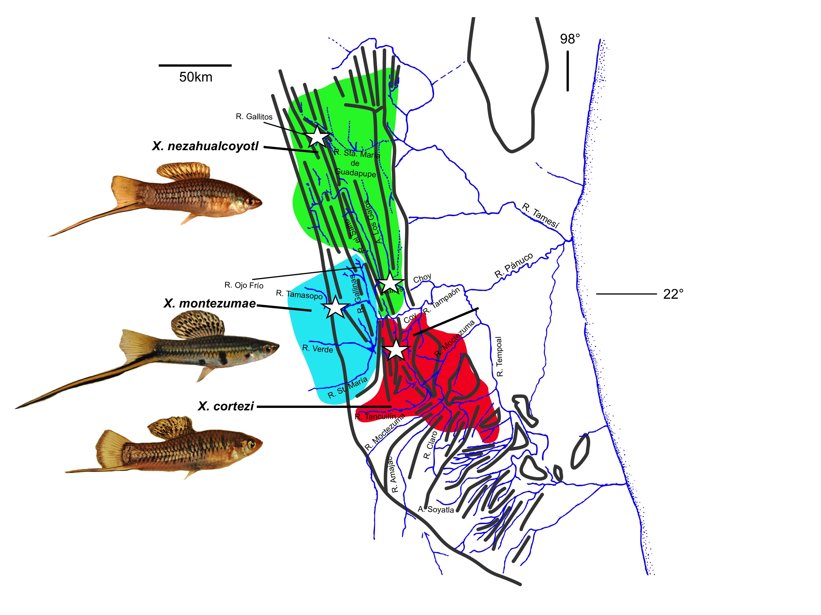

Figure 1. Range of focal species and sampling locations. Map of the geographical ranges and major river systems of the *X. nezahualcoyotl* (green), *X. montezumae* (blue), and *X. cortezi* (red). Stars indicate exact sampling locations of the individuals used for whole genome sequencing in this study. Inset photos on the left show individuals from sampled populations (*X. nezahualcoyotl* – Río Gallitos population shown).

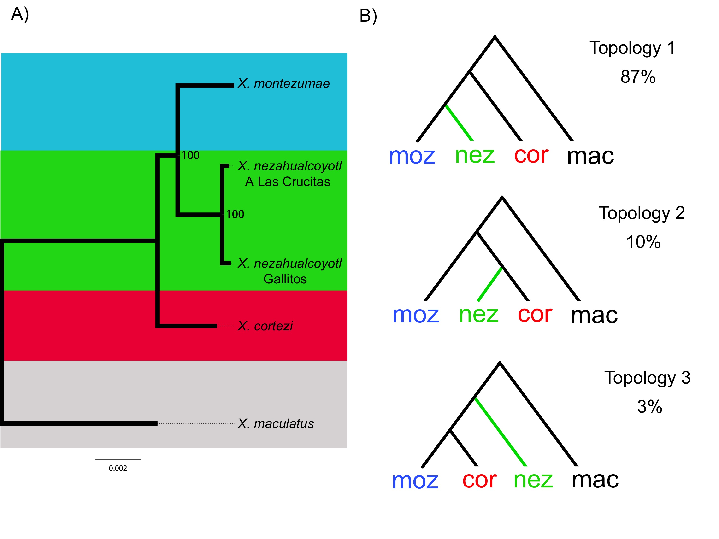

Figure 2. Phylogenetic analysis of *X. montezumae*, *X. cortezi*, and *X. nezahualcoyotl*.A) Species tree based on whole genome alignments and RAxML analysis. B) Results of phylogenetic analysis with the AU test in 10 kb windows show the same major phylogenetic pattern as in A but major asymmetry in the two minor topologies (topology 2 and topology 3), suggestive of hybridization between the *X. cortezi* and *X. nezahualcoyotl* lineages. Abbreviations: nez - *X. nezahualcoyotl*, moz - *X. montezumae*, cor - *X. cortezi*, mac – *X. maculatus*.

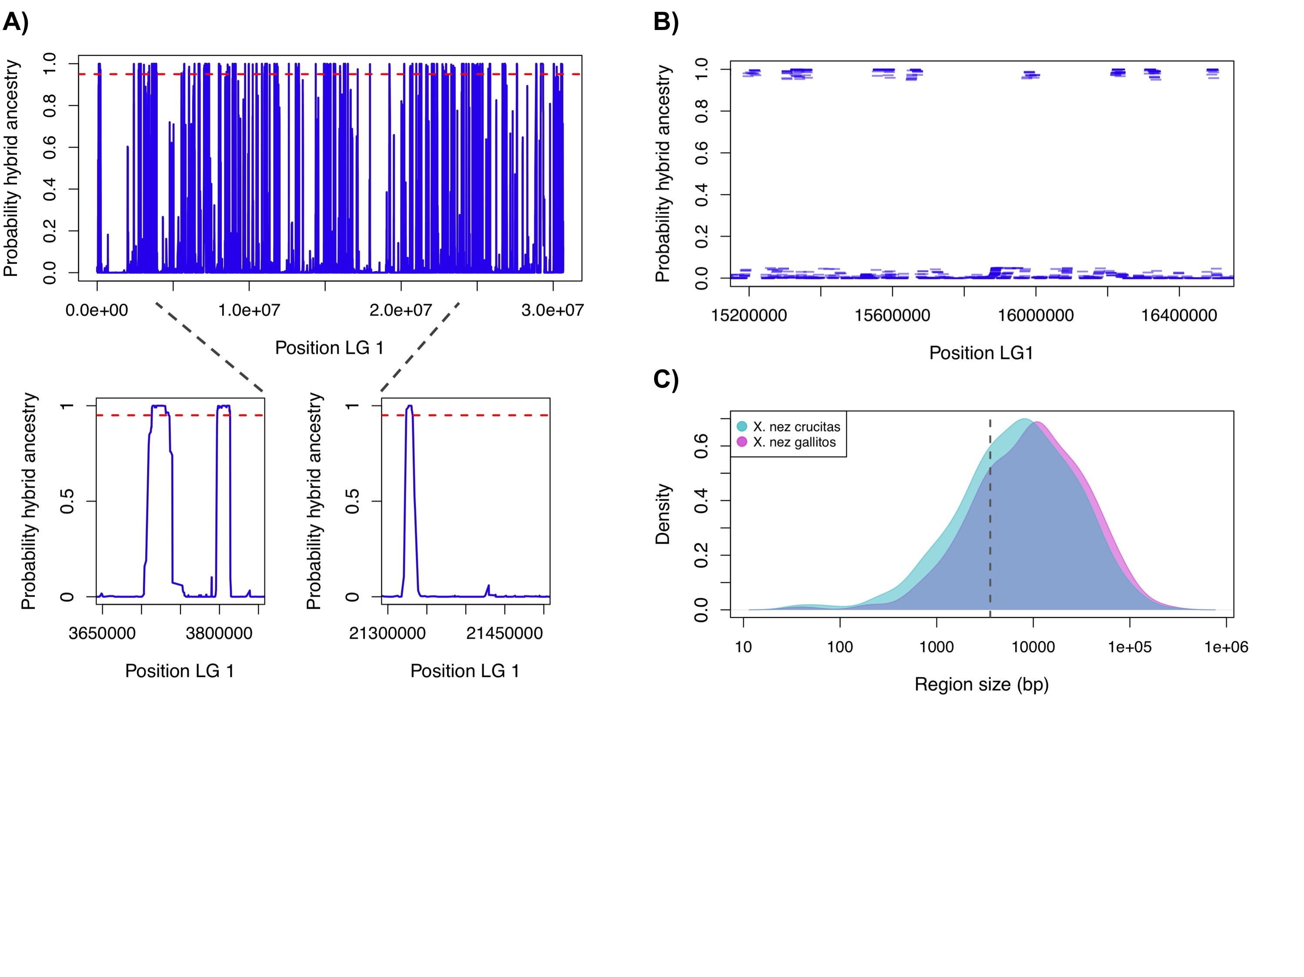

Figure 3. Detection and delimitation of hybridization-derived regions on Linkage Group 1 using PhyloNet-HMM. A) Posterior probabilities for the hybridization topology by position across Linkage group 1, with insets showing close ups of representative regions. B) Example of a subset of Linkage group 1 data after processing to remove sites that lack posterior support for any gene tree at ≥0.95. C) Size distribution of regions inferred to be hybridization derived by PhyloNet-HMM plotted on a log scale.

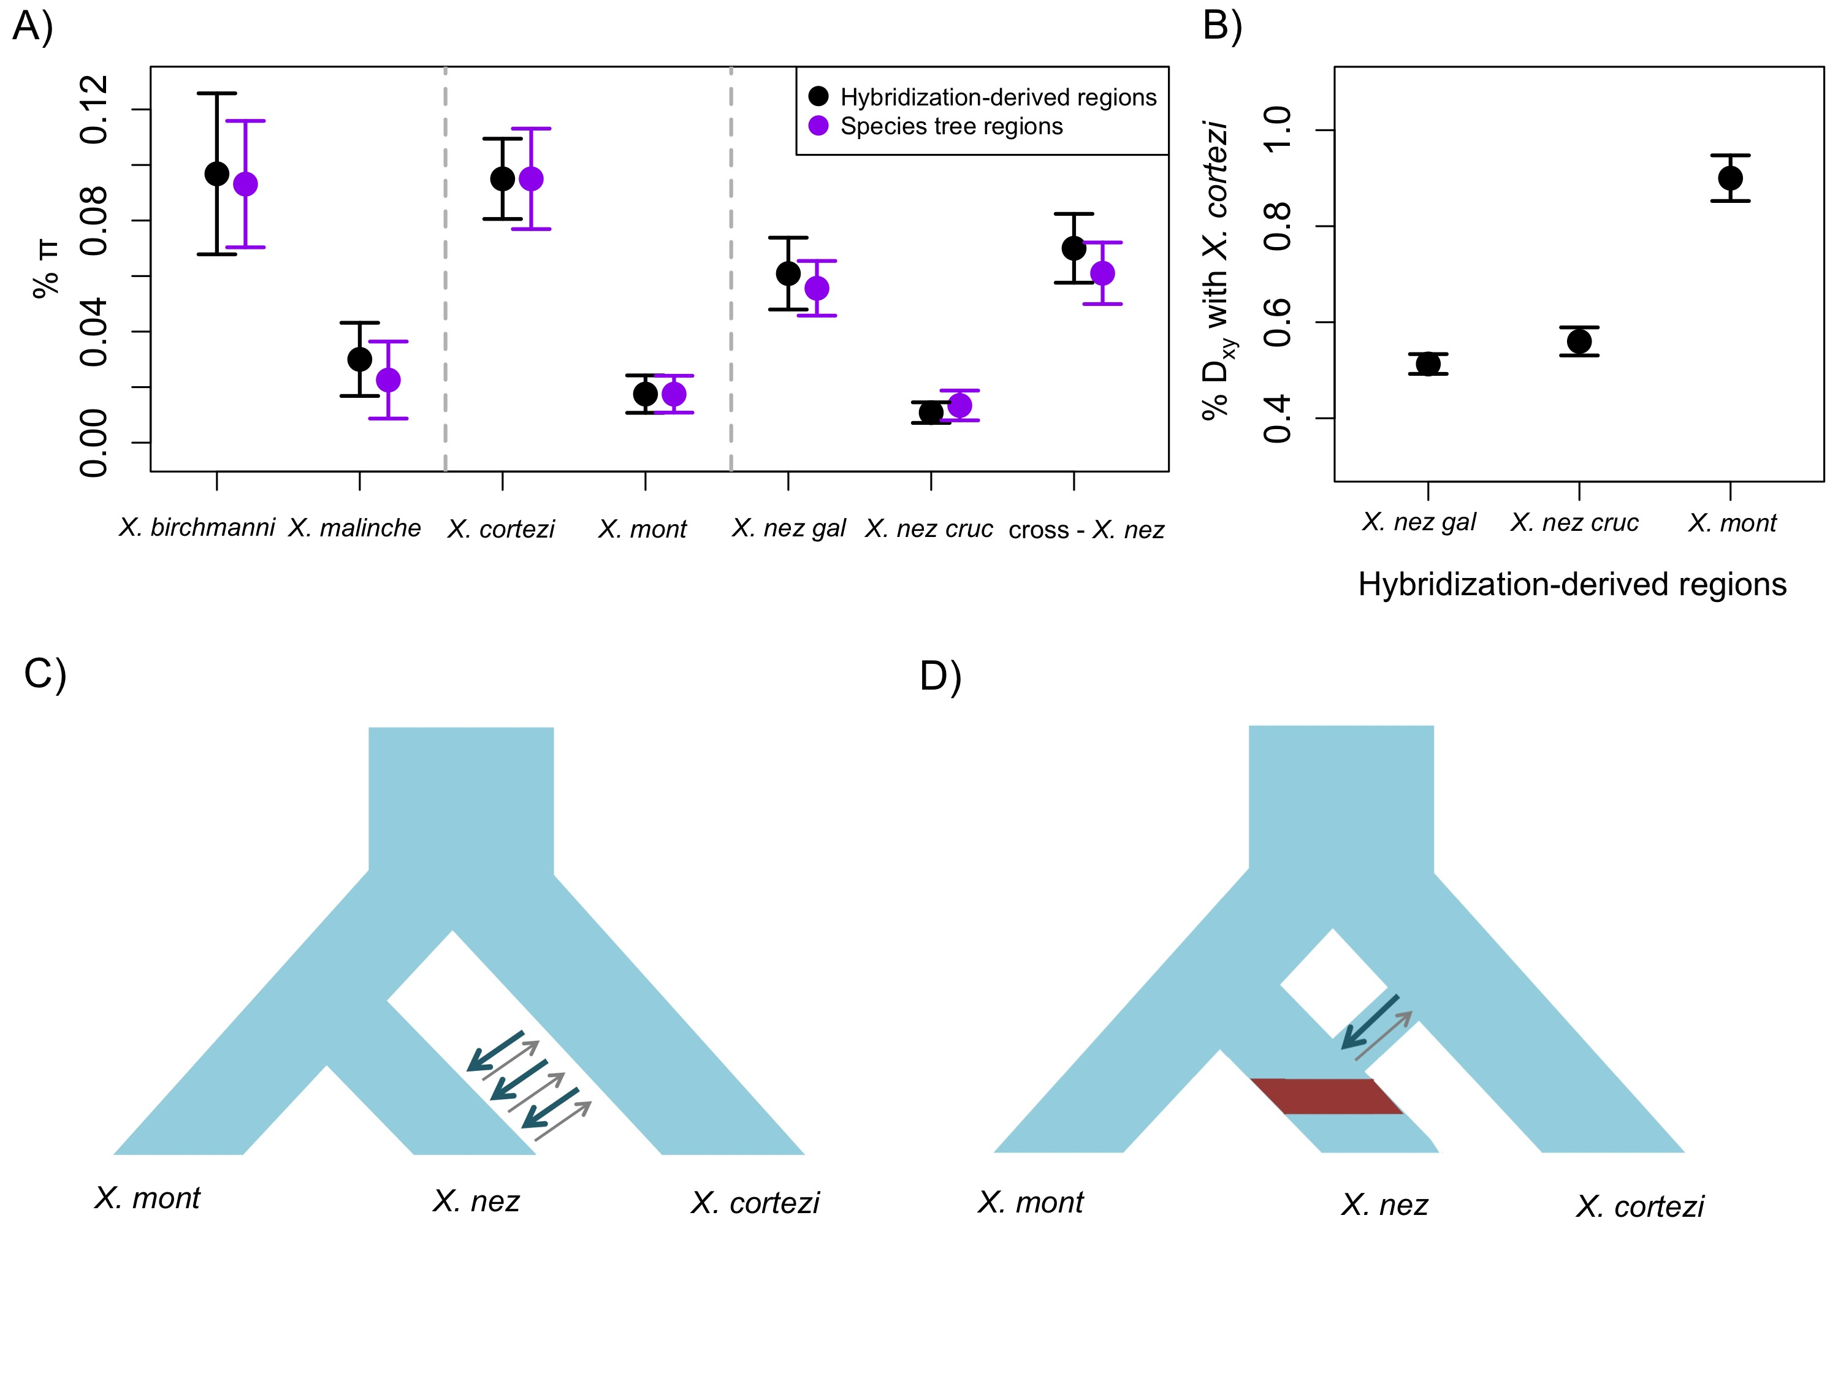

Figure 4. Summary of nucleotide diversity, divergence and potential evolutionary scenarios. A) Mean percent per site heterozygosity () (with error bars indicating two standard deviations of the mean) in regions identified as hybridization-derived or following the species tree in a range of *Xiphophorus* species. Data for *X. birchmanni* and *X. malinche* were taken from Schumer *et al*. 2014. B) Dxy (percent average pairwise sequence divergence per site) between both *X. nezahualcoyotl* samples and *X. cortezi* and *X. montezumae* and *X. cortezi* in regions that are derived from hybridization in *X. nezahualcoyotl* (see also Figure S12). Error bars indicate two standard deviations of the mean. C and D show two possible evolutionary scenarios for the origin of hybrid ancestry in *X. nezahualcoyotl*. In C, ongoing migration introduces hybrid ancestry into *X. nezahualcoyotl*, resulting in segregating hybrid ancestry. In D, a pulse of hybridization followed by stabilization (red shading), driven by a bottleneck or selection, results in stabilized hybrid ancestry in *X. nezahualcoyotl.* The latter scenario is most consistent with results comparing the two *X. nezahualcoyotl* samples.

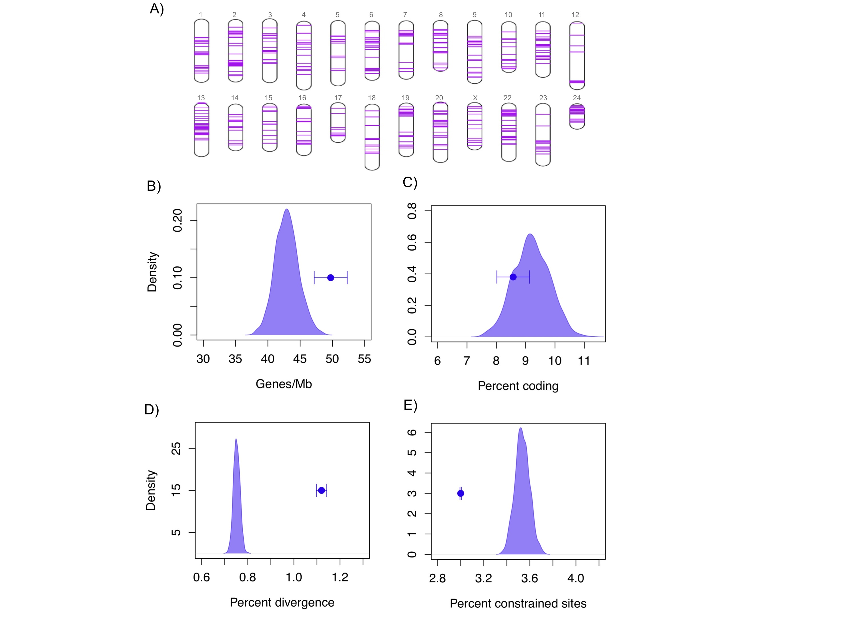

Figure 5. Differences between hybridization-derived genomic regions and the genomic background. A) Locations of hybridization-derived regions in the genome (stringent dataset). (B) Gene density is significantly higher in hybridization derived regions than the genomic background, but the proportion of coding sites is not (C). (D) Hybridization-derived regions are significantly more diverged between *X. montezumae* and *X. cortezi* than the genomic background and (E) have fewer evolutionarily constrained sites, as determined by phastCons analysis. Error bars indicate two standard deviations of the mean. Results shown here are for the stringent dataset; the same plots for the full dataset can be seen in Figure S14.

References

Abi-Rached L, Jobin MJ, Kulkarni S, et al. (2011) The Shaping of Modern Human Immune Systems by Multiregional Admixture with Archaic Humans. Science 334, 89-94.

Amores A, Catchen J, Nanda I, et al. (2014) A RAD-Tag Genetic Map for the Platyfish (Xiphophorus maculatus) Reveals Mechanisms of Karyotype Evolution Among Teleost Fish. Genetics 197, 625-U307.

Andolfatto P, Davison D, Erezyilmaz D, et al. (2011) Multiplexed shotgun genotyping for rapid and efficient genetic mapping. Genome Research 21, 610-617.

Atz JW (1962) Effects of hybridization on pigmentation in fishes of the genus Xiphophorus. Zoologica 47, 153-181.

Barton NH (1979) Gene flow past a cline. Heredity 43, 333-339.

Barton NH, Hewitt GM (1985) Analysis of hybrid zones. Annual Review of Ecology and Systematics 16, 113-148.

Blanchette M, Kent WJ, Riemer C, et al. (2004) Aligning multiple genomic sequences with the threaded blockset aligner. Genome Research 14, 708-715.

Buerkle CA, Rieseberg LH (2008) The rate of genome stabilization in homoploid hybrid species. Evolution 62, 266-275.

Cahill JA, Stirling I, Kistler L, et al. (2015) Genomic evidence of geographically widespread effect of gene flow from polar bears into brown bears. Molecular Ecology 24, 1205-1217.

Carling MD, Brumfield RT (2008) Haldane's rule in an avian system: using cline theory and divergence population genetics to test for differential introgression of mitochondrial, autosomal, and sex-linked loci across the Passerina bunting hybrid zone. Evolution 62, 2600-2615.

Cui R, Schumer M, Kruesi K, et al. (2013) Phylogenomics reveals extensive reticulate evolution in Xiphophorus fishes. Evolution 67, 2166–2179.

Culumber ZW, Fisher HS, Tobler M, et al. (2011) Replicated hybrid zones of Xiphophorus swordtails along an elevational gradient. Molecular Ecology 20, 342-356.

Dobin A, Davis CA, Schlesinger F, et al. (2013) STAR: ultrafast universal RNA-seq aligner. Bioinformatics 29, 15-21.

Earl D, Nguyen N, Hickey G, et al. (2014) Alignathon: a competitive assessment of whole-genome alignment methods. Genome Research 24, 2077-2089.

Falcon S, Gentleman R (2007) Using GOstats to test gene lists for GO term association. Bioinformatics 23, 257-258.

Gavrilets S (1997) Hybrid zones with Dobzhansky-type epistatic selection. Evolution 51, 1027-1035.

Geraldes A, Ferrand N, Nachman MW (2006) Contrasting patterns of introgression at X-linked loci across the hybrid zone between subspecies of the European rabbit (Oryctolagus cuniculus). Genetics 173, 919-933.

Gerke J, Edwards J, Guill K, Ross-Ibarra J, McMullen M (2015) The genomic impacts of drift and selection for hybrid performance in maize. Genetics doi: 10.1534/genetics.115.182410.

Good JM, Giger T, Dean MD, Nachman MW (2010) Widespread Over-Expression of the X Chromosome in Sterile F-1 Hybrid Mice. Plos Genetics 6, e1001148.

Gordon M (1937) Heritable color variations in the Mexican swordtail-fish - Aquarium species as the drosophila of fish genetics. Journal of Heredity 28, 223-230.

Gravel S (2012) Population Genetics Models of Local Ancestry. Genetics 191, 607-619.

Green RE, Krause J, Briggs AW, et al. (2010) A Draft Sequence of the Neandertal Genome. Science 328, 710-722.

Hamilton JA, Lexer C, Aitken SN (2013) Differential introgression reveals candidate genes for selection across a spruce (Picea sitchensis x P. glauca) hybrid zone. New Phytologist 197, 927-938.

Heliconius Genome C (2012) Butterfly genome reveals promiscuous exchange of mimicry adaptations among species. Nature 487, 94-98.

Huang DW, Sherman BT, Lempicki RA (2009) Systematic and integrative analysis of large gene lists using DAVID bioinformatics resources. Nature Protocols 4, 44-57.

Janousek V, Munclinger P, Wang L, Teeter KC, Tucker PK (2015) Functional Organization of the Genome May Shape the Species Boundary in the House Mouse. Molecular Biology and Evolution 32, 1208-1220.

Jin W, Li R, Zhou Y, Xu S (2014) Distribution of ancestral chromosomal segments in admixed genomes and its implications for inferring population history and admixture mapping. European Journal of Human Genetics 22, 930-937.

Jones JC, Fan S, Franchini P, Schartl M, Meyer A (2013) The evolutionary history of Xiphophorus fish and their sexually selected sword: a genome-wide approach using restriction site-associated DNA sequencing. Molecular Ecology 22, 2986-3001.

Jones JC, Perez-Sato J-A, Meyer A (2012) A phylogeographic investigation of the hybrid origin of a species of swordtail fish from Mexico. Molecular Ecology 21, 2692-2712.

Juric I, Aeschbacher S, Coop G (2015) The Strength of Selection Against Neanderthal Introgression. bioRxiv.

Kallman KD (1984) A new look at sex determination in poeciliid fishes. Evolutionary genetics of fishes 95-171.

Kang J, Schartl M, Walter R, Meyer A (2013) Comprehensive phylogenetic analysis of all species of swordtails and platies (Pisces: Genus Xiphophorus) uncovers a hybrid origin of a swordtail fish, Xiphophorus monticolus, and demonstrates that the sexually selected sword originated in the ancestral lineage of the genus, but was lost again secondarily. BMC Evolutionary Biology 13, 1-19.

Larson EL, Andres JA, Bogdanowicz SM, Harrison RG (2013) Differential introgression in a mosaic hybrid zone reveals candidate barrier genes. Evolution 67, 3653-3661.

Li H, Durbin R (2009) Fast and accurate short read alignment with Burrows-Wheeler transform. Bioinformatics 25, 1754-60.

Li J-W, Robison K, Martin M, et al. (2012) The SEQanswers wiki: a wiki database of tools for high-throughput sequencing analysis. Nucleic Acids Research 40, D1313-D1317.

Liu KJ, Dai J, Truong K, et al. (2014) An HMM-Based Comparative Genomic Framework for Detecting Introgression in Eukaryotes. Plos Computational Biology 10, e1003649.

Maddison WP (1997) Gene trees in species trees. Systematic Biology 46, 523-536.

Martinsen GD, Whitham TG, Turek RJ, Keim P (2001) Hybrid populations selectively filter gene introgression between species. Evolution 55, 1325-1335.

McKenna A, Hanna M, Banks E, et al. (2010) The Genome Analysis Toolkit: A MapReduce framework for analyzing next-generation DNA sequencing data. Genome Research 20, 1297-1303.

Mendez FL, Watkins JC, Hammer MF (2013) Neandertal Origin of Genetic Variation at the Cluster of OAS Immunity Genes. Molecular Biology and Evolution 30, 798-801.

Meyer A, Salzburger W, Schartl M (2006) Hybrid origin of a swordtail species (Teleostei: Xiphophorus clemenciae) driven by sexual selection. Molecular Ecology 15, 721-730.

Orr HA (1995) The population genetics of speciation - the evolution of hybrid incompatibilities. Genetics 139, 1805-1813.

Orr HA, Turelli M (2001) The evolution of postzygotic isolation: Accumulating Dobzhansky-Muller incompatibilities. Evolution 55, 1085-1094.

Payseur BA, Krenz JG, Nachman MW (2004) Differential patterns of introgression across the X chromosome in a hybrid zone between two species of house mice. Evolution 58, 2064-2078.

Payseur BA, Nachman MW (2005) The genomics of speciation: investigating the molecular correlates of X chromosome introgression across the hybrid zone between Mus domesticus and Mus musculus. Biological Journal of the Linnean Society 84, 523-534.

Pease JB, Hahn MW (2015) Detection and Polarization of Introgression in a Five-Taxon Phylogeny. Systematic Biology 64, 651-662.

Presgraves DC (2008) Sex chromosomes and speciation in Drosophila. Trends in Genetics 24, 336-343.

Quail MA, Swerdlow H, Turner DJ (2009) Improved protocols for the Illumina genome analyzer sequencing system. Current protocols in human genetics Chapter 18.

Quinlan AR, Hall IM (2010) BEDTools: a flexible suite of utilities for comparing genomic features. Bioinformatics 26, 841-842.

Racimo F, Sankararaman S, Nielsen R, Huerta-Sanchez E (2015) Evidence for archaic adaptive introgression in humans. Nature Reviews Genetics 16, 359-371.

Rieseberg LH, Sinervo B, Linder CR, Ungerer MC, Arias DM (1996) Role of gene interactions in hybrid speciation: Evidence from ancient and experimental hybrids. Science 272, 741-745.

Sankararaman S, Mallick S, Dannemann M, et al. (2014) The genomic landscape of Neanderthal ancestry in present-day humans. Nature 507, 354-357.

Sankararaman S, Patterson N, Li H, Paeaebo S, Reich D (2012) The Date of Interbreeding between Neandertals and Modern Humans. Plos Genetics 8: e1002947.

Schartl M (2004) Sex chromosome evolution in non-mammalian vertebrates. Current Opinion in Genetics and Development 14, 634-641.

Schartl M, Galiana-Arnoux D, Schultheis C, Bohne A, Volff JN (2011) A primer of sex determination. In: Ecology and evolution of poeciliid fishes. University of Chicago Press, Chicago, IL, USA.

Schartl M, Walter RB, Shen Y, et al. (2013) The genome of the platyfish, Xiphophorus maculatus, provides insights into evolutionary adaptation and several complex traits. Nature Genetics 45, 567-U150.

Schmidt HA (2009) Testing tree topologies. In: Phylogenetic Handbook: A Practical Approach to Phylogenetic Analysis and Hypothesis Testing, 2nd Edition. Cambridge University Press, Cambridge, U.K., pp 381-404.

Schumer M, Cui R, Boussau B, et al. (2012) An evaluation of the hybrid speciation hypothesis for Xiphophorus clemenciae based on whole genome sequences. Evolution 64, 1155-1168.

Schumer M, Cui R, Powell D, et al. (2014) High-resolution Mapping Reveals Hundreds of Genetic Incompatibilities in Hybridizing Fish Species. eLife 3 http://dx.doi.org/10.7554/eLife.02535.

Schumer M, Cui R, Rosenthal G, Andolfatto P (2015a) simMSG: an experimental design tool for high-throughput genotyping of hybrids. Molecular Ecology Resources doi: 10.1111/1755-0998.12434.

Schumer M, Cui R, Rosenthal GG, Andolfatto P (2015b) Reproductive Isolation of Hybrid Populations Driven by Genetic Incompatibilities. Plos Genetics 11, 5041-5041.

Shimodaira H (2002) An approximately unbiased test of phylogenetic tree selection. Systematic Biology 51, 492-508.

Shimodaira H, Hasegawa M (2001) CONSEL: for assessing the confidence of phylogenetic tree selection. Bioinformatics 17, 1246-1247.

Siepel A, Bejerano G, Pedersen JS, et al. (2005) Evolutionarily conserved elements in vertebrate, insect, worm, and yeast genomes. Genome Research 15, 1034-1050.

Siepel A, Haussler D (2004) Phylogenetic estimation of context-dependent substitution rates by maximum likelihood. Molecular Biology and Evolution 21, 468-488.

Soltis DE, Soltis PS (1999) Polyploidy: recurrent formation and genome evolution. Trends in Ecology & Evolution 14, 348-352.

Song KM, Lu P, Tang KL, Osborn TC (1995) Rapid genome change in synthetic polyploids of Brassica and its implications for polyploid evolution. Proceedings of the National Academy of Sciences of the United States of America 92, 7719-7723.

Song Y, Endepols S, Klemann N, et al. (2011) Adaptive Introgression of Anticoagulant Rodent Poison Resistance by Hybridization between Old World Mice. Current Biology 21, 1296-1301.

Stamatakis A (2006) RAxML-VI-HPC: Maximum likelihood-based phylogenetic analyses with thousands of taxa and mixed models. Bioinformatics 22, 2688-2690.

Stukenbrock EH, Christiansen FB, Hansen TT, Dutheil JY, Schierup MH (2012) Fusion of two divergent fungal individuals led to the recent emergence of a unique widespread pathogen species. Proceedings of the National Academy of Sciences of the United States of America 109, 10954-10959.

Tayale A, Parisod C (2013) Natural Pathways to Polyploidy in Plants and Consequences for Genome Reorganization. Cytogenetic and Genome Research 140, 79-96.

Teeter KC, Payseur BA, Harris LW, et al. (2008) Genome-wide patterns of gene flow across a house mouse hybrid zone. Genome Research 18, 67-76.

Turner LM, Harr B (2014) Genome-wide mapping in a house mouse hybrid zone reveals hybrid sterility loci and Dobzhansky-Muller interactions. eLife 3, doi: 10.7554/eLife.02504.

Turner LM, White MA, Tautz D, Payseur BA (2014) Genomic Networks of Hybrid Sterility. PLoS Genetics 10, e1004162.

Vernot B, Akey JM (2014) Resurrecting Surviving Neandertal Lineages from Modern Human Genomes. Science 343, 1017-1021.

White MA, Steffy B, Wiltshire T, Payseur BA (2011) Genetic Dissection of a Key Reproductive Barrier Between Nascent Species of House Mice. Genetics 189, 289-U988.

Whitney KD, Randell RA, Rieseberg LH (2010) Adaptive introgression of abiotic tolerance traits in the sunflower Helianthus annuus. New Phytologist 187, 230-239.

Yang ZH (1997) PAML: a program package for phylogenetic analysis by maximum likelihood. Computational Applied Bioscience 13, 555-556.

Yu Y, Degnan JH, Nakhleh L (2012) The Probability of a Gene Tree Topology within a Phylogenetic Network with Applications to Hybridization Detection. Plos Genetics 8, 456-465.

Supporting Information

*1. Determining predicted accuracy of the “align to reference” approach*

I call genotypes by aligning reads from three species to the *X. maculatus* reference genome and following the GATK best practices guidelines. Since the *X. maculatus* reference genome is ~1.5% diverged from northern swordtails and because no verified SNPs exist for the focal species to allow for base and variant quality recalibration, I perform simulations to evaluate the expected accuracy of my genotyping approach.

To generate sequences for analysis, I perform coalescent simulations of 10 kb regions with *macs* (Chen et al. 2009). I estimate divergence times between species using the relationship Tdiv/2Ne=Dxy/θ - 1, assuming θ/ρ =0.5 (see Supporting Information 4 for details) and setting *macs’* *h* parameterto 100. I use the *X. cortezi* value of θπ (Table 1) because higher values of polymorphism will likely be conservative with respect to the number of informative sites in phylogenetic analyses and error rates. Following *macs* simulations, I use the program seq-gen (Rambaut & Grassly 1997) to generate diploid sequences for simulated samples of *X. nezahualcoyotl*, *X. montezumae*, and *X. cortezi* and a haploid *X. maculatus* sequence. I then treat the simulated *X. maculatus* sequence as the reference sequence and used the program wgsim (https://github.com/lh3/wgsim) to generate reads equivalent to 28X coverage from the other species (average observed coverage, Table S1), with a sequencing error rate of 0.01 to simulate sequencing on the Illumina HiSeq 2000 and an insertion-deletion (indel) rate of 0.0012/bp to match the proportion of indels observed in the real data.

Following sequence generation I mapped reads with bwa-mem and followed the GATK best practices pipeline to generate inferred alignments as described in the main text. To determine the number of errors in each simulation, I compared the genotype in the true alignments to the genotype in the inferred alignment. Based on 1,000 replicates of this initial analysis, I observed an average error rate of 0.7 incorrect calls/10 kb region. Upon closer examination I found that nearly all incorrect calls were adjacent to indels. Based on this observation, I introduced a secondary filter to mask indels and all bases within 5 bp of indels. This filter improved the error rate to an average of 0.075/10 kb region. As a result of this analysis, I also apply this filter to the real data (see main text, Methods). Even when filters were applied, I was able to detect real variants using this pipeline with high sensitivity. Sites that were homozygous in the simulated sequence were detected on average 98% of the time. Sites that were polymorphic in the simulations were detected on average 97% of the time.

I note that there are several potential sources of error that could be present in real data but are absent in the simulated data described above. These include contamination, PCR duplication, and mis-mapping. To investigate possible effects of the latter two processes on accuracy, I perform additional simulations.

Based on analysis of the real data with Picard Tools (see main text), I estimate the PCR duplication rate to be approximately 18%. To incorporate this into the simulation pipeline, during the read generation step with wgsim I simulate 18% fewer reads and randomly sample 18% of the simulated reads as PCR duplicates. The incorporation of PCR duplicates increased the error rate slightly to an average of 0.1 errors per 10 kb region in 1,000 simulations (Figure S2). Because of this I perform all subsequent analyses and simulations including PCR duplication. Sensitivity to true variants was identical to simulations without PCR duplicates incorporated (Figure S1).

Simulating mis-mapping is more difficult because it depends on genome assembly completeness and the number of and divergence between duplicated regions. As a first approximation, I perform simulations treating linkage group 1 of the *X. maculatus* reference genome as a known “ancestral sequence” in seq-gen. I then perform simulations as described above generating reads from the simulated group1 and the rest of the *X. maculatus* genome for each species. I perform only 25 simulations due to the increased computational time required for these simulations (approximately 10 hours/simulation). Results under these simulations suggested that mis-mapping may contribute significantly to overall error rates. I observed approximately 3X as many errors in simulations incorporating mis-mapping as in simulations lacking mismapping. These results demonstrate that mis-mapping could increase error but that the error rate is still relatively low (~1/40 kb).

I perform the above simulations using the average observed coverage and duplication values for the four sequenced samples. However, performance may be higher in some samples and lower in others (e.g. 41X versus 21X). To get a sense of how high the error rate could be in the “worst case scenario”, I performed simulations following the PCR simulations described above but used parameters derived from the lowest quality sample (*X. montezumae*; Table S1). In these simulations, error rates were on average 0.15/10 kb.

*2. Potential biases of alignments to a divergent reference*

Although I estimate genotyping error rate to be low, if errors generated by mapping to a divergent reference are systematic, this could cause significant artifacts in the genome-wide analysis. Following the pipeline described in the previous section, I generated 10,000 true and inferred 10 kb alignments and ran the AU test on each alignment as described in the main text. I then resampled 1,000 alignments from this dataset 1,000 times to obtain a distribution of the proportions of each minor topology and estimates of asymmetry (Figure S3).

Based on the results of these 1,000 simulations, I detected no replicates that significantly departed from an equal distribution of minor topologies in the true alignments. This result is expected given that only ILS was simulated. In 1,000 simulations of the inferred alignments, 6% of had non-overlapping 95% confidence intervals for the two minor topologies. However, the average difference between topologies in these false positives was <0.5% and no simulations had non-overlapping 99% confidence intervals. These results suggest that the align-to-reference and SNP-calling pipeline is not introducing biases that could be misinterpreted as introgression.

*3. Potential biases of demography*

The above simulations assume an equal θπ for all species simulated, but θπ for *X. montezumae* (and one of the *X. nezahualcoyotl* specimens) is much lower than the *X. cortezi* value used (0.0003 versus 0.0011). Since other demographic scenarios have been shown to affect gene tree asymmetry (Eriksson & Manica 2012), I wanted to evaluate whether a strong bottleneck in *X. montezumae* could influence the proportion of minor topologies of each type.

Though I do not know the exact demographic scenario that lead to the reduced θπ observed in *X. montezumae* (e.g. timing or severity of the bottleneck), I use a simple bottleneck scenario to explore how this demographic event could influence gene tree asymmetry. The simulations follow the pipelines described in the previous section except that the population size for *X. montezumae* is reduced to 25% its original size immediately after splitting from *X. nezahualcoyotl*.

Neither the simulated or inferred alignments contained any replicates (out of 1,000 simulations) where the minor topologies significantly differed in frequency from each other, suggesting that a severe bottleneck in *X. montezumae* does not increase the likelihood of detecting false positives.

*4. Simulations to test the accuracy and sensitivity of PhyloNet-HMM*

*i. Sensitivity*

PhyloNet-HMM is designed to identify switches in phylogenetic relationships within a sequence using a hidden Markov model approach. The authors suggest that it can distinguish between signals of hybridization and incomplete lineage sorting by allowing for gene tree switches within a topology (see Methods for details). I test the performance of PhyloNet-HMM using simulations.

I simulated 1 Mb alignments with short hybrid regions inserted (Figure S5). I simulate 1 Mb sequences using *macs*, with θπ, the population mutation rate, set to the average of the proportion of heterozygous sites in *X. cortezi* as above. I calculated divergence times based on pairwise sequence divergence (see Supporting Information 1 for details). The population recombination rate, or ρ, was calculated using the relationship ρ=4Ner, where r is the per base pair recombination rate estimated from an average genome-wide recombination rate of ~1 cM/500 kb (Amores *et al.* 2014), and Ne was estimated based on the relationship θ/4μ where μ is the mutation rate. Since no detailed estimates of mutation rate exist for fish species, I used the mutation rate estimate for *Mus musculus* (3.8x10-8 mutations per bp per generation, Lynch 2010). Based on these parameters, I estimate ρ to be approximately equal to 0.5*θ.

Next, I generated a hybrid *X. nezahualcoyotl* sequence by using the program fastahack (<https://github.com/ekg/fastahack>) to splice together simulated *X. nezahualcoyotl* and *X. cortezi* sequences (Figure S5). I generated three types of hybrid sequences with 5 kb, 10 kb, and 20 kb inserts. I generated 1,000 replicates of each sequence type and ran PhyloNet-HMM on each replicate. I accepted posterior probabilities of ≥0.95 as support for a particular parent tree, and delineated regions supporting a particular tree by the distance between the first and last coordinate with ≥0.95 posterior probability for that tree (for example, Figure S6).

Because sensitivity to hybrid signal in *X. nezahualcoyotl* will be dependent on divergence between *X. cortezi* and *X. montezumae*,I repeat these simulations for the 10 kb insert hybrid sequences for low divergence regions between *X. montezumae* and *X. cortezi* to see how error rates and sensitivity vary when there is low phylogenetic signal. I calculated divergence between *X. montezumae* and *X. cortezi* in 10 kb windows and took the lower 5% and 10% quantiles of this distribution (0.3% and 0.4% respectively). To generate sequences with these levels of divergence on average, I repeat simulations with macs and seg-gen, scaling θ.

I found that PhyloNet-HMM had >98% sensitivity to regions derived from hybridization ≥10 kb in my simulations. For smaller regions, sensitivity was poorer. For example, PhyloNet-HMM detected only 56% of 5 kb regions. Sensitivity was reduced to approximately 85% if the regions derived from hybridization were in the lower 5th percentile for divergence between *X. montezumae ­*and *X. cortezi* bur rose to 91% if the regions were in the lower 10th percentile of divergence.

*i. Accuracy*

I evaluated the expected false positive rate due to ILS by examining the rest of the 1 Mb region outside of the hybridization-derived region. The only source of phylogenetic discordance outside of the known hybrid sequence in the 1Mb simulations (see Figure S5) will be ILS. I found that PhyloNet-HMM very rarely attributed ILS discordance to hybridization signal in simulations. In the basic 10 kb insert simulation, false hybridization was detected in only 2% of simulations. A similar false positive rate was observed in simulations of regions with low phylogenetic signal and simulations of severe bottlenecks (2% and 1.5% respectively). These false positive rates would correspond to approximately 15 false positives in each whole genome analysis. When I excluded regions shorter than 10 kb the false positive rate fell to 0.4% in the basic simulations and to 0.1% in the low-divergence simulations. As a result, I analyze the data with and without a size filter normalized for local recombination rate (see Supporting Information 5).

I note that these simulations may give an overly high confidence in PhyloNet-HMM’s ability to identify introgressed regions if introgressed regions have accumulated many changes since they were introduced to the *X. nezahualcoyotl* genome. This is important to keep in mind given that my results suggest that hybridization was likely ancient (Figure S11).

*5. Adjusting region length based on local recombination rate*

Recombination rates vary throughout the genome, which will affect the length of discordant segments in particular genomic regions. I find that false positive rates for hybridization inference with PhyloNet-HMM are lower if switches between the parent tree and hybridization tree of less than 10 kb are excluded (see previous section). However, the appropriate length cutoff for switches will vary with the local recombination rate. No recombination maps are available for the species surveyed in this study. However, an F2 linkage map was recently generated for hybrids between two other swordtail species, *X. maculatus* and *X. hellerii* (Amores *et al.* 2014). I use recombination rates between markers in this linkage map to roughly infer region size in cM. To do this, I downloaded html files from the online linkage map (<http://genome.uoregon.edu/xma/index_v1.0.php>) and extracted marker locations and genetic distance between markers using a custom script. I excluded all markers that had a smaller distance in cM from the beginning of the chromosome than the preceding marker (~15% of markers). For each chromosome, I fit a spline using splinefun in R and the mono-HC method, using position in basepair as the independent variable and distance in cM as the dependent variable. I then used this relationship to estimate the length in cM of each discordant segment.

*6. Simulations to investigate observed DFOIL patterns*

The DFOIL program tests whether there are excesses of particular site patterns which are informative about the direction of introgression. Given the phylogeny, introgression from *X. nezahualcoyotl* into *X. cortezi* is expected to generate the pattern ++-0, while introgression from *X. cortezi* into *X. nezahualcoyotl* is expected to generate the pattern 0+--. When running DFOIL on all sites in the genome I see a composite pattern of ++--, which could be consistent with bidirectional introgression (J. Pease, personal communication). To test this, and ask whether introgression must be symmetrical to generate this pattern, I performed coalescent simulations.

Simulations were performed with macs and seq-gen as described above except that each simulation was of a 10 Mb sequence, sequences were also simulated for *X. malinche* (Dxy *malinche-cortezi* = 0.54) and I implemented gene flow. I arbitrarily simulated gene flow immediately after the split of *montezumae-nezahualcoyotl* for 0.5 generations in units of 4Ne generations. I performed simulations where 10% of the *X. nezahualcoyotl* population was made of migrants from *X. cortezi* each generation, and varied the proportion of the *X. cortezi* population that was made of up of migrants from *X. nezahualcoyotl* from 0, 0.02, and 0.05 between simulations. I performed 100 simulations for each migration level.

Results of these simulations confirm that bidirectional migration generates the ++-- pattern observed in DFOIL results. Interestingly, I find that even highly asymmetric migration can generate this pattern. For example, in simulations where 2% of the population was made up of migrants in *X. cortezi* (versus 10% in *X. nezahualcoyotl*), a significant ++-- pattern was observed in 25% of simulations. Thus, my results can be interpreted as consistent with bidirectional gene flow but not that gene flow occurred at the same level between species. I investigate asymmetry in gene flow using DFOIL in more detail in the main text.

*7. PhyloNet-HMM’s treatment of regions heterozygous for X. montezumae and X. cortezi ancestry*

PhyloNet-HMM does not incorporate polymorphic bases into phylogenetic analyses. To evaluate how PhyloNet-HMM is likely to perform if a region is heterozygous for *X. cortezi* and *X. montezumae* ancestry, I repeat the simulations described above but insert only one 20 kb *X. cortezi* haplotype instead of a homozygous region (see Figure S5).

My simulations demonstrate that PhyloNet-HMM does not detect hybrid signal in this scenario (0% of simulations), and tends to assign posterior probabilities <0.95 for the parent tree in these heterozygous regions (on average only 2 sites per simulation were assigned posterior probabilities ≥0.95 in heterozygous regions). This suggests that this analysis will miss any regions still segregating for *X. cortezi* ancestry in *X. nezahualcoyotl*.

*8. Estimating the time required for stabilization of hybridization-derived regions*

Since hybridization*-*derived ancestry tracts present in the *X. nezahualcoyotl* genome are largely fixed (see Results), I can treat these tracts as ancestry haplotypes and use them to perform a first order estimate of the number of generations of recombination that occurred between hybridization and stabilization of hybridization-derived regions. I use the relationship between ancestry tract length and time since admixture (Gravel 2012; Jin *et al.* 2014) to solve for the number of generations of recombination given the average ancestry tract length of the minor parent (20 kb) and the recombination rate:

Tadmix = 1/(LM*pB)

where Tadmix is the number of generations since admixture, LM is the average tract length in Morgans of the minor parent and pB is the proportion of the genome derived from the major parent (probability of recombining). I calculated the average *Xiphophorus* recombination rate from Amores *et al*. (Amores *et al.* 2014) based on the total map length in cM divided by the total length of the assembly. Note that this approach does not take into account the variation in haplotype lengths.

The accuracy of this estimate depends on several assumptions that are likely violated in my data. In particular, these equations assume that selection has not been acting on introgressed regions, and that there is no bias in ascertainment of ancestry tract lengths (see Figure S7). In addition, demographic events such as small population sizes or changes in population size will influence the accuracy of this inference. The direction of bias introduced (e.g. predicting an older or younger hybridization event) will depend on which of these processes dominates. Thus, this approach should be viewed as approximate.

A further concern in the application of method is that results suggest that introgression has been bidirectional. This means that instead of a single distribution of ancestry tract lengths, I am likely evaluating a mixed distribution potentially made up of ~75% tracts introgressed from *X. cortezi* and ~25% tracts introgressed from *X. nezahualcoyotl*. To evaluate whether this is likely to cause biases in my analysis, I perform simulations in R, assuming admixture occurred at the same time point in *X. nezahualcoyotl* and *X. cortezi*, that 6% of the *X. nezahualcoyotl* genome and 2% of the *X. cortezi* genome is derived from hybridization, and that 76% of the sampled tracts originate from regions introgressed into *X. nezahualcoyotl* while 24% originate from regions introgressed into *X. cortezi*. Based on these simulations, I find that my approach is unlikely to produce large biases in estimates of the time to genomic stabilization (Figure S18), largely because the average tract length of hybrid ancestry is expected to be very similar in *X. nezahualcoyotl* and *X. cortezi* given the predicted mixture proportions (Figure S18). Thus, I propose that this approach can be appropriately applied to estimate the time to genomic stabilization in *X. nezahualcoyotl*.

Based on this approach, I estimate that 2,560 generations of recombination preceded fixation of *X. cortezi* haplotypes in *X. nezahualcoyotl*, or approximately 1,250 years assuming 2 generations/year. Though there are several limitations of applying this approach to the data (listed above), these results suggest that stabilization of hybrid ancestry in *X. nezahualcoyotl* occurred relatively quickly.

*9. Simulations of fixation under drift and corresponding expectations for θπ*

Stabilization of hybrid ancestry in the genome requires either long time periods, small population sizes, or selection on hybridization-derived regions. This estimate of the number of generations of recombination give us an approximate idea of how long regions of hybrid were segregating in *X. nezahualcoyotl* before they fixed. This estimate of 2,560 generations (see above) suggests that stabilization of hybrid ancestry in *X. nezahualcoyotl* occurred relatively rapidly.

To begin to investigate whether fixation likely occurred too rapidly to be explained by genetic drift, I conduct simple simulations of genetic drift on 1,000 alleles at an initial frequency of 6% (proportion of regions that introgressed from *X. cortezi* into *X. nezahualcoyotl*). I started with the estimated effective population size of 5,394 for *X. nezahualcoyotl*, calculated based on observed θπ, from the relationship Ne=θ/4μ (μ from *Mus musculus* as above). I determined what proportion of hybridization-derived sites are expected to fix after 2,500 generations with drift implemented each generation using binomial sampling in R. I repeated these simulations with a series of smaller population sizes (N=2500, 1250, 750, 375).

Results from these simulations demonstrate high levels of fixation of hybridization-derived sites do not occur (defined arbitrarily as 95% of sites fixed) in 2,500 generations unless populations are quite small (~750 individuals; Figure S16).

Though a bottleneck of this size is possible, such an extreme event might leave strong signatures on θπ. To investigate the plausibility of such an event given present-day θπ in *X. nezahualcoyotl* Los Gallitos, I perform additional *macs* simulations. I focus on the Los Gallitos sample instead of the Las Crucitas sample since reduction in θπ in the Las Crucitas population almost certainly occurred long after hybridization (Figure 4). I perform *macs* simulations as described above except that I implement a bottleneck at the inferred time of admixture (see next sentence) and allow the bottleneck to occur for 2,500 generations. I approximate the time of admixture as the divergence time between hybridization-derived regions in *X. cortezi* and in *X. nezahualcoyotl* (Tadmix/2Ne=(Dxy – θπ)/ θπ)*.* I obtain a distribution for this estimate by bootstrapping θπ and Dxy estimates from introgressed regions and used the lower 2.5% quantile of this Tadmix distribution in simulations.I implement a bottleneck that reduces the effective population size to 750 individuals at Tadmix. I ask whether the simulated θπ distribution under this scenario is consistent with observed values in *X. nezahualcoyotl*.

In 500 simulations of this scenario, the average observed π in 1 Mb sequences was only slightly lower than the ancestral π (0.0010/bp versus 0.0011/bp). These simulation results suggest that a strong bottleneck for 2,500 generations following admixture could be consistent with the patterns of π that I observe in the data.

I note that the number of generations to stabilization was calculated under assumptions of a large population size (Gravel 2012), but I investigate results under bottleneck scenarios. If a bottleneck did actually occur in *X. nezahualcoyotl*, this would likely make my estimate of time to fixation shorter than the true value, and as a result would make the simulation parameters conservative.

*10. PAML analysis for a broader range of species*

I primarily focus PAML analysis on *X. montezumae* and *X. cortezi* (see main text) but repeat this analysis with the platyfish *X. maculatus* and southern swordtail *X. hellerii* (data from Schumer et al. 2012) to understand whether substitution differences in hybridization-derived regions observed between *X. montezumae* and *X. cortezi* are also observed in other swordtail species.

The loci in the unfiltered dataset have a higher rate of dN (p<0.001), dS (p<0.001), N (p<0.001), S (p<0.02), and dN/dS (p<0.001) than the null datasets (p-values determined by simulation). In contrast, the filtered dataset did not differ in any of these features from the null datasets (dN p=0.5, dS=0.51, N=0.57, S=0.76, dN/dS=0.54).

*11. Reanalysis of major results using regions that introgressed from X. cortezi into X. nezahualcoyotl*

DFOIL analyses suggest that gene flow between *X. nezahualcoyotl* and *X. cortezi* was bidirectional, but that the majority of hybridization-derived regions introgressed from *X. cortezi* into *X. nezahualcoyotl*. To ensure that my major results are not affected by mixed evolutionary histories, I reanalyzed the data including only regions where I have high confidence that introgression occurred from *X. cortezi* into *X. nezahualcoyotl* based on DFOIL results (N=222).

Results of this analysis were nearly identical to results based on the stringent dataset. Hybridization derived regions were significantly more divergent than the genomic background, based both on raw sequence divergence, and the number of nonsynonymous and synonymous substitutions (all p<0.001), but did not have a significantly higher rate of nonsynonymous substitutions (p=0.76). *cortezi-*derived regions had only a slightly higher gene density than the genomic background (p=0.052) but not a greater proportion of coding basepairs (p=0.22). Notably, these regions had significantly fewer highly conserved bases than randomly selected regions (p<0.001). Analyses were performed as described in the main text.

*12. Comparison to previously collected RNAseq data*

I previously collected RNAseq data for a *X. nezahualcoyotl* individual from a lab strain original collected from Los Gallitos that appeared to be highly admixed (Cui *et al.* 2013). The levels of admixture observed in this individual are inconsistent with the levels of admixture observed in the whole-genome dataset (Cui *et al.* 2013). To compare directly to this previously collected data, I mapped these 11.9 million RNAseq reads to the *X. maculatus* reference genome using the program STAR (Dobin *et al.* 2013). I then followed the GATK best practices pipeline for RNAseq data, using the quality filters described above for variant calling. I calculated levels of polymorphism in the covered regions and compared alignments between the two Los Gallitos samples to calculate Dxy between the two Los Gallitos individuals.

In the RNAseq alignment, 24.8 Mb were covered at depth greater than 10 and passed my quality filters. Though Dxy between the two samples was on the order of that expected for two samples from this low-diversity population (0.00018), polymorphism in the RNAseq individual was much higher than expected. Polymorphism levels were approximately 10-fold higher in this individual – 0.003 per bp – than in the individual sampled for whole genome sequencing (Table 1), despite the fact that only coding sequences were sampled in the RNAseq analysis. Polymorphism in these same regions in the wild-caught, whole genome sequenced individual was only 0.00015. In fact, the level of polymorphism observed in the RNAseq data for the *X. nezahualcoyotl* labstock individual greatly exceeds that measured by whole genome sequencing in any sampled *Xiphophorus* species to date (Table 1; Cui *et al.* 2013; Schumer *et al.* 2012). On average, at 40% of the polymorphic sites in the RNAseq-sampled individual the alternate allele was an allele for which *X. cortezi* was homozygous.

Another possible explanation for differences between RNAseq data and genome-wide data is systematic patterns in which regions of the genome are hybridization derived. I investigate this by repeating the admixture proportion analysis on regions that were covered in the RNAseq data. I summarized the coordinates of regions in the RNAseq dataset that passed the depth and quality filters, collapsing regions that were separated by less than 100 basepairs. I then overlapped the coordinates of these regions with results from PhyloNet-HMM and the AU test (see main text) using bedtools.

I find that the RNAseq – covered regions (at DP>10) do not show a different admixture pattern when I subset these regions from the whole-genome alignments for *X. nezahualcoyotl* Gallitos, *X. montezumae, X. cortezi* and *X. maculatus*. Similar to the whole genome analysis results, 8.4% of these subsampled regions overlapped with thehybridization tree based on PhyloNet-HMM results and 12% of these regions supported the (*X. cortezi, X. nezahualcoyotl*)tree based on AU results.

Overall, this comparison of the RNAseq data to the genome-wide data demonstrates that the *X. nezahualcoyotl* Gallitos lab stock is likely to be a recent hybrid between *X. nezahualcoyotl* and *X. cortezi.* This sample has much higher levels of polymorphism than typically observed in *Xiphophorus* species and more than 10 times higher polymorphism than the wild-caught individual from the Los Gallitos population. In an F1 hybrid, all base pairs that are fixed ancestry informative sites in the parents will become polymorphic (e.g. ~0.5% for a *X. nezahualcoyotl* x *X. cortezi* hybrid). Thus, the levels and patterns of polymorphism observed (0.3%) are consistent with this individual being an early generation hybrid with *X. cortezi*.

Supporting References

Amores A, Catchen J, Nanda I*, et al.* (2014) A RAD-Tag Genetic Map for the Platyfish

(*Xiphophorus maculatus*) Reveals Mechanisms of Karyotype Evolution Among Teleost Fish. *Genetics* 197, 625-U307.

Chen GK, Marjoram P, Wall JD (2009) Fast and flexible simulation of DNA sequence

data. *Genome Research* 19, 136-142.

Cui R, Schumer M, Kruesi K*, et al.* (2013) Phylogenomics reveals extensive reticulate

evolution in *Xiphophorus* fishes. *Evolution* 67, 2166–2179.

Dobin A, Davis CA, Schlesinger F*, et al.* (2013) STAR: ultrafast universal RNA-seq

aligner. *Bioinformatics* 29, 15-21.

Eriksson A, Manica A (2012) Effect of ancient population structure on the degree of

polymorphism shared between modern human populations and ancient hominins. *Proceedings of the National Academy of Sciences of the United States of America* 109, 13956-13960.

Gravel S (2012) Population Genetics Models of Local Ancestry. *Genetics* 191, 607-619.

Lynch M (2010) Evolution of the mutation rate. *Trends in Genetics* 26, 345-352.

Rambaut A, Grassly NC (1997) Seq-Gen: An application for the Monte Carlo simulation

of DNA sequence evolution along phylogenetic frees. *Computer Applications in the Biosciences* 13, 235-238.

Schumer M, Cui R, Boussau B*, et al.* (2012) An evaluation of the hybrid speciation

hypothesis for *Xiphophorus clemenciae* based on whole genome sequences. *Evolution*, doi: 10.1111/evo.12009.

Supporting Tables

Table S1. Mapping and coverage statistics for focal species.

|  |  |  |  |
| --- | --- | --- | --- |
| Sample | Number of reads | Proportion mapped | Average Coverage |
| *X. nezahualcoyotl* Gallitos | 398,245,402 | 98% | 41 |
| *X. nezahualcoyotl*  Las Crucitas | 248,176,130 | 98% | 26 |
| *X. cortezi* | 262,322,432 | 98% | 26 |
| *X. montezumae* | 195,621,433 | 98% | 21 |

Table S2. Pairwise sequence divergence between samples.

|  |  |  |  |
| --- | --- | --- | --- |
| Sample | *X. nez* Gallitos | *X. nez* Las Crucitas | *X. cortezi* |
| *X. nez* Gallitos | - |  |  |
| *X. nez* Las Crucitas | 0.10 | - |  |
| *X. cortezi* | 0.62 | 0.61 | - |
| *X. montezumae* | 0.49 | 0.49 | 0.65 |

Supporting Figures

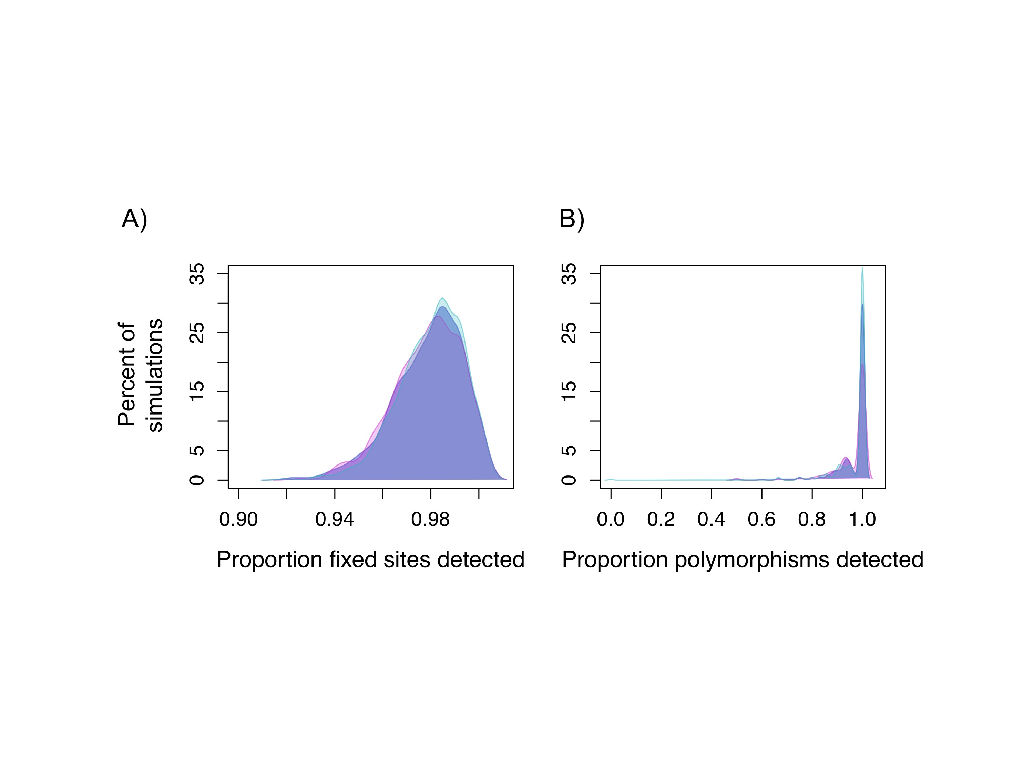

Figure S1. Sensitivity to real variants in align-to-reference simulations. A) Align to reference approaches used in this study had high accuracy in detecting real fixed differences between alignments and B) polymorphic sites within an individual. Overlaid colors show each of the three species simulated for the align-to-reference approach; accuracy did not differ by species as expected given equal sequence divergence to the *X. maculatus* reference.

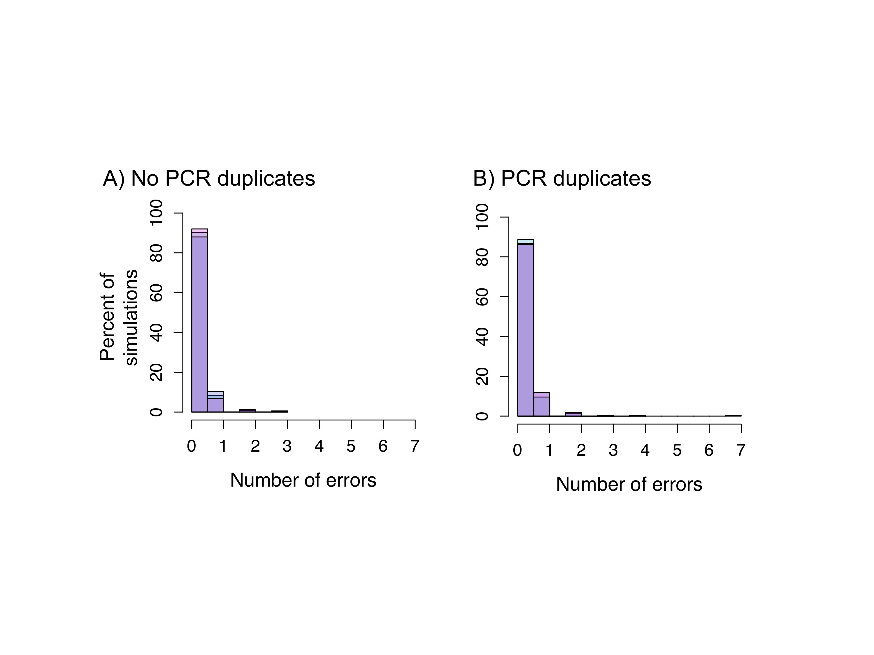

Figure S2. Error rates for align-to-reference approach. A) Lowest error rates estimated for align to reference approach came from simulations excluding PCR duplication (0.075 errors/10kb). B) With PCR duplication levels observed in the experiment, error rates were estimated at 0.1 errors/10 kb. Results shown here are based on 1,000 simulations.

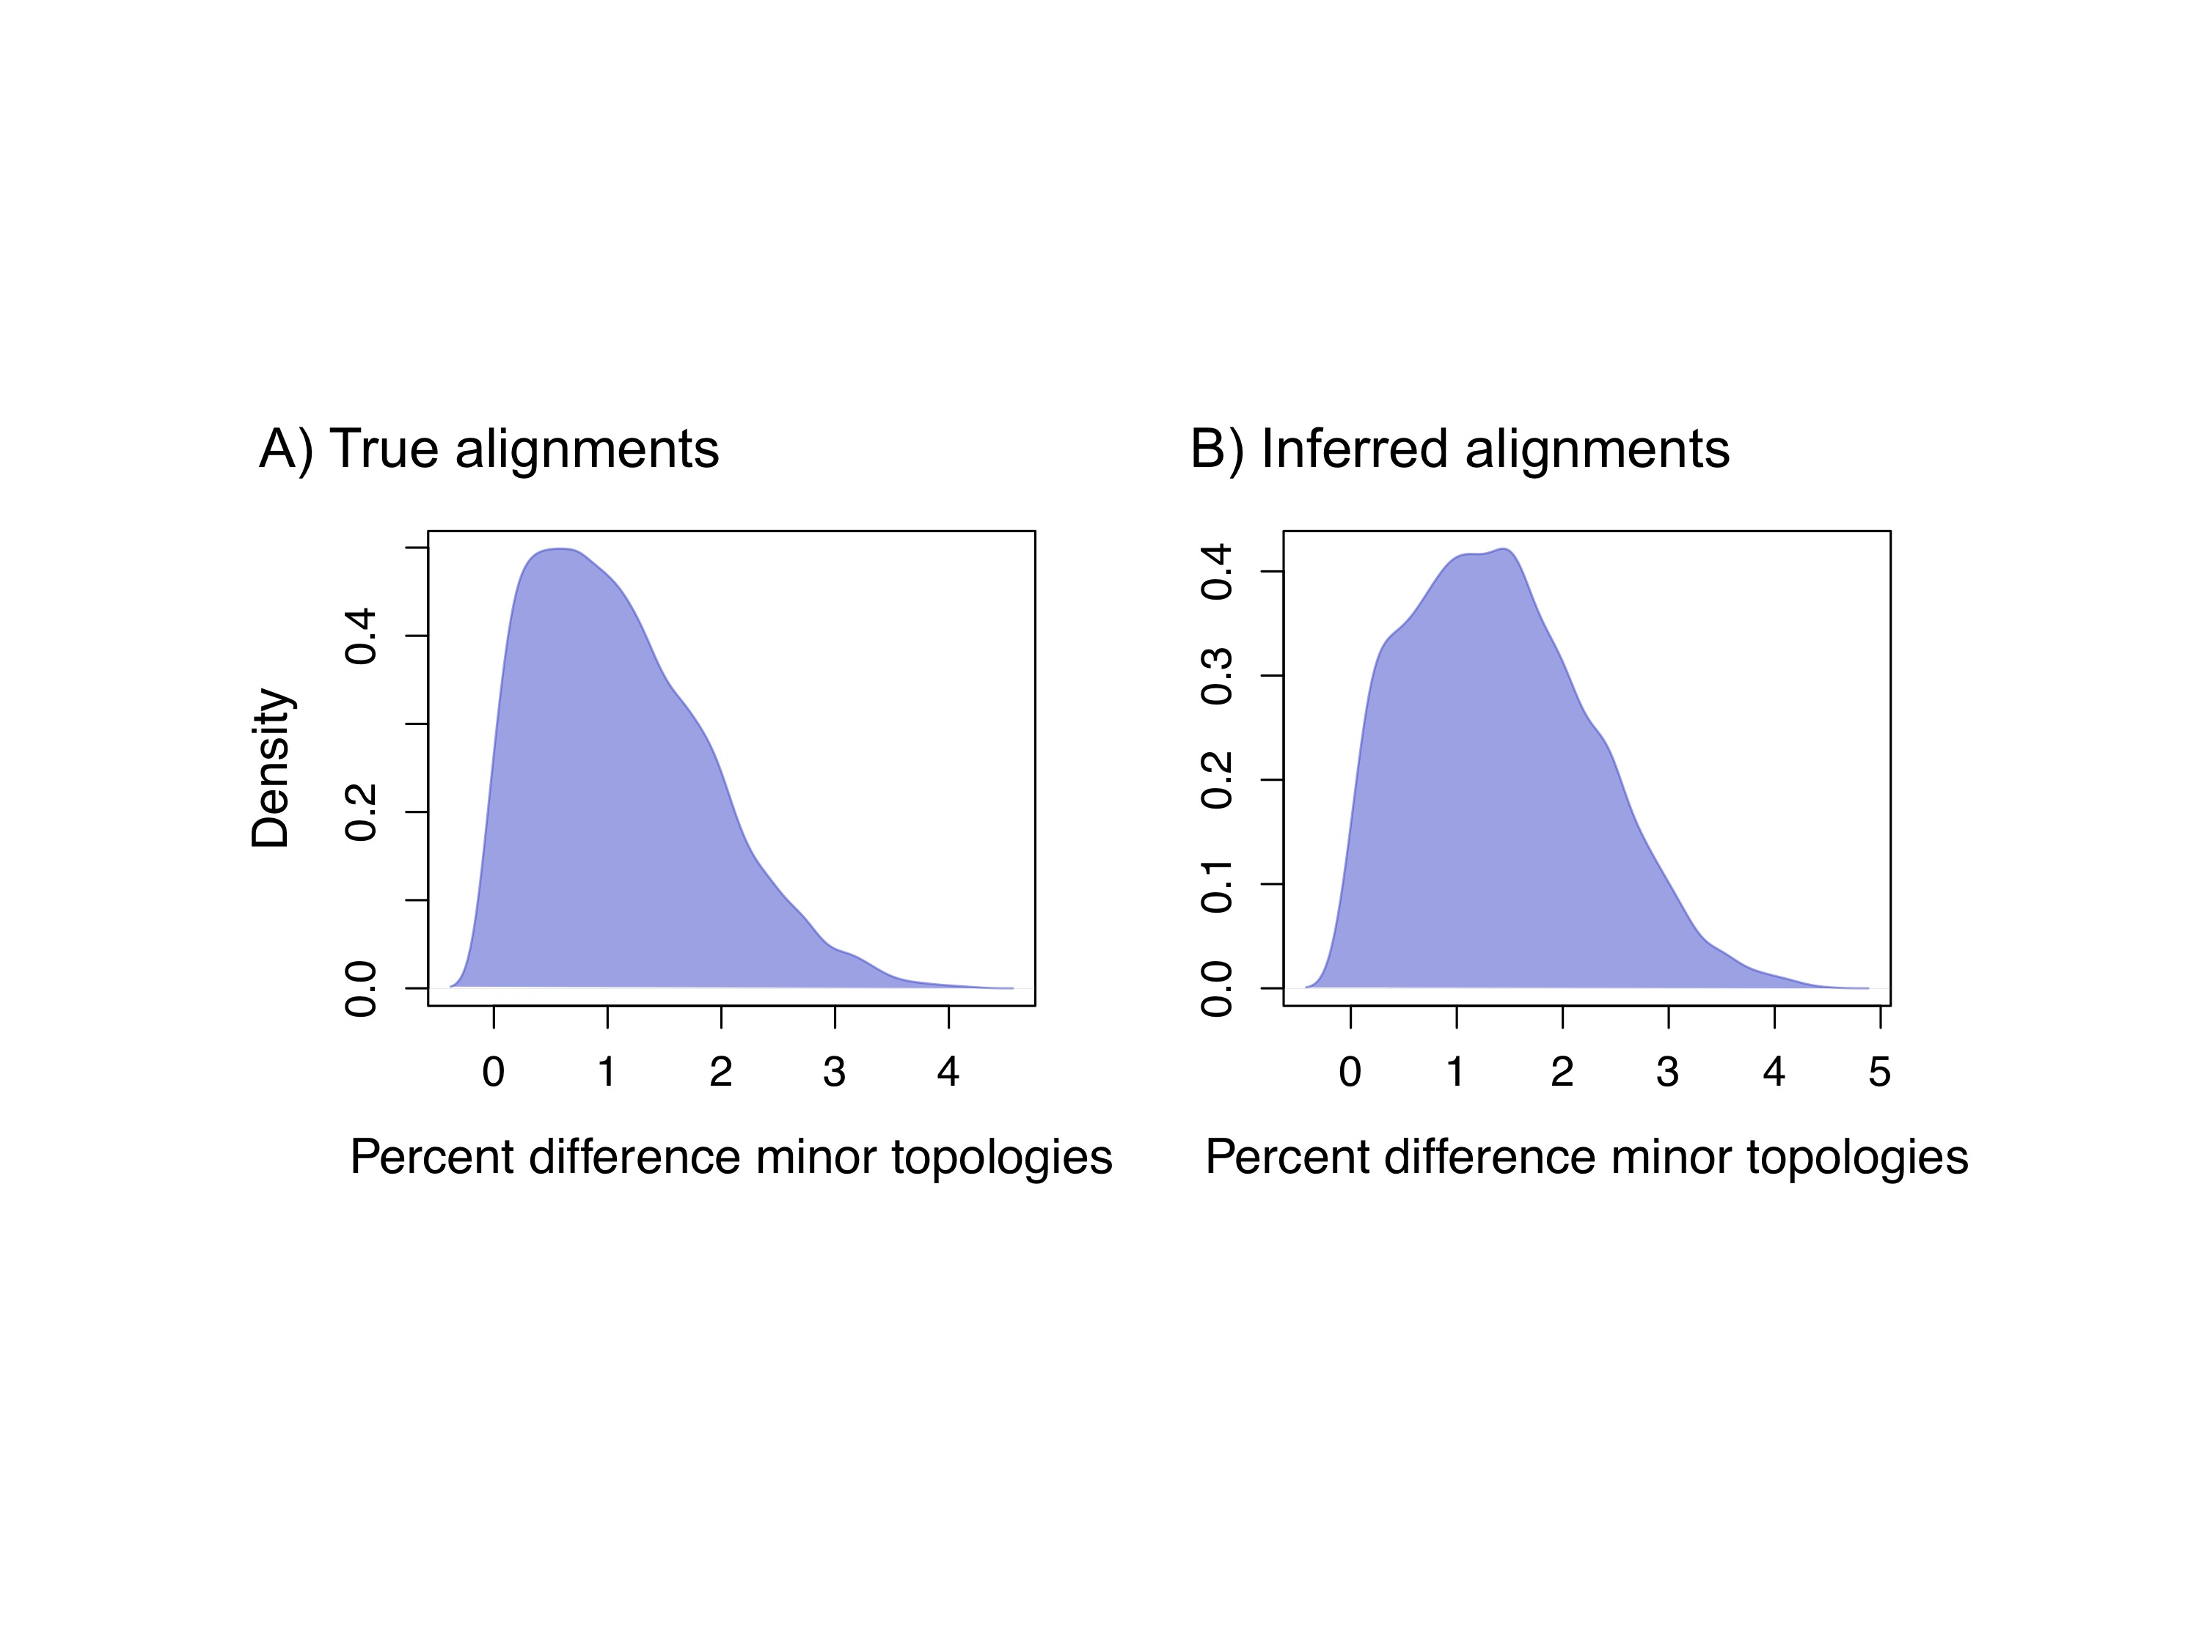

Figure S3. No effect of errors in genotype calling on hybridization inference. Since my genotyping pipeline does result in errors (approximately 1/100 kb), we wanted to confirm that this will not cause a bias in gene tree asymmetry. Comparisons of true alignments generated by coalescent simulations (A) to inferred alignments generated by my genotyping pipeline (B) demonstrate that my approach is unlikely to bias estimates of hybridization.

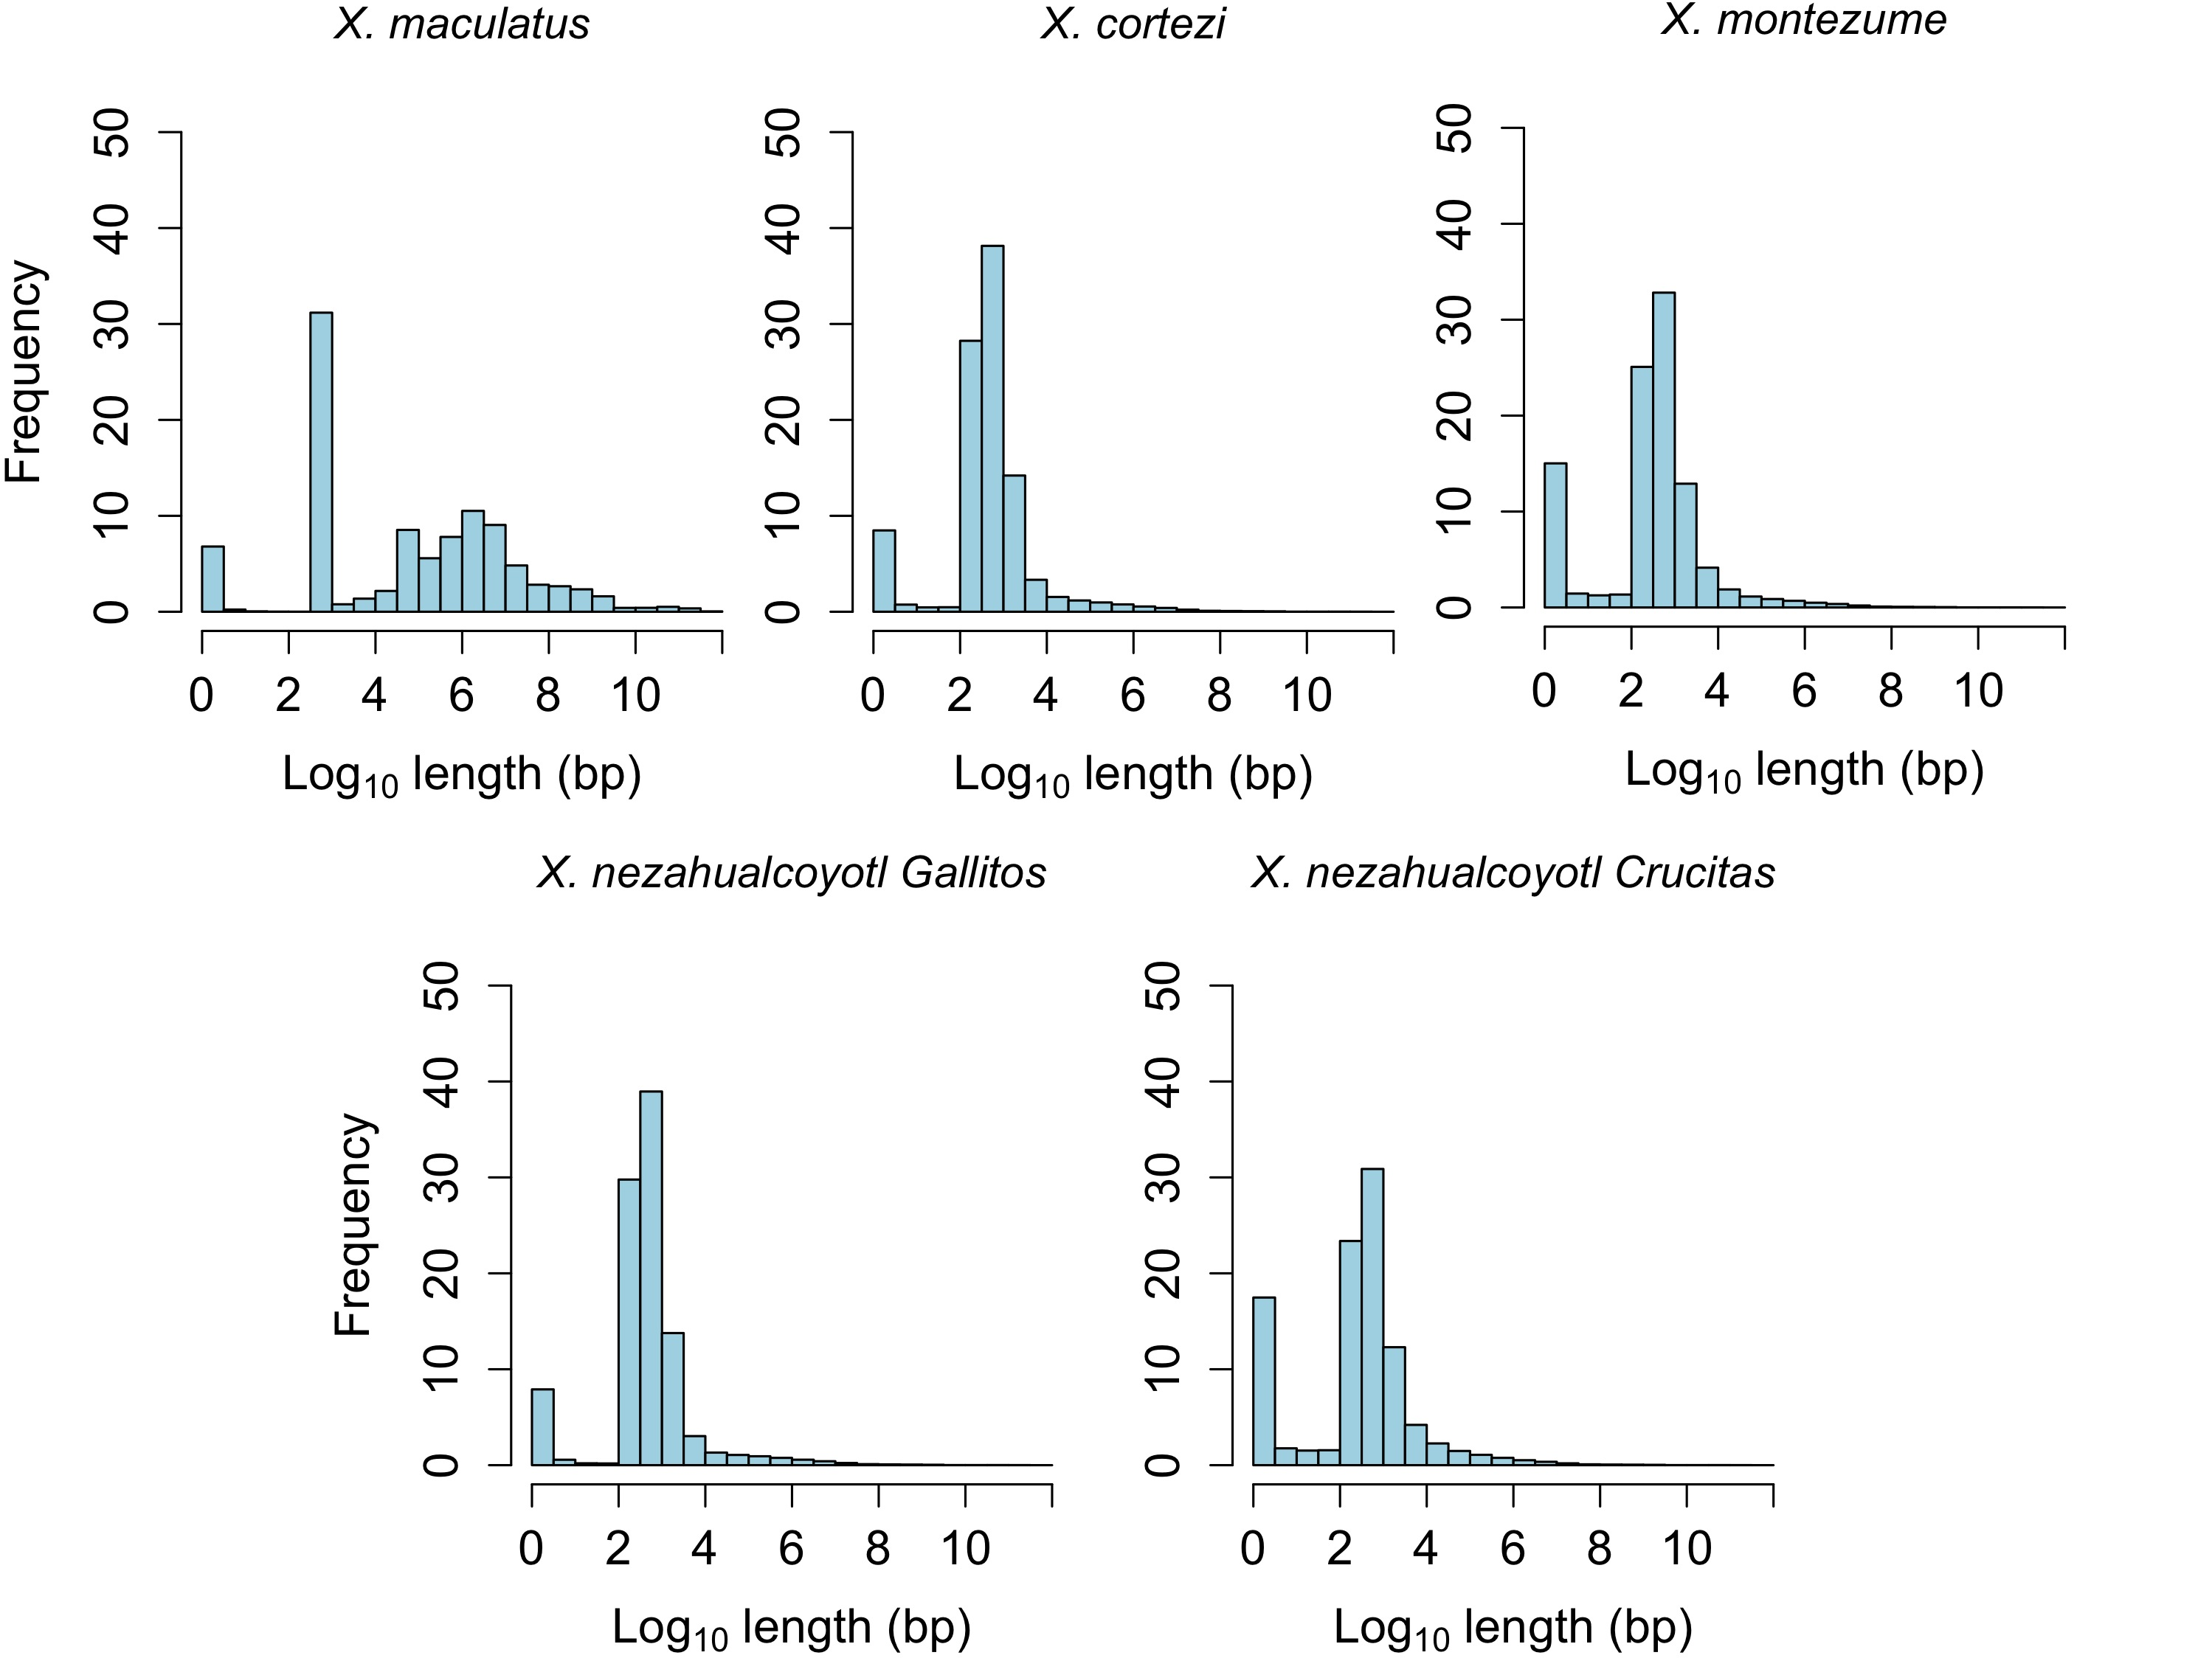

Figure S4. Distribution of missing data in each sample. The distribution of the lengths of N bases in each whole genome sequence included in this study.

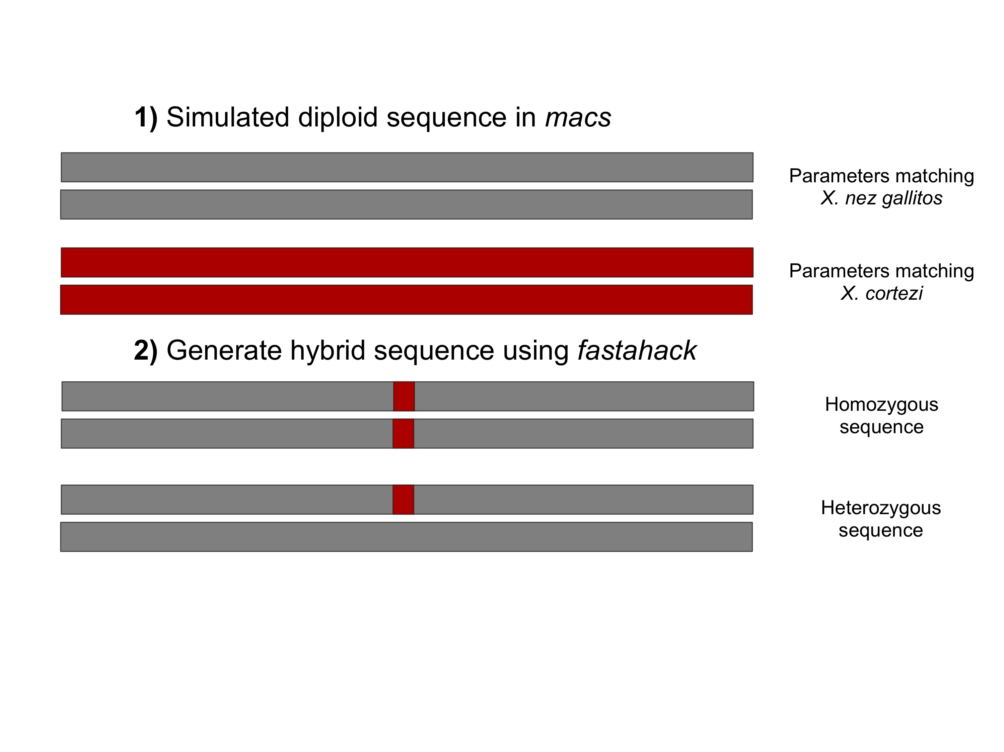

Figure S5. Schematic showing sequence generation for testing of PhyloNet-HMM. Neutral 1 Mb sequences with parameters matching *X. nezahualcoyotl* Gallitos and *X. cortezi* (as well as *X. montezumae* and *X. maculatus*)were simulated using *macs* and seq-genand hybrid sequences were generated using the program fastahack. These sequences were used both to test PhyloNet-HMM’s sensitivity to hybrid ancestry and also determine the false positive rate by identifying false switches outside of the hybridization-derived region.



Figure S6. Example of hybridization simulation results from PhyloNet-HMM. Plot shows the posterior probability for the hybridization tree (black) and the posterior probability for the species tree (gray). In this simulation a 10 kb “hybridization” segment was embedded in a 100 kb region. Shown also is my region delineation approach (dashed red lines). Regions were delineated by the length between the first and last base pairs supporting a particular parent tree at posterior probability ≥0.95, uninterrupted by high posterior support for another parent tree.

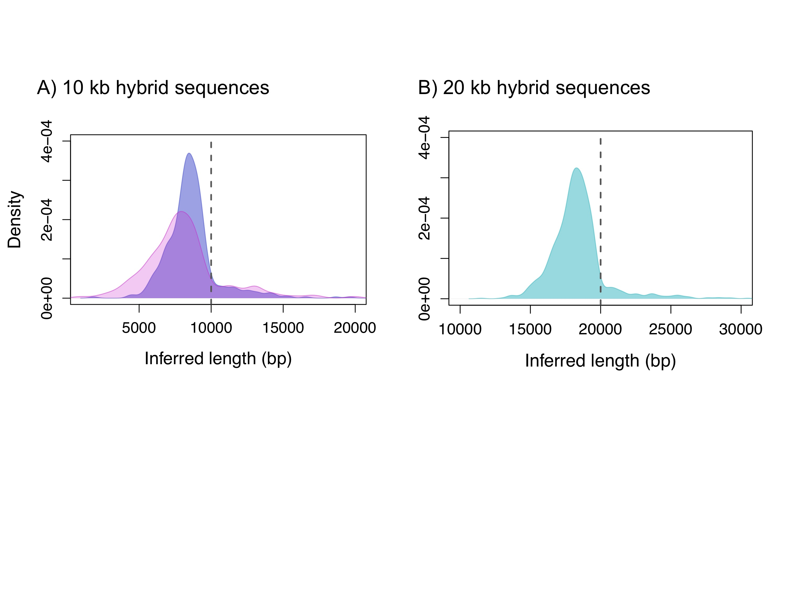

Figure S7. PhyloNet-HMM tends to underestimate the size of hybridization-derived regions. A) Inferred size based on PhyloNet-HMM results from simulations of 10 kb hybridization-derived regions with average sequenced divergence (purple) and low sequence divergence (pink, lower 5% quantile of *X. montezumae-X. cortezi* divergence). The average inferred length in the normal divergence simulation is 8.6 kb and the low divergence simulation is 8.2 kb. B) Inferred size based on PhyloNet-HMM results from simulations 20 kb hybridization-derived regions with average sequence divergence. The average inferred length in this simulation is 18.5 kb.

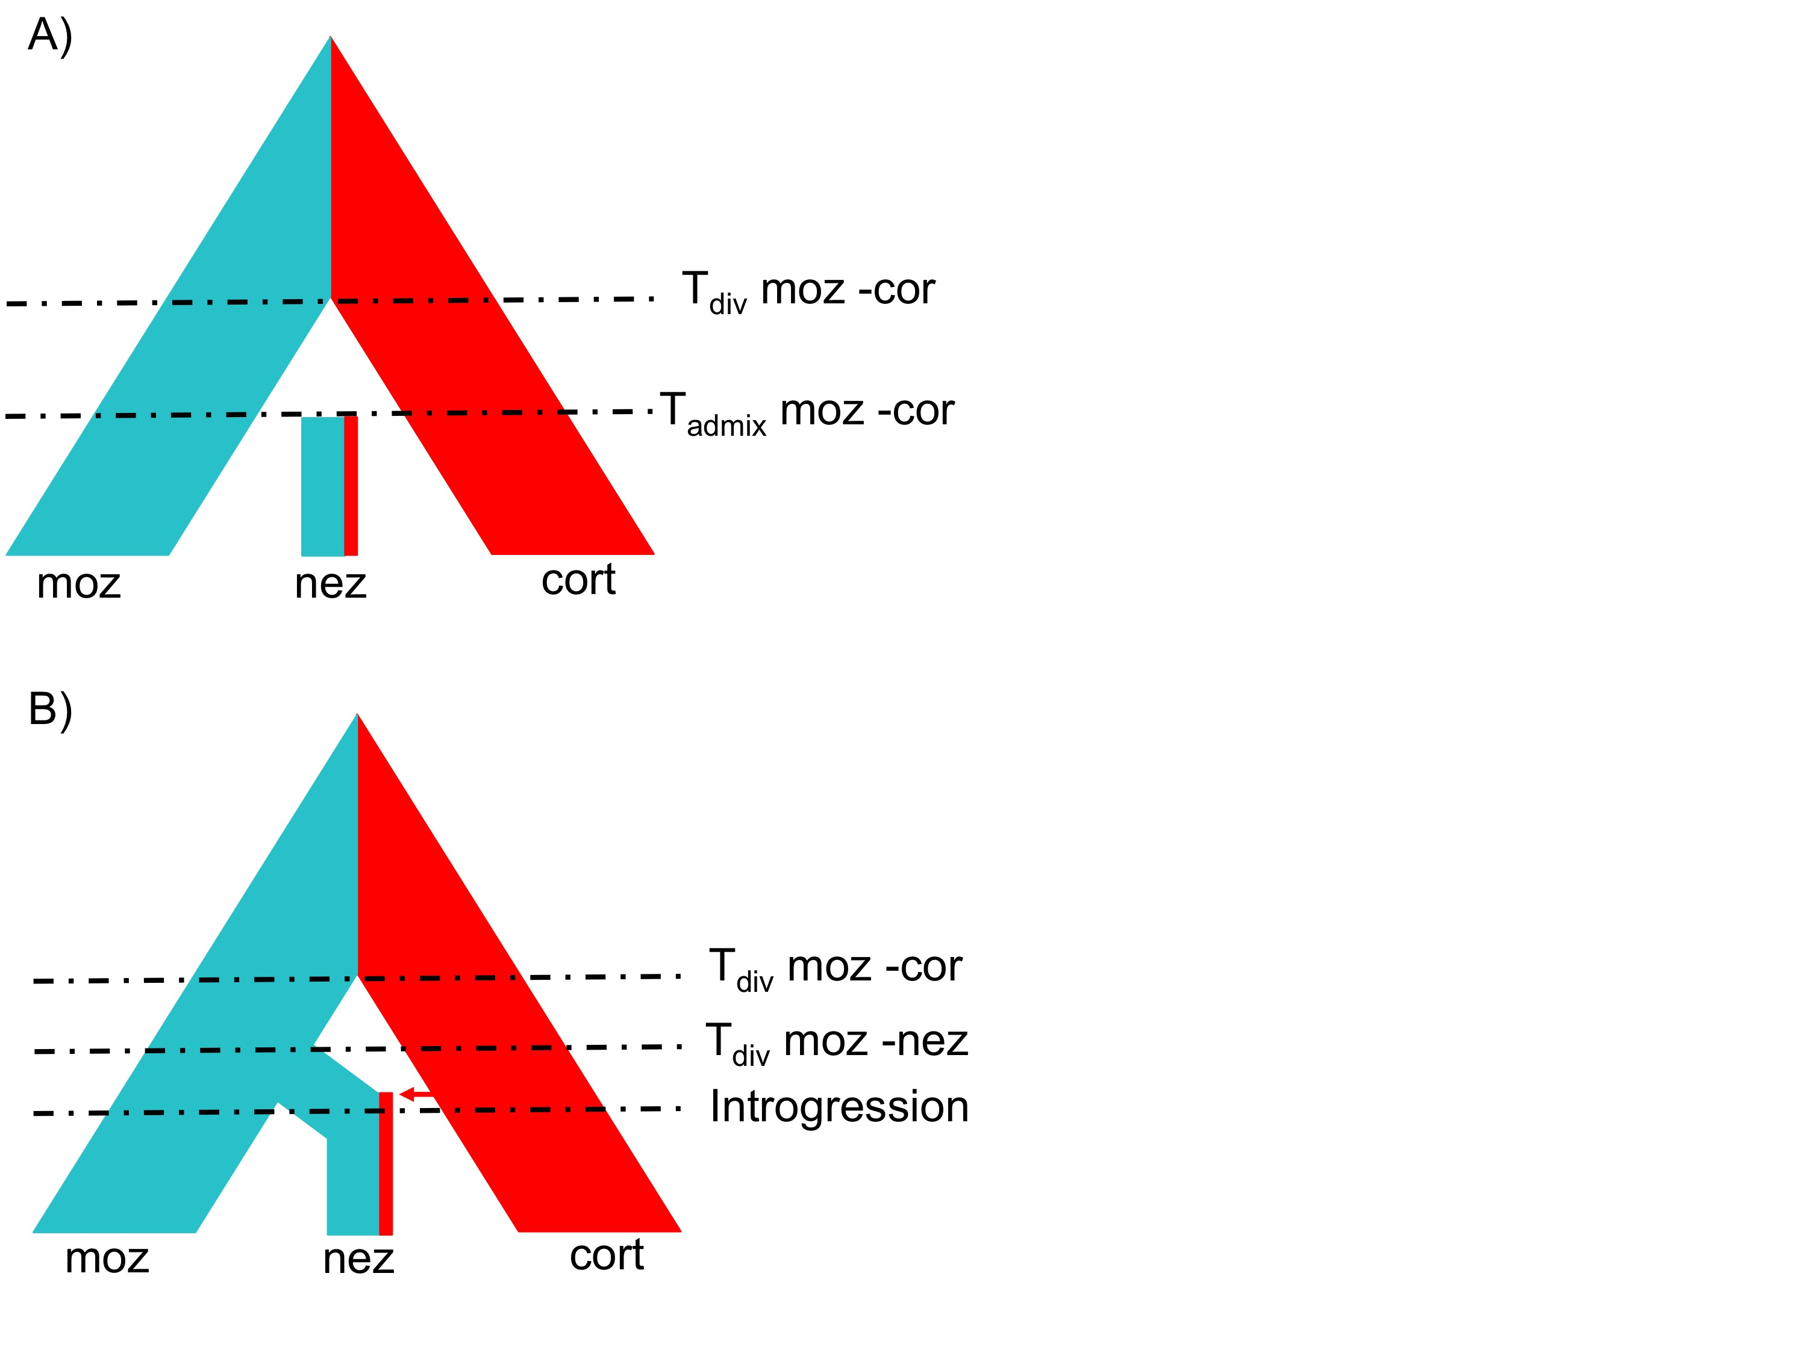

Figure S8. Different evolutionary scenarios potentially leading to present day *X. nezahualcoyotl* genome. In A, divergence between the *X. montezumae* lineage and *X. nezahualcoyotl* lineage precedes gene flow from the *X. cortezi* lineage. In B, *X. nezahualcoyotol* is formed by admixture between the *X. montezumae* and *X. cortezi* lineages. Current evidence based on divergence of ancestry tracts most closely related to *montezumae* or *cortezi* in the *X. nezahualcoyotol* genome supports scenario A.

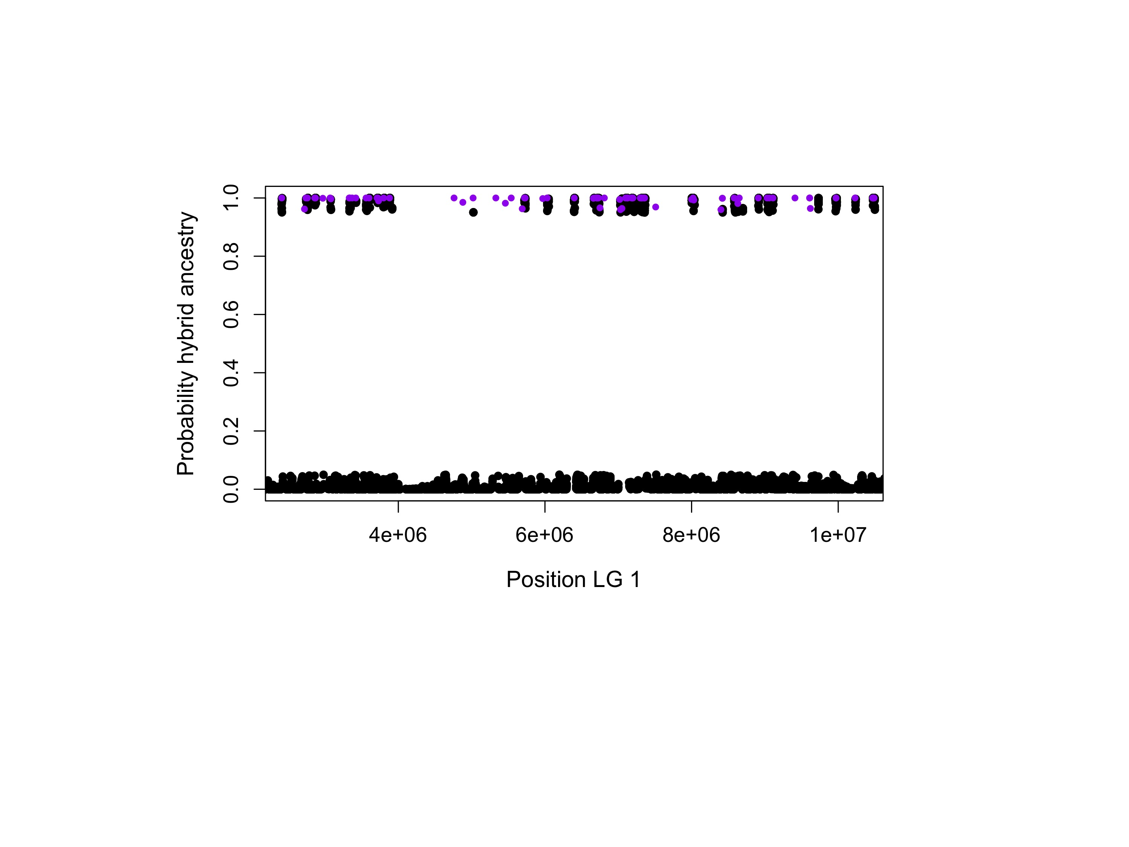

Figure S9. Concordance between AU results and PhyloNet-HMM results for linkage group 1. Regions identified as supporting *X. nezahualcoyotl*-*X. cortezi* hybridization (black points >0.95 posterior probability) largely overlap with regions supporting the *X. nezahualcoyotl*-*X. cortezi* topology in AU tests (purple points).

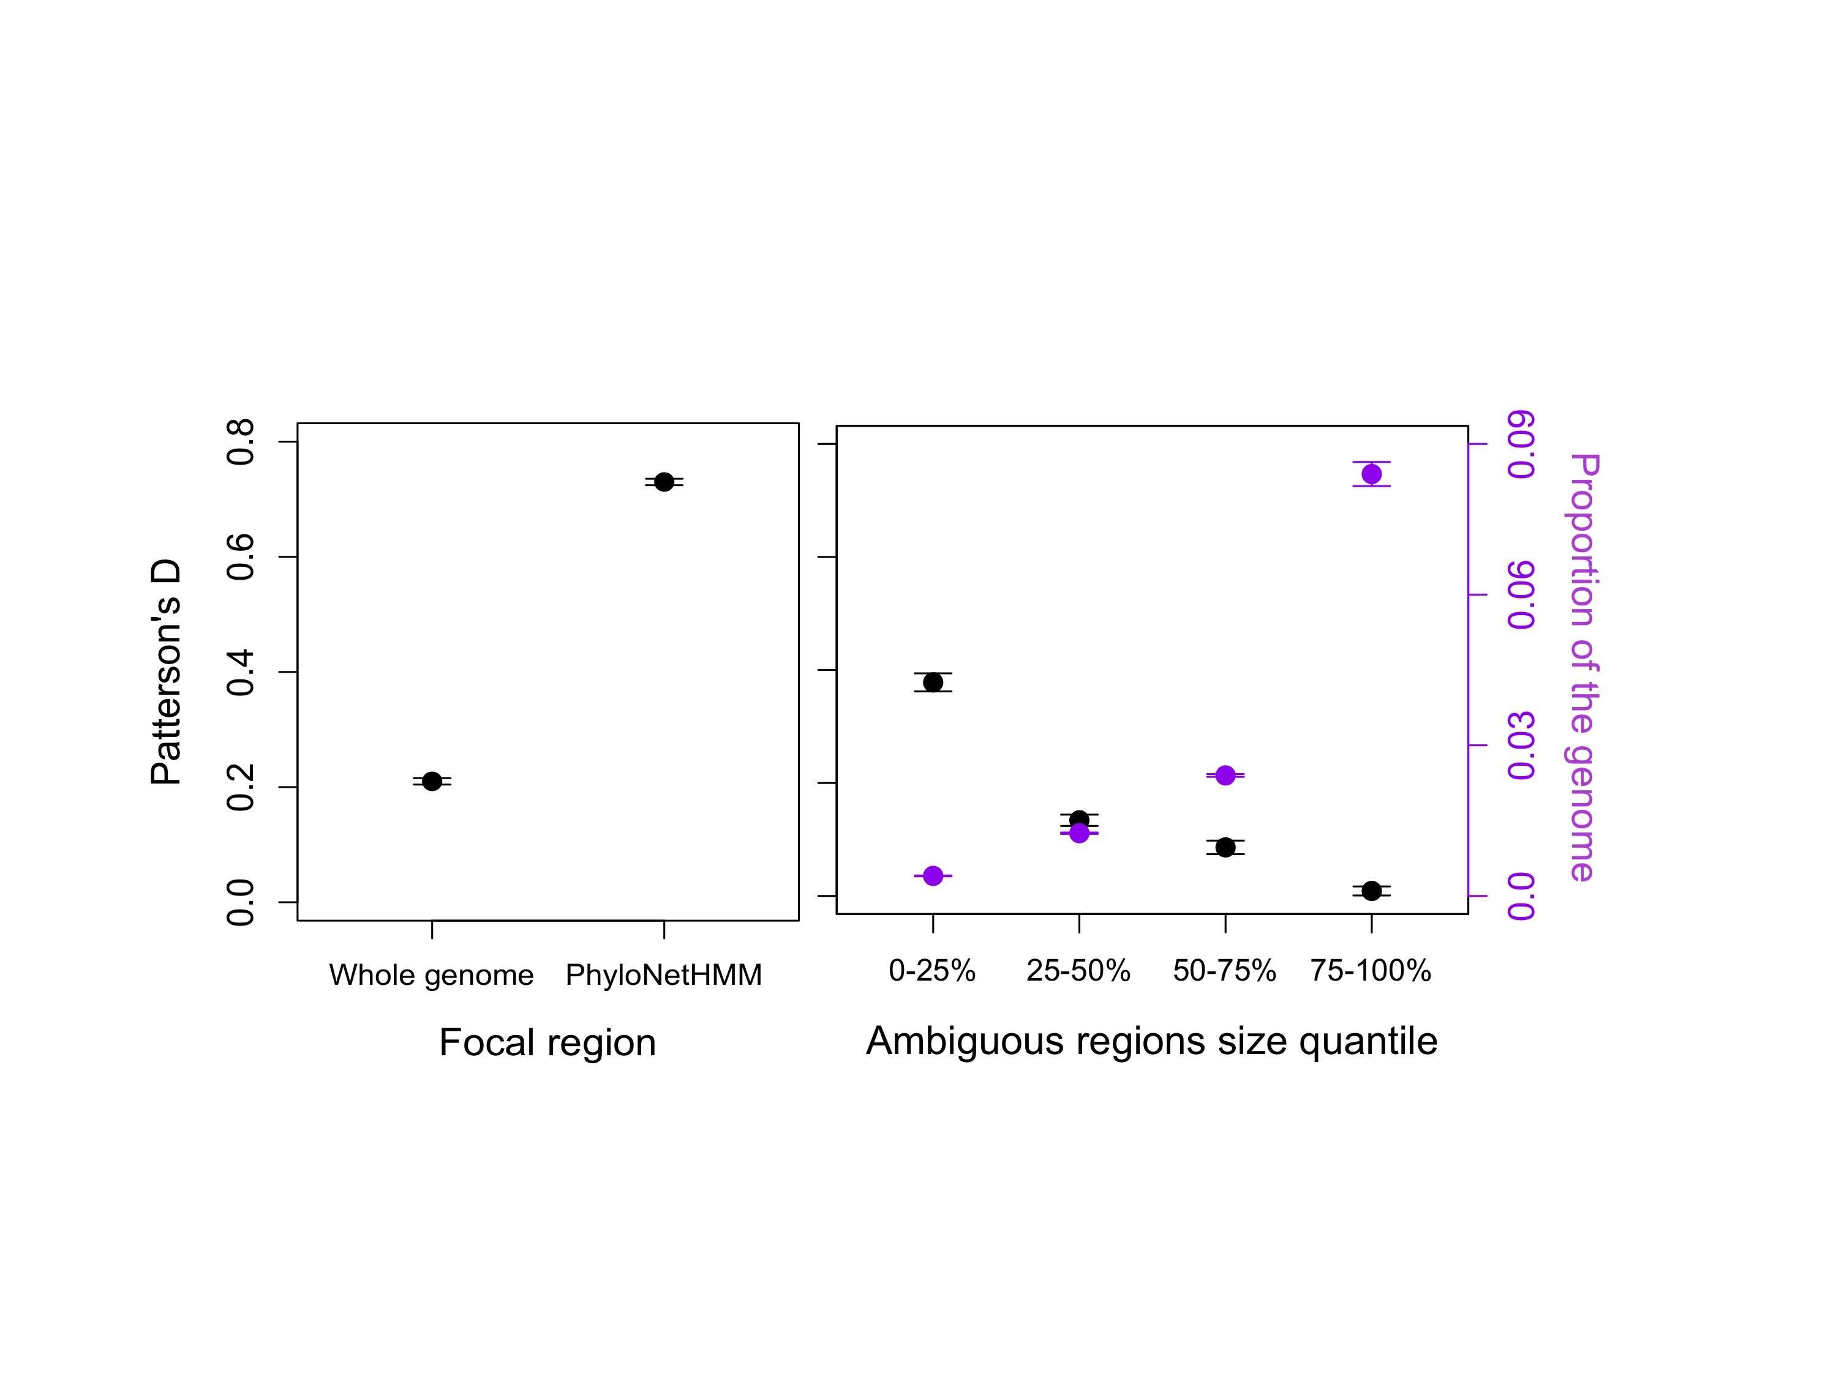

Figure S10. Signature of introgression based on the D-statistic in the whole genome and hybridization-derived regions (left) and in regions not called confidently by PhyloNet-HMM (right). The ambiguous regions with the strongest signature of introgression are small and as a result make up a small proportion of the genome (right). For simplicity, results plotted are from the Crucitas *X. nezahualcoyotl* sample, but identical patterns are observed with the Gallitos sample.

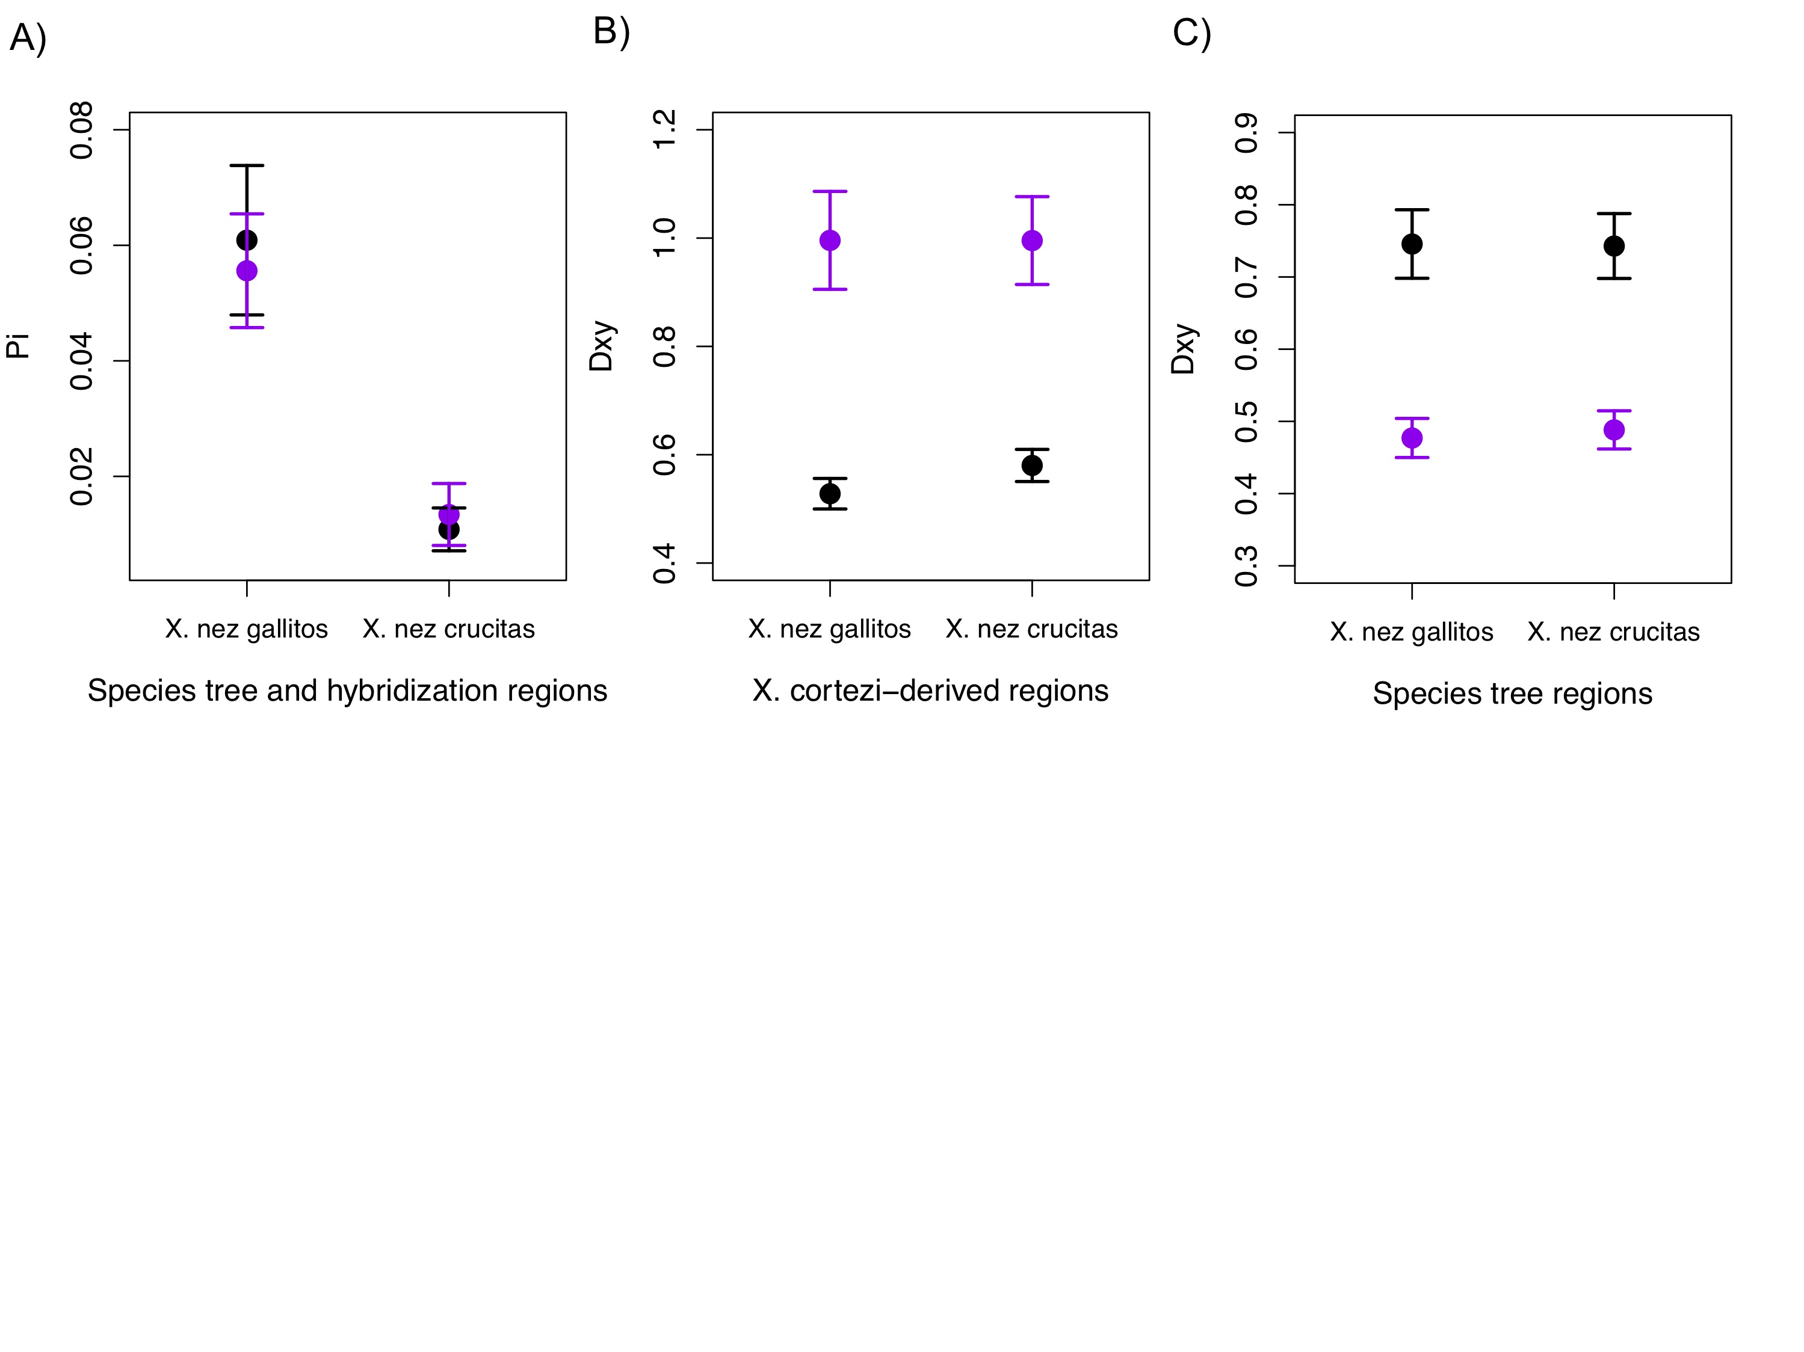

Figure S11. Estimates of nucleotide diversity () and divergence (Dxy) in regions with different evolutionary histories. A) Average percent pi in each *X. nezahualcoyotl* sample in hybridization-derived (purple) and non-hybridization-derived regions. B) Average percent Dxy between *X. nezahualcoyotl* and *X. cortezi* (black) and *X. nezahualcoyotol* and *X. montezumae* (purple) in regions derived from hybridization. C) Divergence between *X. nezahualcoyotl* and *X. cortezi* (black) and *X. nezahualcoyotol* and *X. montezumae* (purple) in regions that are not derived from hybridization.

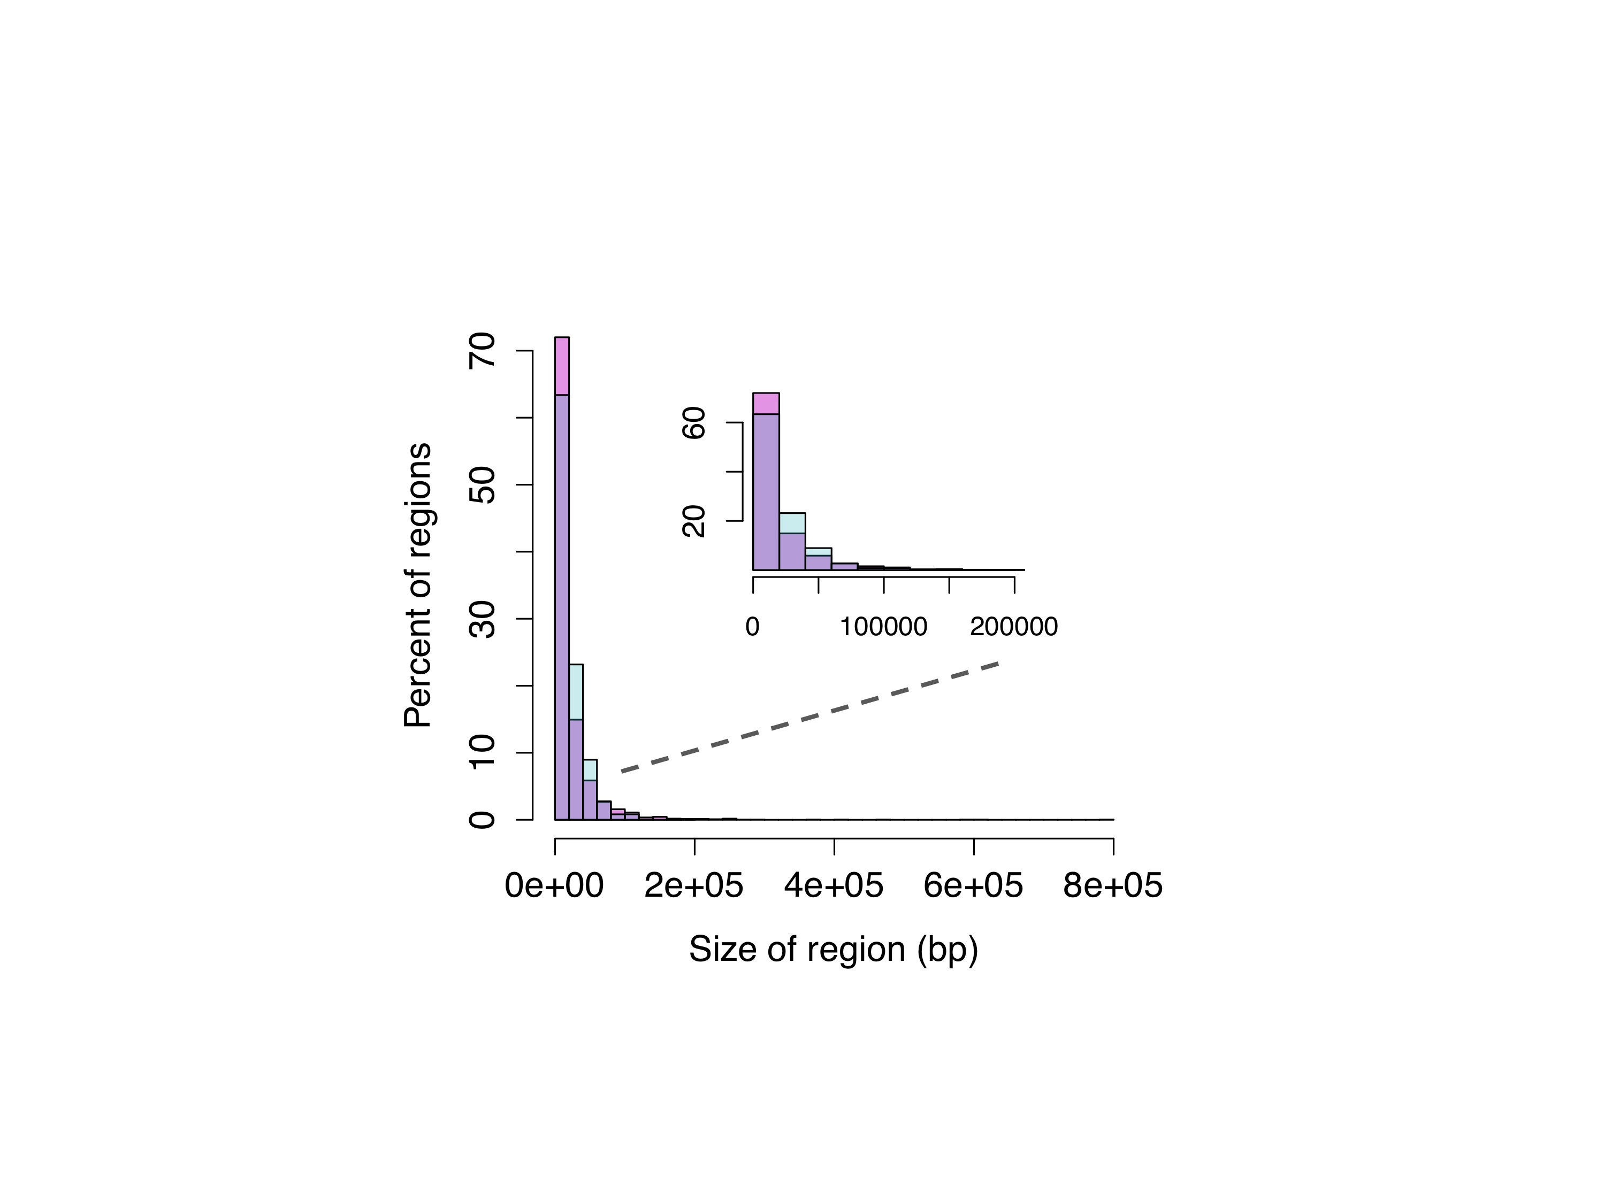

Figure S12. Comparison of the length of hybridization-derived ancestry tracts to a random exponential distribution. Detected hybridization-derived regions are shown in pink. Tract lengths are expected to be exponentially distributed, like the random exponential distribution with the same mean shown in blue. Regions of purple indicate overlapping density between the random and observed distributions.

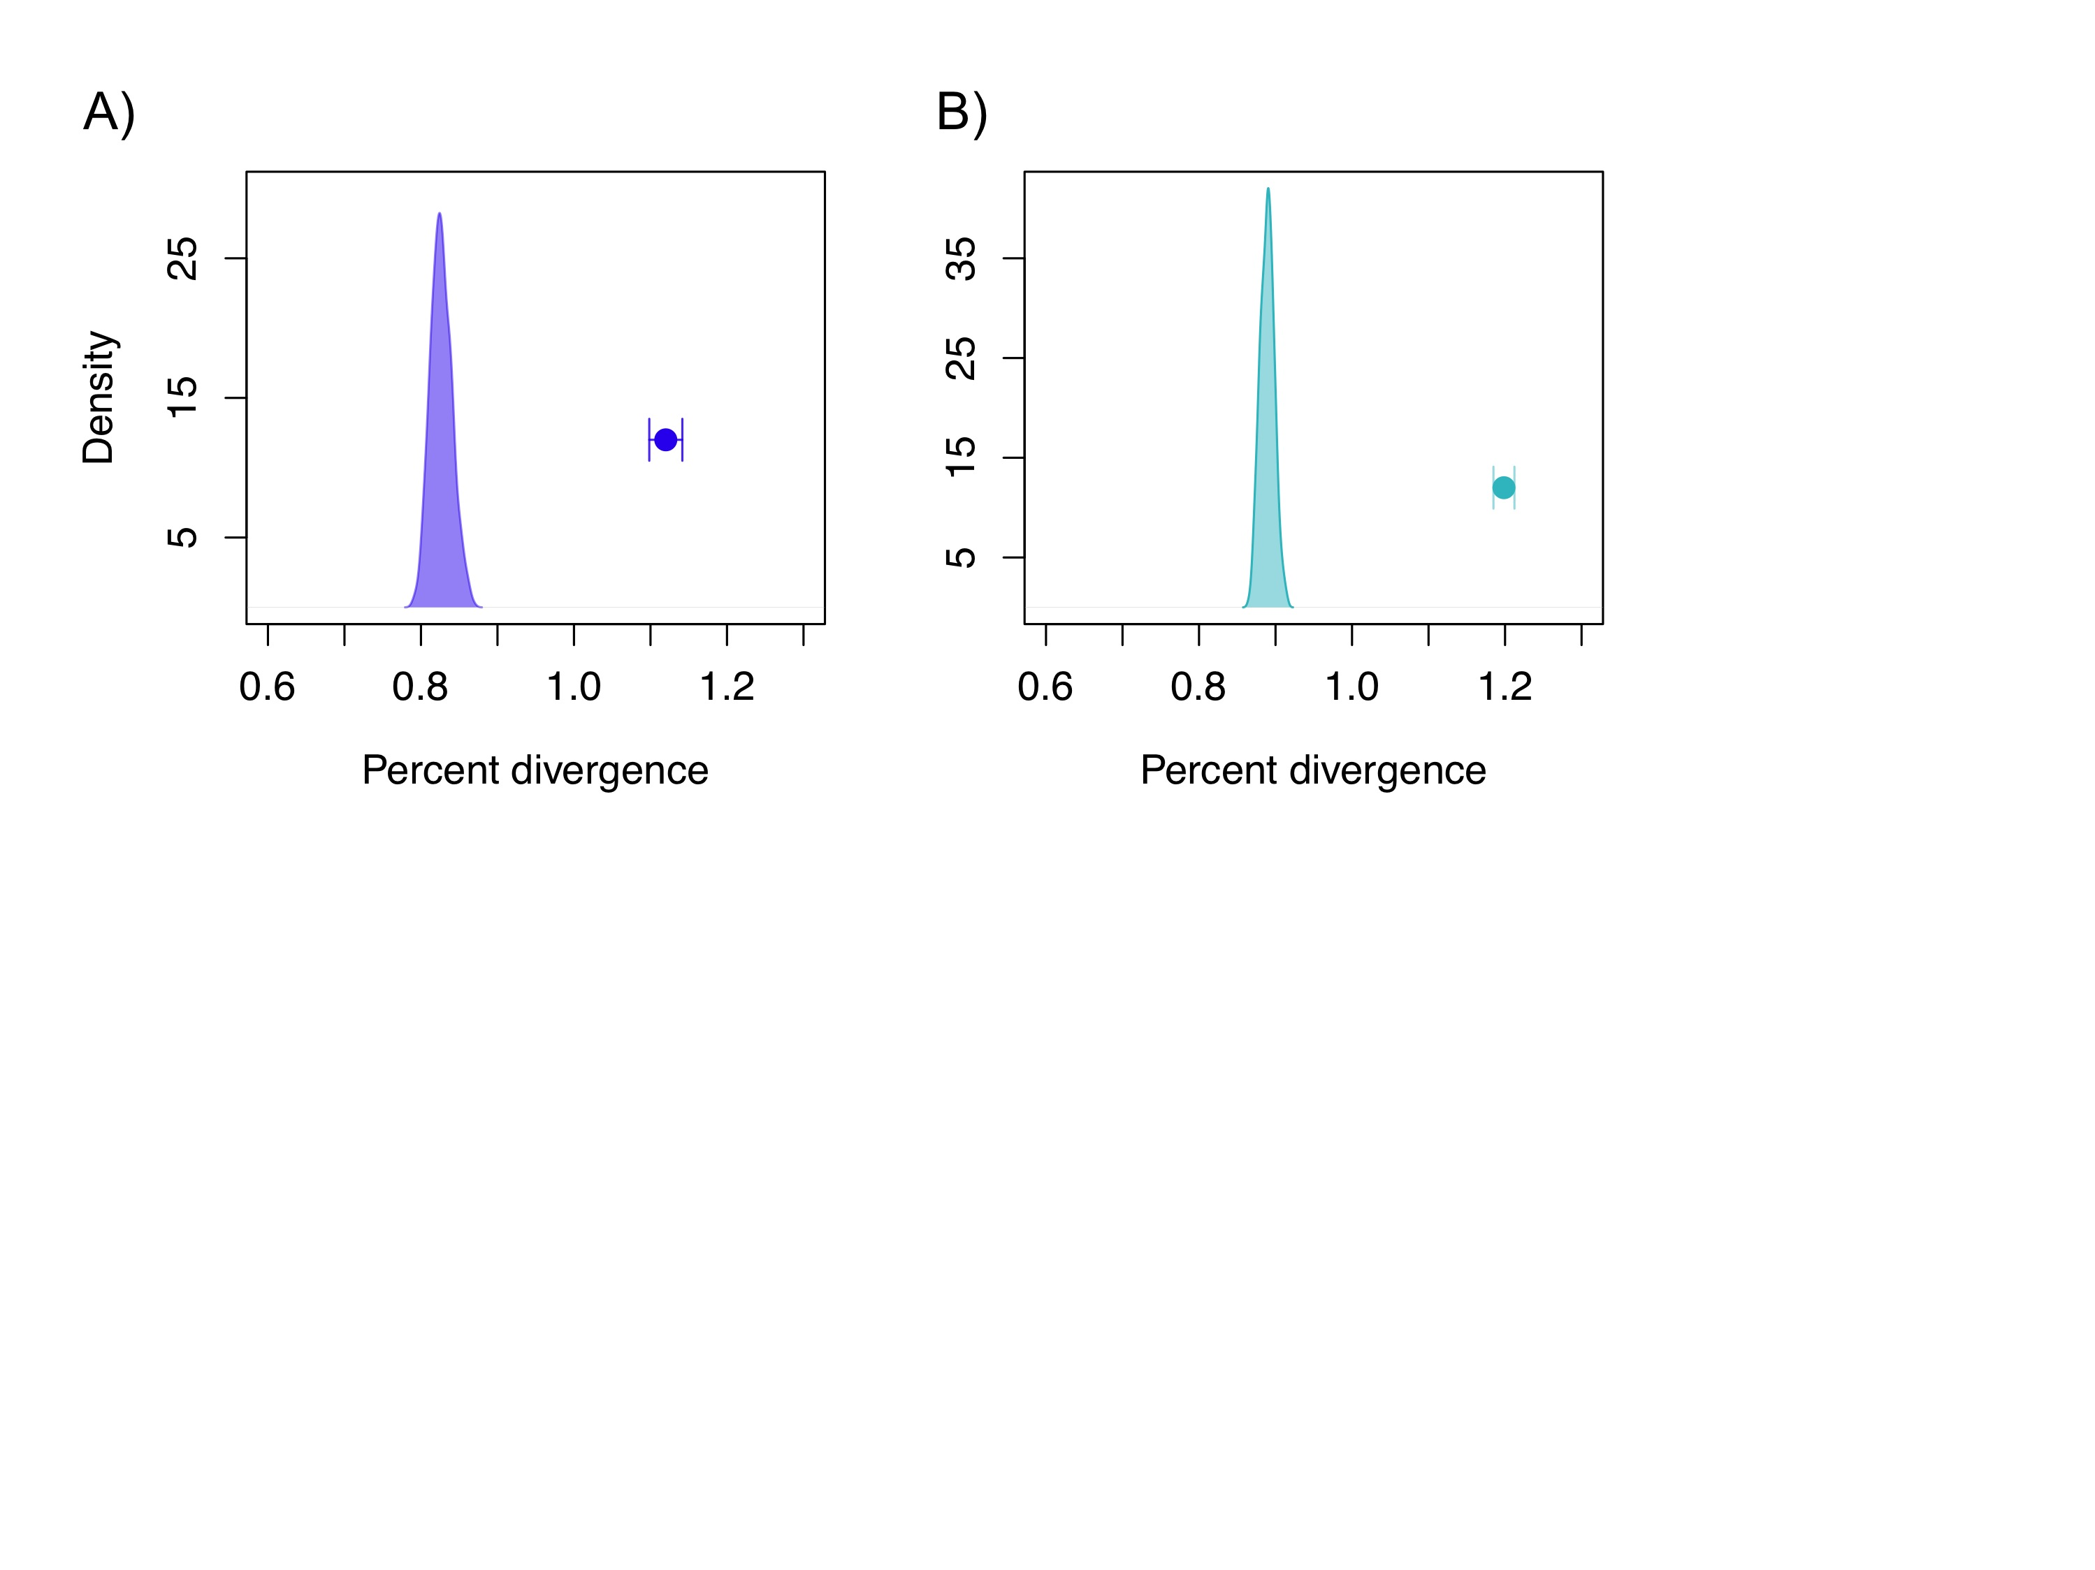

Figure S13. Divergence in hybridization-derived regions when low power windows are excluded. A) Results for the filtered dataset (excluding regions <0.02 cM) and B) results for the unfiltered dataset. Distribution shows the range of average divergences observed in null samples, excluding low-power regions (see Methods), while the point shows the average for the hybridization-derived dataset with 95% confidence intervals from bootstrapping.

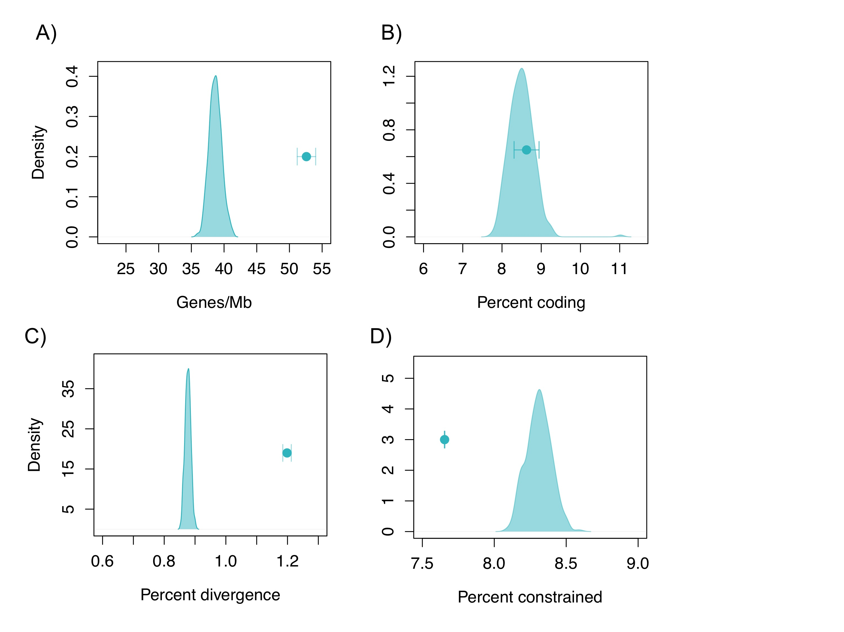

Figure S14. Differences between hybridization derived genomic regions and the genomic background in the unfiltered dataset. (A) Gene density is significantly higher in hybridization derived regions, but the proportion of coding bases is not (B). (C) Hybridization derived regions are significantly more diverged than the genomic background and(B) have fewer evolutionarily constrained bases.

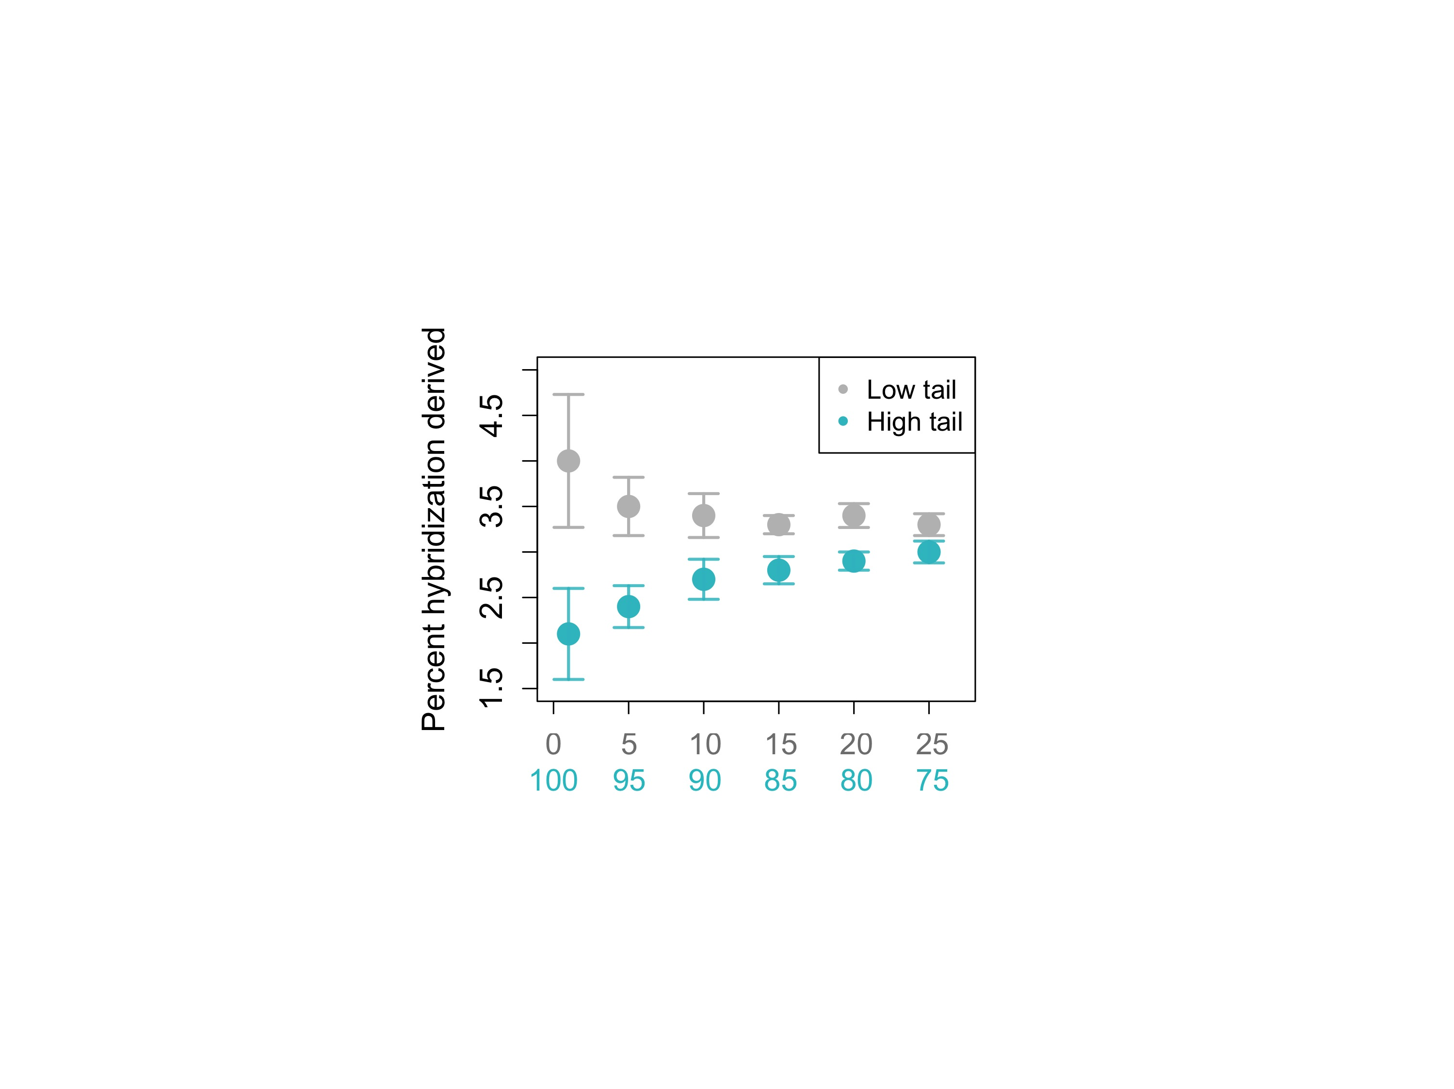

Figure S15. The most strongly conserved genomic regions are the least likely to be hybridization derived. Plot shows the proportion of base pairs that are hybridization derived as a function of conservation score. Conserved elements in the upper *n* quantiles (shown in blue) are increasingly less likely to be hybridization derived, while conserved elements in the lower 1-*n* quantiles (shown in gray) are increasingly more likely to be hybridization-derived. The analysis shown here is for the



Figure S16. Proportion of sites fixed as a function of population size after 2,500 generations. Results are based on 1,000 simulated sites. Drift was implemented using binomial sampling each generation in R.

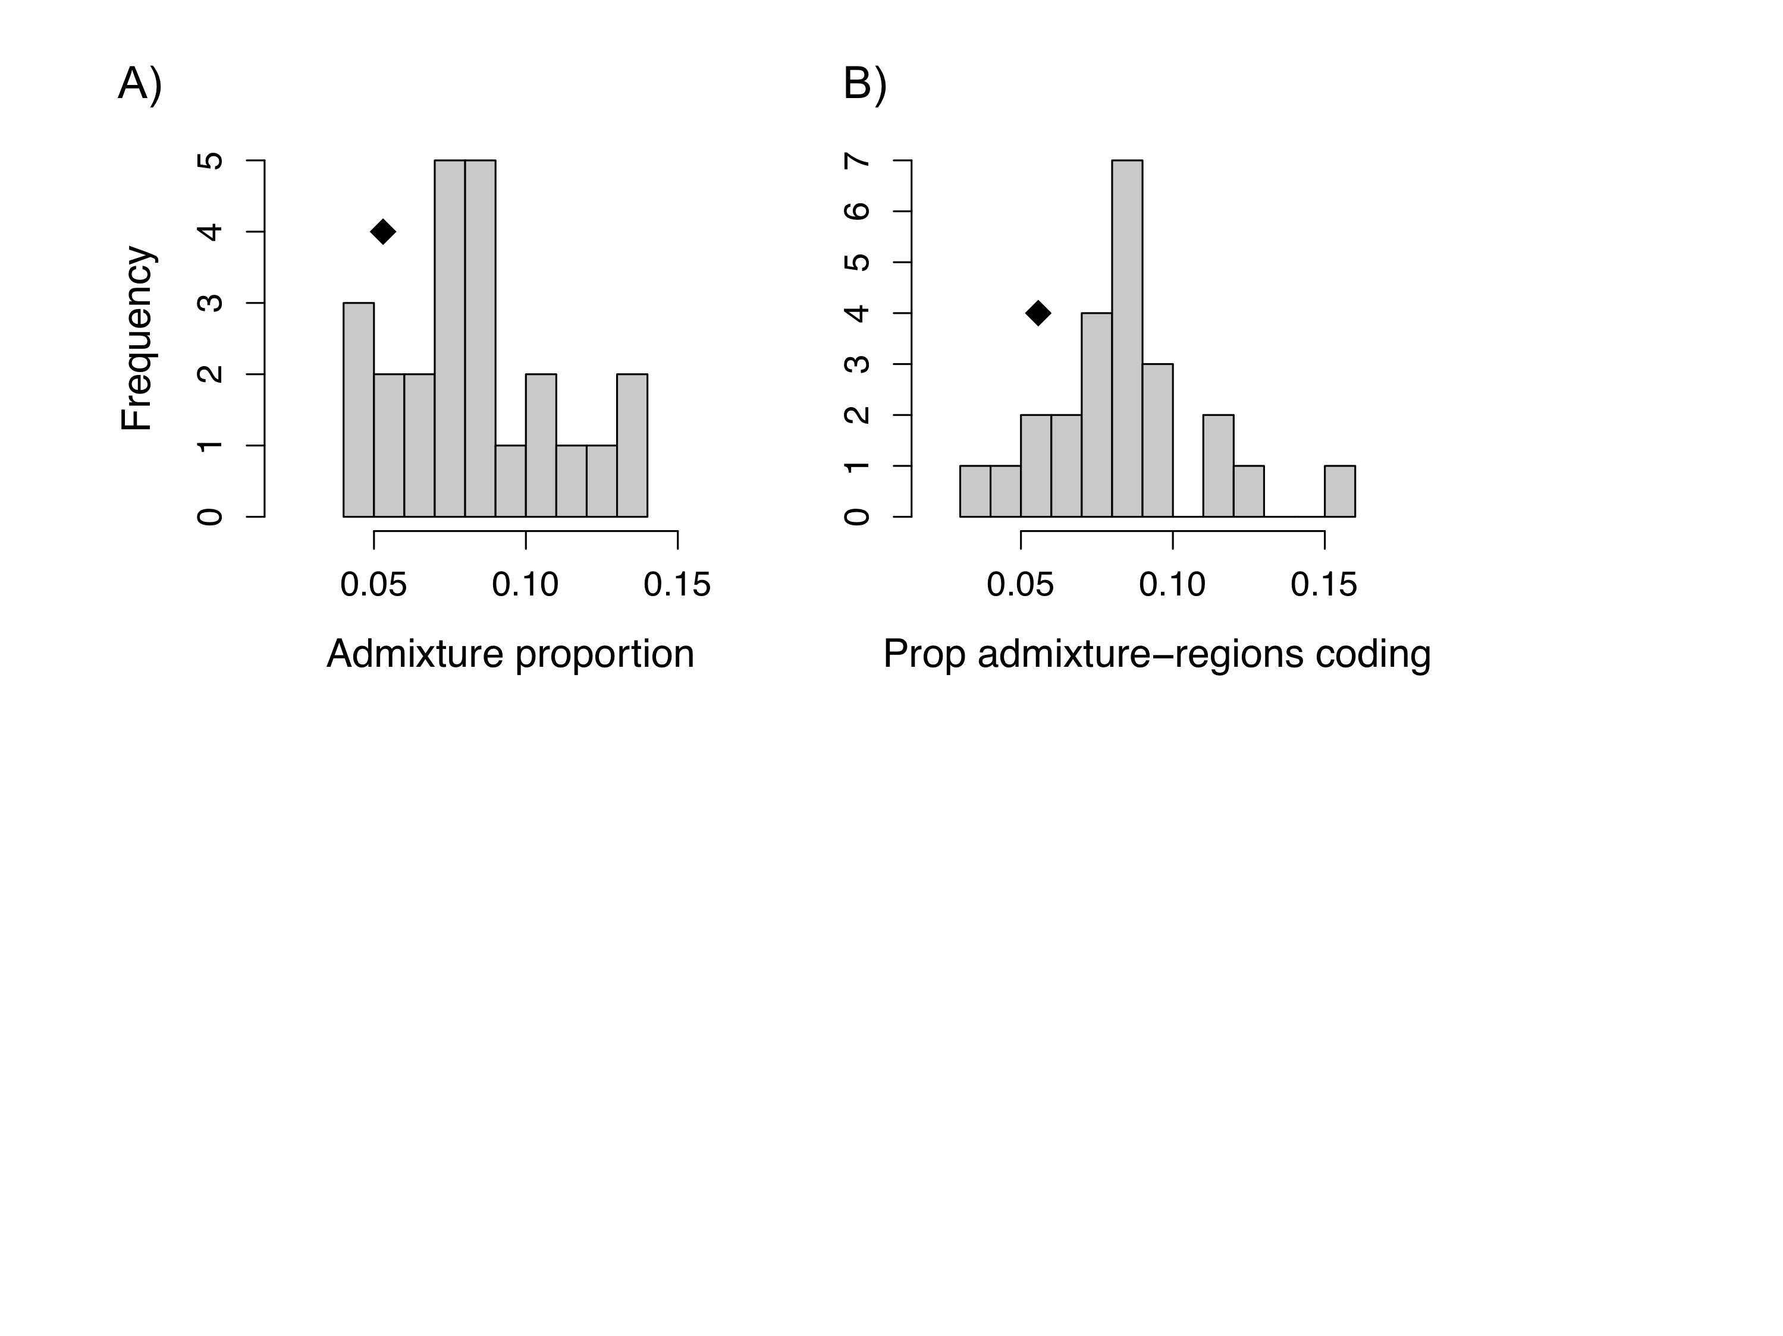

Figure S17. Distribution of hybridization-derived regions by chromosome. A) Admixture proportion by chromosome. B) Proportion admixture-derived regions coding by chromosome. In both cases the location of the putative X chromosome is indicated by the black diamond.

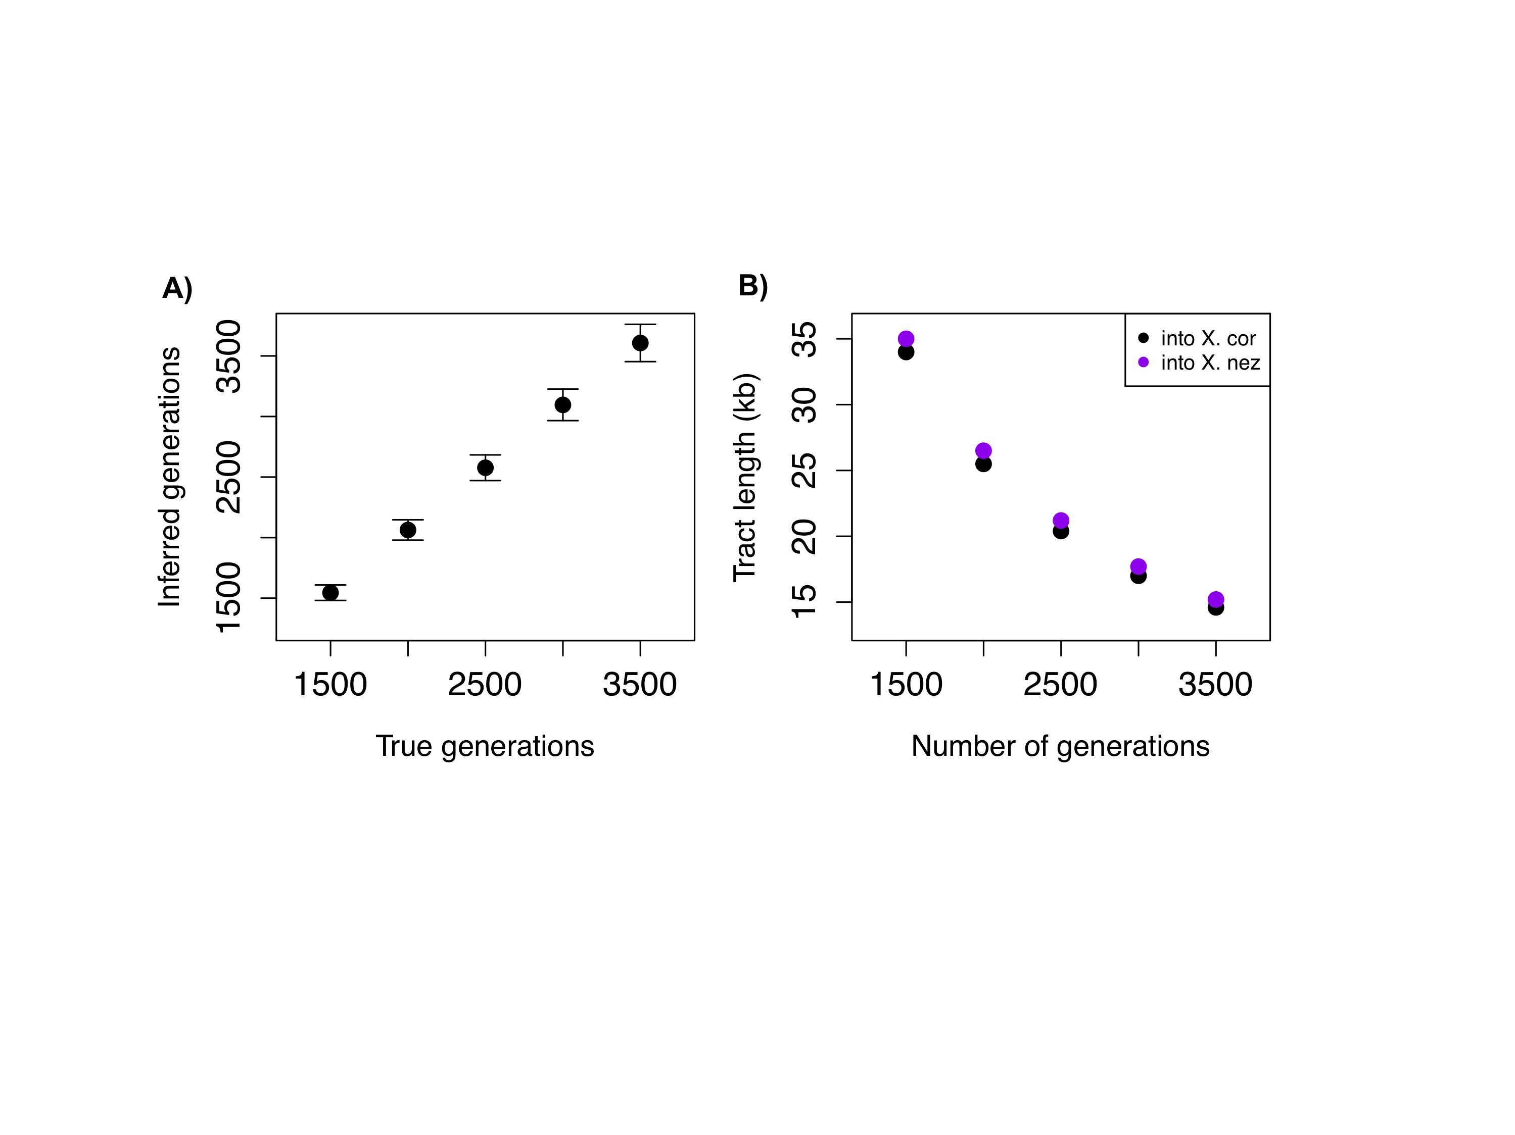

Figure S18. Assessment of potential biases associated with my approach to estimating the time to genomic stabilization. A) Inferred time of admixture versus true time of admixture in simulations using the approach applied in this study. Error bars show two standard deviations. B) Differences in predicted mean hybridization-derived tract length in *X. cortezi* and *X. nezahualcoyotl* at a range of generations since admixture. Since mixture proportions are similar in *X. cortezi* and *X. nezahualcoyotl* (estimated from DFOIL results), expected hybridization-derived tract length in the two genomes is similar.

CONCLUSIONS

Hybridization is a common evolutionary process, but how does it influence evolution? My dissertation research has suggested that hybridization can drive genetic processes that result in new, partially reproductively isolated populations (Chapter 2), but that hybrid speciation through novel traits is likely to be rarer than has been recently proposed (Chapter 1; Mallet 2007).

Although hybridization is likely not a major mechanism driving the formation of new species, my other chapters demonstrate that the process of hybridization can give us many insights into the nature of species and barriers between species. While previous work on artificial hybrids (Presgraves 2010) has suggested that many strong genetic interactions distinguish deeply diverged species, my research presented in Chapter 3 suggests that even closely related, naturally hybridizing species are isolated by many potential incompatibilities but that these interactions are under much weaker selection than what has been previously observed. Furthermore, results of Chapter 3 suggest that hybridization, and selection against hybridization, has been an important force shaping the genomes of species over evolutionary time. Identified hybrid incompatibilities limit gene flow between species, effectively shielding parts of the genome from homogenization. This suggests that these incompatibilities, identified in naturally occurring hybrids, contribute to reproductive isolation between species.

Finally, in Chapter 4, I ask how hybrid ancestry has been shaped in the genome over thousands of generations of selection. A major question that arises from the realization that hybrid ancestry in the genome is common is what the function of this hybrid ancestry is. Results of Chapter 4 present strong evidence that hybrid ancestry is partially constrained in the genome by selection. Hybridization-derived regions were significantly less constrained than expected, suggesting that selection has reduced hybrid ancestry in the most functionally important regions of the genome. My results also suggest that neutral processes, such as genetic drift, likely influence hybrid ancestry in the genome.

Although my dissertation research makes significant advances in our understanding of the interplay between hybridization, selection, and speciation, many important questions remain unanswered. For example, what is the genetic architecture of most hybrid incompatibilities and how does this influence the fixation of these sites and the likelihood that hybrids will evolve reproductive isolation from their parent species? How important is adaptation as opposed to other processes in driving the fixation of regions derived from hybridization? Addressing these questions and others will be a focus of future research in the field.

References

Mallet J (2007) Hybrid speciation. Nature 446, 279-283.

Presgraves DC (2010) The molecular evolutionary basis of species formation. Nat Rev Genet 11, 175-180.